**The Role of Women**

Venice

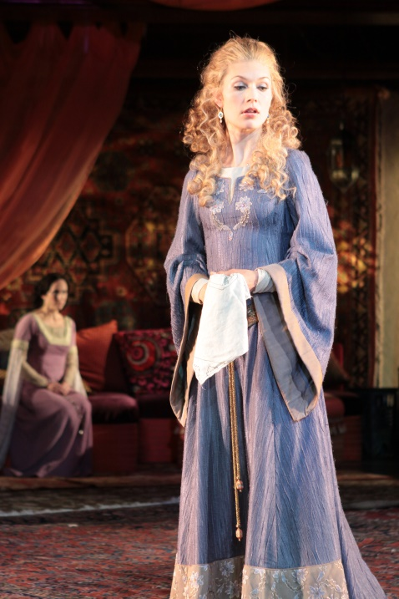The Counter-Reformation played a major role in defining the role and status of Italian women during the sixteenth century. Women were widely viewed as emblems of Catholic morality, serving primarily as matriarchs of the domestic household.

Women were forced to suppress their individual needs and desires to their husbands, all in the name of rationality and civic decorum.

Six of the most significant traits prescribed by men include: Chastity, Silence, Modesty, Reticence, Sobriety, and Obedience.

The patriarchal authoritarianism governing Venice denied any political rights to women.

England

* Women were raised with the mentality that they are inferior to men and therefore, they much obey them.
* Women looked weak to everyone.
* 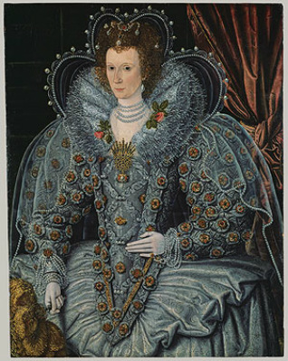Women were not allowed to buy any land.
* Most women were grown up to be domestic servants
* Were not allowed in professions

