**The role of Venice in Renaissance Europe**

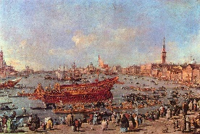-The city-state of Venice was originally established as a safe haven for people fleeing persecution following the collapse of the Roman Empire. However, it soon prospered as a region due to trade in a variety of different goods, most notably salt. Venice was well positioned as a trading center for the merchant class due to its geographic position on the coast of the Adriatic Sea.

-It also had a powerful Navy, which was made up of galleys.

-The wealth and power that Venice gained throughout the Renaissance period helped grow a strong merchant class, who benefitted significantly from trade. These merchants used their wealth to commission Renaissance arts and artists, which came to symbolise the main impacts of the Renaissance in Italy.

-Venice during the Renaissance period is referred to as a Republic, which means that the people of the state has a great deal more power and influence than they previously did under an absolute monarchy.

-The leader of the republic was referred to as the Doge. It was an elected position in which the person could serve as the leader for the remainder of their life.

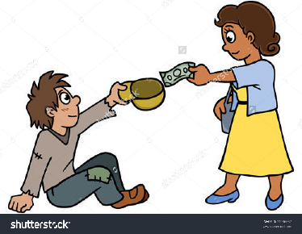-Another significant aspect of Venice life were the Scuole Grandi, which translates to ‘Great Schools’. The Scuole Grandi were known as charitable and religious organizations that operated as an important part of Venice social structure and were known to carry out several different activities, including: sponsoring festivities within Venice, distributing food and clothing to poorer members, carrying out the burial of the poor, and the administration of hospitals in the city-state.

- The most lucrative goods Venice traded were spices and silk, which were bought in the Levant and Egypt and were traded throughout Europe.

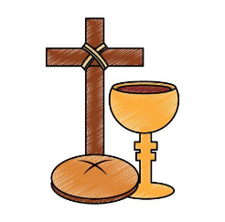-Although the people of Venice generally remained orthodox Roman Catholics, the state of Venice was notable for its freedom from religious fanaticism, and executed nobody for religious heresy during the Counter-Reformation.