**Religious upheaval in the 16th century Europe**

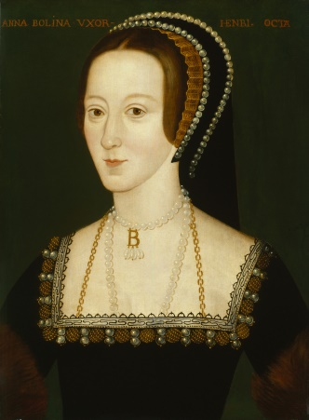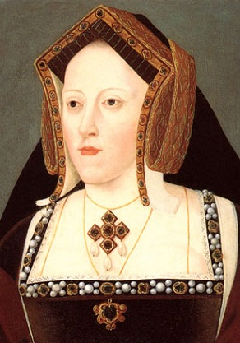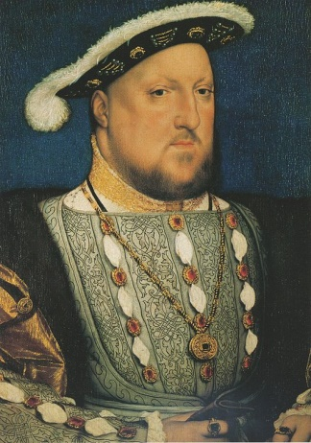In the 16th century England broke away from the Roman Catholic Church and formed its own church (Church of England) so that Henry VIII could divorce his first wife, and marry his second wife, Anne Boleyn (Elizabeth I mother).

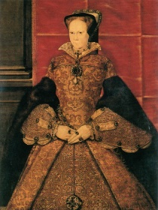Henry tried to enforce the Anglican way of living throughout England, he invaded monasteries and anyone caught not to be following the Church of England was at risk of losing their lives.

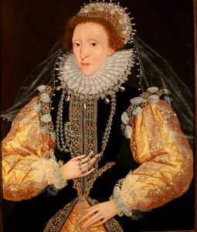However Mary I (daughter of Henry’s first wife, Catharine of Aragon) was extremely Catholic and converted the country’s main religion back to Catholicism. Mary was well known for her bloody hands, anyone caught practising Anglican Christianity was burned at the stake.

As if the English weren’t already confused, when Elizabeth came to the throne, she reintroduced the Anglican way of life. This was probably due to her mother; Anne wouldn’t have been queen if it weren’t for the Church of England.

The general assumption about William Shakespeare's religious affiliation is that he was a conforming member of the established Church of England. However, based on analysis of the historical record and of his published work, with claims that Shakespeare's family may have had Catholic sympathies and that he himself was a secret Catholic.

Venice was Catholic in the 16th century, so it is likely the characters of Othello are also catholic and tried to insult Othello as Othello's religion, culture, and race are all different from those of the Venetians, he is an outsider, and the Venetians treat him with suspicion despite his proven record of integrity. Hence why he is called a “heathen”.

**Heathen -** One who is regarded as irreligious, uncivilized, or unenlightened.