London  I wander thro' each charter'd street,  Near where the charter'd Thames does flow,  And mark in every face I meet,  Marks of weakness, marks of woe.  In every cry of every Man,  In every Infant’s cry of fear,  In every voice, in every ban,  The mind-forg'd manacles I hear.  How the Chimney-sweeper’s cry  Every black'ning Church appalls;  And the hapless Soldier’s sigh  Runs in blood down Palace walls.  But most, thro' midnight streets I hear  How the youthful Harlot’s curse  Blasts the new born Infant’s tear,  And blights with plagues the Marriage hearse. | 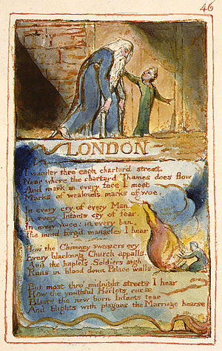

1. Find examples of repetition and think about what the effect of these are in the poem.

2. Where does Blake describe settings (of either time or place) and think about how these add the message of the poem.

3. Find lexis (vocabulary) associated with disease and corruption.

4. What does Blake suggest with the following phrases?
- “the blackening church”
- “the mind-forged manacles”
- “the charter’d Thames”
- “the youthful Harlot’s curse”
- “the marriage hearse”

5. Can you find an example of: oxymoron; anaphora; personification; semantic field of power?

