**How does the diary of Samuel Pepys (1666) record traumatic events?**

|  |  |  |  |
| --- | --- | --- | --- |
| **Area of analysis** | **Features that stand out in text** | **GOOD example of feature (relating to the writer’s depiction of traumatic events)** | **Is this feature a reflection of the text’s mode, audience, purpose or context?** |
| Structure | Temporal markers  Paragraph separation by time shifts/events |  |  |
| Register | Varies from informal (with core lexical choices)  ...to elevated (with non-core choices) |  |  |
| Lexis | Specific fields – mixture of disaster and domesticity  Archaic idioms and vocabulary to evoke situation  Proper nouns |  |  |
| Devices | Emotive tone and hyperbole  Metaphors and similes  Visual imagery |  |  |
| Grammar | Past tense, some past continuous and some present tense  Some non-standard grammar (omission of verbs) |  |  |
| Syntax | Long constructions with multiple clauses  Some shorter constructions |  |  |

**How does the diary of Captain Robert Scott (1912) record traumatic events?**

|  |  |  |  |
| --- | --- | --- | --- |
| **Area of analysis** | **Features that stand out in text** | **GOOD example of feature (relating to the writer’s depiction of traumatic events)** | **Is this feature a reflection of the text’s mode, audience, purpose or context?** |
| Structure | Temporal markers  Paragraph separation by time shifts/events |  |  |
| Register | Varies from informal (with core lexical choices)  ...to elevated (with non-core choices) |  |  |
| Lexis | Specific fields: nature, science, crisis  Archaic idioms and vocabulary to evoke situation  Proper nouns |  |  |
| Devices | Onomatopoeia  Metaphors and personification  Visual imagery |  |  |
| Grammar | Past tense, present tense and future tense  Heavy use of pre-modification |  |  |
| Syntax | Short constructions and minor sentences  Minor sentences and questions |  |  |

**ESSAY:**

**Referring back the diary of EITHER Samuel Pepys OR Captain Scott, compare the ways in which your chosen text and the following text use language to record disastrous events. In your answer, you must refer to the contexts of the texts.**

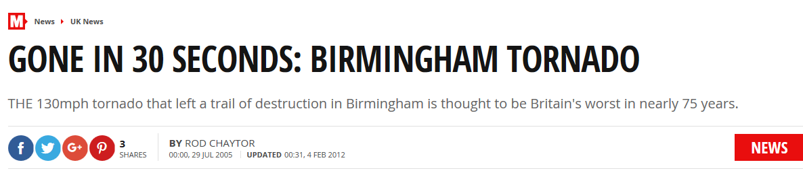

THE 130mph tornado that left a trail of destruction in Birmingham is thought to be Britain's worst in nearly 75 years. The freak storm uprooted trees and sent street signs flying, turned over vehicles and wrecked hundreds of buildings - many of which had their roofs ripped away.

One woman had severe injuries to her arms and legs when she was hit by a flying street sign as the tornado tore through the city. Another man was hit by a falling tree. At least six youngsters are among those hurt.

Dave Doherty, who works in a store in the King's Heath district, said the storm hurled a car park kiosk - with the attendant still inside - through his window.

Dave, 20, said: "Everything went black. People were rushing in from the street to take cover. Within seconds it was chaos. Things were crashing around and stuff was falling off the roof. People started screaming. Across the street is a little church car park with a hut for the attendant. The wind picked it up and blew it across the street, straight through the shop window. The attendant's a pensioner and was inside the shed when it smashed through the glass, but wasn't badly injured."

Another witness, Elaine Draper, 57, said: "I saw a man clinging to a lamppost. He was hanging on for dear life and his feet were in the air. Traffic signs were flying through the air and tiles were smashing on the ground. It was the worst thing I've ever experienced, really frightening. I hope I never have to face anything like that ever again."

The twister, which witnesses said lasted barely half a minute, struck at around 2.45pm after a furious burst of thunder and lightning. It tore through several square miles of the city, including King's Heath, Moseley, Sparkbrook, Highgate and Sparkhill. A police helicopter hovered above, with a tannoy announcement telling residents to evacuate the area for their own safety.

Brian Cassidy, 30, took refuge in a car near Ladypool Road as the twister passed overhead.

He said of the devastation: "It was like breaking matches. Ladypool Road's a write-off."

Another man said: "You see something like this and you realise why they call it the Finger of God. I just can't believe it." Stephanie Ellis, deputy manager of a Moseley nursery, told how youngsters screamed in horror as they watched through windows.

Stephanie, 33, said: "All the children were playing out in the garden but as soon as the rain started pelting down we got them inside. The children were crying and screaming as we saw the twister hit the garden, with furniture and paper being sucked up. Tiles flew off the roof into the fence and the chimney collapsed and some of the children were terrified but the staff managed to calm them down."

Diane Taylor, whose roof in Small Heath was ripped off, said: "I was in my living room with my niece, who's 14, and my daughter, who's 16, when we heard thunder and lightning. Everything went black and I opened the front door to take a look. Then the floor rose and we were all screaming, thinking we were going to die. We ran to the bottom of the stairs and were hiding there when we heard the living room roof crash in. I think I went into shock and froze and this gentleman just pulled us out. I think I had a lucky escape, I don't know how we survived. I'm not sure I've got much of a house left."

Ironically the last major tornado to hit Britain, almost three-quarters of a century ago, struck Birmingham's Small Heath district, leaving one person dead.

Yesterday an emergency medical centre was set up in Moseley to deal with the walking wounded. A spokesman for West Midlands Ambulance service confirmed they had treated 20 wounded people. Three were in a serious condition with broken limbs.

The spokesman said: "Nearly 30 ambulance vehicles with more than 50 ambulance staff attended a number of incidents across South Birmingham."

"A Met Office spokesman confirmed yesterday's tornado was rated T3-T4, meaning a speed of up to 130mph.

The Association of British Insurers said last night householders, car owners and shop-keepers should be covered if they have fully comprehensive policies.

But lesser policies, such as third party fire and theft, do not pay out for storm damage. "Bad weather damage is an integral part of buildings and household contents insurance," a spokesman said.