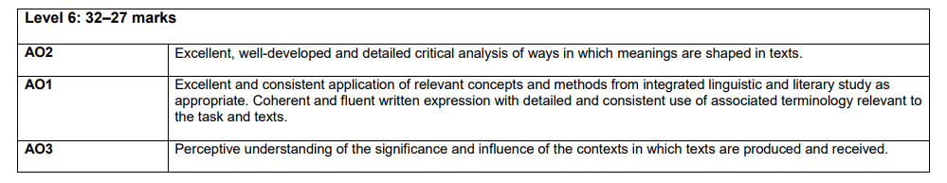**SECTION B – PLAYS: DRAMATIC AND STYLISTIC ANALYSIS**

|  |  |
| --- | --- |
| *Jerusalem*  OCR English Language and Literature A Level A Short Revision Booklet | Contents  Revising the text; structuring your essays; annotating your text; understanding and tackling the question; collecting quotes; analysing what the examiners want |

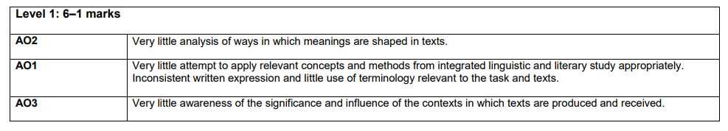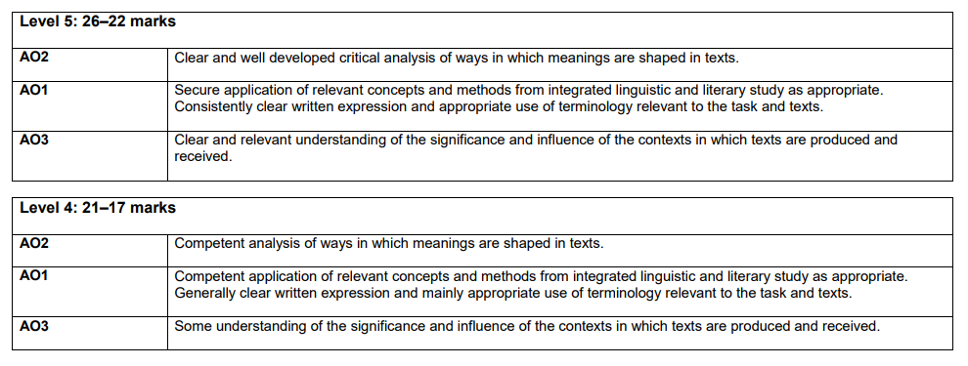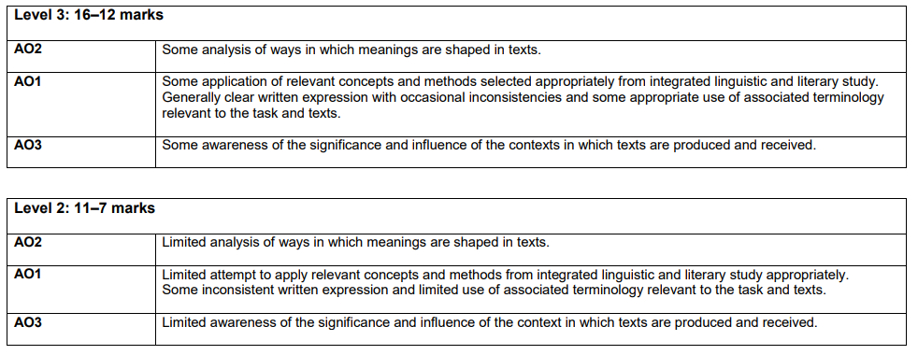The weightings for the assessment objectives are: AO2 6.0% AO1 5.0% AO3 5.0% Total 16%

Answers should explore how meanings are shaped by analysing the playwright’s use of dramatic and stylistic techniques (AO2). They should develop a coherent argument, using relevant concepts and methods from linguistic and literary study and associated terminology (AO1). Answers should be developed with reference to dramatic or other contexts (AO3).

**THE THREE PARTS TO THE DRAMA QUESTION**

1. **Dramatic**
2. **Stylistic**
3. **Contextual**
4. **Stylistics: What is it?**

A method used to help understand literature, where you identify the patterns made and the patterns broken. You look for patterns of words (lexis), or patterns of sentences (“parallelism”), or patterns of sound (“phonetic parallelism”). You can look for unusual use of words (“lexical deviation”) or grammar (“syntactical deviation”), or even unusual ways of presenting the words (“graphological deviation”).

In approaching a text in this way you will be focusing on:

* lexis (word choices)
* grammar
* sound/phonetic patterns
* graphological features (punctuation, lineation, layout).

(Adapted from the OCR guidance to a stylistic analysis of poetry)

1. **Dramatic: What are you looking for?**

* *Performance* (The volume of the speech, the speed of the speech, the use of paralinguistic elements such as gestures, facial expressions), the use of pauses to build suspense, for example.
* *stage directions* - Instructions for the actor (delivery, volume, pace); instructions for the director (lighting, weather, set, sound); the level of detail within the directions; lexical patterns within the directions
* *dramatic conventions* (soliloquy, monologue, the use of stichomythia, the use of the chorus, the use of the epilogue, the use of exits and entrances)
* *stage effects* (music, sound, lighting, use of props, set design)
* *production and critical reception* (Set of the original and subsequent productions; costume of productions – costume changes etc. directorial decisions: placing of the actors on the stage (proxemics); directorial decisions: about the delivery of the lines, about timings; theatrical reviews of the time, interviews with author/director/actors)
* *genre etc*. (Does the play neatly fit into the genre of comedy? Does the play neatly fit into the genre of tragedy? If it does fit into a genre, what conventions of that genre do you see? Does the play challenge or subvert that genre?)

1. **Contextual: What would you include?**

* There will be overlaps with the dramatic features section (generic conventions, the original and subsequent productions, dramatic conventions), but context might also focus on the production and reception of this play, and you could turn to interviews with Rylance and Butterworth for this (see, for example, https://www.youtube.com/watch?v=ENEoRHLuZ1I:
* ideas behind its conception (production)
* ideas behind creation of character (production)
* audience reaction (reception)
* critical reaction (reception)

**CONTEXT:**

**One area that you could write about is the original production, the film of which you have seen at the V and A Museum**

**A few observations about the original production:**

* **Phaedra depicted** as frightened from the start. Dramatic contrast between her vulnerability at the start, the chaos of the party and the precision of the county officials.
* **Johnny’s change of outfits** – green man of the woods to Viking king to a dark, funereal suit at the end. Red representing his period of rule, perhaps.
* **Phaedra opening Act 2 – contrast with Act 1** is clear. She is no longer centre stage, the lighting is muted, she is juxtaposed with an axe – sinister tone.
* **Visual comedy** of Byron and the giant story – talking down to the bullet/lighter.
* **Vulnerability of Johnny** is clearer in the production – the moment when he has to put on his reading glasses to read the writ. The scene where he sits on the sofa with Dawn is almost domestic – he is holding the booties she has knitted.
* Johnny and Dawn leave, to be replaced with the characters of Tanya and Lee – contrast of a love and a lust. Both **thwarted loves.**
* **In the production: costumes** distinguish the characters from one another: the extraordinary outfits of Ginger (pirate/tiger/Viking helmet) etc contrast with the sensible costumes of Dawn and Troy (emphasising the contrasting worlds). Visual humour of pith helmet scene and Davey with his face made up as a tiger.
* **Proxemics**: when Troy tells Johnny the story about how his friends turned against him, the audience can only see Johnny’s back. Our focus is on how the other characters react. Johnny is vulnerable: with no top on.
* **Returning to Johnny for help** (Phaedra, Wesley, the Professor) – to the last they turn to him.
* **Costumes:** contrast between the appearance of Wesley in the final act (dirty shirt and drunk) and Byron (dressed in a three-piece suit with a hat) – Byron preparing himself.
* **The lighting –** indicating the passing of time, with the orange light reflecting on the mobile home in the final act, and the green light transforming the scene as Johnny calls the giants.

**NOW ADD YOUR OWN:**



**CONTEXT**

**This is an essay that appeared as a blog post, written by the journalist and critic Paul Mason.**

**It is useful to be able to include a quote or two that illustrates the critical reception of this play in your answer.**

**READ THE FOLLOWING ESSAY AND SELECT TWO QUOTES THAT YOU MIGHT USE.**

**Butterworth's Jerusalem: the full English**

[Paul Mason](http://www.bbc.co.uk/blogs/newsnight/paulmason/paul_mason/) | 16:47 UK time, Friday, 18 December 2009

*[Back in July I* [*promised*](http://www.bbc.co.uk/blogs/newsnight/paulmason/2009/07/upcoming.html) *to write a blog about Jez Butterworth's play* ***Jerusalem****. Here, finally, it is.]*

"This, Wesley, is a historic day," says a middle aged drunken traveller, posed at the front of his caravan with various no-hopers, low-lifes, teenage runaways and misfits from semi-rural England..."For today I Rooster Byron and my band of educationally subnormal outcasts shall swoop and raze your poxy village to dust. In a thousand years Englanders will awake this day and bow their heads and wonder at the genius, guts and guile of the Flintock Rebellion..."  
  
It's just one glorious speech out of many from Jez Butterworth's play Jerusalem, staged at the Royal Court Theatre this summer with Mark Rylance in the role of Johnny "Rooster" Byron, and set to be [revived early in 2010](http://www.royalcourttheatre.com/whatson01.asp?play=568).

Butterworth's play achieves two things: in Rooster he has created one of the most compelling, complex and iconic characters in modern British theatre; at the same time he has managed to capture an era in British political and social life at the very moment of its ending.

Jerusalem was five years in the writing and depicts the life of a poor-ish, prospectless, rave-addicted, casual drug using, unskilled social group that is absolutely central to the society we live in, but which the media barely notices exists. It captures their reality better than any soap opera and their dreams better than any tawdry Saturday night talent show.

Life for such people is about to get very tough. Indeed, the economic data tells us that the UK's "flexible labour market" has already been the key to avoiding mass unemployment. The real life Daveys, Lees and Tanyas have gone on short time, taken pay cuts, slept on floors at their mates' houses, worked for no wages (in what our parents' generation used to call overtime).

They have scrabbled around the bargain shelves of major supermarkets, shopped in the pound shops, borrowed from doorstep lenders and bunged their electrical goods into Britain's booming pawnbroking sector. As we go into 2010, they will now be faced with an economic "recovery" in which public services are cut, benefits are very likely frozen or slashed, credit is in short supply and all political parties implore them to "help themselves" and become "social entrepreneurs".

The sociology of Jerusalem is interesting: Rooster is a drug-dealer and fairground daredevil rider, a kind of anti-social entrepreneur. In real life he would be drawing some kind of benefit. Of the three young male foils to Rooster, Lee is "a pisshead and a wizzhead" about to emigrate to Australia; Ginger is an unemployed plasterer with delusions of being a DJ; Davey is a slaughterman. The West End theatre [reviewers](http://www.royalcourttheatre.com/whatson_reviews.asp?play=568) tended to describe this demographic as a "bucolic underclass", "wastrels", "waifs and strays".

But the power of the play lies in the fact that Rooster's band of outcasts are not at all marginal to real life in Britain. They are only marginal to the "real life" portrayed on soap operas and the slick, unreal drama series that British TV specialises in making - and of course to the pop tribute shows and star vehicles that clutter the West End.

Jerusalem then, is real. The plasterer, the DJ, the weekend drug dealer, the ex-squaddie looking to work abroad, the bored slaughterman - are mainstream figures in the real English workforce and down the real English pub: two million ecstasy tablets are taken in Britain every week; one in eight young people are not in work, education or training; 15% of all households claim in-work benefits.

Also real is the effing and blinding which seems to have uniformly discomforted the mainstream theatre critics: the swear wordcount in Jerusalem is acutally low compared to reality, and the swearing is generally genial, compared to reality where it is often aggressive, racist and violent. This, then, is the real English spoken by something close to the majority of real people: it's an indictment of the state of theatre (also, while I am at it, English literature, which has recently become dominated by surreal narratives told in a kind of quasi-poetry) that the language of Jerusalem is seems so challenging to theatregoers and critics alike. For this alone Jerusalem will go down as one of the great plays of the decade.

But Jerusalem's greatness is that it is also hyper-real. In Rooster Byron the playwright has created a character who both embodies, understands and rebels against everything that is wrong with this real England. (I am deliberately not writing here about Mark Rylance's superb rendition of Byron, because I think the play is even bigger than the performance).

A relentless fantasist and purveyor of tall stories to his mates, Rooster is also the protector of runaway kids abused by their parents, a serial rebel against the planning department of Kennet and Avon council, the local bogeyman whose anti-social behaviour can fill the local church hall with outraged Rotarians ("You get a cup of tea. Flapjack. Then they all sit down on foldy chairs and go beserk."). He is also a force of nature: Falstaff and Henry V in the same body, the original Green Man of pagan folklore whose face vomiting vegetation can be found on the corbels of early medieval churches all over England.

And he embodies magic. At the centre of the play, which is dark in ways impossible to discuss without revealing the plot, is the ambiguity between Rooster's tall tale telling (I will call it that because this is a BBC blog but you know the word I am thinking of) and the tantalising question of whether or not he really has magical powers. Is the 90ft tall giant who once gave Rooster an earring in the shape of a golden drum on Salisbury Plain, and who will one day be Rooster's own personal close protection guy in showdown with Kennet and Avon Council, real or imaginary?

By placing this unreal, magical, flawed, wounded, complex character onstage amid an unflinching portrayal of real life in low-skill, low-pay, low-horizon England ("When I leave Wiltshire, my ears pop," says one character) Butterworth asks layer upon layer of questions about the society we live in.

And the biggest one is this: what would happen if this happy go lucky world of cheap booze, semi-employment, casual sex, Saturday night raves etc were one day disrupted by something serious. What if the music stopped, the benefit office closed its doors and the caravan got dragged away by the council.

The coming fiscal crunch has made this a relevant question. Because Butterworth's characters are captured at the end of an era of debt-fuelled consumption, cheap credit and amoralistic drift. When we sit in London and say: the Greeks' lifestyle can't go on; or Latvia is living above its means; or Dubai was a dream built on sand, Butterworth's play shows us there are equally telling observations to be made about British society in the era of Shopacheck and [whizz at £3 a tab](http://www.mdma.net/club-drugs/uk.html).

And what still stuns me is how new and raw and original and terrifying life in semi-rural working class Britain seems when viewed through the experience of Rooster and his mates. And the very low chances of escaping it.

As whizzhead Lee explains to slaughterman Davey:

"Ever since I've known you, come Tuesday you ain't never got a pound for a saveloy. You're broke...You are a sad, fat povvo what thinks he's Alan Sugar. You're going to live your whole life with the same ****ing people, going to the same s*** pubs, kill two million cows and die a sad fat povvo."

Davey, capturing the spirit that has sustained the downtrodden English bloke from Agincourt to Helmand replies:

"Sounds unimproveable".

***

*Jez Butterworth's "Jerusalem" is published by Nick Hern Books in association with the Royal Court Theatre. The Royal Court production* [*reopens*](http://www.royalcourttheatre.com/whatson01.asp?play=568) *at London's Apollo Theatre in January.*

**SELECT AN EXTRACT. USE THESE QUESTIONS AND POINTERS TO ANNOTATE THE TEXT.**

|  |  |
| --- | --- |
| **Performance;** Eg The volume of the speech. The speed of the speech. The use of paralinguistic elements (gestures, facial expressions) The use of pauses to build suspense, for example. |  |
| **Stage Directions.** E.g. Instructions for the actor (delivery, volume, pace) Instructions for the director (lighting, weather, set, sound) The level of detail within the directions Lexical patterns within the directions |  |
| **Genre:** e.g. Does the play neatly fit into the genre of comedy? Does the play neatly fit into the genre of tragedy? If it does fit into a genre, what conventions of that genre do you see? Does the play challenge or subvert that genre? |  |
| **Stage Effects**: Lighting. Sound. Music.  Use of props. Set design |  |
| **Production and critical reception** eg. Set of the original and subsequent productions. Costume of productions – costume changes etc. Directorial decisions: placing of the actors on the stage (proxemics). Directorial decisions: about the delivery of the lines, about timings. Theatrical reviews of the time. Interviews with author/director/actors |  |
| **Dramatic conventions.** Eg. The use of the soliloquy. The use of stichomythia. The use of the chorus. The use of mime. The use of split stage etc. Exits and entrances |  |
| **Stylistics.** Eg. Patterns of words (lexis)  patterns of sentences (“parallelism”) patterns of sound (“phonetic parallelism”) unusual use of words (“lexical deviation”)  unusual use grammar (“syntactical deviation”) unusual ways of presenting the words (“graphological deviation”). |  |
| **Discourse.** Eg. instrumental power v influential power.Interruptions. Use of rhetorical devices. agenda setting. use of discourse markers to hold the floor. allocating the next speaker. Adjacency pairs. Terms of address. Turn taking etc. Types of utterances: private conversation v public speech, quoted lines |  |

**CLOSE ANALYSIS: USE THE ANNOTATIONS BELOW TO ANSWER THE QUESTION:**

How does Butterworth explore power in this extract? **You should consider the use of dramatic and stylistic techniques in the extract, its significance within the play and any relevant dramatic or other contexts.**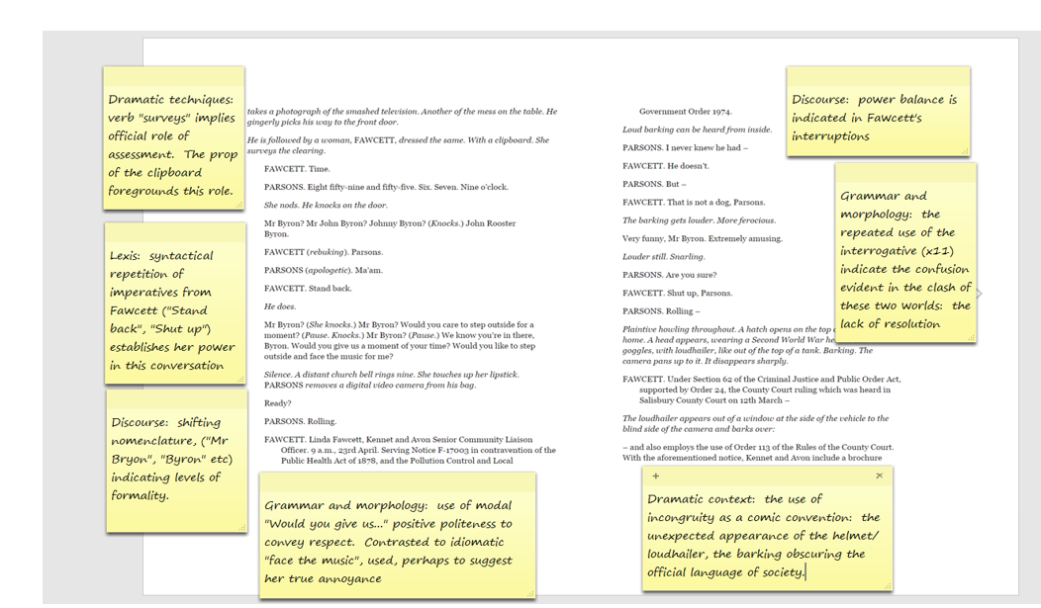

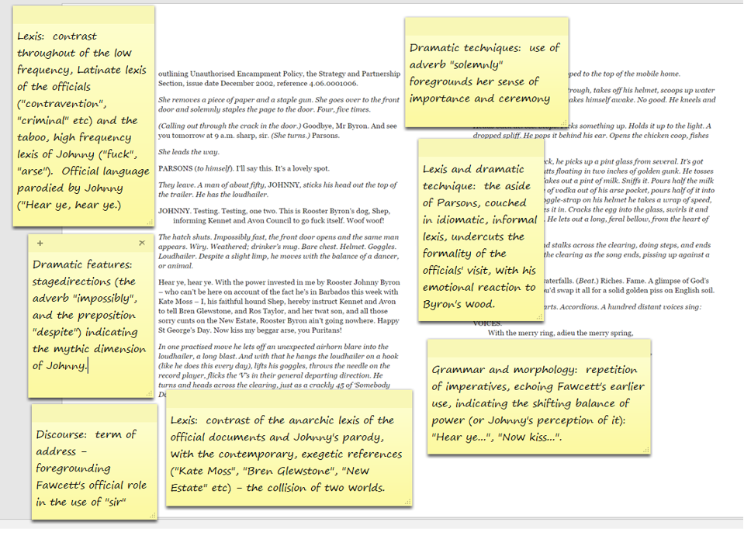

**POSSIBLE STRUCTURE FOR YOUR ESSAY:**

**One Hour – 32 Marks**

**Examine some of the ways in which power is presented in the extract from pp 6-7 (from “He is followed by a woman” to “Woof, woof!”)**

* **You should consider the use of dramatic and stylistic techniques in the extract, its significance within the play and any other relevant dramatic or other contexts**

**Open:** with ***setting the scene in context***: where does it appear in the play? What function does it have? What is it doing in terms of structure? Explain your conceptualised response to the theme/focus named in the question, and its relevance to the play as a whole.

**First Section:** give an analysis that is focused on ***dramatic features***- the use of a prop to symbolise a theme, for example; the detailed analysis of stage directions and what they reveal about theme/character etc: each time giving specific examples, and analysing their use with reference to the theme/focus named in the exam question. Link your analysis to the wider context – another point in the play (the characteristic use of this feature by Butterworth) – an observation about the original production – a link to a reviewer’s comment, or one made by Butterworth/Rylance etc. Return to the question and hook into the next paragraph.

**Section Section:** add to your argument with a ***stylistic analysis,*** looking at syntactical parallelism, lexical repetitions/oppositions/clusters. Each time give a specific example, and analyse it. Consider the syntactical use in the extract: the choice of sentence types and moods and how they might shape the meaning of the play, in terms of the theme/focus named in the exam question. Link your analysis to the wider context – another point in the play (the characteristic use of this feature by Butterworth) – an observation about the original production – a link to a reviewer’s comment, or one made by Butterworth/Rylance etc. Return to the question and hook into the next paragraph.

**Third Section:** focus on ***discourse*** – on the features of power in terms of the language; on the supportive or combative communication; on how the discourse features shape the character, or the theme. Link your analysis to the wider context – another point in the play (the characteristic use of this feature by Butterworth) – an observation about the original production – a link to a reviewer’s comment, or one made by Butterworth/Rylance etc. Return to the question and hook into the next paragraph.

**Conclusion:** give a ***conceptualised analysis of the focus of the question***: an overview of way in which the lexical/syntactical use; the dramatic features shapes our understanding of this extract and of the play as a whole.

**SAME QUESTION, DIFFERENT EXTRACT: AN ANNOTATED TOP LEVEL ANSWER**

**Examine the way in which power is presented in this extract from pp 16-17**

**You should consider the use of dramatic and stylistic techniques in the extract, its significance within the play and any other relevant dramatic or other contexts**

This extract appears early on in Act 1, and in this respect, it has an expository function. It has the role of introducing the character of the Professor; of illustrating the respect that Johnny has for him, as well as reiterating the theme of conflict and power that runs throughout the play.

The opening of the play exposed the battle for power between the official and the anarchic, between society and the individual, between Johnny and the council, as foregrounded by the number of World War II props evident in the first scene. However, this extract is exploring a different battle for power; a battle, I will argue, between instrumental and influential power. It is a battle between those who have nominal status (the Professor), those who would like to gain power (Ginger), and those who have both status and power (Johnny).

It has already become clear that although Johnny’s power is being threatened by the council and the law of the country, he recognises himself as having had power “invested” in him by an unnamed force. It is precisely this power that enables him to “instruct” Kennet and Avon Council, but the power that becomes evident in the extract from pp16-17 is less declarative: illustrated, perhaps, through his control of the conversation and his refusal to adhere to the rules of conversational discourse.

At the start of the extract it appears that it is Ginger who has the instrumental power: he holds the floor, instructing the Professor to wait: “Just a tick, mate”, and allocating the turn taking: “Sorry. You were saying”, but it soon becomes clear that it is Johnny who really has control. Despite the fact that the imperative “say it” is repeated nine times, for example, Johnny refuses to follow the order. Indeed, at one point, he not only refuses to respond, but he also replies in taboo language, clearly unaffected by the face-threatening act that he levels at Ginger.

The focus in this extract, then, is on the power balance within the conversation, rather than on the action of the scene. Consequently, there are very few stage directions, and in a sense, this foregrounds the final direction on page 17: “beat”. In this single world that is ambiguously either noun or verb, the reader, actor and director are left creating a meaning. This is a form of lexical deviation, in so far as “beat” replaces the more conventional “pause”, and it is difficult to dismiss the associations we have in this play with the “beating” of the drum in the Prologue and again at the end of the play. In foregrounding this stage direction, Butterworth is perhaps re-enforcing the power that is “invested” in Johnny Byron. This is a power, arguably, that draws on the “fields of ghosts who walk these green plains still.”

By this point in the play, Johnny has already warned Ginger about the need to respect the Professor, asking him to “play nicely”. However, at the start of the extract, Ginger apparently deliberately undermines the Professor’s status, by this choice of term of address: “mate”. He repeats this term of address three times in this extract, enforcing the sense that he is unwilling to recognise the Professor’s nominal status. This is foregrounded further by Butterworth, as Ginger awards himself a doctorate, in order to gain social status in the academic world of the Professor, and the graphological deviation of the use of italics (“*Doctor* Maureen Pringle”) highlights his insistence, not just once, but twice in this extract.

Clearly, Butterworth is also using this device for comedic effects, drawing on the accepted comedic convention of mistaken identity and disguise. Here, however, the comedy has darker overtones. The uncertainty of the Professor’s hold on reality is foregrounded in his repeated use of interrogatives (“A DJ eh?” “How does that work?” “…isn’t it?” “…funding cuts there?) and both Ginger and Johnny assert their superior levels of power as they indulge the Professor’s confusion, reiterating the proper noun “Maureen” no fewer than four times. In the world beyond Rooster’s Wood, the Professor should have a status that affords him power and control. In this green world of the carnivaleseque, however, there is a levelling of status in this respect. It is a place where plasterer and professor are both incidental and also socially equal.

Therefore, it is clear that the balance of power shifts in this extract. The Professor has the power of status, that has become irrelevant to all of the characters with the exception of Johnny; Ginger has a transient power that enables him initially to control the conversation, but it is arguably Johnny who holds the enduring power.

It may appear, in the stichomythic exchange between Johnny and Ginger that they are equally matched, with the fast pace of the delivery suggesting a sense of conflict between the two. However, a stylistic analysis reveals something else. Johnny’s lexical repetition of the future tense (“I’ll tell you what…” “I’ll roll a spliff, we’ll spruce up…” “I’ll never say it.”), suggests an inflexibility and a certainty about what will happen. In contrast, Ginger attempts to set up a condition for the future (“Only if…”, and his repeated imperatives (x6) are met with the lexical clusters of refusal (“Never”. “Never” “No.” “No.”) In terms of discourse, too, it is evident that Johnny’s responses that were initially elliptical, simple sentences, are dwindling down to emphatic, single word answers.

Although, therefore, Johnny and Ginger may share a sociolect (“Ruckus”, “spliff” etc.) Ginger does not have the same power as Johnny. Ginger may have instrumental power over the delusional Professor, able to adapt his register and to parody the Professor’s language for comedic effect (“I don’t see how we’re going to meet our quotas.”), but his attempts to overpower Johnny are ineffectual. In terms of lexical repetition, “DJ” appears seven times in this extract, said five times by Ginger, and twice by the Professor. Johnny does not say the word once.

In a play that is all about the conflict between worlds and ideologies, the figure of Johnny Byron is axiomatic. This is a character whose wold is being threatened, and whose kingdom is shrinking, and yet his power, this play suggests, is instrumental. In this drama, that has been variously described as being about contemporary life, and as being a state of England play, an intransigent, stubborn individual stands up against the faceless power of the law. The power that enables him to do this is obviously rooted more deeply than in his unwillingness to respond to agency pairs, or in his use of imperatives. His power, this play seems to argue, lies in the recognition of the power of language to seduce and to heal, and perhaps in his connection to the ancient, to the mythic, to the “beat” that echoes through the green plains of England.

**APPROACHING ANOTHER QUESTION:**

Remember that you are being assessment on 3 different objectives in this question

Notice that the AO1 (writing) and AO3 (context) are almost equally weighted.

* AO1 Apply concepts and methods from integrated linguistic and literary study as appropriate, using associated terminology and coherent written expression. 9%
* AO2 Analyse ways in which meanings are shaped in texts. 12%
* AO3 Demonstrate understanding of the significance and influence of the contexts in which texts are produced and received. 8.5%

**In detail:**

**AO1**

* Use linguistic and stylistic approaches and an understanding of dramatic techniques to develop an analysis of the text
* use English and terminology appropriately and coherently
* explore dramatic techniques such as on-stage and off-stage action, paralinguistic features (gesture/ manner of speech/facial expressions), soliloquy, asides and dramatic irony
* Apply relevant methods for text analysis, drawing on linguistic and literary fields.

**AO2**

* analyse aspects of the text foregrounded through the use of repetition, pattern-making, pattern breaking and deviation
* make accurate references to texts.
* identify and describe how meanings and effects are created and conveyed through language

**AO3**

* Explore contexts and connections between the scene and the play as a whole, as well as literary and generic contexts.
* consider the significance of relevant dramatic or other contexts

**PLAN OR WRITE THE FOLLOWING QUESTION. THEN LOOK AT THE MARK SCHEME THAT FOLLOWS, AND DECIDE IF YOUR ESSAY WOULD MOST ACCURATELY FIT THE DESCRIPTORS FOR THE HIGHER OR FOR THE LOWER LEVEL RESPONSE.**

**Your question: Examine the way in Johnny and Phaedra are presented in this extract from pp 100-101 ( from “Have they gone?” to “Time’s running out”**

**You should consider the use of dramatic and stylistic techniques in the extract, its significance within the play and any other relevant dramatic or other contexts**

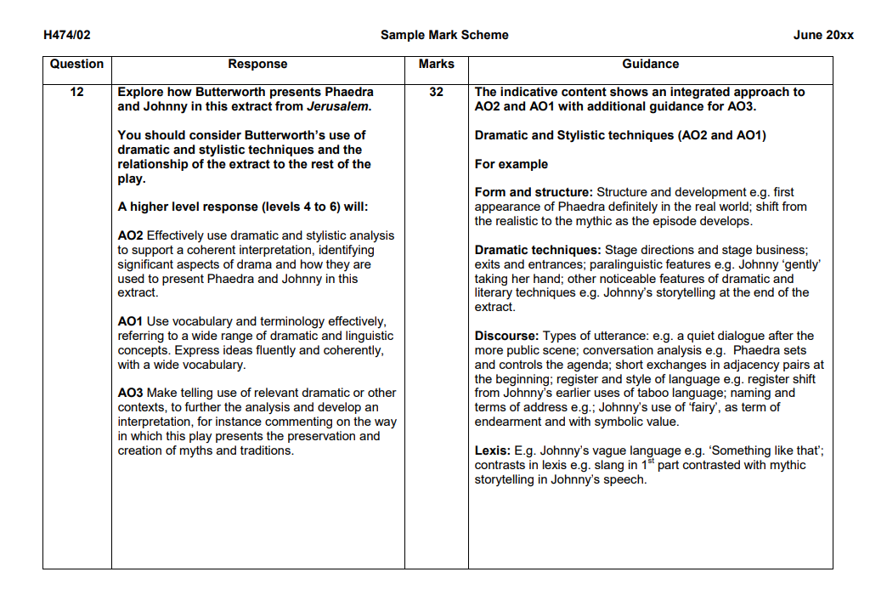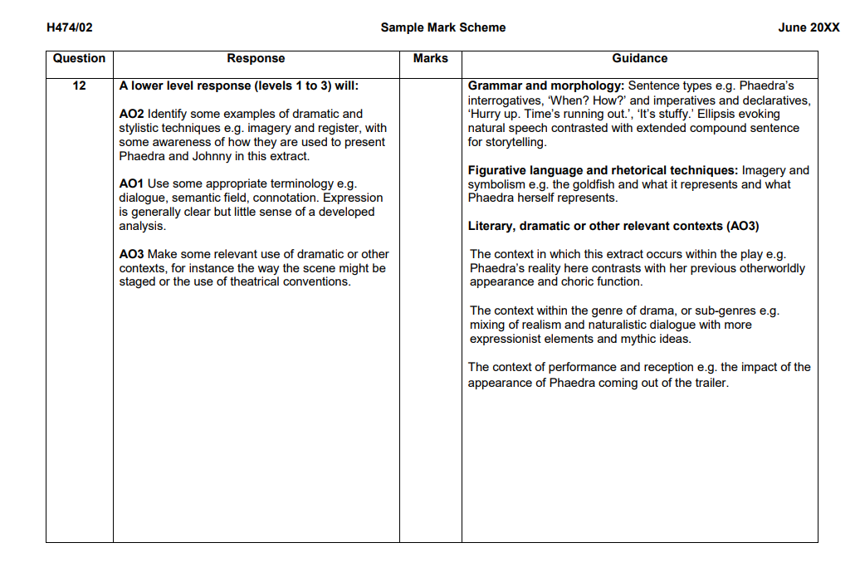

**WRITING ABOUT CHARACTER**

**It is important to think about the FUNCTION of the character:**

* To play a major, central role, or a minor one.
* To act as a foil or contrast to another character, to bring out their qualities.
* To be representative of a “type” (e.g. jealous husband, orphaned child)
* To further the plot (playing a key role in events)
* To create a dramatic experience (to create light relief, for example, or to comment on the action)
* To develop a key theme of the play (e.g. conflict, power, identity, loyalty etc)
* To help create a mood or a tone, associated with a particular type of language (e.g. the magical, the commercial, the official, the comical)
* Something else particular to an individual play or character.

**Think about how the stage directions help to create the character:**

* practical directions for tone/mood,
* instructions about pace/volume of speech
* Directions for costume.
* Adjectives or verbs or imagery associated with the character
* Directions for action

**You many think about the choice of name for the character.**

* To signal a moral dimension of the character
* To signal a physical or emotional characteristic
* To signal a cultural or racial dimension

**CREATING CHARACTER PROFILES FOR THE CHARACTERS**

**YOU ARE NOW IN THE POSITION TO CREATE YOUR OWN CHARACTER PROFILE FOR EACH CHARACTER, AS PART OF YOUR REVISION.**

You should think about:

**Their function:**

* Does s/he act as a foil? (If so, to whom, and in what way?)
* Is s/he the protagonist?
* Does s/he develop key themes? (if so, what are they, and where are they illustrated in the text?)
* Does s/he carry a particular mood or tone? Is he associated with a kind of language (the poetic, the magical, the crude?)

**His/her development**

* To what extent is s/he a dynamic character?
* Pick three points in the play that illustrate a development in his/her character.
* Look, for example, at the first appearance: what do the stage directions reveal about the character? What do the props reveal about the character?
* What differences do you notice between her/his words in private and in public?
* What do the other characters say about her/him at three points in the play? Do their perceptions change?
* Is there a turning point in the play that prompts his/her development?
* How does s/he end up? What is revealed about his/her character in terms of what the stage directions/props reveal about him/?

**His/her language**

* What words, expressions and particular grammatical structures does s/he use? (his/her idiolect)
* Does s/he draw from a particular lexical field, for example? Or does it depend on the context in which s/he is speaking? (give examples)
* Is there a difference between his/her speech and that of other characters?
* Are there any occasions when s/he deviates from his/her typical idiolect?

**AN EXAMPLE OF HOW TO APPLY YOUR CHARACTER WORK TO AN EXAM-TYPE QUESTION.**

* Examine the presentation of the relationship between Johnny and Dawn, on pp 67 – 68; from "So tell me…" to "You having a baby, Dawn?".   
  You should consider the use of dramatic and stylistic techniques in the extract, its significance within the play and any other relevant dramatic or other contexts

**Three main points:** 1) Johnny's power evident in his ability to craft a story 2) Dawn's seduction by and then rejection of Johnny 3) similarities between characters' use of non-standard English – creating sense of unity between them

A**nnotations:**

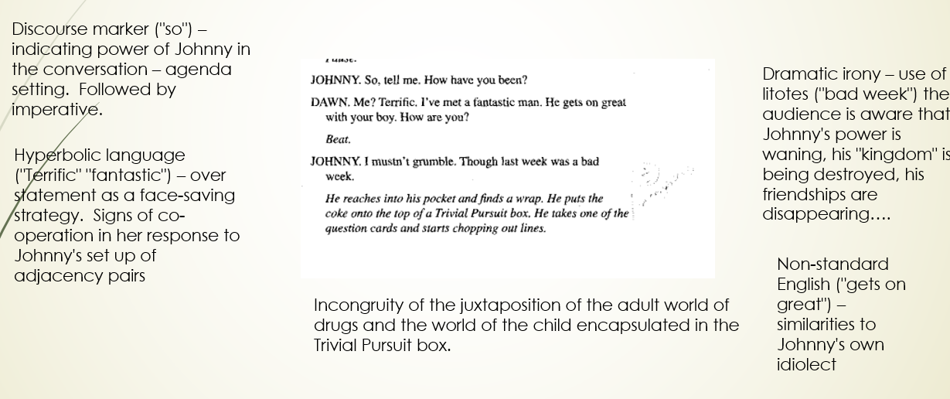

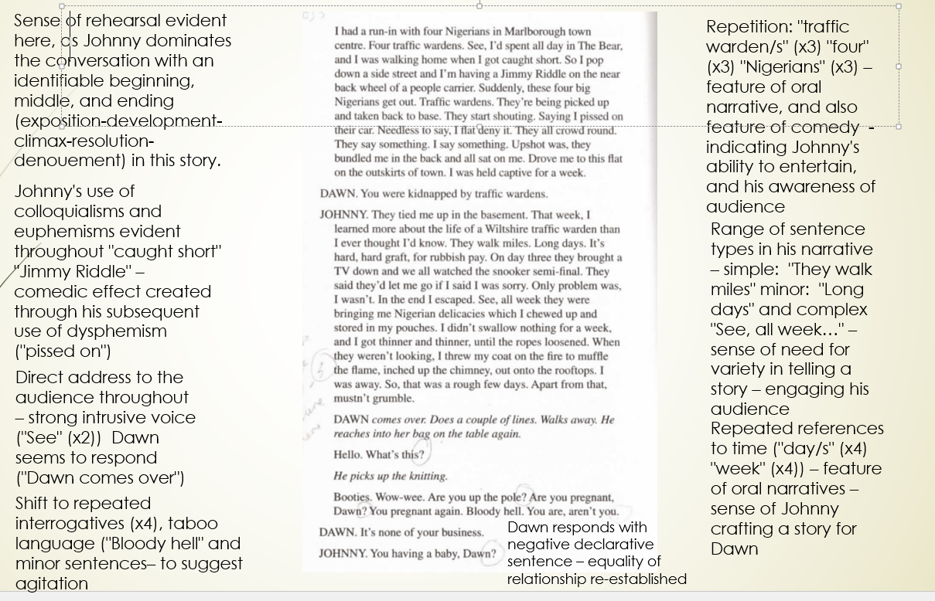

**FINDING QUOTES**

**In the exam, you will not have the text with you, and it will be useful to know a few quotes on various themes, so that you can, for example, demonstrate your understanding and knowledge of the play as a whole.**

**The following quotes are chosen to illustrate three themes in the play.**

**AS PART OF YOUR REVISION, YOU MAY CHOOSE TO ADD TO THESE LISTS AND TO COMPLETE OTHER LISTS OF QUOTES APPROPRIATE FOR SUCH THEMES AS FRIENDSHIP, LOSS, NATURE, CREATION OF STORIES, URBAN V RURAL, THE ESTABLISHMENT, CONFLICT, ENGLISHNESS ETC.**

|  |  |  |
| --- | --- | --- |
| **Theme** | **Quote** | **Comment** |
| **Power** | **They should put him in the town square. Next to King Arthur p 33** | **Power of Byron – equated with royalty** |
| **Power** | **It’s a Swindon-level decision p 35** | **Power of institution against the individual** |
| **Power** | **This wood is called Rooster’s Wood p 45** | **The power to name and therefore to define** |
| **Power** | **I just passed a new law p 29** | **Contrast of laws decreed by Byron and those of the council** |
| **Power** | **I, Rooster Byron, your merciless ruler p 50** | **Power of Byron’s anarchic rule** |
| **Power** | **We will rise up… until the whole plain of Wiltshire dances to the tune of our misrule p 52** | **Power of Byron’s anarchic rule** |
| **Power** | **This land belongs to Kennet and Avon Council. P 95** | **Official laws of council** |
| **Power** | **It’s over Bryon. We have you. P 98** | **Power of law** |
| **Power** | **“Enter the Professor garlanded with flowers” p 98** | **contrast between the power of warrants, enforced by the outside world (Fawcett and Parsons exit) and the natural (flowers, crown of blossom): professor assuming the costume of a king** |
| **Power** | **“Hurry up. Time’s running out.” p 101** | **symbolic reference to Byron’s waning power (repeated references to time – it’s five to six, till six o’clock etc)** |
| **Power** | **I, Rooster John Byron…” p 108** | **repetition from Act 1, p 50 – the power of language, here used to curse – the power of repetition (never, never, and may, and may etc”)** |
| **Myth** | **Despite a slight limp, he moves with the balance of an animal p 9** | **Mythical nature of Byron – defined by grace** |
| **Myth** | **St George, and all the lost gods of England p 18** | **Connection with the mythic** |
| **Myth** | **The wild green time is upon us p 19** | **Connection with the mythic through the character of the other-worldly Professor** |
| **Myth** | **Wood with free troll p 30** | **Mythical, anarchic nature of Byron** |
| **Myth** | **This wood is holy. This is holy land. P 72** | **Mythic ancient world** |
| **Myth** | **I’m magic, me p 78** | **Mythic quality of Byron** |
|  | **And by this city was a stagnant pond wherein dwelled a dragon which envenomed all the country. P 84** | **The traditional/mythic** |
| **Myth** | **Written there is old words that will shake you p 49** | **Mythic quality of Byron** |
| **Myth** | **Us, the giants, we’ll hear it, and we’ll come p58** | **Mythic, ancient world** |
| **Myth** | **“Hear ye…. Hear ye!” p98** | **lexical clusters of the official (gavels, leaflets, warrants) and the anarchic and wild (wind, babes, blood, chalk)** |
| **Myth** | **“I’ve seen a lot of strange things in this wood.” p 102** | **lyrical poetic language, echoing the green man of the woods archetype – mythical and timeless** |
| **Myth** | **“Johnny stretches his arms wide, smiling” p 104** | **stage directions suggest a Christ-like pose – supported by proxemics in the original production. Ginger also turns from him – rejecting him.** |
| **Myth** | **“Relentlessly, he beats the drum….” p 109** | **power of the drum (heard throughout the play (“beat”) – natural culmination and climax of the play – in the production you hear the sound of the giants – in the text, it is left ambiguous (ellipses).** |
| **Freedom/**  **Entrapment** | **You’re barred from every pub in Flintock p 14** | **isolation of Johnny from the modern world** |
| **Freedom/**  **Entrapment** | **I leave Wiltshire, my ears pop p 24** | **Characters trapped in their lives, here, voluntarily** |
| **Freedom/**  **Entrapment** | **The world turns… And it moves on and you don’t. You’re still here. P 66** | **Fixed in one place - timeless** |
| **Freedom/**  **Entrapment** | **I don’t want to go p 90** | **Need to move on – unable to do so** |
| **Freedom/**  **Entrapment** | **You’re on your own. You and the trees. P 70** | **Isolation of Byron – timeless figure – righting wrongs of the modern world** |
| **Freedom/**  **Entrapment** | **“I feel suddenly light …. Like pure light. “ p 99** | **Epiphanic moment as the Professor is released from his delusion - released from Johnny – he does not need him any more. Sense of change (the winter is over.)** |

**PAST QUESTIONS ON *JERUSALEM* TO DATE**

* **June 2017:** Explore how Butterworth presents the conflict between the council and Johnny in this extract from *Jerusalem*. Act 1 Fawcett: Mr Byron (she knocks) Mr Byron? Now kiss my beggar arse, you Puritans! pp7-9
* **Specimen Paper:** Explore how Butterworth presents Phaedra and Johnny in this extract from *Jerusalem* “Exit the Professor Johnny watches him leave… I don’t expect nothing from you, fairy.” pp100-102
* **Practice Paper 1:** Explore how Butterworth presents the story about Johnny Rooster Byron in this extract from *Jerusalem*. Ginger: weren’t always like that… keep the change love – and downs it in one. Walks out. Walks it off. pp30-32
* **Practice Paper 2:** Explore how Butterworth presents Johnny and Dawn’s relationship in this extract from *Jerusalem*. Dawn comes over. Does a couple of lines… Johnny: Well, now. There now. What’s to worry? pp68-71

**NOW MAKE YOUR OWN PRACTICE QUESTIONS**

The question will always be worded in a very similar way.

It will have a thematic, or a character-based focus

1. PICK A THEME, FOR EXAMPLE,

* “Englishness”
* Role of myth in contemporary England
* Anarchic v civilised world
* Creation of stories
* Truth/reality
* Official and the anarchic
* Society v the outsider
* Urban v rural
* Ancient v the modern
* Love
* Friendship
* Power
* Authority
* Loyalty etc etc

1. PICK AN EXTRACT
2. PLAN FOR 10 MINUTES, USING THE STRUCTURE OF “**EXAMINE THE WAY IN WHICH…….. (INSERT YOUR CHOSEN THEME/CHARACTER HERE) IS PRESENTED IN THIS EXTRACT FROM (INSERT YOUR CHOSEN EXTRACT HERE)**

**You should consider the use of dramatic and stylistic techniques in the extract, its significance within the play and any other relevant dramatic or other contexts**

1. REPEAT WITH ANY NUMBER OF THEMATIC, OR CHARACTER-BASED FOCI.