**1st Year A level English Language – Benchmark Assessment**

**Putting it All Together – Applying the Levels to Analysis of a Text**

**Preparation (at home or in class)**

If you now look again at the summary of the language levels in your booklet and flick through the pages you have read you will see that you now have a set of tools that you can use to analyse any text.

Activity – Analysing a Text for the Exam (Component 1)

On the next page you will find an A level style question, followed by an extract from an advertisement feature for DeLonghi coffee machines. Note that the question requires you to focus on lexis and semantics for one part and on sentence types for the other. **For this first assignment, I would like you to concentrate only on 1a) lexis and semantics.**  We can’t do 1b) yet as we have not got on to sentence types. (Also, the boxes alongside the text will not be there to help you in the exam!)

* If you are in class, join up with another student and work on one of the language levels, using the boxes to help you
* Write up the evidence you would use in your analysis on a mini-whiteboard
* Prepare a short presentation of your material where you frame your ideas for an examiner, present your evidence and link back to the genre, audience, purpose and overall context of the text
* Present your findings

**The Assignment**

The following pages take you through a sequence of activities that are designed to develop your analytical writing and get you ready to have a go at answering the question below. It is very early days for you to tackle this, so there is no need to *actually* spend only 30 minutes writing. Spend as long as you like this time. There is not much point in writing more than 500 words, though, given that you will not be able to produce much more than that in the real thing.

Please work through the activities at home or with your teacher and hand in the assignment by…

**Deadline:**

**Example of A Level-Style Question from Component 1 – Exploring Language**

**Task 1**

Text A is an extract from an advert for De Longhi coffee machines, written in the format of an article and published in the magazine section The Guardian newspaper in November 2012. An advertising agency produced the text and paid to place it in the magazine.

**1** Giving careful consideration to the context of the text:

**(a)** identify and analyse uses of lexis and semantics in this text **[10]**

**(b)** identify and analyse the way sentences are constructed in this text. **[10]**

**(for reference only – we will get on to this!)**

*You are advised to spend no more than 40 minutes on this task. Of that time you are advised to spend 10 minutes reading and about 30 minutes writing your answer.*

This is the actual length of text you would get. The full text is on the next page and is given mostly for reference. If you would like to write about the whole text this time, you can do that.

**(20 marks)**

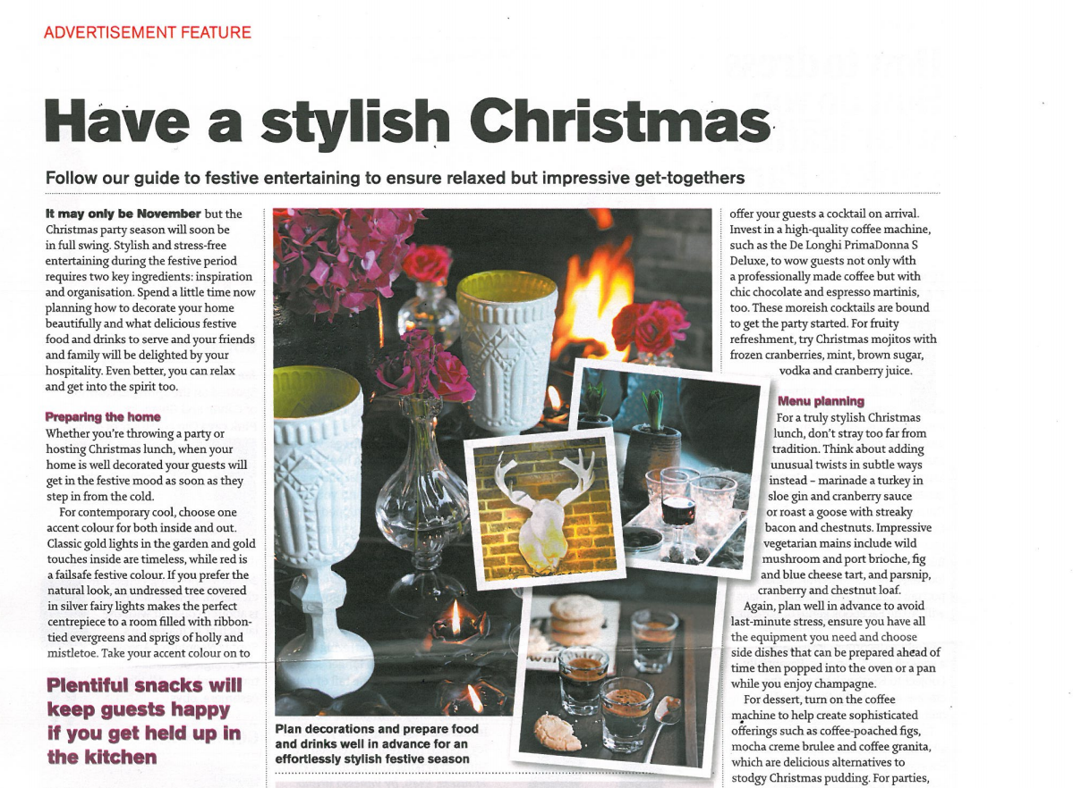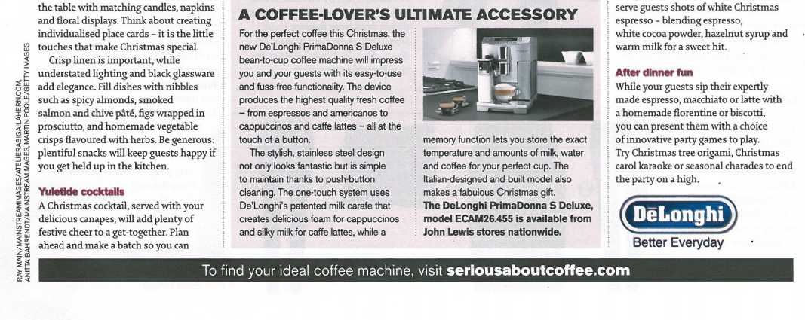

ADVERTISEMENT FEATURE

**Have a stylish Christmas**

**Follow our guide to festive entertaining to ensure relaxed but impressive get-togethers**

**It may only be November** but the Christmas party season will soon be in full swing. Stylish and stress-free entertaining during the festive period requires two key ingredients: inspiration and organisation. Spend a little time now planning how to decorate your home beautifully and what delicious festive food and drinks to serve and your friends and family will be delighted by your hospitality. Even better, you can relax and get into the spirit too.

Register and formality

Mode : *don’t stray… think about…*

*The device produces…*

**Preparing the home**

Whether you’re throwing a party or hosting Christmas lunch, when your home is well decorated your guests will get in the festive mood as soon as they step in from the cold.

Lexis

1. *Brioche, canapes, …*
2. *Sophisticated, tradition …*

For contemporary cool, choose one accent colour for both inside and out. Classic gold lights in the garden and gold touches inside are timeless, while red is a failsafe festive colour ….

**Yuletide cocktails**

A Christmas cocktail, served with your delicious canapes, will add plenty of festive cheer to a get-together. Plan ahead and make a batch so you can offer your guests a cocktail on arrival. Invest in a high quality coffee machine, such as the De Longhi PrimaDonna S Delux, to wow guests not only with a professionally made coffee but with chic chocolate and espresso martinis, too. These moreish cocktails are bound to get the party started. For fruity refreshment, try Christmas mojitos with frozen cranberries, mint, brown sugar, vodka and cranberry juice.

Grammar

1. Noun phrases: *sophisticated offerings, professionally made coffee,*
2. Softened or modified imperatives:

**Menu planning**

For a truly stylish Christmas lunch, don’t stray too far from tradition. Think about adding unusual twists in subtle ways instead – marinade a turkey in sloe gin and cranberry sauce or roast a goose with streaky bacon and chestnuts. Impressive vegetarian mains include wild mushroom and port brioche, fig and blue cheese tart, and parsnip, cranberry and chestnut loaf.

….

Grammar (continued)

1. Pronoun use:

2. Concrete nouns:

For dessert, turn on the coffee machine to help create sophisticated offerings such as coffee-poached figs, mocha crème brulee and coffee granite, which are delicious alternatives to stodgy Christmas pudding. For parties, serve guests shots of white Christmas espresso – blending espresso, white cocoa powder, hazelnut syrup and warm milk for a sweet hit….

**A COFFEE-LOVER’S ULTIMATE ACCESSORY**

For the perfect coffee this Christmas, the new De Longhi PrimaDonna S Deluxe bean-to-cup coffee machine will impress you and your guests with its easy-to-use and fuss free functionality. The device produces the highest quality fresh coffee – from espressos and Americanos to cappuccinos and caffe lattes – all at the touch of a button.

Discourse structure

Hybrid (mixed) genre: magazine article, …

Two part structure : ‘article’ and main copy (advertiser’s sales pitch)

The stylish, stainless steel design not only looks fantastic but is simple to maintain thanks to push-button cleaning. The one-touch system uses De Longhi’s patented milk carafe that creates delicious foam for cappuccinos and silky milk for café lattes, while a memory function lets you store the exact temperature and amounts of milk, water and coffee for your perfect cup. The Italian-designed and built model also makes a fabulous Christmas gift.

Semantic Fields

1. *Stylish, Italian-designed…*
2. *Relaxed, …*

**The DeLonghi PrimaDonna S Deluxe, model ECAM26.455 is available from John Lewis stores nationwide.**



**Producing Top Grade Analytical Writing**

The two assessment objectives that are tested in the first task in Component 1 of the A Level are AO1 and AO3. Here they are, below. You’ll get a sheet like this back when you we’ve marked your work

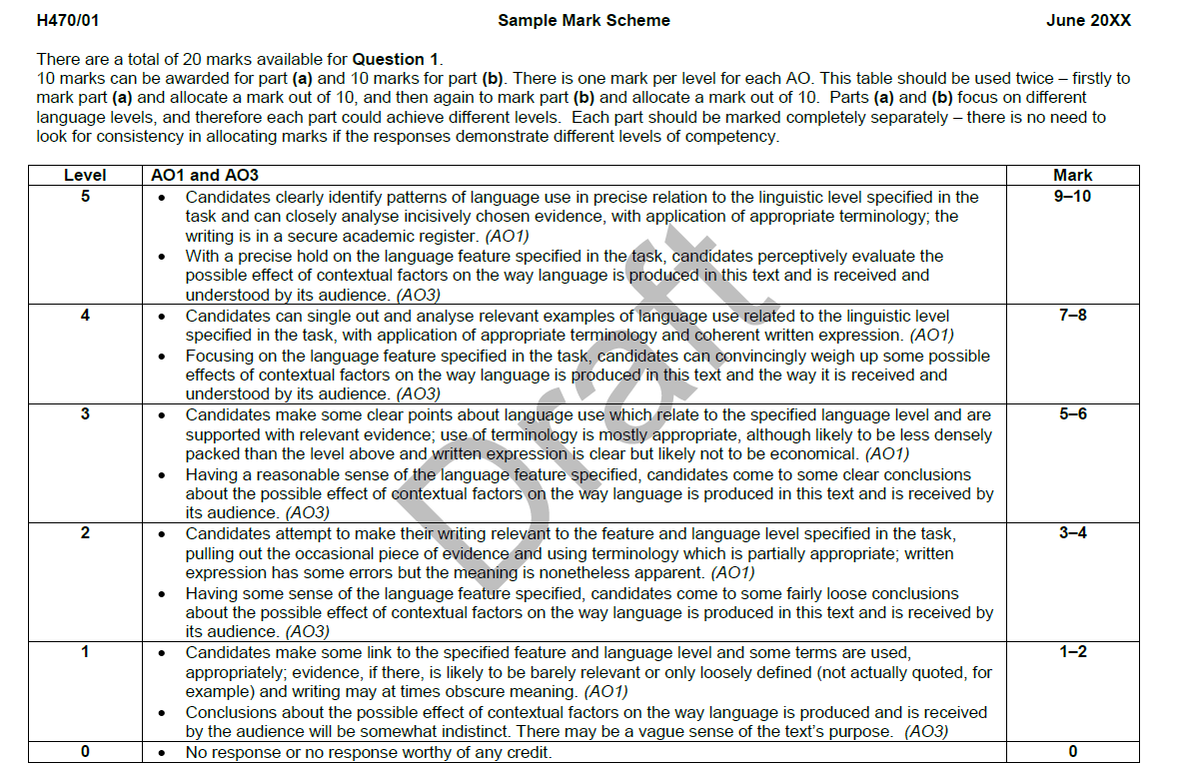

**Starting off**

You don’t have much time to write this, and you are answering a question focused on a specific linguistic level, so one introductory sentence will do, which can double as a topic sentence (see ‘perfect paragraph’ below).

**Applying the Levels**

In terms of whether you choose lexis or semantics, or both, that depends on the point you want to make and on the text. You also need to write well, within a secure structure.

**Creating the ‘perfect’ paragraph**

There is, of course, no such thing as a perfect paragraph structure. However, there are some rough principles that examiners will always respond to positively. Here is a possible structure for a paragraph.

1. A topic sentence which defines the linguistic feature that will be the focus of the paragraph
2. Make a point/identify a pattern/orientate the examiner - where in the text are we?
3. Bring in your evidence
4. Analyse the evidence closely (eg take one fragment from a pattern of evidence you have found)
5. Evaluate *why* the linguistic feature you have analysed has been used, given the context (including genre, audience, purpose etc) of the text

The evaluative process, at the end of the paragraph, is where most of the marks for A03 will come. The more perceptive you are about this, provided you have already been analytical and used correct terminology, the more marks you will get. Perceptive does not mean you have to be a genius; it simply means that you need to think through the possible effects of linguistic features.

Activity

Below you will find two sample paragraphs written in response to the question on page xx. Both are roughly the same length.

* Read the paragraphs and decide which one seems to be most clearly using the paragraph structure you have just been shown
* How is the other paragraph different?
* Take a new level (grammar, for example) and use the structure to write a paragraph of your own.

*There are particular lexical features within this text that identify its purpose to persuade and entertain its readers. There are a number of loanwords in the text such as ‘canapes’ and ‘brulee’ (French) and ‘espresso’ and ‘macchiato’ (Italian). This identifies the general register of the text as one about eating and drinking; however it also gives the text a feeling of European sophistication. The DeLonghi coffee machine is probably a luxury item and these associations would help to sell the product. The use of Italian terms for coffee, in particular, allow readers to imagine themselves enjoying a slice of Italian culture at home. Of course this would involve them buying a coffee machine!*

*Taking a lexical approach to the text there is a clear use of loanwords throughout, in particular lexis with Italian derivations such as ‘espresso’, ‘cappucino’ and ‘macchiato’ and some actual Italian language in the product name (‘PrimaDonna’). This creates an air of European sophistication which readers should, if the advert is working well, aspire to emulate. There is a semantic field relating to style (‘stylish…impress… sophisticated… contemporary cool… Italian designed’) found in the title as well as in the main copy at the bottom of the advert; this field breaks the boundaries between the ‘article’ and the advert part of the text and underlines the idea that you can be stylish and admired if you buy this machine.*

Commentary

Both these paragraphs would get a candidate into band 5 if they were accompanied by more of the same. The first one is following the structure quite rigidly, the second less so. However, the second packs more in. It is still being systematic since the second point about semantic fields is still related to lexis. As a result it would probably be part of an answer that would score a higher mark overall. Either paragraph is worth trying to emulate yourself, however.