Emoji 'ruining people's grasp of English' because young rely on them to communicate

[8](https://www.telegraph.co.uk/education/2018/04/17/emojis-ruining-english-language-young-people-rely-communicate/" \l "comments)

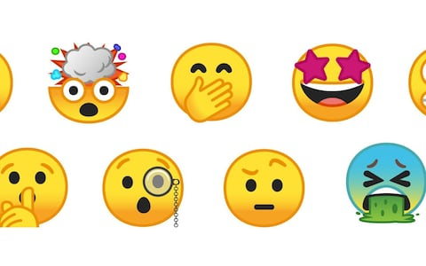Over a third of British adults believe that emojis are to blame for the deterioration of the English language, according to new research

* [Camilla Turner](https://www.telegraph.co.uk/authors/camilla-turner/), education editor

17 APRIL 2018 • 9:00PM

Emoji are ruining the English language because young people rely on them to communicate, research by Google has found.

Over a third of British adults believe that emoji are to blame for the deterioration of the English language, according to new research.

YouTube, the video sharing website owned by Google, commissioned a study where 2,000 adults aged between 16 and 65 were asked about their views on the current state of the English language.

The vast majority (94 per cent) of respondents said they believe there has been a decline in the correct use of English, with four in five identifying youngsters as the worst culprits.

The research found that more than half of British adults are not confident with their command of spelling and grammar.

Almost three quarters of adults are now dependent on emoji to communicate with each another, as well as spell checks and predictive text.

A spokesman for YouTube said that English language tutorial videos are seeing a huge surge in popularity. Since April 2017 there has been a 126 per cent increase in views of English language lesson videos on the site, they added.

Lucy Earl, whose YouTube channel English With Lucy has over a million subscribers,  gives tips and advice to those looking to improve their language skills.

She said: "As we increasingly communicate through our phones and computers, it is only natural that our language will evolve.

“Digital communication should not be an excuse to take the easy road out. We all need to understand the foundations."

Emoji, a popular way to replicate non-verbal communication, are used six billion times a day and h[ave been described as the fastest growing language in history.](https://www.telegraph.co.uk/news/newstopics/howaboutthat/11614804/Emoji-is-Britains-fastest-growing-language-as-most-popular-symbol-revealed.html)

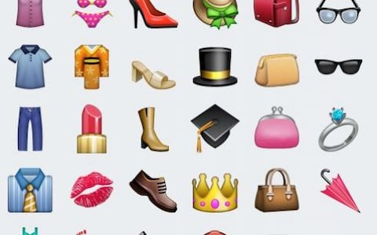

Almost three quarters of adults are now dependent on emojis to communicate with each another, the study found

But one expert has warned that while there is a "superficial attraction” to using emoji, they are among the most damaging aspects of communication technology.

Chris McGovern, a former Government adviser and chairman of the Campaign for Real Education said: “There has unquestionably been quite a serious decline in young people’s ability to use the English language and write properly punctuated English.

“We are moving in a direction of cartoon and picture language, which inevitably will affect literacy. Children will always follow the path of least resistance.

“Emoji convey a message, but this breeds laziness. If people think ‘all I need to do is send a picture’, this dilutes language and expression.”

[Academics have previously warned that peppering an email with emoji could harm your job prospects by making colleagues less likely to share information with you.](https://www.telegraph.co.uk/news/2017/08/14/using-emojis-makes-people-think-incompetent-research-finds/)

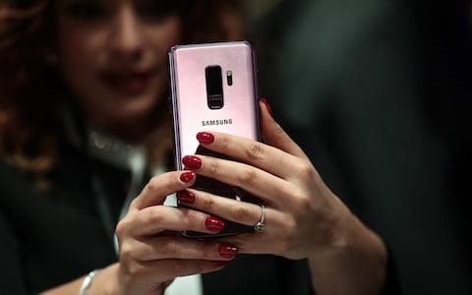

Emojis are ruining the English language because young people rely on them to communicate, research suggests

A study, published in Social Psychological and Personality Science, advised that people should avoid emoji at work altogether, especially the first time you talk to someone.

Dr Ella Glikson, an expert in business and management at Ben-Gurion University of the Negev in Israel, said that the research shows using emojis in the workplace does not increase perceptions of warmth, and actually decrease perceptions of competence.

However, other studies have focused on the positive aspects of emoji. [Researchers from Edinburgh University published a paper earlier this month which found emojis are helping people feel included on social media.](https://www.telegraph.co.uk/science/2018/04/10/skin-tone-emojis-boost-inclusion-social-media-study-shows/)

When the inclusive emoji were first introduced in 2015 there were fears that the icons could be used inappropriately or abusively, and could even stoke racial tensions.

But when researchers analysed a sample of a billion tweets they found that most people who choose to personalize the colour of their emoji do it to make it more aligned with their own skin tone.

And even in tweets where the selected skin tone was different from that of the user, posts were found to be mostly positive. The researchers called for even more options to personalise characters to a greater degree.

[In 2016, a High Court judge took the unusual step of including a smiley face emoji in an official ruling.](https://www.telegraph.co.uk/news/2016/09/14/smile-high-court-judge-uses-emoji-in-official-ruling/)

 In an attempt to make a judgment in a family court case comprehensible for the children it affects, Mr Justice Peter Jackson used a smiley face symbol.

The ruling was thought to be the first in English legal history to incorporate an emoji, or web symbol, to explain a point of evidence.

Related Topics

* [Emoji](https://www.telegraph.co.uk/emoji/)

# Emoji is Britain's fastest growing language as most popular symbol revealed

## **Most popular emoji animations announced as university linguistics expert claims it is the fastest-growing language in the UK**

Emoji is evolving faster than ancient languages such as hieroglyphics, it is claimed

By Agency

10:05AM BST 19 May 2015

Emoji is now the fastest growing language in the UK - and many find it easier to communicate using its smiley faces and icons than text, says one linguistics expert.

Professor Vyv Evans, from Bangor University, claims the group of smiley faces and symbols is evolving faster than ancient languages such as hieroglyphics.

Prof Evans has partnered with telecoms TalkTalk Mobile, which found that eight out of 10 people in the UK have used the symbols and icons to communicate, with 72 per cent of 18 to 25-year-olds adding that they found it easier to put their feelings across using emoji than with words.

### Top 10 most popular emoji symbols

1. Smiley face
2. Crying with laughter
3. Love heart
4. Beaming red cheeks
5. Thumbs up
6. Tongue out winking face
7. Blow kiss
8. Wink face
9. Confused
10. See no evil monkey

Prof Evans said: "Emoji is the fastest growing form of language in history based on its incredible adoption rate and speed of evolution.

"As a visual language emoji has already far eclipsed hieroglyphics, its ancient Egyptian precursor which took centuries to develop."

• [**Emoji: Why we are all so obsessed**](https://www.telegraph.co.uk/women/womens-life/11312346/Emoji-why-were-all-so-obsessed.html)  
• [**Are emoji killing off internet slang?**](https://www.telegraph.co.uk/technology/news/11585496/Are-emoji-killing-off-internet-slang.html)

However it seems this is not a view the wider public share, with emoji now a default keyboard option on most smartphone interfaces, while 29 per cent of those surveyed said they used emoji in at least half of their messages.

Prof Evans has partnered with the telecoms firm to create a new online video tutorial called Emoji IQ, which is aimed at improving understanding of the symbols and their meanings.

Andy Murray [**marked his wedding day last month by tweeting the story of the day entirely in emoji**](https://www.telegraph.co.uk/news/celebritynews/11530692/Andy-Murray-cannot-hide-his-delight-as-he-says-wedding-was-alright.html).

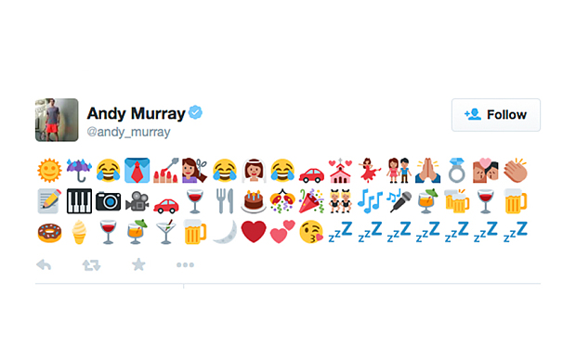

**Andy Murray's wedding day tweet**

Technology giant Apple recently [**moved to make the faces in their emoji more diverse**](https://www.telegraph.co.uk/finance/newsbysector/mediatechnologyandtelecoms/media/11524193/Apple-focuses-on-diversity-with-new-emoji.html) by adding the option of changing the colour of different faces.

The word emoji was also added to the Oxford English Dictionary in 2013, with the word coming from the Japanese words meaning picture and character.

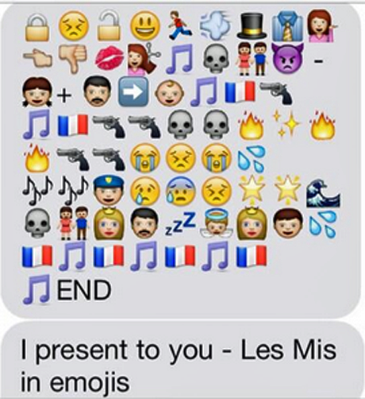Les Miserables by Telegraph writer Rhiannon Williams

[The Telegraph](https://www.telegraph.co.uk/)

* [Home](https://www.telegraph.co.uk/)
* [News](https://www.telegraph.co.uk/news/)
* [Sport](https://www.telegraph.co.uk/sport/)
* [Business](https://www.telegraph.co.uk/business/)

ALL SECTIONS

* [News](https://www.telegraph.co.uk/news/)
* [Science](https://www.telegraph.co.uk/science/)
* [Telegraph](https://www.telegraph.co.uk/)
* [News](https://www.telegraph.co.uk/news/)
* [Science](https://www.telegraph.co.uk/science/)

# Skin tone emoji boost inclusion on social media, study shows

[7](https://www.telegraph.co.uk/science/2018/04/10/skin-tone-emojis-boost-inclusion-social-media-study-shows/" \l "comments)

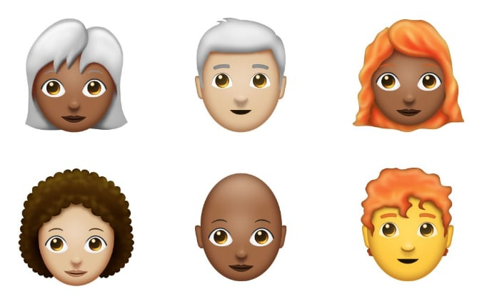Emoji with different skin tones help people feel included, the University of Edinburgh has found Credit: Emojipedia

* [Sarah Knapton](https://www.telegraph.co.uk/authors/sarah-knapton/), Science Editor

10 April 2018 • 5:24pm

Emoji with darker skin tones are helping people feel included on social media, researchers have found, as they call for even more diversity in the little cartoons.

When the inclusive [emoji](https://www.telegraph.co.uk/technology/2018/02/08/redhead-campaigners-victory-12-gingers-added-2018-emoji-list/)were first introduced in 2015 there were fears that the icons could be used inappropriately or abusively, and could even stoke racial tensions.

But when researchers analysed a sample of a billion tweets they found that most people who choose to personalize the colour of their emoji do it to make it more aligned with their own skin tone.

And even in tweets where the selected skin tone was different from that of the user, posts were found to be mostly positive.

The researchers, from the [University of Edinburgh](https://www.ed.ac.uk/) have called for even more options to personalise characters to a greater degree.

Alexander Robertson, of the University of Edinburgh's School of Informatics, said:  "This result should encourage the addition of more emoji options for self-representation - adding to those that have been recently made available, such as red hair.

“I would expect to see options like more combinations of skin and hair colour (at the moment the number of combinations is restricted, for example you can’t have blonde hair and darker skin) and perhaps a wider range of skin tones than the current five.”

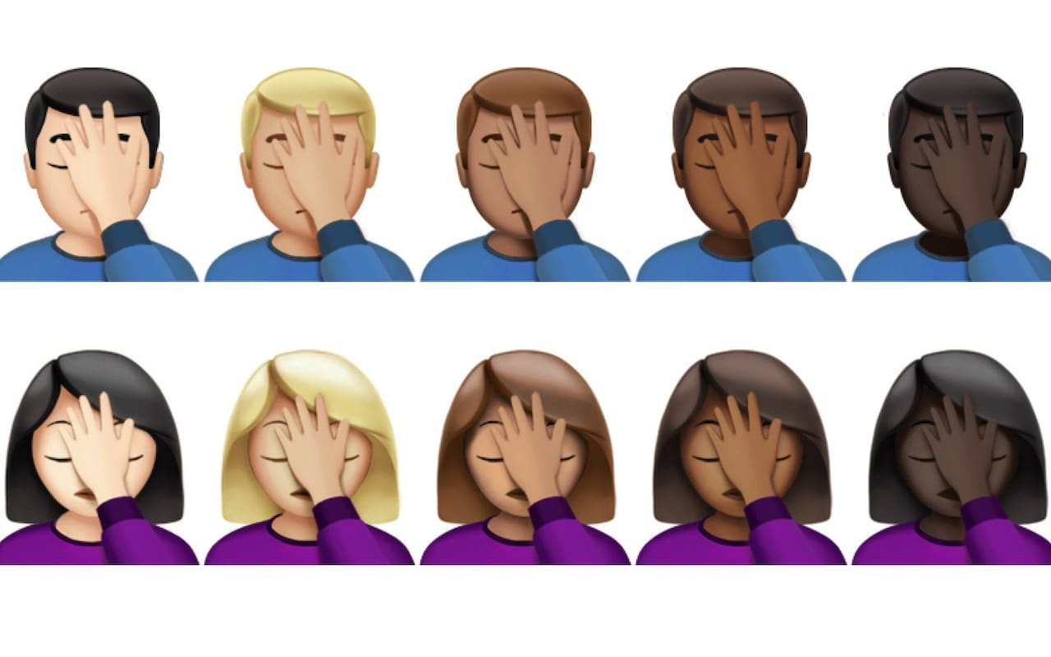

Emoji have become more personliased in recent years  Credit: Emojipedia

The study found that users with darker skin, according to their Twitter profiles, were most likely to modify their emoji, while users with light skin were less likely to make any changes. This underlines the importance to users of being able to express their identity online, researchers say.

Almost half of modified emoji used a light skin tone, because most users are white, the study found.

The darkest skin tones were used least throughout most regions of the world, even in Africa, perhaps reflecting the lack of internet access in developing regions.

Dr Walid Magdy, of the University of Edinburgh's School of Informatics, who led the research, said: "The introduction of skin tone choices for emoji has been a success in representing diversity and their extensive use shows that they meet a real demand from users."

The study, by scientists at the University of Edinburgh,will be presented at the 12th International AAAI Conference on Web and Social Media in Stanford, California, in June.

### Related Topics

* [Emoji](https://www.telegraph.co.uk/emoji/)
* [Social media](https://www.telegraph.co.uk/social-media/)
* [University of Edinburgh](https://www.telegraph.co.uk/university-of-edinburgh/)