**EnGlish**

English Language Investigation

2018

Introduction

Welcome to what may prove to be the highlight of the course! The English Language Investigation is your chance to do a proper linguistic study on an aspect of English Language that you are interested in. It is a miniature version of the kind of study that linguists do at university level. It’s worth a quarter of your marks in the second year. You have done a mini-investigation this year and so many of this will be familiar. Here’s a reminder…

* The Language Investigation includes:-

1. A **cover sheet** with your investigation title or question
2. A 150 word **introduction**, explaining why you have chosen this particular field of study (language and technology, for example)
3. A 250 word **methodology**. This is where you explain how you gathered your data and why you are focusing on the particular aspects of language you have chosen (rather than the field of inquiry itself, which is tackled in the intro.)
4. **Data**, which you collect yourself (eg transcriptions of real talk, adverts for washing-up machines, speeches etc). You base the whole investigation on analysis of this data. No limit to the amount, but best to keep it fairly tight. Minimum two texts/transcripts. Maximum ten.
5. 1800 words of **analysis**. This is where the marks come from. It should have a focus and be subdivided (eg into 3 600 word sections) into appropriate analytical methods (eg lexis, modal verbs, pragmatics)
6. 300 word **conclusion/evaluation** where you draw together your findings
7. A **bibliography of wider reading**. Minimum 6 different books/sources
8. An **academic poster** of around 1000 words (sample to be circulated in class).

**Dates and deadlines**

June 2018 – select your area of interest; start some wider reading in the field of study you have chosen (see pages 13-18)

Week beginning 9th July – ensure that you have had your proposal form checked and signed by one of your teachers

Summer holidays – collect your data; conduct wider reading

September 2018 – bring your data and notes from wider reading to your first lesson

Autumn term – hand in draft sections of your investigation to your teacher; 1-2-1 support sessions with your one teacher. Complete full draft of investigation by half term and begin work on academic poster.

**Final Deadline for investigation and poster: 2pm Wednesday 12th December 2018**

**What is the best way to conduct a language investigation?**

Although this is not the only way to study`` language, the following process is probably the most reliable way to ensure that you pick up all the marks available:-

1. Decide on an area of interest. It’s always best to play at your strengths. For example:-

* Interested in politics and power: base the investigation on political speeches
* Younger sister or cousin: do an investigation into how children acquire language
* English as a second language in your family: study how two members of the family have traces of your mother tongue
* Want a career in journalism: study how particular groups are represented in the media
* Really enjoyed the technology/power/gender topics: pick one and focus the investigation on that
* And so on!

1. Pick out some books and articles ( you might start with the AS or A2 textbooks) and start some wider reading
2. Formulate a question and plan how you will collect your data. Keep one constant element across the data and then vary the context so that the language can be studied.

* **Try filling out one or more lines of the table on the next page, using the first line as a model.**
* **Do a short presentation on a past investigation that you like the look of**

1. Complete your proposal form and have it checked by your teacher (end of summer term)
2. Continue with your wider reading and collect your data (summer holidays)
3. Annotate your data
4. Start drafting in sections as directed by your teacher

|  |  |  |  |  |  |
| --- | --- | --- | --- | --- | --- |
| **Field of interest/study/ concepts** | **Constant element** | **2+ Pieces of data with minimal non-linguistic variation** | **Linguistic Variation that you would study** | **Investigation Question** | **Three Appropriate Methods** |
| Technology, speech/writing, idiolect/sociolect | A 17 year old female A level student (not doing English Language) | Transcriptions of her talking to a friend and texting to the same friend | Spoken and written mode; face to face vs computer/phone mediated language | How does language vary between texting and face-to-face conversation? | Standard/non standard grammar; lexical choices; graphology and prosodics |
| Language change, language and power, representation | Adverts for Ovaltine | Print adverts only; all the same brand; one from every twenty years from 1900 to 2000 |  |  |  |
| Language and gender, language change | How-to guides for children | A pair of texts one from 1970 for girl-guides one from 1970 for boy scouts |  |  |  |
| Language and religion; language change | A single psalm (religious text eg ‘The Lord is My Shepherd etc’) | 6 versions from bibles over 1000 years at 1-200 year intervals |  |  |  |
| Language and humour |  |  |  |  |  |
| Language of literature |  |  |  |  |  |
| Language of newspapers |  |  |  |  |  |
| Language of politics |  |  |  |  |  |
| Language of sport |  |  |  |  |  |
| English as a second language |  |  |  |  |  |
| Language of children |  |  |  |  |  |
| Language and regional variation |  |  |  |  |  |
| Language and the media – eg interviews |  |  |  |  |  |
| Language and multimodality | Weather reports on a single day |  |  |  |  |
| Language in the classroom |  |  |  |  |  |
| Language and thought | The spoken and written language of twins | One identical, one non-identical pair of twins, given the same visual stimulus and asked to describe what they see in speech and writing |  |  |  |

Sample Areas for Investigations/Topics

1. Language Change: e.g. adverts through the ages, perhaps for one product/brand. Children’s stories.
2. The bible: changes over time e.g. from King James Bible to modern ‘street’ versions
3. 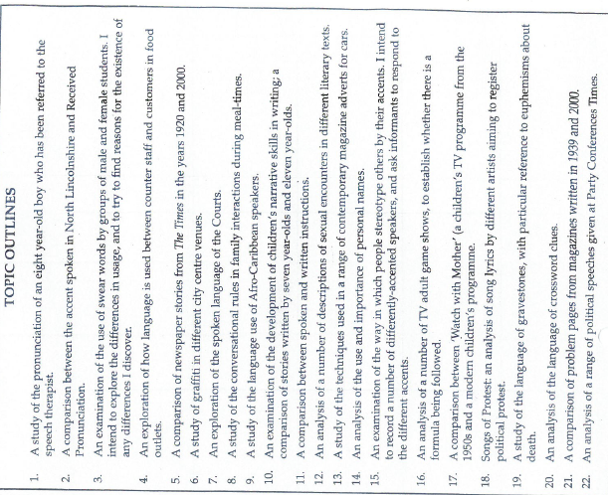Comparison between novel/film/tv/drama script and real speech
4. Technology: texts, emails, twitter. Case study of particular writer, writing for different audiences
5. Technology: comparison between real speech and instant message/Facebook ‘conversation’
6. Interviews (really good thing from current emag on this) of all types, perhaps focusing on a particular interviewee. Or interviewee in face to face interview vs political speech.
7. Spoken: case study of a young person speaking in different contexts (gender/power etc.) – means transcribing
8. Black English – comparison of spoken data (e.g. from the Listening Project?) vs transformed versions (rap, dub poetry)
9. Mode: spoken vs written versions within same genre (e.g. recipes)
10. Speeches: perhaps focusing on prosodics?
11. CLA: study of reading scheme books, collections of children’s writing, focus on particular child’s speech development. Longitudinal studies must be started now if they are going to be any good…
12. Language Variation: Estuary English: to what extent is it being used by students in Surrey, for example. Combination of transcript and questionnaire?

More Ideas taken from *Researching Language,* by Angela Goddard

**Comparative Data for study and discussion**

Look at the following batches of data. Looking back at your table, what is the *methodology* that has been used here? Text A is taken from a very useful book called Evolving English. Text B is from the internet

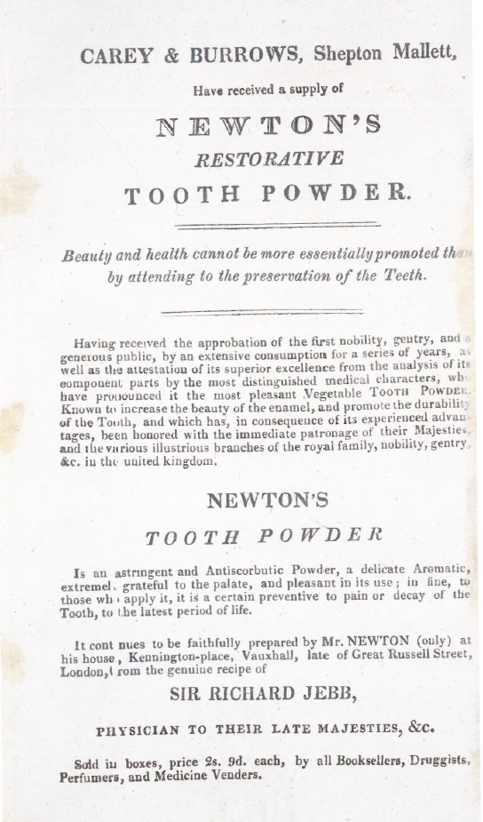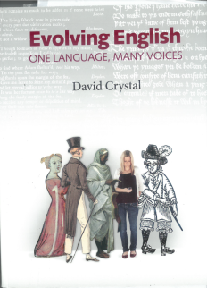

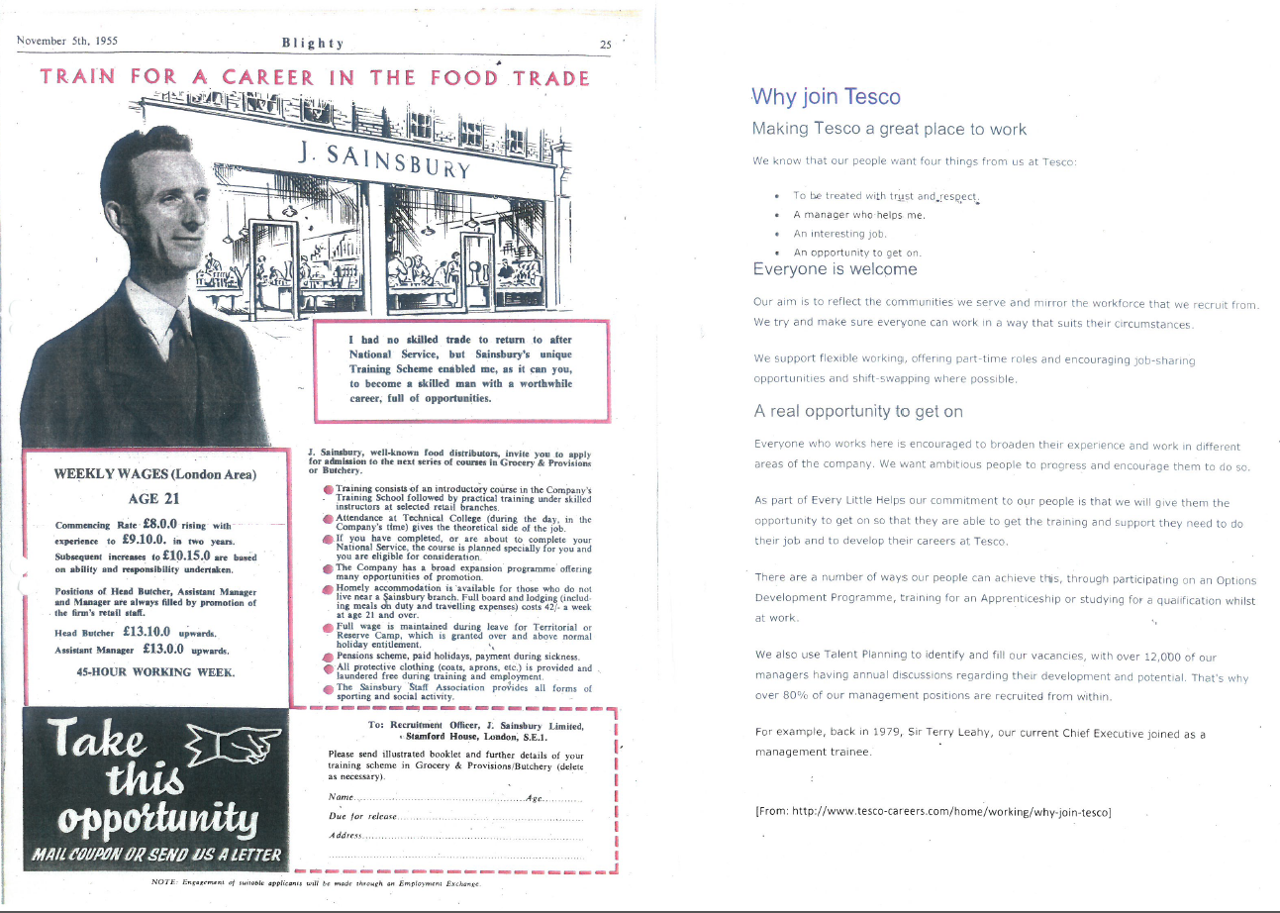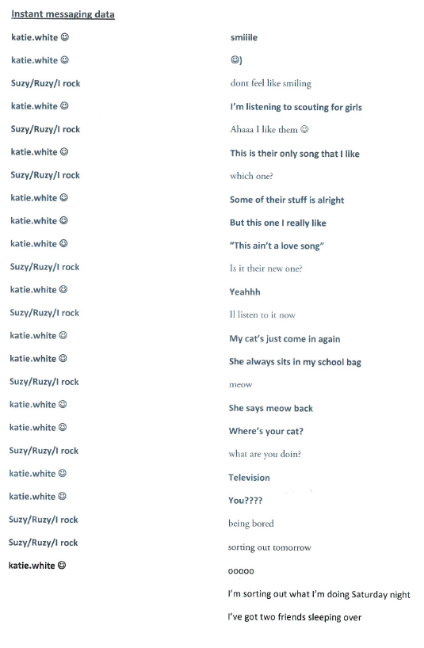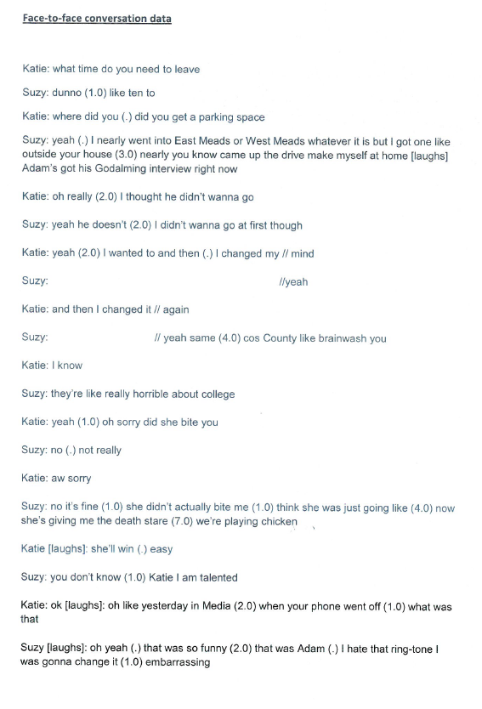

**Transcribing Speech**

This skill is vital for many investigations and we would like you to practise it before the summer holiday so that you can see if it is for you.

* Use the key below to help you transcribe a short section of dialogue between two speakers. Take the same two speakers and ask for a text or instant message conversation between them. Bring the data to the lesson for discussion.
* If you have already done the above activity this year, transcribe using a different principle (see above discussion of methodology – eg two family meals, different topic)

There are different ways of doing it. Here is one:-

(.) micropause

(1) 1 second pause

erm, err Filled pause

**bold** emphatic stress

= marking a smooth transition from one turn to another or an interruption

// to signal overlapping speech

(unclear) to indicate speech which is hard to make out

Example (from *Mastering English Language,* Sara Thorne):-

S1: we’ll talk about Sheffield=

S2:=as we remember it=

S1=as we//remember it

//as we remember it (.) what years ago it was a // very busy town full of steel works (.) now to

S2: // yes umm

S1: my knowledge

**Wider Reading**

A few pages on from here is a list of all the titles we currently have available to borrow in the Godalming College Library with where to find them.

* Here are some tasks you need to work through…

1. Go on to Godalming Online, click on the ILC link and see if you can find one of the titles from this list on the Heritage catalogue system.



1. Take one of the rows from the table you completed earlier, and find three texts from the book list on the next page that you think could be useful to start your wider reading on that subject. Put a mark beside them and be ready to find the book when you go round the library in one of your early lessons.
2. Follow the instructions below to the ***emagazine*** website and find an article that links with the same topic.
3. Go to ILC and click on this link:



1. Find the ***emagazine*** link. Make a note of the username (Godalming) and password (emag1) and then click the hyperlink.
2. 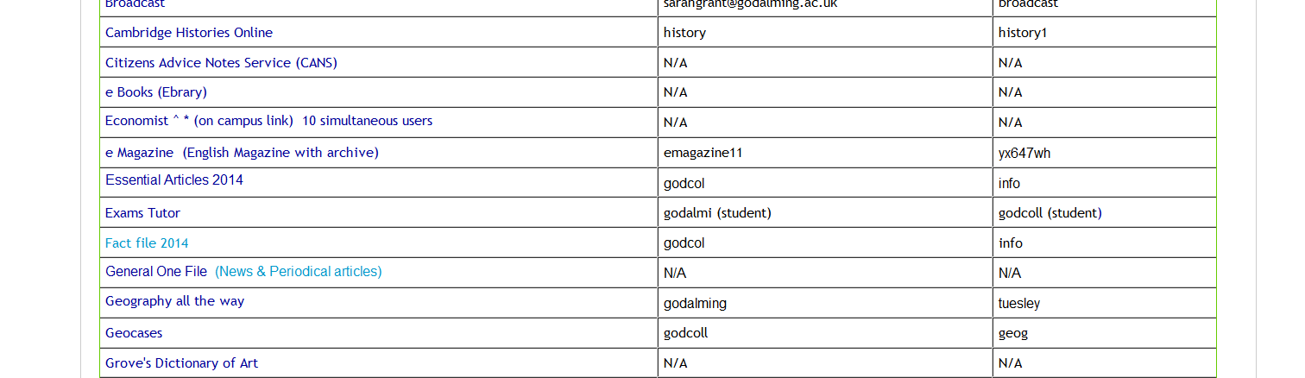Click to ‘Enter emagazine student area’ and enter user name and password

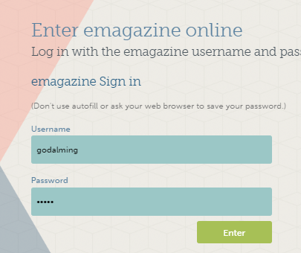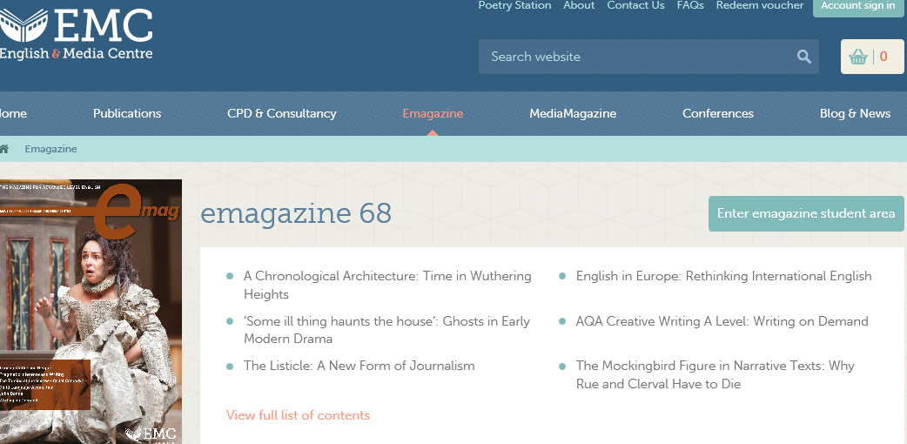

1. Browse articles on things you might want to research for your investigation

|  |  |  |  |  |  |  |
| --- | --- | --- | --- | --- | --- | --- |
| **Title** | **Shelf Location** | **Author** |  |  | **Date** |  |
| Language myths | 420 BAU | Bauer, Laurie | 3 | 3 | 1998 |  |
| The Story of the English Language | 420 PEI | Pei, Mario | 1 | 0 | 1968 |  |
| Child language (Second edition) | 420 PEC | Peccei, Jean Stilwell | 6 | 4 | 1999 |  |
| Living language, language acquisition | 420 MYS | Myszor, Frank | 3 | 1 | 1999 |  |
| The language of speech and writing | 420 COR | Cornbleet, Sandra | 5 | 2 | 2001 |  |
|  |  |  |  |  |  |  |
| Mastering advanced English language (Second edition) | 420 THO | Thorne, Sara | 11 | 49 | 2008 |  |
| Language change, progress or decay? (3rd edition) | 420 AIT | Aitchison, Jean | 2 | 3 | 2001 |  |
| The elements of style | 420 STR | Strunk, William | 1 | 2 | 2000 |  |
| The Language of television | 420 MAR | Marshall, Jill | 4 | 0 | 2002 |  |
| Grammar, structure, & style | 420 RUS | Russell, Shirley | 2 | 2 | 2001 |  |
| The language of drama | 420 SAN | Sanger, Keith | 2 | 0 | 2001 |  |
| Projects in linguistics : a practical guide to researching language | 420 WRA | Wray, Alison | 1 | 0 | c2006 |  |
|  |  |  |  |  |  |  |
| Womanwords : a dictionary of words about women | 420 MIL | Mills, Jane | 1 | 0 | 1993 |  |
| The language of ICT : information and communication technology | 420 SHO | Shortis, Tim | 3 | 0 | 2001 |  |
| Your own words (2nd edition) | 420 EAM | Eames, Jackie | 1 | 0 | 1999 |  |
| Cambridge grammar of english | 420 CAR | Carter, Ronald | 4 | 2 | 2006 |  |
| Discover grammar | 420 CRY | Crystal, David | 1 | 2 | 1996 |  |
| Dialects | 420 TRU | Trudgill, Peter | 7 | 0 | 1994 |  |
| Describing language (Second edition) | 420 GRA | Graddol, David | 1 | 1 | 2001 |  |
| AQA B English language:unit 4: language investigation | 420 CRE | Cresswell, Alison | 1 | 0 | 2007-2008 |  |
| The Faber book of reportage | 420 CAR | CAREY, JOHN | 1 | 1 | 1987 |  |
| The language of websites | 420 BOA | Boardman, Mark | 3 | 1 | 2005 |  |
| Child language | 420 ELL | Elliot, Alison J. | 2 | 5 | 1981 |  |
| Women, men and language : a sociolinguistic account of gender differences in language | 420 COA | Coates, Jennifer | 2 | 3 | 1993 |  |
|  |  |  |  |  |  |  |
| Language; a student handbook on key topics and theories | 420 CLA | Clayton, Dan | 30 | 9 | 2012 |  |
|  |  |  |  |  |  |  |
| Txtng: the gr8 db8 | 420 CRY | Crystal, David | 6 | 2 | 2008 |  |
| The Fight for English:how language pundits ate,shot,and left | 420 CRY | Crystal, David | 1 | 2 | 2006 |  |
| Internet linguistics : a student guide | 420 CRY | Crystal, David | 2 | 1 | 2011 |  |
| AQA language and literature B AS. | 420 PIC | Picton, Marian | 16 | 1 | 2012 |  |
| The Language instinct: The new science of language and mind | 420 PIN | Pinker, Steven | 1 | 2 | 1994 |  |
| Language change | 420 TRA | Trask, R.L | 12 | 3 | 1994 |  |
| Language in the British Isles | 420 TRU | Trudgill, Peter | 1 | 0 | 1984 |  |
| The language of sport | 420 BEA | Beard, Adrian | 2 | 0 | 1998 |  |
| The language of humour | 420 ROS | Ross, Alison | 2 | 0 | 1998 |  |
|  |  |  |  |  |  |  |
| Language: the basics | 420 TRA | Trask, R.L | 3 | 3 | 1999 |  |
| Language and gender : a reader. | 420 COA | Coates, Jennifer | 5 | 0 | 2011 |  |
| The State of the language : 1990 edition | 420 RIC | RICKS, CHRISTOPHER | 1 | 1 | 1990 |  |
| Unit 3b:language change: AQA B A2 English language | 420 CRE | Cresswell, Alison | 1 | 0 | 2007-2009 |  |
| Style | 420 HAY | Haynes, John | 1 | 0 | 1995 |  |
|  |  |  |  |  |  |  |
| Language and mind | 420 CHO | Chomsky, Noam | 1 | 2 | 2006 |  |
| The Language of politics | 420 BEA | Beard, Adrian | 4 | 0 | 2000 |  |
| AQA AS English Language B | 420 GIO | Giovanelli, Marco | 112 | 90 | 2008 |  |
| The Sociolinguistics of language | 420 FAS | Fasold, Ralph | 1 | 3 | 1989 |  |
| Introducing language in use : a coursebook | 420 BLO | Bloomer, Aileen | 2 | 0 | 2005 |  |
| Language and technology | 420 GOD | Goddard, Angela | 10 | 7 | 2011 |  |
| The New Journalism | 420 WOL | Wolfe, Tom | 2 | 0 | 1996 |  |
|  |  |  |  |  |  |  |
| Researching language (Second edition) | 420 GOD | Goddard, Angela | 3 | 2 | 2000 |  |
| Language and style | 420 JAG | Jago, Michael | 2 | 1 | 1999 |  |
| A-level study guide English language; revised and updated for 2008 | 420 GAR | Gardiner, Alan | 21 | 45 | 2008 |  |
|  |  |  |  |  |  |  |
| Language and gender | 420 GOD | Goddard, Angela | 10 | 3 | 2009 |  |
| The language of work | 420 KOE | Koester, Almut | 3 | 0 | 2004 |  |
| A-level study guide English language | 420 GAR | Gardiner, Alan | 2 | 9 | 2003 |  |
| An Introduction to Sociolinguistics (Third edition) | 420 HOL | Holmes, Janet | 3 | 1 | 2008 |  |
| An introduction to the pronounciation of English | 420 GIM | Gimson, A | 1 | 2 | 1980 |  |
| The language of conversation | 420 PRI | Pridham, Francesca | 2 | 0 | 2001 |  |
| The Frameworks of English: Introducing language structures | 420 BAL | Ballard, Kim | 1 | 1 | 2007 |  |
| AQA A2 English Language B student's book | 420 SAU | Saunders, Mark | 114 | 225 | 2009 |  |
| Language and religion | 420 BEA | Beal, Joan C. | 2 | 0 | 2006 |  |
| The language of comics | 420 SAR | Saraceni, Mario | 2 | 0 | 2003 |  |
| Language and silence | 420 STE | Steiner, George | 1 | 0 | 1967 |  |
| The language of science | 420 REE | Reeves, Carol | 2 | 0 | 2005 |  |
| Mastering advanced English language | 420 THO | Thorne, Sara | 8 | 6 | 1997 |  |
| The language of war | 420 THO | Thorne, Steve | 3 | 0 | 2006 |  |
| The Myth of Mars and Venus | 420 CAM | Cameron, Deborah | 3 | 1 | 2007 |  |
|  |  |  |  |  |  |  |
| A history of the English language (5th edition) | 420 BAU | Baugh, Albert C. | 3 | 0 | 2002 |  |
| Mother Tongue | 420 BRY | Bryson, Bill | 4 | 4 | 1991 |  |
|  |  |  |  |  |  |  |
| The Cambridge encyclopedia of the English language (2nd edition) | 420 CRY | Crystal, David | 2 | 3 | 1995 |  |
| Unit 3a: Child language acquisition: AQA B A2 English language | 420 CRE | Cresswell, Alison | 1 | 1 | 2007-2009 |  |
| Linguistic criticism (Second edition) | 420 FOW | Fowler, Roger | 1 | 2 | 1996 |  |
| The language of children | 420 GIL | Gillen, Julia | 10 | 0 | 2003 |  |
| Begat : the King James bible and the English language | 420 CRY | Crystal, David | 1 | 3 | 2010 |  |
| Language and social contexts AS/A2 | 420 COU | Coultas, Amanda | 3 | 5 | 2003 |  |
| Evolving English : one language, many voices : an illustrated history of the English language | 420 CRY | Crystal, David | 4 | 4 | c2010 |  |
|  |  |  |  |  |  |  |
| Language change | 420 BEA | Beard, Adrian | 10 | 0 | 2004 |  |
| Spell it out : the singular story of English spelling | 420 CRY | Crystal, David | 1 | 2 | 2013 |  |
| AQA A2 English Language B | 420 GAR | Gardiner, Alan | 80 | 40 | 2003 |  |
| The Language of magazines | 420 MCL | McLoughlin, Linda | 4 | 6 | 2000 |  |
|  |  |  |  |  |  |  |
| Eats, Shoots & Leaves, the zero tolerance approach to punctuation | 420 TRU | Truss, Lyn | 3 | 2 | 2003 |  |
| The language of newspapers | 420 REA | Reah, Danuta | 5 | 0 | 2002 |  |
|  |  |  |  |  |  |  |
| Understanding language | 420 PER | Perera, Katharine | 2 | 0 | 1987 |  |
|  |  |  |  |  |  |  |
| The language of poetry | 420 MCR | McRae, John | 2 | 0 | 1998 |  |
| The language of advertising : written texts | 420 GOD | Goddard, Angela | 6 | 7 | 2002 |  |

**Past Investigations:**

There are scanned past investigations on the Godalming Onlin English Language page, in the ‘Investigations’ section.

* Try looking at the one on Barack Obama’s speeches and the one on Driving Instructors. Which would you have done and why?

**Language Investigation Research Log**

All academic research must be underpinned by previous research and the investigation is no exception. You must, therefore, read/listen to at least six academic sources before you collect your data or start to write anything. In order to be prepared to start the coursework as soon as you return to College, you need to gather your sources and log six weeks of reading. Feel free to start this before the summer holidays, to give yourself some time off, but you must commit to six weeks of research or your investigation will show a lack of knowledge which cannot be compensated for later in the course.

You are not expected to read a whole collection of essays in a book; just find the relevant chapters and stick to them. Your research could be a chapter from a book, a journal (see Google Scholar), an article if it’s by a specialist (see *emagazine*) or a recorded interview with a linguist. Once you have six reliable pieces of research, logged below, you are ready to consider a methodology of your own and collect some data.

**The data and research log will need to be handed to your teacher in the first week of the autumn term.** Enjoy your reading!

|  |  |  |
| --- | --- | --- |
| Progress | Author, Title and Year and Place of Publication | Relevant Knowledge/Quotations |
| Week 1 |  |  |
| Week 2 |  |  |
| Week 3 |  |  |
| Week 4 |  |  |
| Week 5 |  |  |
| Week 6 |  |  |

With a greater awareness of your area of research, rethink your methodology before collecting data:

Who/what will you find/record?

How many texts/recordings will you need?

Are these texts/recordings comparable i.e. have you eliminated all but one variable?

Will this data give you a reliable answer to your research question?

Once you’ve answered these questions, and feel confident that you’re choosing appropriate data, gather it and transcribe any original spoken data. Your teacher will check this but, assuming it’s sufficient, you should now be ready to start your coursework…

English Language Investigation Proposal Form

**EnGlish**

Name ­­­­­­­­________________________________

Student Number ________________

Area(s) of interest

Proposed Methodology

Proposed title/investigation question

Details of **data** to be collected

PTO

**Wider Reading** (6 books/articles/web resources) relating to field of study

Wider Reading – Minimum of 6 books/articles/web resources

**Student Declaration**

I hereby agree that, subject to agreement of this proposal by my teacher, I will collect a viable amount of data and will provide notes drawn from 6 wider reading texts/articles/videos by the first lesson of the A2 year. I do not expect to be able to continue with this course if I have not achieved this summer work.

Signed ­______________________________________________ Date ____________________

**To be completed by the teacher** and returned to student by the last lesson of summer term:-

Subject to suggested amendments (where necessary) I approve this investigation.

Teacher signature ______________________________________ Date ___________________