Passage 1 From ‘Language Change, Progress or Decay’, by Jean Aitchison

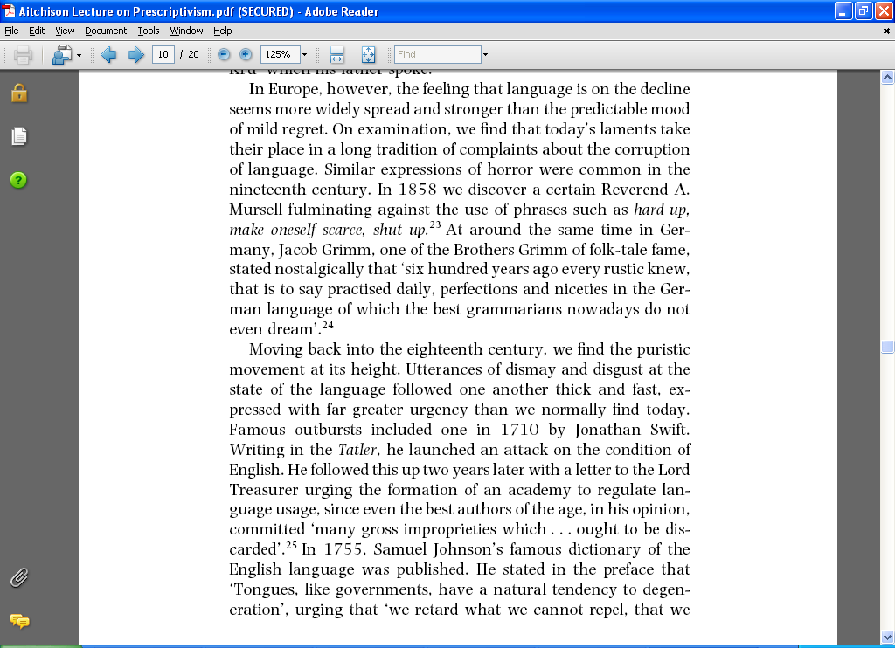

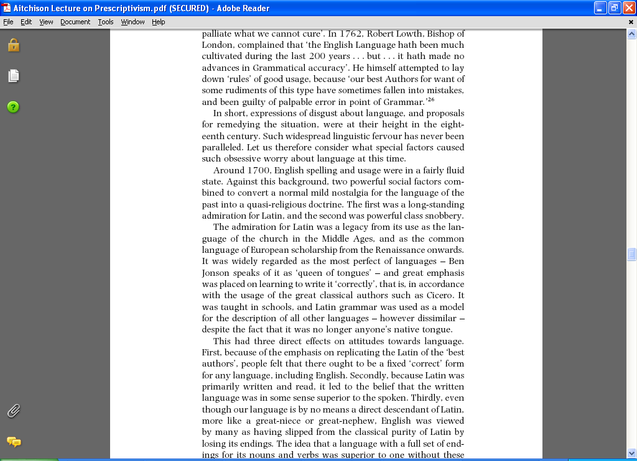

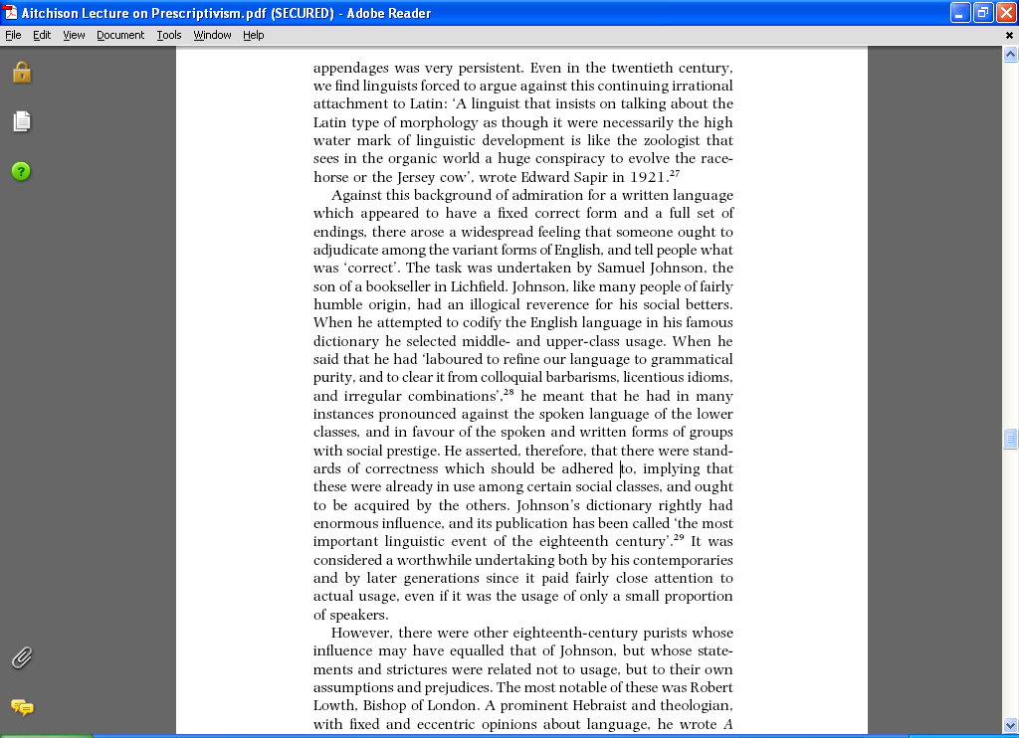

1. Read your passage carefully
2. Summarise the main point in each paragraph on your own
3. Share your summaries with your group
4. Select 3 key quotations that you think sum up the gist of the extract
5. Now pick the single best quotation



Passage 2 From ‘Language Change, Progress or Decay’, by Jean Aitchison

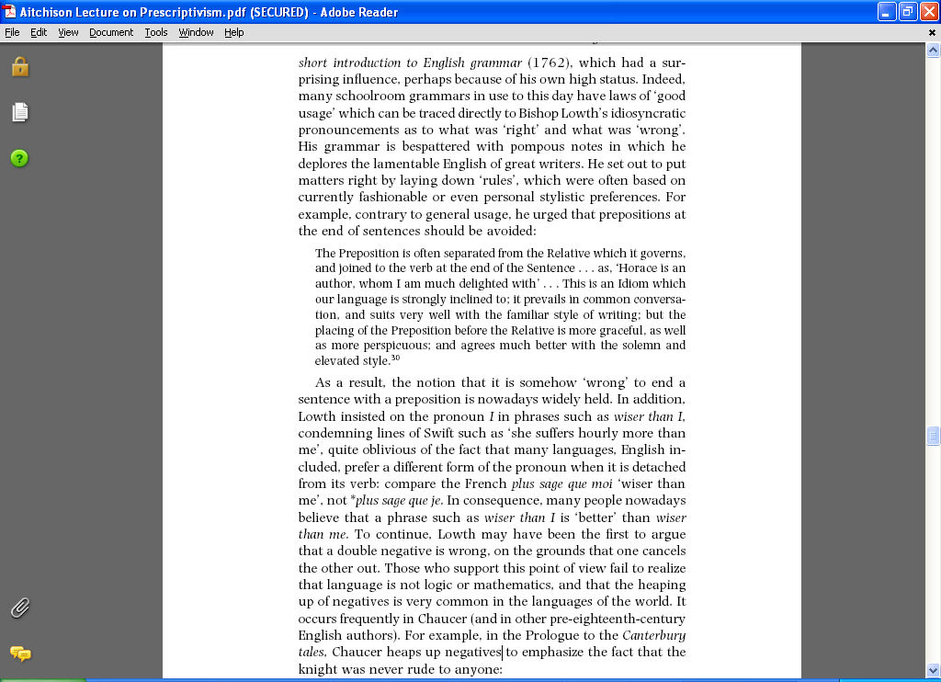

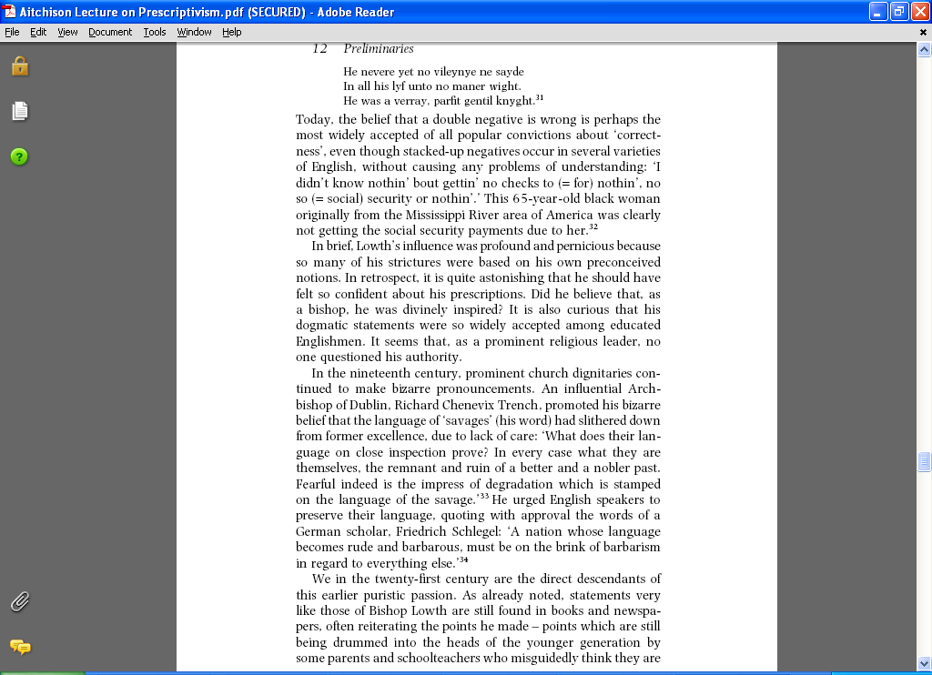



1. Read your passage carefully
2. Summarise the main point in each paragraph on your own
3. Share your summaries with your group
4. Select 3 key quotations that you think sum up the gist of the extract
5. Now pick the single best quotation

Passage 3 From ‘Language Change, Progress or Decay’, by Jean Aitchison

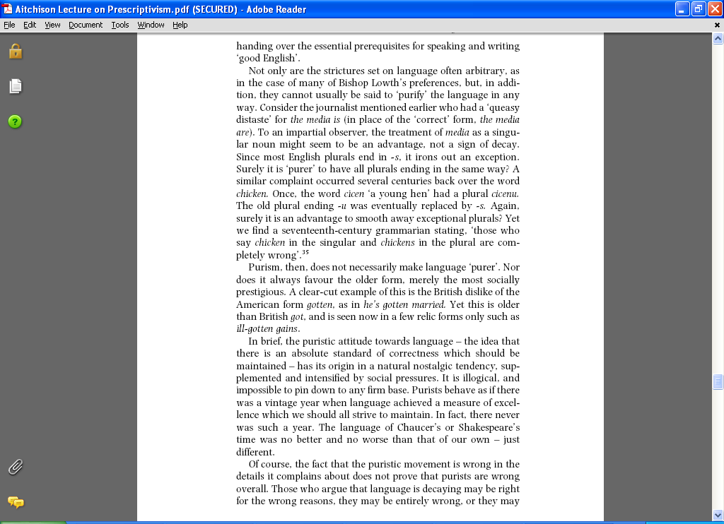

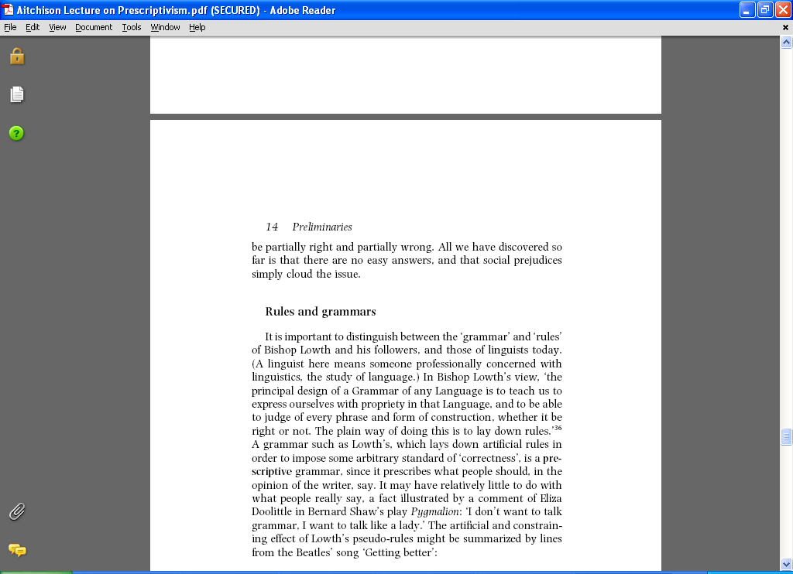

1. Read your passage carefully
2. Summarise the main point in each paragraph on your own
3. Share your summaries with your group
4. Select 3 key quotations that you think sum up the gist of the extract
5. Now pick the single best quotation