**A Level English Language**

Paper 2: Dimensions of Linguistic Variation

**Section C:**

*Language Change Texts*



**Contents:**

**Section: Pages:**

**Outline of Question, Assessment Objectives, Top Tips** 3-4

**Starting to compare:**

**Text 1 (1620) + Text 2 (1979) Wills** 5

**Text 3 (1802) + Text 4 (1940) Diary Extracts** 6

**Text 5 (1623) + Text 6 (2015) Sermons** 7

**Text 7 (1796) + Text 8 (2008) Travel Articles** 8-9

**Text 9 (1854) + Text 10 (2003) War Correspondence** 10-11

**Full Comparison Texts**

**Text 11 (Shipwreck Account 1693) + Text 12 (*Guardian* Article 1997)** 11-12

**Text 13 (*Spectator* Letter 1711) + Text 14 (*Telegraph* Article 2014)** 13-14

**Text 15 (Clergyman’s Diary Extract 1788) + Text 16 (Durrell’s Autobiography 1978)** 15-16

**Text 17 (1703) + Text 18 (1896) Etiquette Guides** 17-18

**Text 19 (1878) + Text 20 (1965) Dancing Guides** 19-20

**Text 21 (Committee Report 1799) + Text 22 (Orwell’s Autobiography 1933)** 21-22

**Text 23 (1894) + Text 24 (1980) Sainsbury’s Adverts** 23-25

**Text 25 (1892) + Text 26 (2011) School Rules** 26-27

**Text 27 (Fashion Pamphlet 1745) + Text 28 (Online Cosmo Article 2018)** 28-31

**Text 29 (1840s) + Text 30 (2017) Gambling Texts** 32-33

**Section C: Language Change** (1 hour 5 minutes)

**Question:** Read **Text C** and **D** in your **Resource Booklet** and answer the following question.

1. By detailed analysis of the writing in both passages, discuss and illustrate the variations in language between the *x*th and *x*th centuries. In your answer you should explore the ways language is used in each text, as well as how contextual factors influence the way meaning is constructed. **[36]**

**Assessment Objectives assessed:**

**AO1:** Apply appropriate methods of language analysis, using associated terminology and coherent written expression. **[12]**

**AO3:** Analyse and evaluate how contextual factors and language features are associated with the construction of meaning. **[12]**

**AO4:** Explore connections across texts, informed by linguistic concepts and methods. **[12]**

**Top tips:**

1. Consider the **mode, context, genre, audience** and **purpose** of the text. Make sure you spend **15 minutes** annotating the language of the text with these points in mind. Try to group the **similarities** and the **differences** together before you write a **succinct, introduction** addressing these.
2. When preparing your answer, think about the **date** of each text. You will be given **two texts both from 1600 onwards**. Be aware of the different time periods of English. Applicable for you is **Early Modern English (1500 – 1700), Modern English (1700 – 1950) and Late Modern English (1950 – present)**. Think about **general trends** that were happening with the language over these key periods.
3. Use **appropriate contextual detail** in your answers. **Don’t** obsess over the printing press or Johnson’s dictionary. Think about whether it is relevant to bring in these pieces of historical context and think of broader issues such as education, women’s rights, etc.
4. When you compare both texts, make sure that you are grouping points of your analysis around the same **language level features**. For example, if you are analysing **syntax** in one text, compare it with an interesting syntactic point found in the other text. This shows insightful comparison rather than comparing any language features which doesn’t convey you being **systematic.**
5. Do remember that nobody knows for sure or precisely why certain words have changed. All you can do is look at general trends in the language. Think about how, for example, the words ‘peng’, ‘lit’ and ‘sick’ have entered youth sociolect over the past 5 – 10 years due to the influence of Multicultural London English. You know this because you’ve lived through it. You just need to think more broadly and engage with **historical context** to work out why other linguistic changes happened earlier on. Think of yourself as a **detective**.
6. Apply relevant **language change theories** where appropriate e.g. lexical gap. Also think about other **language change concepts** such as standardisation, codification, political correctness, informalisation, globalisation, etc and where you can add them in. Remember concepts such as standardisation didn’t just happen overnight. They are long processes lasting hundreds of years. With this example in mind, standardisation started in the mid 15th century with the introduction of printing presses and ‘ended’ in the mid 19th century when prescriptivism had been a growing force over the 1700s and 1800s.
7. Remember this is not just a comparison of language; you’ve got to think about how it’s changed. **Lexical** and **semantic change** terminology is important to include along with looking for key **grammatical change** features such as placement of adverbials, pronoun use, noun clauses, etc.

**Text 1:**

**Text C** is an opening of a will drawn up by a man called Christopher Mountjoy in 1620.

*In the name of God Amen,* the Six & twentieth day of January *Anno Dm secundum computacionem Ecclesiae Anglicanae 1620,* I, Christopher Mountjoy of London, Marchant, being sicke and weake in body but of perfect mind and memory (thankes bee given to almightie God therefore) doe make & ordeyne this my last will & Testament in manner and forme followinge (that is to say): *first* I give & bequeath my soule unto almighty God my maker and Creator, trusting and assuredly beleivinge that by the merritte of *Jesus Christ my Saviour* I have and shal have free and cleire remission of all my sinnes … *Item* my will and minde is that all such Goods & Chattels as God hath bestowed upon mee shall, after my debtes paid and funerals discharged, bee given & disposed of in manner & forme following (that is to say) Three Third partes of my goods & Chattells (the whole being devided into ffower Third partes) I give & bequeath unto my wellbeloved wief Isabell. *And* one other thirde part of the said ffower Third parts I doe hereby give & bequeath unto my daughter Mary Blott the wief of Stephen Blott. And I doe hereby make & appoint the said Isabell my wife the full and sole Executrix of this my last will & testament.

**Text 2:**

**Text D** is the opening of John Lennon’s will, made in November, 1979.

I, JOHN WINSTON ONO LENNON, A RESIDENT OF THE County of New York, which I declare to be my domicile, do hereby make, publish and declare this to be my Last Will and Testament, hereby revoking all other Wills, Codicils and Testamentary dispositions by me at any time heretofore made.

FIRST: The expenses of my funeral and the administrations of my estate, and all inheritance, estate or succession taxes, including interest and penalties, payable by reason of my death shall be paid out of and charged against the principal of my residuary estate without apportionment or provation.

SECOND: Should my beloved wife YOKO ONO survive me, I give, devise and bequeath to her absolutely, an amount equal to that portion of my residuary estate, the numerator and denominator of which shall be determined as follows:

1. The numerator shall be an amount equal to one-half (1/2) of my adjusted gross estate less the value of all other property included in my gross estate for Federal Estate Tax purposes and which pass or shall have passed to my wife either under any provision of this will or in any manner outside of this will in such manner as to qualify for a marital deduction. The words “pass”, “have passed”, “marital deduction” and “adjusted gross estate” shall have the same meaning as said words have under the provisions of the United States Internal Revenue Code applicable to my estate.

**Text 3:**

**Text C** contains extracts from the journals of Dorothy Wordsworth, who wrote them in 1802, primarily for her brother, the poet William Wordsworth, with whom she was sharing a cottage in the Lake District.

*Friday 12th.* In the afternoon a poor woman cameto beg some rags for her husbands leg which had been wounded by a slate from the Roof in the great wind. She looks broken, & her little boy, a pretty little fellow, looks thin & pale. I observed this to her. Aye says she we have all been ill. Our house was unroofed in the storm recently & *so* we lived in it for more than a week. The Child wears a ragged drab coat & a fur cap, & seems scarcely at all grown since I first saw him. Poor creatures! When the woman was gone, I could not help thinking that we are not half thankful enough that we are placed in that condition of life in which we are.

*Friday 16th April (Good Friday).* When I undrew my curtains in the morning, I was much affected by the beauty of the prospect & the change. The sun shone, the wind had passed away, the hills looked chearful. The Church rises up behind a little Knot of Rocks, the steeple not so high as n ordinary 3 story house. Bees, in a row in the garden under the wall.

*Monday 19th.* Mist and small rain. Wm worked in the garden, I baked pies & bread. We sate in the orchard after dinner, it was a beautiful afternoon. When we were sitting after Tea, Coleridge came to the door. He came up palish but I afterwards found he looked well. We sate comfortably in the garden. Coleridge & I drank black currants and water.

**Text 4:**

**Text D** comprises extracts from the 1940 diaries of Nella Last, a housewife living in the Lake District, who was writing them as part of a government project to find out more about the day-to-day lives of ordinary people.

*Monday, 5 August, 1940.* Arthur [*her* *husband*] asked if I would like to go to Morecambe as his brother had given him an extra petrol coupon. It did not take me long to pack a picnic tea and we were off by 1.30. It was lovely after the rain and all looked clean washed. We always go on Heysham Head and there was such an odd collection of people there. I went into the ladies’ toilet and on the pretence of getting two half pennies changed into a penny got talking to quite a crowd and found that quite half were unused to a day-trip that ‘cost such a lot of money.’ Two were agricultural workers’ wives and they were staying over the weekend – one had a son in the Air Force stationed at Morecambe. I said ‘It’s lovely here, isn’t it? Did you never think of paying Morecambe a visit before this?’ She smiled and said ‘Aye, thought on it, but it’s first time I’d had cash eno’. Happen next year we will aw come for a week, if t’money’s as good.’

*Tuesday, 6 August.* I’d a busy morning for I’d a wire from Cliff [*her son in Chester*] to say he would be home by lunch time. I started to prepare tongue, fruit set in jelly to eat with a wee dab of tinned cream and whole meal bread. In the middle of the morning two little girls came. They said their mothers had told them to ask me what they could do [*for the war effort]* and as I was busy and wanted them to go I said ‘What about collecting paper and magazines for the sailors and I’ll take you down to Sailors’ Home and you can give them to My Dickinson yourself?’ I thought I’d got rid of them but they were soon back with a pile of a woman’s paper called *Mother* and when Arthur opened it at random it was at a page on ‘What to do the last week before the little stranger’s arrival’. We had a good laugh at imagined remarks of a minesweeper or submarine crew!

**Text 5:**

**Text C** is part of a sermon written by John Donne in 1623. As well as being Dean of St Paul’s Cathedral (a religious post), he was a poet.

All mankind is of one Author, and is one volume; when one man dies, one Chapter is not torne out of the booke, but translated into a better language; some peeces are translated by age, some by sicknes, some by war, some by iustice; but Gods hand is in euery translation; and his hand shall binde vp all our scattered leeues againe, for that Library where euery booke shall ly open to one another: As therefore that Bell that ringes to a Sermon, calls not vpon the Preacher onely, but vpon the Congregation to come, so this Bell calls vs all; but how much more mee, who am brought so neer the doore by this sicknesse. No Man is an Iland, intire of it self; euery man is a piece of the Continent, a part of the maine; if a clod be washed away by the Sea, Europe is the lesse, as wel as if a Promontory were, as well as if a Mannor of thy friends, or of thine owne were; Any mans death diminishes mee, because I am involved in mankind; And therefore neuer send to know for whom the bell tols; It tols for thee.

**Text 6:**

**Text D** is the opening of a sermon from 2015.

Self-promotion. Self-preservation. Self-centeredness. It’s all about me!

Everyone told us it was all about us, didn’t they? Weren’t we urged to look out for number one? Find a place in the sun? Make a name for ourselves? We thought self-celebration would make us happy.

But what chaos this philosophy creates. What if a symphony employed such an outlook? Can you imagine an orchestra with an ‘It’s all about me’ approach to music? Each artist clamoring for self-expression. Tubas blasting out non-stop. Percussionists pounding to get attention. The cellist shoving the oboist out of a more prominent chair. The trumpeter drowning out the flutist. The director being ignored.

Harmony? Hardly. Happiness? None at all. Who is happy to be part of a cacophony?

No wonder our homes are so noisy, our businesses so stress-filled, our governors so cut-throat. If you think it’s all about you, and I think it’s all about me, what hope is there of a melody?

But what would happen if we took our place and played our parts? If we played the music our Maestro gave us to play in the way He tells us to play it?

**Text 7:**

**Text C** is an extract from *Narrative of a Five Years Expedition Against the Revolted Negroes of Surinam* by John Gabriel Stedman in 1796.

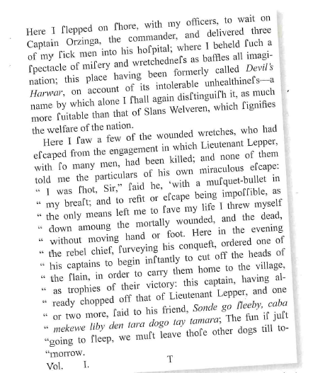

**Text 8:**

**Text D** is an extract from www.travelblog.org published in 2008.

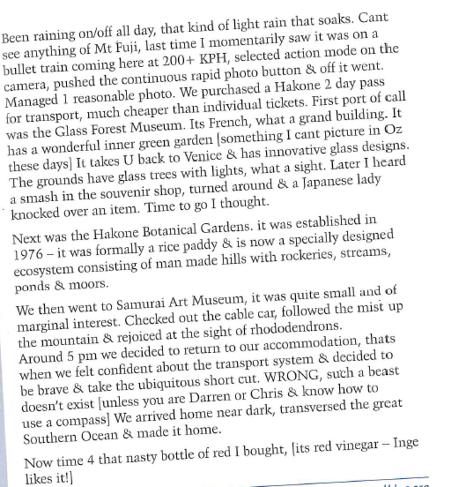

**Text 9:**

**Text C** is a letter sent home during the Crimean War in 1854.

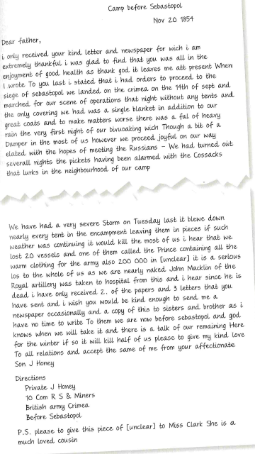

**Text 10:**

**Text D** is an email written during the Iraq War in 2003.

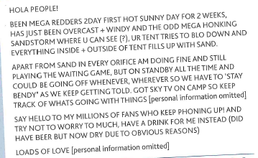

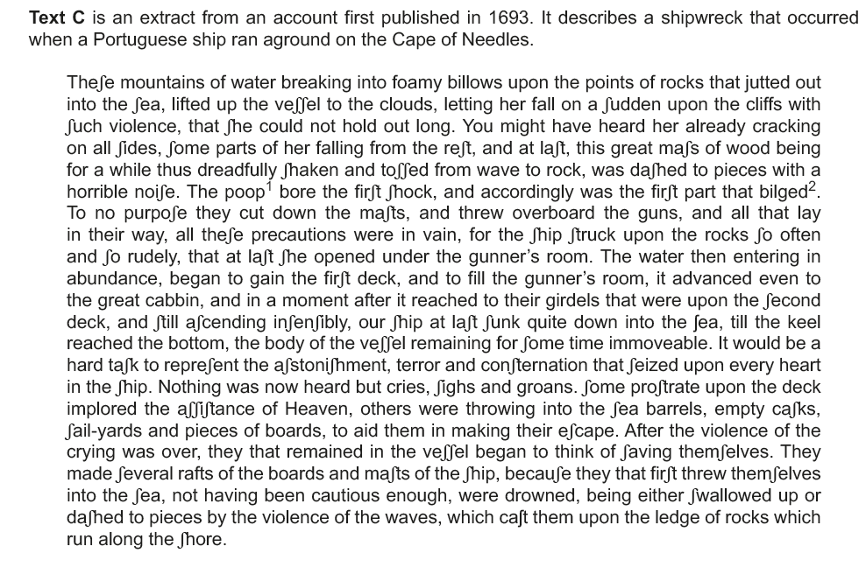**Text 11:**

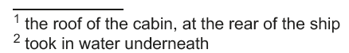

**Text 12:**

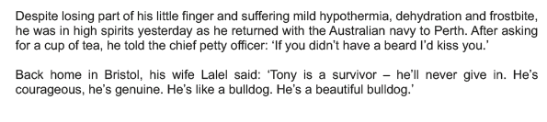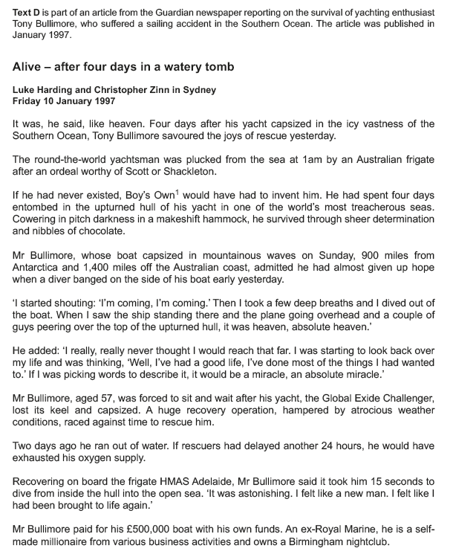



**Text 13:**

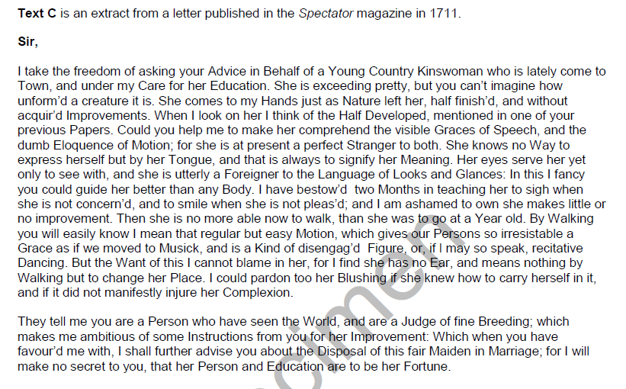

**Text 14:**

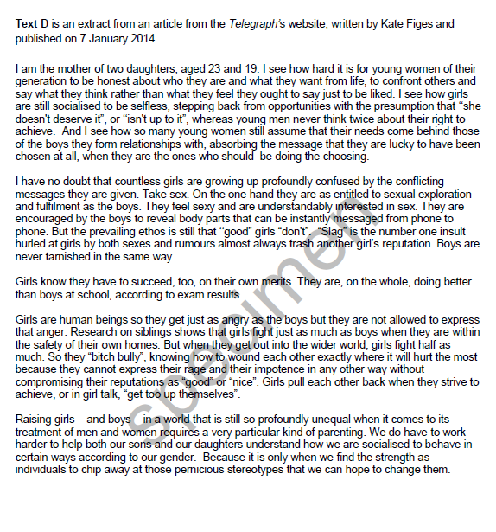

**Text 15:**

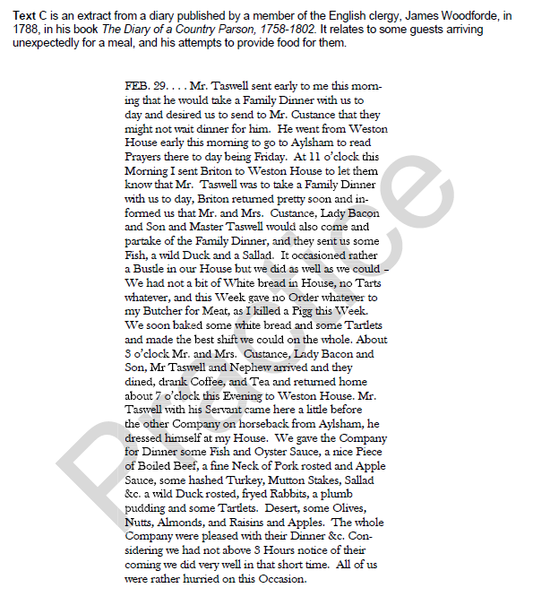

**Text 16:**

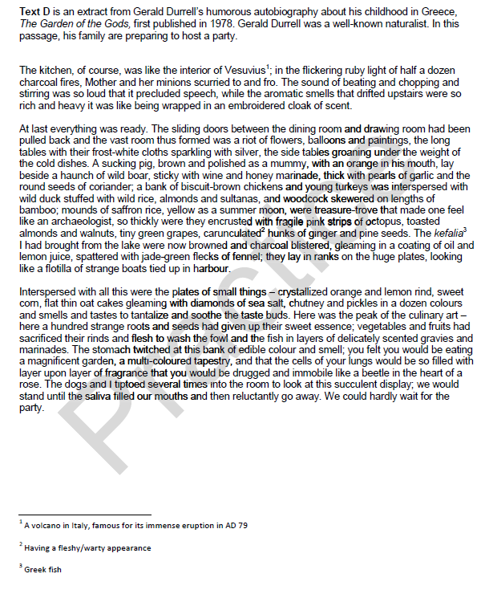

**Text 17:**

**Text C** is an extract from an etiquette guide written in 1703 called ‘*The Rules of Civility; or, The Maxims of Genteel Behaviour’*.

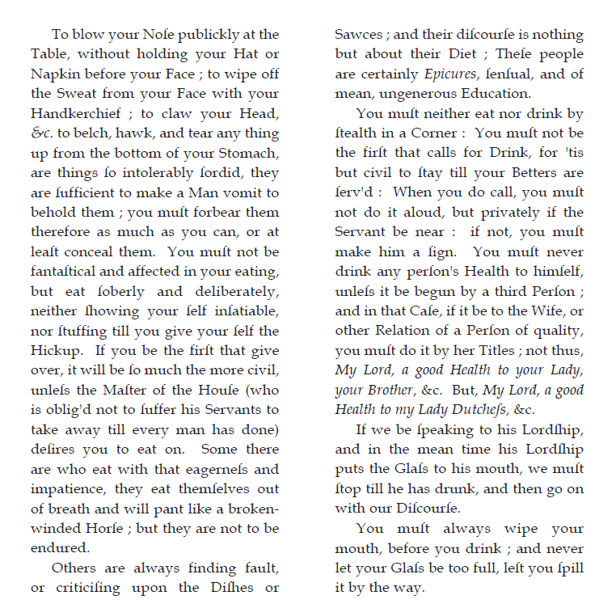

**Text 18:**

**Text D** is an extract from an etiquette guide produced in 1896 called ‘*Social Etiquette or Manners and Customs of Polite Society*’.

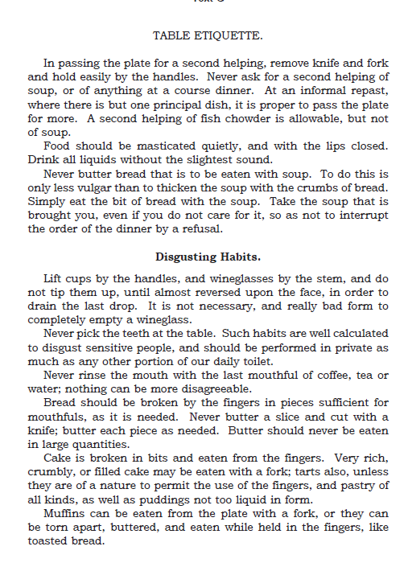

**Text 19:**

**Text C** is from ‘*How To Dance. A Complete Ball-Room and Party Guide*’ published in 1878.

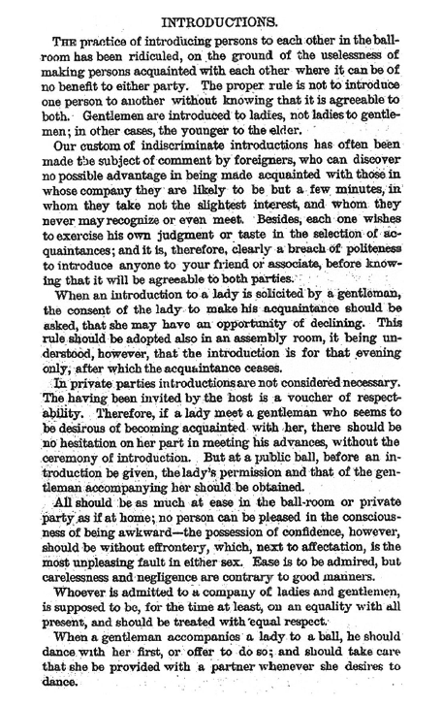

**Text 20:**

**Text D** is from an article, ‘Dancing to Romance’, from *The Boyfriend Book*, a girl’s annual, published in 1965.

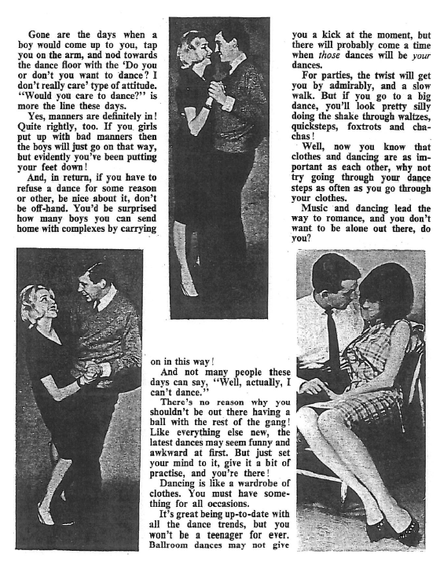

**Text 21:**

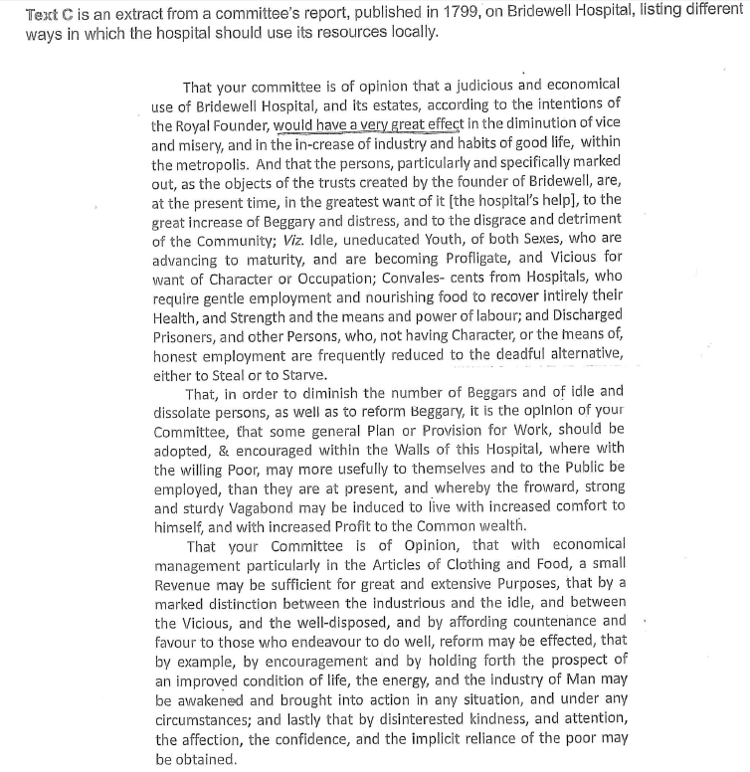

**Text 22:**

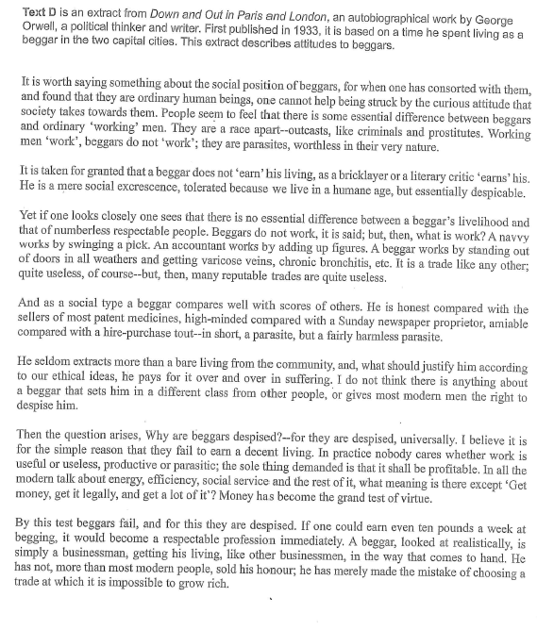

**Text 23:**

**Text C** is an advertisement produced for J. Sainsbury in 1894. The final paragraph of the original text is enlarged on the next page.

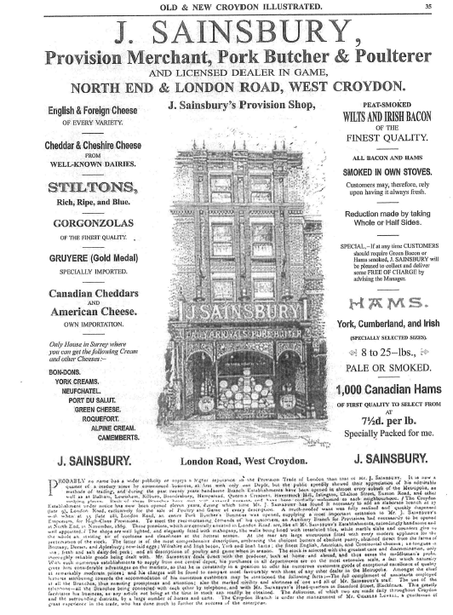

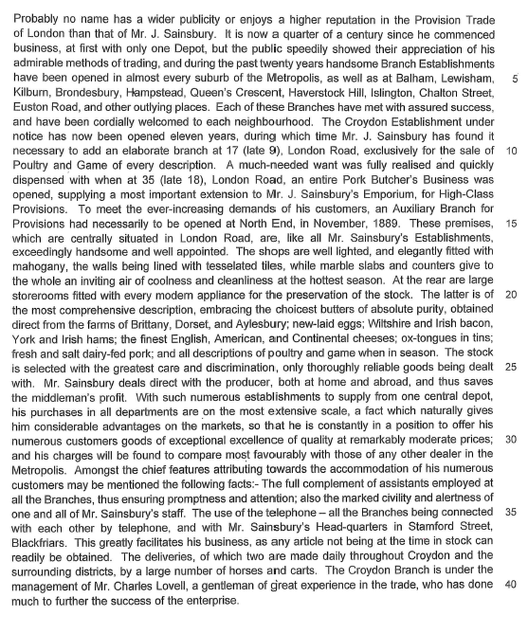

**Text 24:**

**Text D** is an advertisement from 1980 promoting the launch of a new Sainsbury’s store.

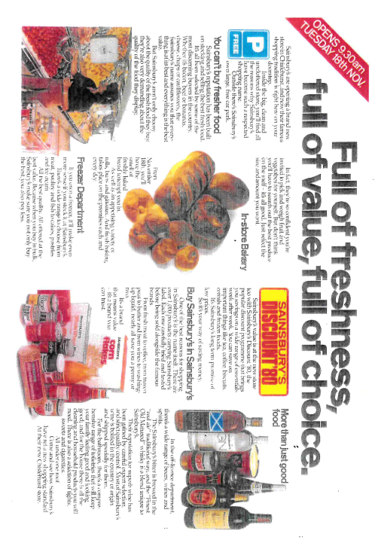

**Text 25:**

**Text C** is an extract from the rules of a school in London c.1892.

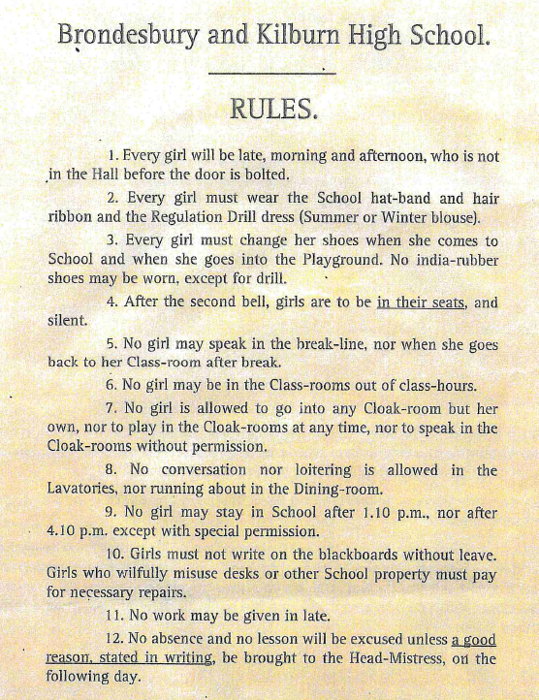

**Text 26:**

**Text D** is an extract from the student handbook of a sixth-form college in the UK in 2011.

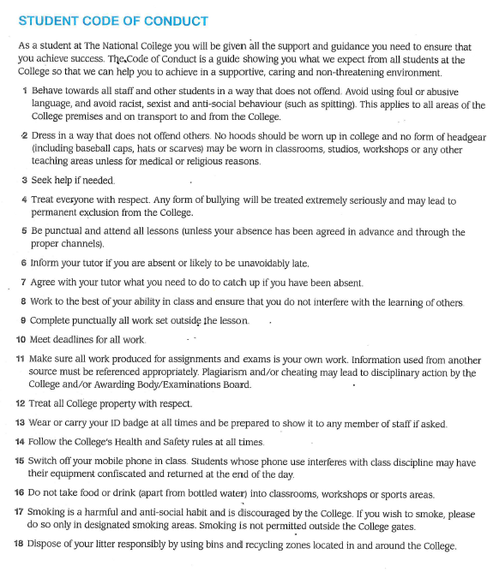

**Text 27:**

**Text C** is the opening of a pamphlet written in 1745 by a man only identified as A.W. Esq. entitled ‘*The Enormous Abomination of the Hoop-Petticoat, as the Fashion Now Is, and Has Been for about These Two Years Fully Display’d: In Some Reflexions Upon It, Humbly Offer’d to the Consideration of Both Sexes; Especially the Female*’. It continues onto the next page.

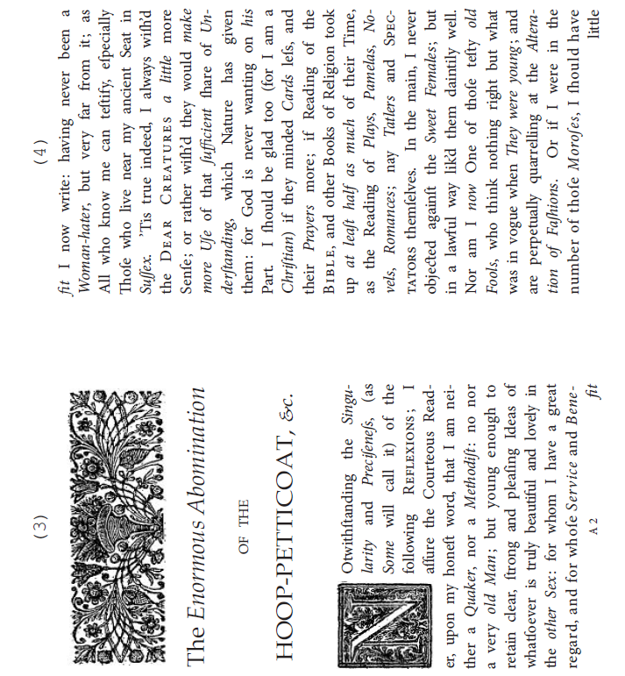

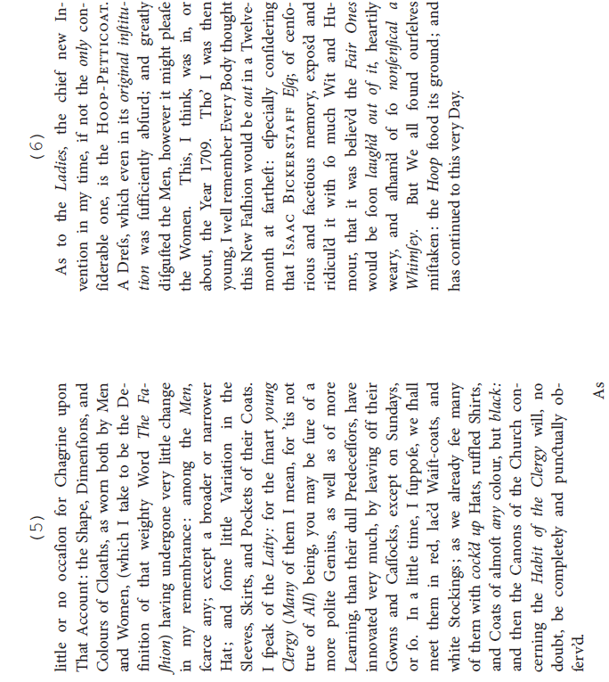

**Text 28:**

**Text D** is an extract taken from *Cosmopolitan* online concerning how well-catered plus size women are from British high streets. It was accessed in November 2018.

**An open letter to the British high street from plus-size women**



*By* [Laura Capon](https://www.cosmopolitan.com/uk/author/10319/laura-capon/)

Nov 29, 2018



As a size 22 woman, we haven’t always had the best relationship. I’ve called you out for failing plus-size women and you’ve made it virtually impossible for me – or the average British woman who is a size 16 - to buy clothes that aren’t office-inappropriate kimonos. But I’ve heard that you’re going through a hard time and I wanted to reach out.

Profit warnings, shop closures, job losses, your outlook might look bleak, but it’s not too late to change. **You see, it’s not that I don’t want to give you my money, far from it**. Hell, the amount of times I’ve pounded your pavements in desperation only to pay £10 for ASOS same day delivery says it all.

I live in London, I work a stone’s throw away from Oxford Street, so how is it that on the world’s busiest shopping street there are literally three shops I can actually buy clothes from?! Three shops out of three hundred. **There’s a reason why 45% of plus-size shoppers buy their clothes online…**

**Some of you have tried, I’ll give you that.** You’ve launched plus-size collections full of clothes that could masquerade as beach cover ups, that none of us actually want to wear. But you tucked them away at the back of the store, out of sight, to further remind us that we are inferior to everyone else.

As model **Louise O’Reilly** points out, you’re not just hiding plus size ranges, you’re actively encouraging plus-size women to shop online instead. **“More stores are cutting back and saying you can only buy online now, even from a size 18. What happens if plus size women have a last-minute fashion dilemma? There are very few places to turn to when it comes to a physical store and this causes stress and anxiety.”**

That might sound dramatic, but I’m sure everyone can relate to that ‘I have nothing to wear’ feeling. The difference is that for plus-size women like me, not only do we have nothing to wear, we have nowhere to shop. That feeling of isolation can’t be good for anyone.

(section omitted)

The thing is, I don’t really want to write this letter. I don’t want to have to tell the entire Internet that it’s a genuine struggle for me to buy clothes. **I just want to have a wardrobe as good as my smaller sized friends.** So I’m asking if you can finally make plus-size women your priority, instead of an afterthought.

We want the same clothes as everybody else, in bigger sizes, available in store. **It’s not enough to create a diverse marketing campaign if you can’t actually cater to the women it was intended for.**

**Text 29:**

**Text C** is taken from Henry Mayhew’s book *London Labour and the London Poor*, a compilation of his articles about the conditions poor Londoners were living in that first appeared in *The Morning Chronicle* in the 1840s.

**Gambling of Costermongers.**

It would be difficult to find in the whole of this numerous class, a youngster who is not - what may be safely called - a desperate gambler. At the age of fourteen this love of play first comes upon the lad, and from that time until he is thirty or so, not a Sunday passes but he is at his stand on the gambling ground. Even if he has no money to stake, he will loll away the morning looking on, and so borrow excitement from the successes of others. Every attempt made by the police, to check this ruinous system, has been unavailing, and has rather given a gloss of daring courage to the sport, that tends to render it doubly attractive.

If a costermonger has an hour to spare, his first thought is to gamble away the time. He does not care what he plays for, so long as he can have a chance of winning something. Whilst waiting for a market to open, his delight is to find out some pieman and toss him for his stock, though, by so doing, he risks his market-money and only chance of living, to win that which he will give away to the first friend he meets. For the whole week the boy will work untiringly, spurred on by the thought of the money to be won on the Sunday. Nothing will damp his ardour for gambling, the most continued ill-fortune making him even more reckless than if he were the luckiest man alive.

Many a lad who had gone down to the gambling ground, with a good warm coat upon his back and his pocket well filled from the Saturday night’s market, will leave it at evening penniless and coatless. The coldest winter’s day will not stop the Sunday’s gathering on the river-side, for the heat of play warms them in spite of the sharp wind blowing down the Thames. If the weather be wet, so that the half-pence stick to the ground, they find out some railway-arch or else a beer-shop, and having filled the tap-room with their numbers, they muffle the table with handkerchiefs, and play secretly. When the game is very exciting, they will even forget their hunger, and continue to gamble until it is too dark to see, before they think of eating. One man told me, that when he was working the races with lemonade, he had often seen in the centre of a group, composed of costers, thimble-riggers and showmen, as much as 100*l.* on the ground at one time, in gold and silver. A friend of his, who had gone down in company with him, with a pony-truck of toys, lost in less than an hour his earnings, truck, stock of goods, and great-coat. Vowing to have his revenge next time, he took his boy on his back, and started off on the tramp to London, there to borrow sufficient money to bring down a fresh lot of goods on the morrow, and then gamble away his earnings as before.

It is perfectly immaterial to the coster with whom he plays, whether it be a lad from the Lambeth potteries, or a thief from the Westminster slums. Very often, too, the gamblers of one costermonger district, will visit those of another, and work what is called “a plant” in this way. One of the visitors will go before hand, and, joining a group of gamblers, commence tossing. When sufficient time has elapsed to remove all suspicion of companionship, his mate will come up and commence betting on each of his pals’ throws with those standing round. By a curious quickness of hand, a coster can make the toss tell favourably for his wagering friend, who meets him after the play is over in the evening, and shares the spoil.

**Text 30:**

**Text D** is comes from an online article from *The Guardian* dated August 24th 2017.

**Number of UK Gamblers Rises to over 400,000**

[[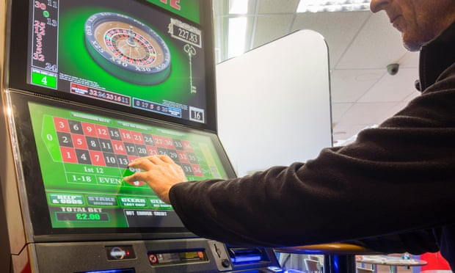](https://www.theguardian.com/society/2017/aug/24/problem-gamblers-uk-gambling-commission-report#img-1)](https://www.theguardian.com/society/2017/aug/24/problem-gamblers-uk-gambling-commission-report" \l "img-1)

Photograph: Alamy Stock Photo

Campaigners have urged a crackdown on gambling on fixed-odds betting terminals, which allow punters to bet £100 every 20 seconds.

More than 2 million people in the UK are either problem gamblers or at risk of addiction, according to the industry regulator, which warned that the government and industry were not doing enough to tackle the problem.

[The report by the Gambling Commission](http://www.gamblingcommission.gov.uk/PDF/survey-data/Gambling-behaviour-in-Great-Britain-2015.pdf) estimated that the number of British over-16s deemed to be problem gamblers had grown by a third in three years, suggesting that about 430,000 people suffer from a serious habit.

It also found evidence of an increase in addiction among those playing controversial [fixed-odds betting terminals](https://www.theguardian.com/uk-news/fixed-odds-betting-terminals-fobts) (FOBTs), which [have been criticised](https://www.theguardian.com/commentisfree/2017/aug/19/a-stupid-gamble-on-evil-machines) for allowing betting shop customers to spend up to £100 every 20 seconds.

Earlier this year, the government [delayed a report on whether to curb FOBTs](https://www.theguardian.com/society/2017/jun/30/fixed-odds-betting-terminal-review-delayed-until-autumn) and limit the [spread of gambling ads](https://www.theguardian.com/society/2016/jul/15/betting-firms-spent-half-a-billion-pounds-on-tv-adverts-since-2012) on television.

With the Department of Culture, Media and Sport not due to publish its recommendations until October, [Gambling](https://www.theguardian.com/society/gambling) Commission executive director Tim Miller warned that neither the government nor the gambling industry were moving fast enough.

“We have a clear commitment to make gambling fairer and safer and these figures show that this is a significant challenge,” he said. “Success will depend upon us, the industry, government and others, all working together with a shared purpose to protect consumers.”

The Gambling Commission’s report, which has taken nearly two years to collate and charts gambling addiction up to 2015, found that the rate of problem gambling rose to 0.8% of over-16s [from 0.6% in 2012](http://www.gamblingcommission.gov.uk/PDF/survey-data/Gambling-behaviour-in-England-and-Scotland-Findings-from-the-Health-Survey-for-England-2012-and-Scottish-Health-Survey-2012.pdf).

That suggests an increase of more than 100,000 in the number of problem gamblers to 430,000, although the commission described the rate as “statistically stable”. The overall number of people in danger rises to more than 2.3 million when including 2 million people deemed to be at low or moderate risk of addiction.