[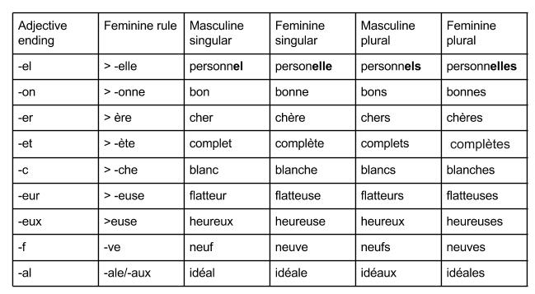](http://lecoursdefrancais.weebly.com/uploads/2/1/8/6/21864886/98721_orig.jpg)

[](http://lecoursdefrancais.weebly.com/uploads/2/1/8/6/21864886/98721_orig.jpg)