**Name:**

**Urban Forms**

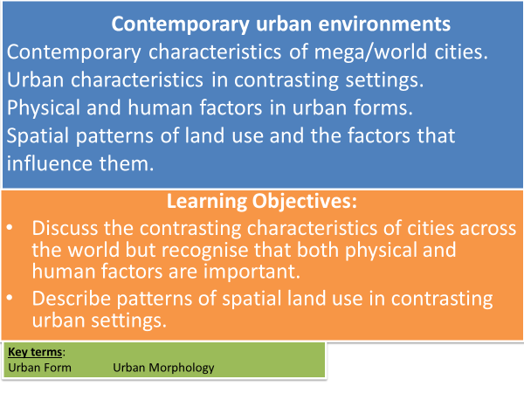

**Key Terms**

* **Urban form** is the physical characteristics of built-up areas including the **shape**, **size**, **density** (of population) and make-up or **configuration** of settlements.
* **Urban morphology:** the spatial structure and organisation of an urban area.

**TASK: What factors were relevant in the siting of towns and cities?**

**Physical Human**

* **Are these factors still relevant today?**
* **Have Human factors become more relevant?**

**Land Values**

* Main factor affecting land-use is land value.
* Traditionally higher in the centre of a city – high accessibility
* Peak Land Value Intersection (PLVI) – point with the highest land value. Land prices decline in line with the theory of distance decay.

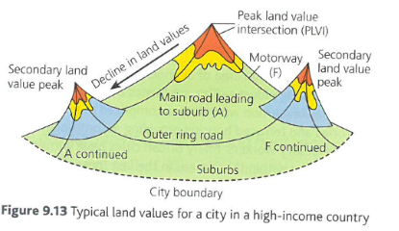

**Main land-use zones in a city**

**TASK: Complete the following.**

* **Suggest where each of the land-use zones is located in a city.**
* **Suggest what is found in each of the land-use zones and why.**
* Central Business District (CBD)

* Inner City
* Residential
* Green Areas
* Out of town retail developments
* Business or Science Parks
* Industry
* Informal Settlements

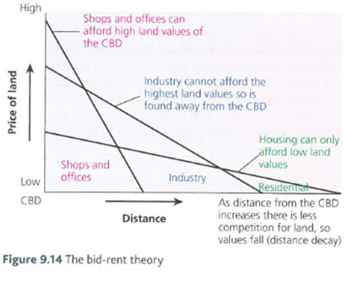

**The Bid Rent Theory**

The location of urban land uses is determined by the willingness to pay high prices for central locations and reliance on accessibility.

**Urban form will change over time in response to several factors:**

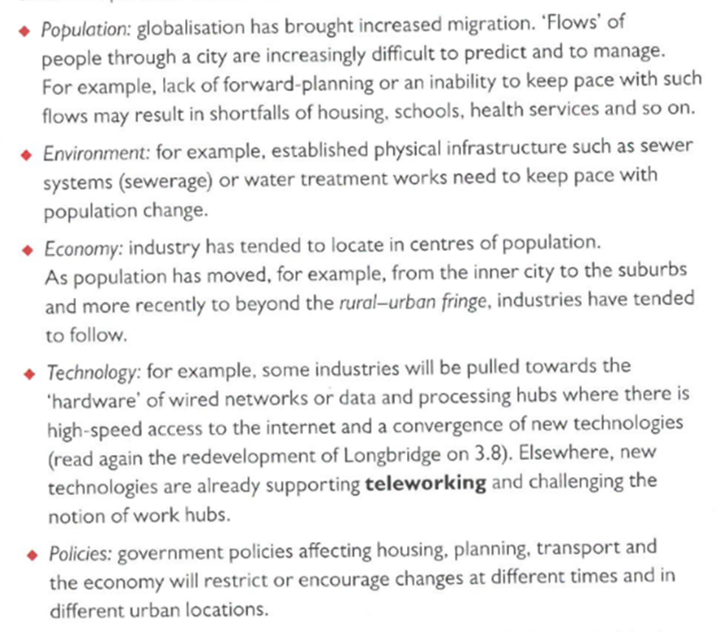

**TASK: Use the information on Urban Form on the previous page to help answer the questions on Mumbai, Los Angeles and London below.**

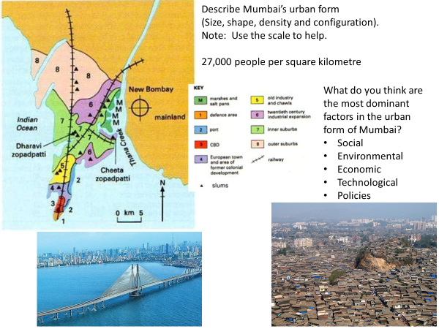

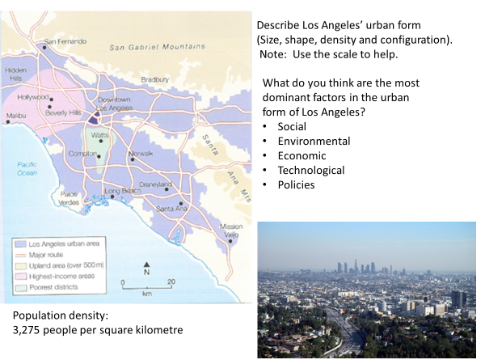

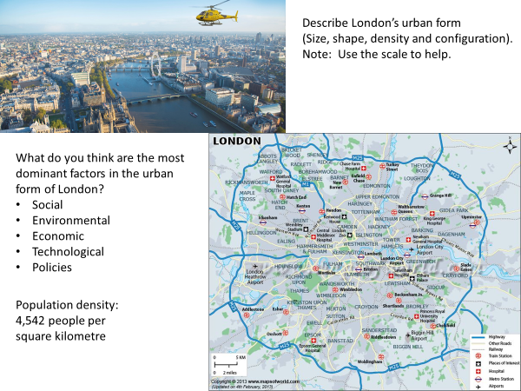

**TASK: Answer the exam-style question on a separate piece of paper.**

* **‘Using examples, evaluate the factors responsible for urban form.’ (9 marks)**

**Homework/flipped learning**

Read Hodder textbook p 394-398 and produce a mind map/notes on New Urban Landscapes under the following headings: - Changes in the city centre

* + Town centre mixed development
  + The development of cultural and heritage quarters
  + Gentrified areas
  + Fortress landscapes
  + Edge cities
  + The concept of the postmodern western city.