**Name:**

**Urban Waste**

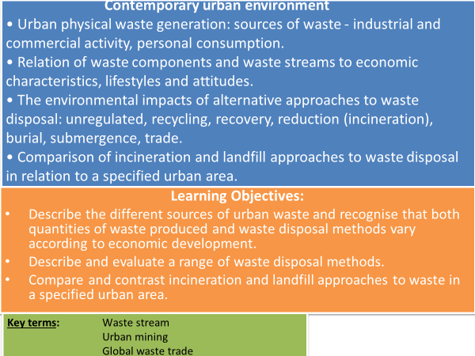

**Key Terms**

* **Waste stream –** the complete flow of waste from its source through to recovery, recycling or final disposal.
* **Urban mining –** the process of recovering compounds and elements from products, buildings and waste which would be left to decompose in landfills.
* **Global waste trade –** the movement of waste between and within countries.

**Urban Waste Generation**

**TASK: Use your pre-work to answer: What has caused the amount of waste produced to increase?**

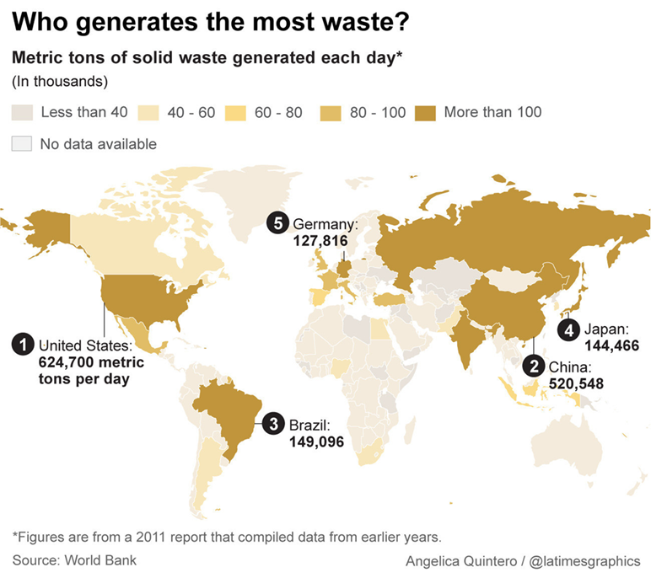

**TASK: Describe and suggest reasons for the pattern shown by the map.**

**Urban waste generated by income level and year**

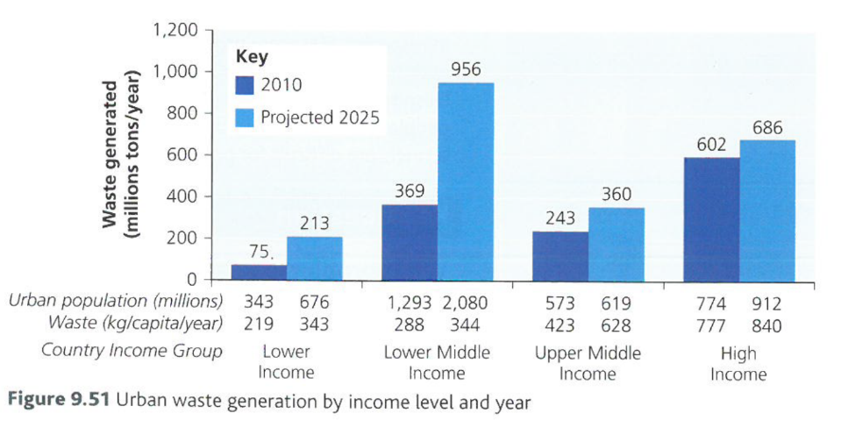**TASK: Analyse the graph. (PADL)**

**Generators and types of solid waste**

**TASK: Use your pre-work to answer: What are the sources of global waste?**

**TASK: Use your pre-work to fill in the blanks.**

* Urban waste is made up of _____________ separate waste items.
* Some larger waste items, ____________ (food and horticultural waste) and _________ are easier to manage.
* Waste such as multi laminates, hazardous (e.g. syringes) and e-waste pose large __________ for disposal.
* Particularly concerning for _____________ counties where they may not have the facilities to properly dispose of them safely.
* As countries ________ consumption of inorganic materials increase.
* Generally low- and middle-income countries have a ____ percentage of organic matter 40-85% of the total urban waste stream.

**organics numerous high develop paper problems low-income**

**TASK: Use your pre-work to answer: What are the impacts of increasing waste generation?**

**Approaches to waste management**

The flow of waste from source to recovery, recycling of final disposal is a **waste stream.**

**TASK: Use the words below to fill in the blanks under ‘Waste management options’.**

**Reuse Recover Dispose Reduce**

|  |  |
| --- | --- |
| **Waste management options** | **How it works** |
| 1. _______________ the amount of waste | * ________________ could think more carefully about the lifespan of goods and about how much packaging is essential. * ________________ could consider the issues of packaging and lifespan when making purchasing decisions. |
| 1. ________________ goods to extend their lifespan | * _________ ________ where containers are refilled – such as milk bottles. * __________________________ goods to extend their useful life. * ________ _________ being put to another use rather than being thrown out – e.g. plastic bags being used as bin liners and old clothes being used as cleaning cloths. * _________________ providing a place for goods to be passed on to new owners. |
| 1. ________________ value | * _________________ goods such as glass bottles and paper. * _________________ biodegradable waste for use as fertiliser. * _________________ of waste and collecting electricity and sometimes heat from it. |
| 1. ________________ of waste in landfill sites | * ______________ is put into a hole, which can be natural or the result of quarrying, or used to make artificial hills. |

**Use the words below to fill in the blanks under ‘How it works’.**

Recycling Waste Refurbishing/reconditioning

Charity shops Incineration (burning) Used goods Consumers

Composting Bring-back schemes Producers

**The Waste Hierarchy**

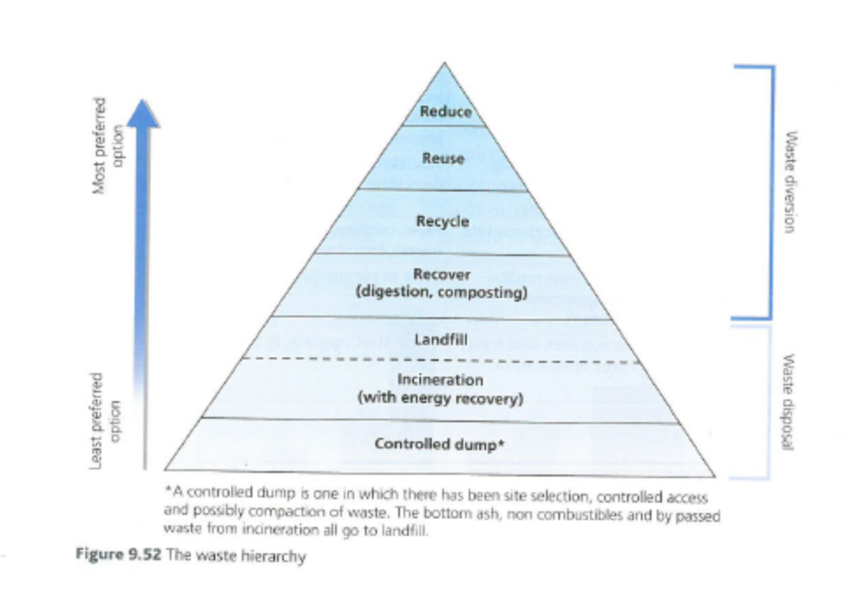

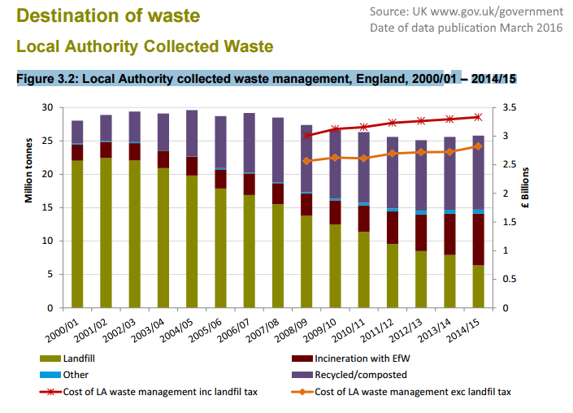

**TASK: Describe the destination of waste in England from 2000-2015 – quote and manipulate figures in your answer.**

**TASK: Watch video clips and make notes:**

Norway’s bottle recycling scheme[**http://www.bbc.co.uk/news/science-environment-42953038**](http://www.bbc.co.uk/news/science-environment-42953038)

UK faces build-up of plastic[**http://www.bbc.co.uk/news/business-42455378**](http://www.bbc.co.uk/news/business-42455378)

**TASK: Answer the following:**

Suggest reasons for the statements below:

* On average, people in HICs produce 10 to 30 times more waste than those in LICs.
* Waste generation globally is growing exponentially.

Use your pre-work to outline the political, economic, social and environmental arguments for reducing landfill, but increasing recycling and incineration.

**CASE STUDIES**

**Waste management Mumbai, India**

**Link to case study notes on social and economic issues in Mumbai.**

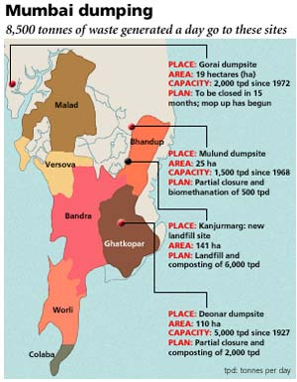

* Mumbai produces 7,500 metric tonnes of waste every day
* There is no comprehensive city based system of collection and this waste poses a hazard to human health.
* The slum of Dharavi has a recycling zone.
* It is claimed that Dharavi’s recycling zone could be the way forward to a sustainable future.
* Everything is recycled from cosmetics and plastics to computer keyboards. 23% of plastic waste gets recycled in the UK, in Dharavi it is 80%.
* Despite this Mumbai still has major problems getting rid of its waste.

In January 2016, fire raged in the largest landfill in the Indian city of Mumbai.

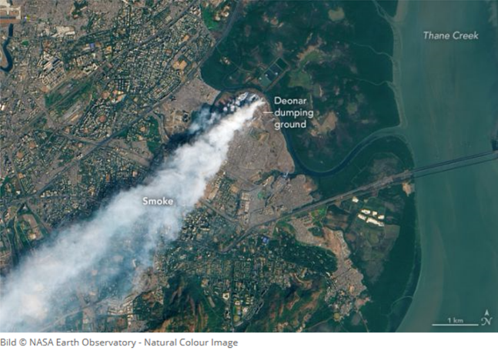Located in an eastern suburb, the Deonar dumping ground stretches across 132 hectares (326 acres) near Thane Creek.

It receives more than 3,700 metric tons (8.1 million pounds) of trash per day, about one-third of the city’s waste. With piles of trash that rise up to 30 meters (100 feet) tall—the equivalent of a nine-story building—the landfill has literally become a mountain of trash.

**TASKS: Watch the clips and make notes on why waste is an issue in Mumbai and how it is being managed. Quote specific facts and figures in your notes.**

<https://www.youtube.com/watch?v=yUY7wwdZCvg>

<http://www.youtube.com/watch?v=QtHi6ewEiD8>

<http://www.bbc.co.uk/news/world-asia-17254642>

**Landfill v Incineration – Amsterdam Case Study**

**TASK:** Watch the video clip and make notes on waste management in Amsterdam.

[**https://www.youtube.com/watch?v=luf86Jwsjs0**](https://www.youtube.com/watch?v=luf86Jwsjs0)

**Semakau Landfill – Waste management in Singapore**

**TASK:** Watch the video clip and make notes on waste management in Singapore.

[**https://www.bing.com/videos/search?q=singapore+semaku&&view=detail&mid=BE15CA68B61C37440D21BE15CA68B61C37440D21&&FORM=VRDGAR**](https://www.bing.com/videos/search?q=singapore+semaku&&view=detail&mid=BE15CA68B61C37440D21BE15CA68B61C37440D21&&FORM=VRDGAR)

**TASK: Read the Hodder text book (p424-425) on Amsterdam (The Netherlands) and PowerPoint slides on Singapore on GOL to complete the following *using separate paper:***

* Why is waste management a problem for?
  + Amsterdam, The Netherlands (Hodder textbook)
  + Singapore (video clip and PowerPoint slides)
* Describe and evaluate the success of the waste management system in:
  + Amsterdam, The Netherlands (Hodder textbook)
  + Singapore (PowerPoint slides)
* Watch the clip - <https://www.youtube.com/watch?v=nPHzg0cHdtw>
  + How does this information contrast with the article? Use to re-evaluate Singapore’s success?

**Extension Task: Read extract on the circular economy below (Oxford text book p249).**

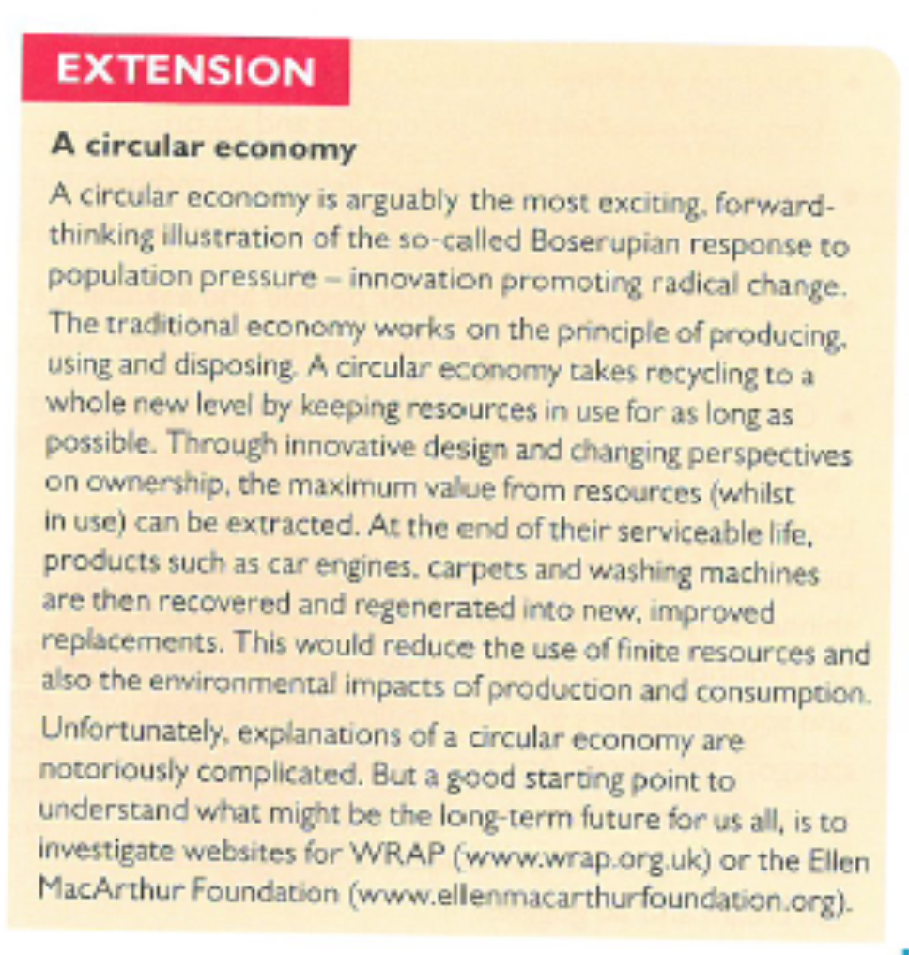**To what extent could the circular economy be a way forward in addressing environmental issues associated with urbanisation?**

**Exam Style Question**

Evaluate the extent to which government strategies can improve waste disposal. (9 marks)

**Pre-work/Flipped learning**

* Using pages 427-429 in the Hodder textbook produce a mind map/notes identifying:
  + Causes of water pollution
  + Consequences of water pollution
  + Strategies to manage water pollution