Welcome to The PE & Sport Department!

The PE and Sport department at Godalming College has an excellent tradition in terms of academic successes, high performance achievements and high levels of recreational participation.

The department values all aspects of involvement, whether it is high levels of academic success, international level performance or a student who takes up an activity for the first time. If you wish to get involved in sport already offered or to organise something different, then speak to one of the members of the department who will be happy to help.

We hope you enjoy your time with us and develop your ability to work and play hard.

The PE Department
Who are we?

Physical Education Staff

Mr Danny Bonney (Head of Department)

Mr Kevin Broad

Mrs Kelly Hill

Mrs Ruth Jones

Mr Neil Winstone

Amy Johnson

Seb Jefferies (Gym Instructor).

How to contact us

The staff will spend most of their time in the PE office in the Sports Centre. The direct line telephone number is 01483 411226 or 411282. You can also use email to contact us.

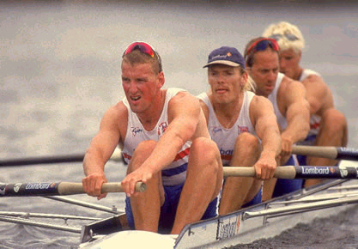
Our Aim

The aim of The PE, Sport & Leisure Department is:

To provide a broad, balanced and challenging introduction to a wide range of physical education theory and application.
To provide opportunities to develop skills of analysis, interpretation, and evaluation, encouraging students to extend and challenge their own thinking.
To encourage students to take responsibility for their own learning in order that they become self-motivated and effective learners.
To enable each student to evaluate their own progress and achievement.
To provide opportunities for students to consider sports knowledge and ideas in the context of:
Each student’s own practical experience
Current social issues
Its role in our own and others societies
Other academic disciplines e.g. Leisure and Biology
Future Careers
To provide equality of opportunity and individual support in order that effective academic and personal development can occur.
To maintain as high a level of physical activity as possible through encouragement to participate in college clubs and through the practical elements of the course.

How to use this guide

This student guide to the BTEC First Award in Sport is intended to give background information which we hope will be of use to students studying the subject. It includes policies, expectations, resources and general information as well as working documents, which will be needed during the course.

This booklet should be placed in your file, read, referred to and used throughout your course. There are essential documents, which will need to be used as the course progresses and which must be available at all times.

You will also find a copy of the subject specifications and an outline of what you will be studying and when on The BTEC Sport page of Godalming Online.

What you can expect from us!

- Teachers that have up to date and well developed subject knowledge.
- Teachers that treat you as adult human beings (unless you demonstrate you are not!)
- Informative and well presented learning materials that follow the syllabus precisely.
- A range of learning / teaching styles that try to make the experience as positive as possible. These will include:
  - Teacher lead sessions
  - Whole group discussions
  - Small group/partner work
  - Presentations
  - Use of videos
  - Task centred approaches
  - Practical approaches to theoretical areas
  - Use of ILT in the classroom

How will we support you?

- Your progress will be monitored throughout the course with feedback from homework, coursework and unit tests.
- You will receive a one on one tutorial at least once a term to check how you are doing and to discuss the problems you are encountering. This will be done with the PE teacher who teaches you most. You can of course choose to talk to your preferred member of staff.
- This process will initially involve the teaching staff, but should you require further action or support, the Head of Department will become involved either at your request or that of the staff member.

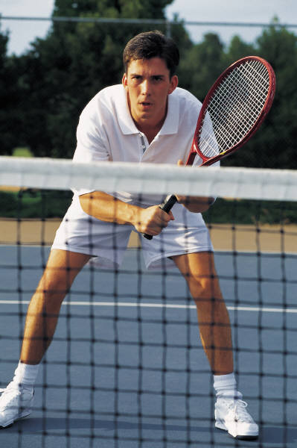
Practical Lessons

Our expectations of you are just as high in practical lessons. We expect you to wear suitable PE kit which should be a white polo shirt with navy or black shorts / tracksuit bottoms. The correct footwear is vital in the reduction of injury and further advice will be issued if necessary.

It is impossible to develop all skills to the highest level in 1-2 hours a week. For this reason you must work on your practical choices in your own time and the joining of sports clubs in and out of college is vital. Remember, you will have to perform in one team sport and one individual.

Health and safety procedures must be followed at all times. A copy of the health and safety policy is included in this guide.

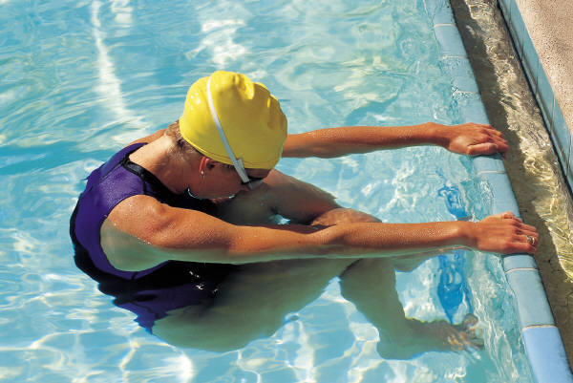

Progression Routes

Students completing the BTEC First Award in Sport successfully will be able to progress to level 3 courses such as the BTEC Nationals in Sport or AS / A2 Physical Education.

The course will also help prepare you for a career in the sport, recreation and fitness field and help in studying national governing body coaching awards.



Coursework

Some units are assessed by your staff at college and then verified by an external verifier. Your work will be assessed by a range of written coursework, video evidence, teacher and coach observations. All coursework must be submitted by the deadline given to you by the staff. Extensions will not be granted unless there are exceptional circumstances. This will usually require medical certification to be produced.

You will receive assignment briefs (including the deadlines) and weekly task sheets with a checklist of tasks to complete. You will also receive advice on how the tasks that you complete match the grading criteria for the unit.
What we expect from you!

We expect you to:
- Attend all lessons and tutorials.
- Bring with you all the equipment required to work. (Pens, paper, books etc.)
- Supply a note outlining any injury stopping practical performance.
- Bring appropriate kit for all lessons.
- Prepare fully for all assessments.
- Treat all others, as you would wish to be treated.
- Give everything your best effort!
- If you miss a lesson, we expect you to have caught up the work by the next lesson. This includes completing handouts and any assignment / homework that was set.

Please print off this page, sign below and bring with you to your first Sport lesson

Print name Signature

Plagiarism

What is plagiarism?
Plagiarism is attempting to pass off other people’s work and ideas as your own.
Plagiarism can include:
• copying from another learner copying from books or the internet
• paraphrasing
• subcontracting the work to someone else
• submitting the same piece of work for two different purposes

Why is plagiarism wrong?
• It is fundamentally dishonest
• Learners who commit plagiarism are seeking an unfair advantage over other
learners
• Learners who commit plagiarism are devaluing the value of the qualification
they seek
• It is disrespectful to their Assessors, and a betrayal of their trust

What are the consequences of plagiarism?
• Learners who commit plagiarism learn far less than those who do not
• Assessment procedures are compromised if the work submitted is not the
learner’s own
• Assessors are unable to form correct decisions on the progress of individual
learners
• It may result in legal action due to infringement of copyright laws
• It may be penalised by failure in one or more components of a course

• It could be unfairly interpreted

Health and Safety Policy

The department endorses the College Health & Safety Policy. The tutors will carry out risk assessments to maintain a safe working environment with minimum risk to the students and themselves. The presentation of the course topics is not normally associated with specific hazards but your tutors will brief you should the need arise. Any visits associated with your course are also covered by risk assessments.

Students have a duty of care and are expected to follow the general College Health & Safety guidelines displayed in set bases and in the student diary, to ensure their own safety and that of others.

Many sports by their very nature involve an element of danger. Both staff and students have a duty to minimise the risks involved.

Students are required to adhere to the following guidelines:

- Follow all instructions given by staff
- Wear appropriate clothing for the activity
- Where appropriate, wear the recognised safety equipment - Mouth guard etc.
- Act in a safe/mature fashion at all times
- Use all equipment as instructed
- Remove all jewellery
- Tie back long hair
- Report any faults with equipment immediately to a member of the PE department and stop using that piece of equipment immediately
- Report any injury to a member of the PE department
- Avoid behaviour likely to result in an injury
- The college fitness room may only be used by those who have undertaken an induction session or when supervised by a member of staff.

FAILURE TO FOLLOW THESE GUIDELINES OR BEHAVIOUR LIKELY TO ENDANGER STAFF OR STUDENTS WILL RESULT IN DISCIPLINARY ACTION.
Please print off this page, sign below and bring with you to your first Sport lesson.

Print name Signature

Equal Opportunities Policy

At Godalming College and within the department we aim to:

- Treat everyone with respect as an individual
- Create a climate in which students and staff feel valued and are encouraged to develop their skills, abilities, qualities and interests.
- Value the race, colour, gender, sexual orientation, social class, religion, culture, ability and age of every member of staff and student.
- Develop a community in which tolerance, respect, courtesy, sensitivity and understanding are encouraged.
- Encourage students and staff to achieve their potential and to raise their level of achievement.

We encourage these aims by:

- Offering students equal participation in academic, extra curricular and social activities;
- Using written and spoken language in ways which does not assume stereotypes and by applying rewards and sanctions impartially in a way which does not reinforce stereotypes.
- Using resource materials, where possible and appropriate, which make positive representations of race, colour, gender, social class, religion, culture, ability and age.
- Providing tutorial support appropriate to the learning needs of all students;
- Identifying and responding to the needs of students with disabilities and/or learning difficulties.
- Avoiding discrimination based on race, colour, gender, sexual orientation, social class, religion, culture, ability or age.

The Course

You will study the three units outlined below. Please look at the Unit Content and Grading Grid on Godalming Online for an in depth description of each unit.
Unit | Teacher | Assessment
Unit 1  Fitness for Sport & Exercise | Amy Johnson | Test
Unit 2  Practical Sports Performance | Amy Johnson | Practical/Officiating skills in 2 sports (and coursework
Unit 5  Training for Personal Fitness | Amy Johnson | Devising/  Carrying out then reviewing training programmes
Unit 6  Leading Sports Activities | Amy Johnson | Planning, leading and reviewing sports sessions.

One grade will be awarded at the end of the course and this will be pass, merit, distinction or distinction*. To achieve a pass overall, you must pass each unit.

Each unit will be awarded the following points depending on the grade received.

Grade | Points per Credit
Pass | 12
Merit | 18
Distinction | 24

Your overall grade is awarded based on the total number of points you achieve for the four units studied.

Points | Overall Grade
48-65 | Pass
66-83 | Merit
84-89 | Distinction
90-96 | Distinction*

Further information on grading will be given throughout the course.

