**Unit 3 Applying the Principles of Personal Training**

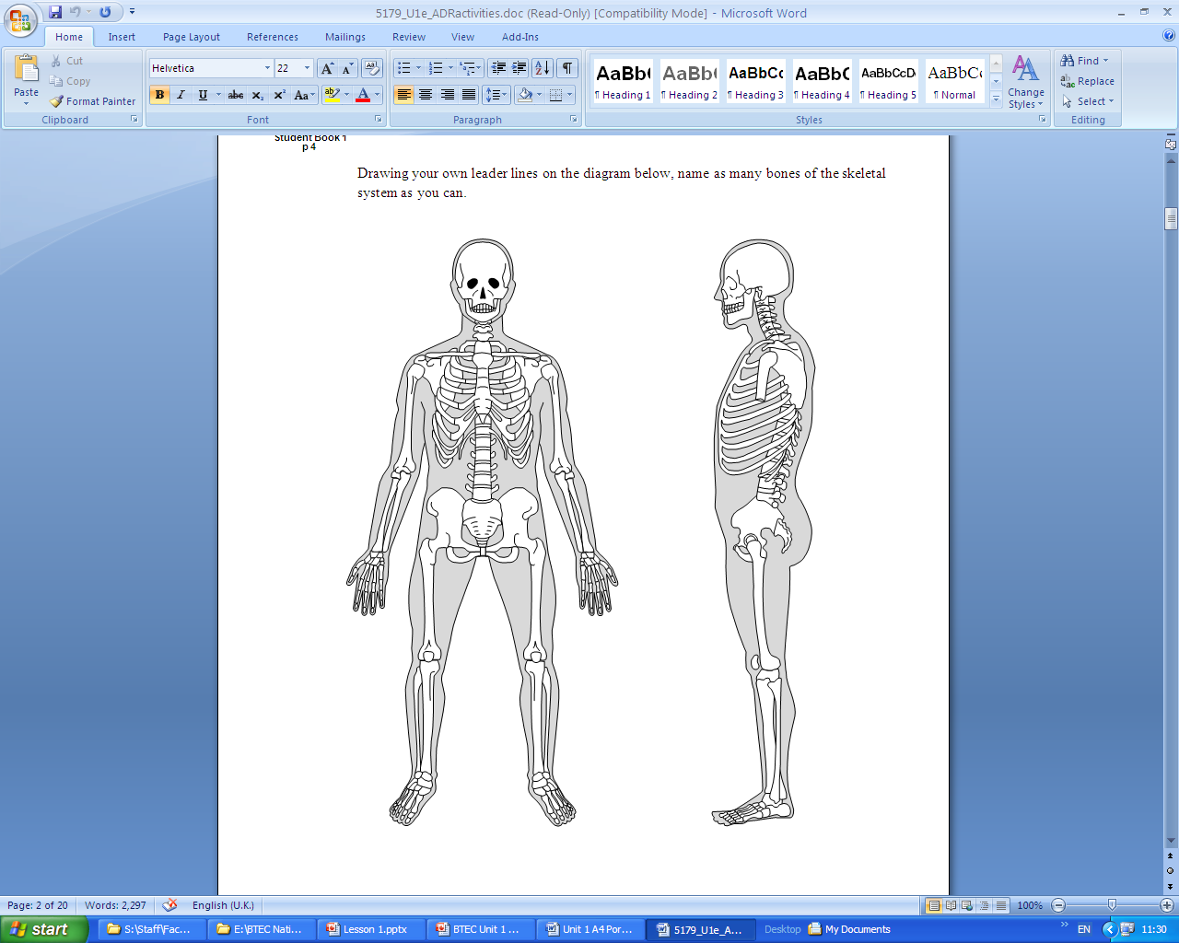**The Human Skeleton**

**Functions of the skeleton?**



**Joints**

What is the definition of a joint?

What is a synovial joint?

Please label the joint below and describe what each part does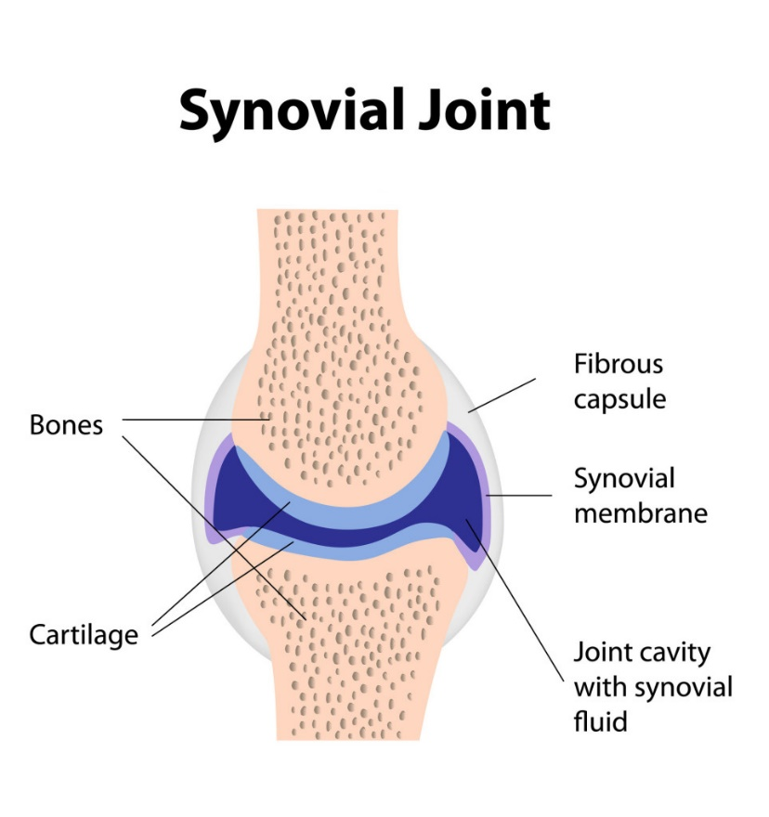

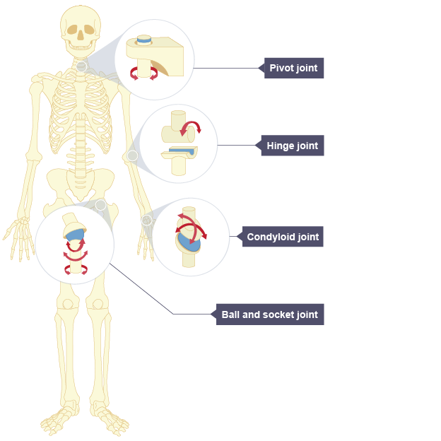

|  |  |
| --- | --- |
| **Type** | **Description and location** |
| **Hinge** |  |
| **Ball and Socket** |  |
| **Pivot** |  |
| **Condyloid** |  |

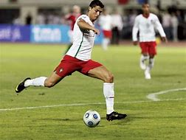**Synovial Joints in Action**

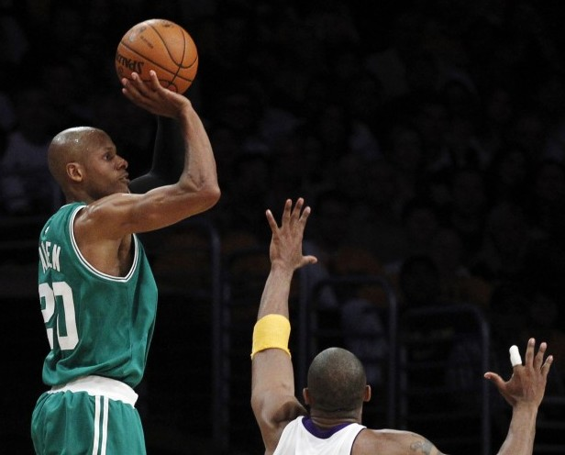

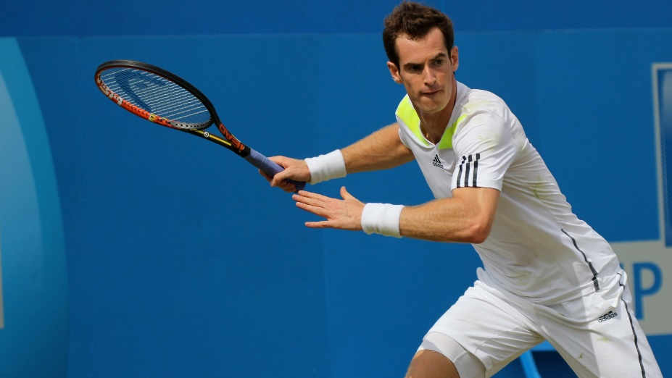

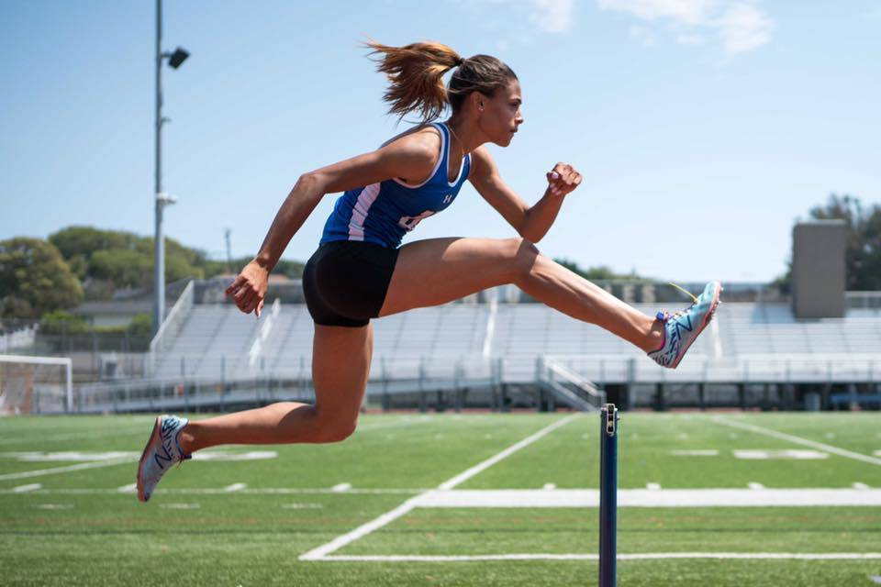

**The Musculoskeletal System**

OHT%205

**Short term effects of exercise on the musculoskeletal system**

What will happen to your body during your training sessions?

|  |  |  |
| --- | --- | --- |
| **Component** | **What Happens?** | **For each, state WHY** |
| Warm Up   1. Pulse Raiser 2. Stretches |  |  |
|  |  |
| Main Session |  |  |
|  |  |
| Cool Down   1. Lower Pulse 2. Stretches |  |  |
|  |  |

**The Cardiovascular System**

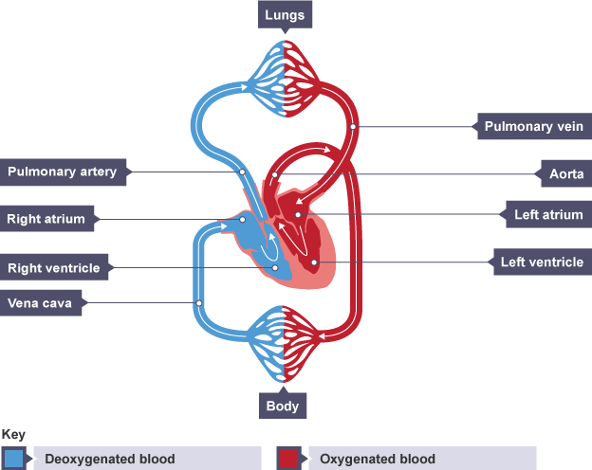

|  |  |
| --- | --- |
|  | **Description and Function** |
| Atria |  |
| Ventricles |  |
| Aorta |  |
| Vena Cava |  |
| Pulmonary Artery |  |
| Pulmonary Vein |  |

**What does each part of the heart do?**

**The Respiratory System**

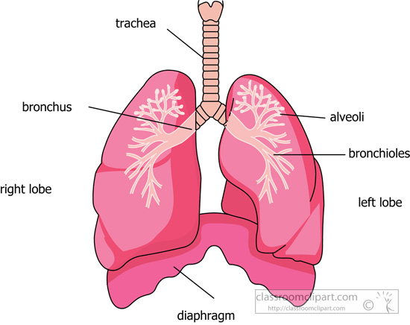

|  |  |
| --- | --- |
|  | **Description and Function** |
| Lungs |  |
| Trachea |  |
| Bronchus |  |
| Bronchioles |  |
| Alveoli |  |
| Diaphragm |  |

**What does each part of the respiratory system do?**

**Short term effects of exercise on the cardiorespiratory system**

What will happen to your body during your training programme?

|  |  |  |
| --- | --- | --- |
| **Component** | **What Happens?** | **For each, state WHY** |
| Warm Up  Pulse Raiser |  |  |
|  |  |
| Main Session |  |  |
|  |  |
| Cool Down  Lower Pulse |  |  |
|  |  |