Unit 6: Leading Sports Activities
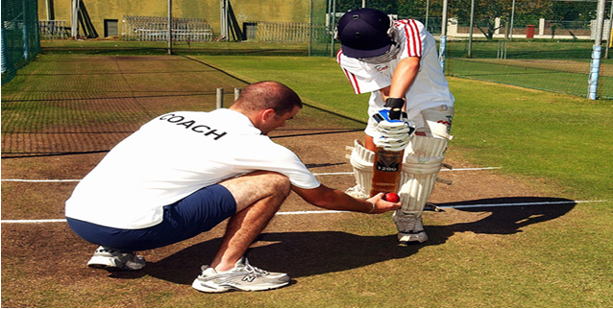

Task 1
Produce a PowerPoint presentation that can be used in a school assembly to show both students and teachers the key attributes and responsibilities needed by a successful sports leader and the reason why they need these characteristics. This presentation should include examples where relevant
Key attributes to include are:
- Skills- communication; organisation of equipment; knowledge
- Advanced Skills- activity structure; target setting; use of language; evaluation
- Qualities- appearance; enthusiasm; confidence
- Additional Qualities- leadership style; motivation; humour; personality
Key responsibilities to cover are:
- Core responsibilities- professional conduct; health and safety; equality
- Wider responsibilities- insurance; child protection; legal obligations; ethics and values; rules and regulations
- You must DESCRIBE what each is- define them.
- You must then EXPLAIN what is meant by each. Explain why an effective sports leader would require each attribute/responsibility- Give an example of why it would be important for a sports leader to possess, your example can come from any sports leader you like.

Task 2
You must now produce two posters that the sports department can display in their Sports Hall, to leave a lasting message from your assembly and provoke students to think of sports leaders that they have observed.
Undertake observations of 2 different sports leaders, either in person or from video, recording your observations and explaining relevant attributes of leadership. Identify strengths and areas for improvement. (Make sure you include relevant details of the leaders observed i.e. names, evidence used etc). You must pick at least 2 characteristics from each of the leadership attribute categories (skills, advanced skills, qualities and additional qualities).
Produce a colourful poster for each leader, introducing who they and describing and explaining each attribute that the leader possesses (as identified from your research). You must state what they possess and where/how you have seen them demonstrate it.
You must then evaluate the impact each attribute has on the success (or otherwise!) of the coach. Give an example of the EFFECT each skill/quality has on their ability to be a successful leader- how does it make them a good leader/how does it make them a poor leader?
Task 1 Template
