Unit 6: Leading Sports Activities
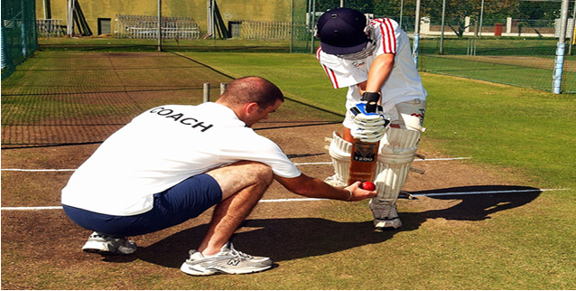

Task 3
Now that the students have been able to read your posters, they are curious to know how your two chosen sports leaders differ from each other. They want to understand the differences so that they can determine which aspects of sports leadership will be most successful for them in their sports.
Produce 2 extra posters to identify and explain similarities and differences between the 2 sports leaders that you have observed.
One poster should be on similarities
One poster should be on differences
You only need to analyse the attributes, so remember that these are:
- Skills- communication; organisation of equipment; knowledge
- Advanced Skills- activity structure; target setting; use of language; evaluation
- Qualities- appearance; enthusiasm; confidence
- Additional Qualities- leadership style; motivation; humour; personality
You must make sure you cover ALL of these as either a similarity or difference (or both if there are elements that are similar and elements that are different.)

