**September 2018 Induction homework:**

**Welcome to A-level PE!**

Complete the following instructions. Fill in the analysis sheet, print off and bring to your first PE lesson to hand in.

Instructions:

1. For A-level PE you will be assessed in one sport. Find the assessment criteria for your chosen sport from the specification on Godalming online. It will be divided into 3 assessment areas: AA1, AA2 and AA3.  It will look like this:

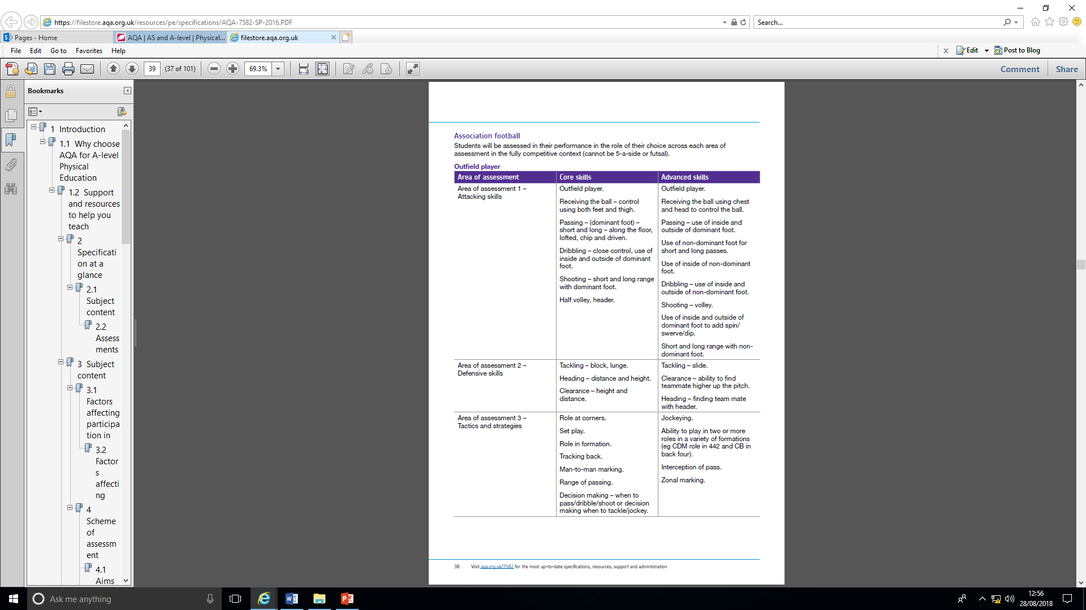

2. Select one of the Area of Assessment 2 skills from either the core or advanced skills listed for your sport.

3. Enter this skill into the AA2 analysis planning sheet (at the end of this document). Break down the skill into preparation (beginning), execution (middle) and follow-through (end) phases. You may want to find a coaching site or coaching manual to help you. This might look something like this:

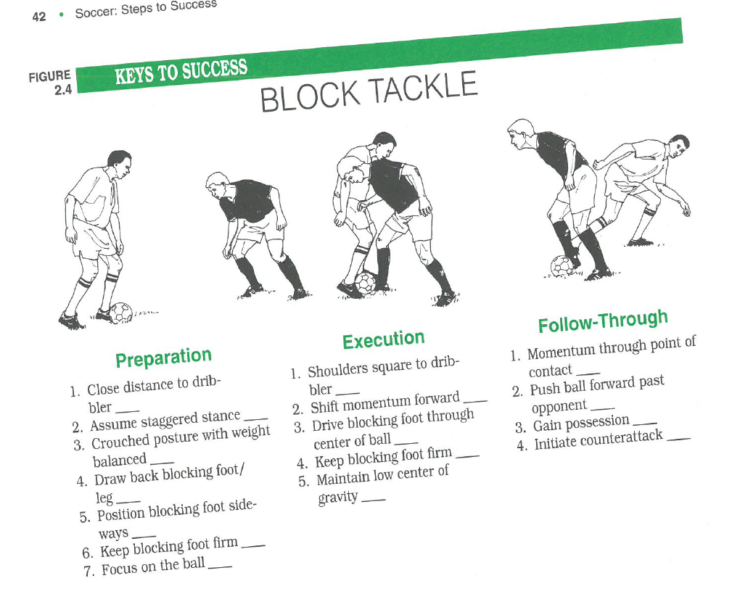

4. In your written coursework, you will be given credit for how well you highlight and explain your weaknesses. In the 2nd column, state what your main weaknesses are. In the 3rd column describe how your own performance differs from the perfect technical model (this is the ideal way to perform the skill that you might find in a coaching manual) for the skill. Then in the 4th column, explain the impact this weakness has on your overall performance.

|  |  |  |  |
| --- | --- | --- | --- |
| **Phase of skill** | **Weaknesses in my skill performance** | **Perfect technical coaching point** | **Impact of weakness on skill execution and overall performance** |
| **Preparation** |  |  |  |
|  |  |  |
|  |  |  |
|  |  |  |
|  |  |  |
| **Execution** |  |  |  |
|  |  |  |
|  |  |  |
|  |  |  |
|  |  |  |
| **Recovery/ follow-through** |  |  |  |
|  |  |  |
|  |  |  |
|  |  |  |
|  |  |  |