**A-level PE Year 1**

NAME =

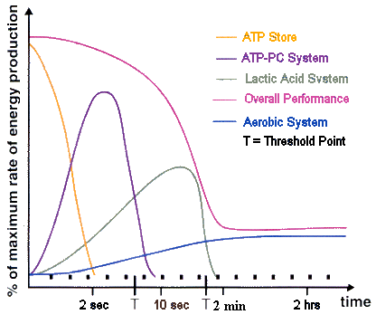

**Energy & Training methods**

**What you need to know:**

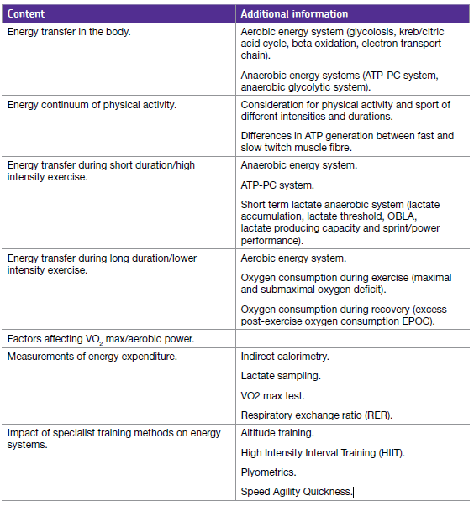

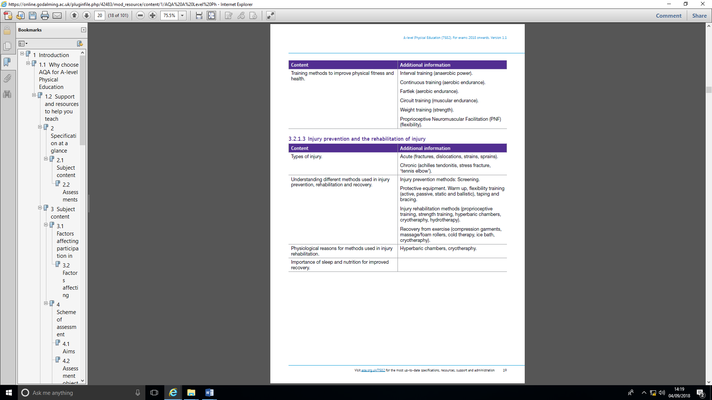

**Circuit training for muscular endurance**

1

**Session**

**What is circuit training?**

The term ‘circuit training’ covers a massive range of different activities and intensities. Commonly it comprises of 8 – 10 exercises where performers work for a period of time before rotating to the next station after a rest or recovery period. The work intensity and recovery period can be modified so that a circuit targets many different components of fitness. However, the AQA specification for A-level PE wants you to understand how circuit training can target muscular endurance only.

|  |  |
| --- | --- |
| Circuits can include bodyweight exercises: | Circuits can also include resistance machines and weights: |
| [Image result for circuit training](https://www.google.co.uk/url?sa=i&rct=j&q=&esrc=s&source=images&cd=&cad=rja&uact=8&ved=2ahUKEwjTmsSJk6bdAhVH0RoKHaMkAdAQjRx6BAgBEAU&url=https://www.medicaldaily.com/why-7-minute-workout-works-high-intensity-circuit-training-331160&psig=AOvVaw1PwRlTajAbyQbAt75KHq6O&ust=1536314847817068) | [Image result for circuit training with weights](http://www.google.co.uk/url?sa=i&rct=j&q=&esrc=s&source=images&cd=&cad=rja&uact=8&ved=2ahUKEwiT4tbx0qjdAhVBxYUKHb5UAk4QjRx6BAgBEAU&url=http://www.cardiotrek.ca/2016/04/diy-circuit-training-routine.html&psig=AOvVaw1nRQ6SmP-zUYiw2AfIvD1_&ust=1536401179423029) |

**Using circuit training to develop muscular endurance**

Muscular endurance can be defined as the ability to sustain muscular contractions over time without fatigue. So here again, the definition covers a lot of different types of sports and intensities!

By modifying the duration and intensity of work and recovery intervals, circuits can be tailored toward the specific muscular endurance needs of individuals.

For example,

|  |  |  |  |
| --- | --- | --- | --- |
|  | **200m sprinter** | **Soccer midfielder** | **Olympic rower (2000m)** |
| **Duration of work at each station** | **30s** | **45s** | **90s** |
| **Recovery between stations** | **60s REST** | **45s JOG** | **90s REST** |
| **No. of circuits** | **2** | **2** | **1** |

1

**Session**

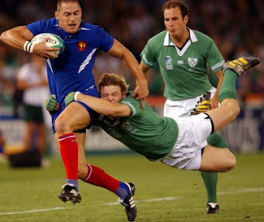

**TASK TO TACKLE!**

Using the work: recovery ratio detailed in the above table, plan a bodyweight circuit for either the sprinter, soccer midfielder or rower in the space below.

* Try to make sure that the exercises are **specific** to the sport being trained for.
* Arrange the circuit so that consecutive stations do not stress the same part of the body.

|  |  |
| --- | --- |
| **Advantages of circuits** | **Disadvantages of circuits** |
|  |  |
|  |  |
|  |  |

**Energy**

2

**Session**

**ATP =**

**ADENOSINE**

**P**

**P**

**P**

The Breakdown of ATP provides energy for sport and exercise

|  |  |
| --- | --- |
| **ATP Breakdown** | **ATP Re-synthesis** |
| **Exothermic/Endothermic?** | **Exothermic/ Endothermic?** |

The ATP-PC System

**PC =**



Complete the diagram to show how energy from PC is used to rebuild ATP

2

**Session**



















**This is called a reaction**

|  |  |  |  |
| --- | --- | --- | --- |
| Site of Reaction | Type of Reaction | By-products | Duration & Intensity |
| Specific Stages | Energy yield | Chemical/Food Fuel | Sporting example |

|  |  |
| --- | --- |
| ***Advantages of the PC system*** | ***Dis-advantages of the PC system*** |
| ATP can be re-synthesised **rapidly** using the ATP-PC system | There is only a **limited supply** of phosphocreatine in the muscle cell, ie. it **can only last for 10 seconds** |
| **Phosphocreatine** stores can be **re-synthesised quickly** – (30secs =50% replenishment and 3 mins = 100%) | **Only one ATP** molecule can be re-synthesised for every mole of PC |
| There are **no fatiguing bi-products** | **PC re-synthesis can only take place in the presence of oxygen** (i.e. the intensity of the exercise is reduced) |
| It is possible to extend the time the ATP-PC system can be utilised through use of creatine supplementation |

**Task to tackle:** Can you think of four sporting examples when the ATP/PC system would be the predominant method of re-synthesising ATP?

1. 3.

2. 4.

**Be the umpire!** Use the mark scheme below to award a mark out of 4……..

2

**Session**



Q. Name the **main** energy system being used in the 100m **and** explain how this system provides energy for the working muscles. *(4 marks)*

**Student answer:** *The system is called the ATP system. It works by using ADP and joining it to an inorganic phosphate to make ATP for energy that the muscles can use directly for exercise. Unfortunately it can only last for 10 seconds until the ATP runs out but for sports like 100m that can be run in less than 10s*

**Mark Scheme: (4 marks in total)**

1 mark for system:

1. ATP-PC system/ PC system/ Phosphocreatine system

3 marks for explanation from:

1. PC is broken down by creatine kinase
2. Producing P + C + energy
3. Energy used to resynthesize ATP/ coupled reaction
4. Reactions take place in the sarcoplasm of muscle cell
5. Yield = 1 ATP/ 1 ATP mole for every 1 PC/ 1:1
6. PC depleted after 10 seconds/ system only lasts 10 seconds
7. Fast reactions/PC readily available/ PC stored in muscle/quick energy source
8. Anaerobic/without oxygen

**The Lactic Acid Energy System**

**(Also known as Anaerobic Glycolysis)**

**= =**

Complete the diagram:

|  |  |
| --- | --- |
| **Where is Glycogen Stored?** |  |
| **Why is the pyruvic acid turned into Lactic Acid?** |  |
| **What effect does Lactic Acid have on performance?** |  |

2

**Session**

State 2 sporting examples of when the Lactic Acid System would be used to make ATP:

|  |  |
| --- | --- |
| Individual Sport | Team Sport |
|  |  |

Complete the following information about the Lactic Acid Energy System:

|  |  |  |  |
| --- | --- | --- | --- |
| Site of Reaction | Chemical/Food Fuel | Type of Reaction | Energy Yield |
| Specific Stages of the System | By-products | Intensity/Duration | Active enzyme |

|  |  |
| --- | --- |
| ***Advantages of the Lactic Acid system*** | ***Dis-advantages of the Lactic A system*** |
| ATP can be re-synthesised **quite quickly due to few chemical reactions.** Good for high intensity work e.g. extra fuel for a sprint finish | The **accumulation of lactic acid** in the body de-natures enzymes and prevents them increasing the rate at which chemical reactions take place. |
| In the presence of oxygen, **lactic acid can be converted back into liver glycogen** or used as a fuel through oxidation into carbon dioxide and water. | Still **relatively small amount of energy** can be released from glycogen under anaerobic conditions |
| **More ATP yielded compared to PC system** | **Pain and fatigue**! |

**Task to tackle:**



2

**Session**

The picture belowshows a sprint cycle race. This activity involves cycling four laps of a 250 metre track, with the final lap being completed as fast as possible. Elite performers cover the final lap in times of between 10 and 11 seconds.

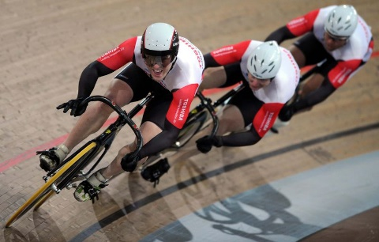

Name the **main** energy system being used in the final sprint to the finishing

line **and** explain how this system provides energy for the working muscles. (4)

……………………………………………………………………………………………………………………………………………………………………………………………………

……………………………………………………………………………………………………………………………………………………………………………………………………

……………………………………………………………………………………………………………………………………………………………………………………………………

……………………………………………………………………………………………………………………………………………………………………………………………………

In the space below, sketch a graph to show how muscle ATP and PC stores change during the first 10 seconds of sprint work.

**Aerobic Energy System**

**Top tip:** If the question asks for the main energy system used then just write about the relevant one.

2

**Session**

Label the Diagram of stage 1: Krebs Cycle

**G L Y C O L Y S I S**





**Acetyl CoA**

|  |  |
| --- | --- |
| Why is the Pyruvic Acid turned into Acetyl CoA (not Lactic Acid?) |  |
| Where does the Krebs cycle take place? |  |

|  |
| --- |
| Krebs Cycle Summary |
|  |
|  |
|  |
|  |
|  |
|  |

Label the diagram of stage 2: Electron Transport Chain

2

**Session**

|  |
| --- |
| **Acetyl CoA**  [http://www.techassistnow.com/wp-content/uploads/2010/05/pathfindertutorial7.gif](http://www.google.co.uk/url?sa=i&rct=j&q=&esrc=s&frm=1&source=images&cd=&cad=rja&docid=FihvVfJBJMmu9M&tbnid=sYRmZjZLdM6UZM:&ved=0CAUQjRw&url=http://www.techassistnow.com/2010/05/using-the-illustrator-pathfinder-tool.html&ei=QrcpUoO0FaTs0gWvw4CIBA&bvm=bv.51773540,d.ZGU&psig=AFQjCNHT9Rwf9KxxOfe-Lf082IxNzPyo4w&ust=1378551756433379) |
| Q. How do we get the leftover Hydrogen out of the body?  A. |

|  |
| --- |
| Electron Transport Chain Summary: |
|  |
|  |
|  |
|  |

**Fats can also be used as an energy source in the aerobic system!**

2

**Session**

|  |
| --- |
| More ATP can be made from one mole of fatty acids than one mole of glycogen which is why in long duration exercise fatty acids will be the predominant energy source.  [http://www.techassistnow.com/wp-content/uploads/2010/05/pathfindertutorial7.gif](http://www.google.co.uk/url?sa=i&rct=j&q=&esrc=s&frm=1&source=images&cd=&cad=rja&docid=FihvVfJBJMmu9M&tbnid=sYRmZjZLdM6UZM:&ved=0CAUQjRw&url=http://www.techassistnow.com/2010/05/using-the-illustrator-pathfinder-tool.html&ei=QrcpUoO0FaTs0gWvw4CIBA&bvm=bv.51773540,d.ZGU&psig=AFQjCNHT9Rwf9KxxOfe-Lf082IxNzPyo4w&ust=1378551756433379)  **B E T A – O X I D A T I O N**    **Acetyl CoA** |

|  |  |
| --- | --- |
| ***Advantages of the Aerobic system*** | ***Dis-advantages of the Aerobic system*** |
| More ATP can be produced **36-38 ATP** per glucose molecule | This is a **complicated system so** cannot be used straight away. It **takes time** for enough oxygen to become available to meet the demands of the activity and ensure glycogen and fatty acids are completely broken down. |
| There are **no fatiguing by-products** (carbon dioxide and water) | Cannot be used to fuel high intensity / sprint exercise |
| Lots of glycogen and triglyceride stores so exercise **can last for a long time (hours)** | If using fat - 15% more oxygen is required to break it down than glycogen |

|  |  |  |  |
| --- | --- | --- | --- |
| Site of Reaction | Chemical/Food Fuel | Type of Reaction | Energy Yield |
| Specific Stages of the System | By-products | Intensity/Duration | Active enzyme |

**Plyometric training**

3

**Session**

**Plyometric training**

**Plyometrics =** incorporates jumps, bounds and hops for the development of power (explosive strength).

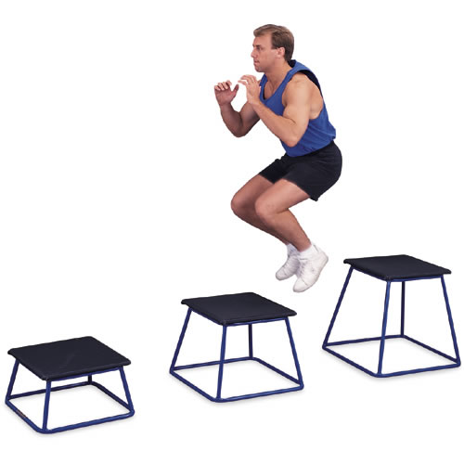

**Top tip:** make sure you can relate plyometrics to the muscle spindle apparatus

Task 1

How does Plyometric training work?

Task 2

Consider the strengths and weaknesses of using plyometrics to improve strength for your sport.

|  |  |
| --- | --- |
| **Advantages of Plyometrics** | **Disadvantages of Plyometrics** |
|  |  |
|  |  |
|  |  |

**Plyometrics**

**3**

Session

If leg power is crucial to successful performance, for example, long jump and 100m sprint in athletics or rebounding in basketball, then plyometrics is one method of strength training that improves power or elastic strength. It works on the concept that muscles can generate more force if they have previously been stretched. This occurs in plyometrics when, on landing, the muscle performs an eccentric contraction (lengthens under tension). This stimulates the muscle spindle apparatus as it detects the rapid lengthening of the muscle and then sends nerve impulses to the central nervous system (CNS). If the CNS believes the muscle is lengthening too quickly it will initiate a stretch reflex, causing a powerful concentric contraction as the performer jumps up.

To develop leg strength a line of benches, boxes, hurdles is made and the performer has to jump, hop, leap from one to the other. Recovery occurs as you walk back to the start line and repeat the exercise.

To develop arm strength, press-ups could be performed with mid air claps or through throwing and catching a medicine ball.

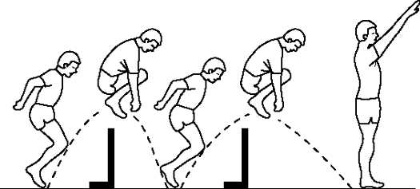

**What are the physiological adaptations to plyometric training?**

Neural adaptations

What is the impact of plyometrics on the anaerobic energy systems?

Muscle adaptations

Metabolic adaptations

**The Energy Continuum**

**4**

**Session**

The energy continuum describes the **relative contribution of each energy system** to total ATP re-synthesis based on the **intensity** **and** **duration** of exercise.



What does the term “**threshold**” mean?

**OBLA**

OBLA is the **O**nset of **B**lood **L**actic acid **A**ccumulation. This can be defined as the point at which there is a rapid increase in blood lactic acid concentration or if the level exceeds 4mmolsl-1.

**Differences in ATP generation between fast and slow twitch muscle fibres**

**Slow twitch fibres** – mainly use the aerobic pathway to generate up to 36ATP from each glucose molecule

**Fast twitch fibres** – mainly use anaerobic pathway. Can only produce 2 ATP due to a lack of oxygen but can produce AP quickly.

**What activates each system?**

|  |  |
| --- | --- |
| **Energy System** | **Activator** |
| PC System | Increase in ADP |
| Lactic Acid System | Decrease in PC |
| Aerobic System | Increase in adrenalin / decrease in insulin levels |

**For each of the activities in the table below, estimate the emphasis placed on the 3 energy systems as a percentage.**

4

**Session**

|  |  |  |  |  |
| --- | --- | --- | --- | --- |
| Sports or Exercise Activity | ATP-PC | Lactic Acid | Aerobic System. | Notes: |
| 5000-metre race | 5% | 15% |  | * First 10secs: ATP/PC system * 10-30 secs: transition from ATP/PC to lactic acid system * 2-5 mins: transition from lactic acid to aerobic system * 5 mins +: aerobic system * Final sprint: combined pc/lactic acid system |
| 11 a-side Soccer match |  |  | **40%** |  |
| Game of Basketball or 5-a-side Soccer. |  |  | **15%** |  |
| Maximum Sprint Shuttles in 60 seconds |  |  |  |  |
| Vertical Jump |  |  |  |  |

**Sources of energy, their locations and use in replenishing ATP**

4

**Session**

Task to tackle: Fill the blanks!

***Phosphocreatine*** is used to re-synthesise ATP in the first 10 seconds of intense exercise. It is easy to break down and stored within the muscle cell but its stores are limited

***Carbohydrates*** – stored as in the muscles and the liver and converted into glucose during exercise. During high intensity anaerobic exercise glycogen can be broken down without the presence of oxygen, but it is broken down much more effectively during aerobic work when oxygen is present.

***Fats*** – stored as in the adipose tissue and converted to free

when required. At rest two thirds of our energy requirements can be achieved through the breakdown of fatty acids. This is because fat can produce more energy per gram than glycogen. Fat contains a lot of carbon which is why they give us so much energy. It is the secondary energy fuel for low intensity, aerobic work such as jogging but has to be used in combination with glycogen due to its hydrophobic quality (low water solubility) that inhibits fat metabolism.

***Protein*** – approximately of energy used during exercise comes from proteins in the form of amino acids. It tends to be used when stores of glycogen are low.

Carbohydrates and fats are the main energy providers and the  and

of exercise plays a huge a role in determining which of these are used. The breakdown of fats to free fatty acids requires around 15% more oxygen than that required to breakdown glycogen so during high intensity exercise when oxygen is in limited supply glycogen will be the preferred source of energy. Fats, therefore, are the favoured fuel at rest and during long endurance-based activities.

Stores of glycogen are much than stores of fat and it is important during prolonged periods of exercise not to deplete glycogen stores as some needs to be conserved for later when the intensity could increase, for example, the last kilometre of the marathon.

Glycogen Triglycerides Duration

Smaller Fatty acids 5-10% Intensity

|  |  |  |  |
| --- | --- | --- | --- |
| **Energy source** | **Location in the body** | **Why/when used?** | **ATP yield?** |
| **Phospho-Creatine** |  |  |  |
| **Fats** |  |  |  |
| **Carbohydrates** |  |  |  |
| **Protein** |  |  |  |

**Weight training for Strength**

5

**Session**

Before starting to use weights to increase strength in a given muscle group it is necessary to out its **1-Repetition Maximum (1RM)**; that is, the maximum weight that can be lifted by a muscle group once.

You will then need to decide the appropriate % of your 1RM to work at and this will depend upon which type of strength you are aiming to train, as follows:

|  |  |  |  |
| --- | --- | --- | --- |
| **Type of strength** | **Repetitions** | **Intensity**  **(% of 1RM)** | **No. of sets** |
| Maximum Strength | 1-7 | 80+% of 1RM | 3 |
| Explosive Strength | 6-10 with high speed of contraction | 40 – 75% of 1RM | 3 |
| Strength Endurance | 12+ reps | 40-80% of 1RM | 4-6 |

In order to be effective, weight training will need to be carried out a minimum of twice a week.

|  |  |
| --- | --- |
| **Advantages of weight training** | **Disadvantages of weight training** |
|  |  |
|  |  |
|  |  |

**Preparation for weight training practical**

[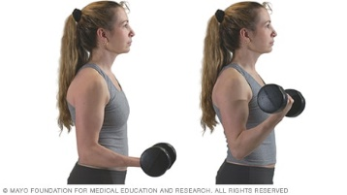](https://www.google.co.uk/url?sa=i&rct=j&q=&esrc=s&source=images&cd=&cad=rja&uact=8&ved=2ahUKEwiL76vj66jdAhUN6RoKHQItCRcQjRx6BAgBEAU&url=https://www.mayoclinic.org/healthy-lifestyle/fitness/multimedia/weight-training/sls-20076904?s%3D5&psig=AOvVaw2X6k4vAFrU6ltOjCu1PC2Y&ust=1536407918020606)

**My 1RM for Bicep curls using a dumbbell is KG**

[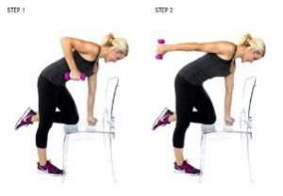](http://www.google.co.uk/url?sa=i&rct=j&q=&esrc=s&source=images&cd=&cad=rja&uact=8&ved=2ahUKEwjK-P297KjdAhVLUBoKHd0TChsQjRx6BAgBEAU&url=http://www.medguidance.com/thread/Bicep-and-Tricep-Workout.html&psig=AOvVaw3MhdJ7OF-9e_hvTPYhA5J6&ust=1536408129678997)

**My 1RM for Tricep extensions using a dumbbell is KG**

**Weight training practical – Arms**

5

**Session**

Warm-up! 5 minutes pulse raiser following by stretches.

Before you start you will need to work out your 1RM for dumbbell bicep curls and dumbbell tricep extensions.

1. **Simple Set System**

|  |  |  |  |  |
| --- | --- | --- | --- | --- |
| **Exercise** | **Repetitions** | **Intensity**  **(% 1RM)** | **No. of sets** | **Rest between sets** |
| Dumbbell Bicep Curls | 5 | 80% of 1RM | 3 | 60s |

1. **Pyramid system – Repetitions are reduced as the load increases**

|  |  |  |  |  |
| --- | --- | --- | --- | --- |
| **Exercise** | **Set** | **Repetitions** | **Intensity**  **(% 1RM)** | **Rest between sets** |
| **Dumbbell bicep curls** | **1** | **15** | **40** | **60s** |
| **2** | **10** | **60** |
| **3** | **5** | **80** |

1. **Super set system – training two antagonistic muscle groups without rest in between sets**

|  |  |  |  |  |
| --- | --- | --- | --- | --- |
| **Exercise** | **Repetitions** | **Intensity**  **(% 1RM)** | **No. of sets** | **Rest between sets** |
| **Dumbbell bicep curls** | **15** | **50** | **4** | **0** |
| **Tricep dumbbell extensions** | **15** | **50** | **4** | **0** |

**High Intensity Interval Training (HIIT)**

6

**Session**

Complete 4 minutes of HIIT using the following format:

|  |  |  |  |  |  |  |  |
| --- | --- | --- | --- | --- | --- | --- | --- |
| 20s SPRINT | 10s  JOG | 20s SPRINT | 10s  JOG | 20s SPRINT | 10s  JOG | 20s SPRINT | 10s  JOG |
| 20s SPRINT | 10s  JOG | 20s SPRINT | 10s  JOG | 20s SPRINT | 10s  JOG | 20s SPRINT | 10s  JOG |

After a 3 minute recovery period, complete another 4 minutes of HIIT but this time vary the format in order to increase the intensity.

Plan your 4 minute session in the space below:

|  |  |
| --- | --- |
| **Advantages of High Intensity Interval Training** | **Dis-advantages of High Intensity Interval Training** |
|  |  |
|  |  |
|  |  |

**SAQ (Speed, Agility, Quickness) Training**

6

**Session**

**SAQ (Speed, Agility, Quickness) Training**

Agility Ladder session (to be performed with maximum force at high speed)

[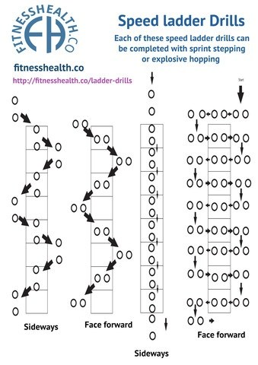](https://www.google.co.uk/url?sa=i&rct=j&q=&esrc=s&source=images&cd=&cad=rja&uact=8&ved=0ahUKEwjpkNL6qITXAhVBkBQKHRFrBx0QjRwIBw&url=https://www.quora.com/What-are-some-workouts-to-increase-footwork-and-foot-speed-in-football&psig=AOvVaw2XDn2l4slt9a-OVOclTNYS&ust=1508764620163702)

**Set 1**

* Complete using power hops
* Repeat all ladders twice
* On sideways ladders change direction on second rep

**Set 2**

* Complete using sprint steps (one foot at a time)
* Repeat all ladders twice
* On sideways ladders change direction on second rep

**SAQ Shuttles**

* With cones, divide a court space up into 3-metre sections.
* Jog up and down the court
* When the whistle sounds, complete the following exercises between your two cones until the whistle sounds again.
* You must touch the cones

|  |  |
| --- | --- |
| Exercise | Reps |
| Front and back sprinting (no turning) | 8 |
| There and back sprinting (turning after cone-touch) | 8 |
| Side steps facing left | 8 |
| Side steps facing right | 8 |

What will be the impact of the session on the anaerobic energy systems?

**Relationship of OBLA with VO2 Max**

7

**Session**

**What you need to know;**

* A knowledge ofVO2(max) and the factors that can affect it
* Definition and effects of OBLA
* Relationship of OBLA with VO2(max)

**Key term: VO2(max)** - the maximum volume of oxygen that can be taken in and used by the muscles per minute.

**Significance of maximum oxygen consumption (VO2max) in sporting performance.**

This is the maximum volume of oxygen that can be taken in and used by the muscles per minute. A person’s VO2(max) will determine endurance performance in sport. Average VO2(max) for an A-Level student is around 45-55ml/kg/min for males and 35-44ml/kg/min for females. Paula Radcliffe’s VO2(max) is around 80ml/kg/min. This means she has more oxygen going to the muscles and can utilise this oxygen to provide energy to enable a high rate of exercise.

VO2(max) depends on:

1. How effectively an individual can inspire and expire
2. Once they have inspired how effective the transportation of the oxygen is from the lungs to where it is needed.
3. How well that oxygen is then used.

**Onset blood lactate accumulation (OBLA)**

**Key term: OBLA -** the point where lactate starts to accumulate in the blood

OBLA is the point where lactate starts to accumulate in the blood. Lactate is a product of lactic acid occurring when hydrogen is removed from the lactic acid molecule. At rest approximately 1-2 millimoles/litre of lactic acid can be found in the blood. However during intense exercise levels of lactic acid will rise dramatically and as it starts to accumulate OBLA occurs. This is usually when the concentration of lactic acid is around 4mmol/l. Measuring OBLA gives an indication of endurance capacity. Some individuals can work at higher levels of intensity than others before OBLA and can delay when the threshold occurs. OBLA is expressed as a percentage of VO2(max). An average untrained individual will work at approximately 50-60% of VO2(max) whereas a trained endurance performer can work at around 85-90% of VO2(max) before OBLA occurs.

The multi-stage fitness test is a good practical example to illustrate OBLA. The performer eventually reaches a point due to the increasing intensity of this test where energy cannot be provided aerobically. This means the performer has to use the anaerobic systems to re-synthesise ATP. Blood lactate levels start to increase until eventually muscle fatigue occurs and the performer slows down or is no longer able to keep up with the bleep!

***Factors affecting VO2(max)***

7

**Session**

***Physiological***

*Training*

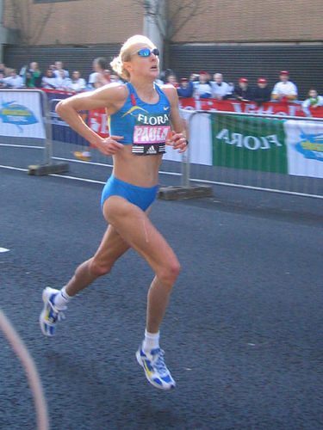

***Lifestyle***

*Body Composition*

***Differences in age***

**Diagram to summarise OBLA**

7

**Session**

**Factors affecting the rate of lactate accumulation:**

*Exercise intensity.*

The higher the exercise intensity the greater the demand for energy (ATP). Fast twitch fibres are used for high intensity exercise and can only maintain their workload with the use of glycogen as a fuel.

*Muscle fibre type.*

Slow twitch fibres produce less lactate than fast twitch fibres. When slow twitch fibres use glycogen as a fuel, due to the presence of oxygen, the glycogen can be broken down much more effectively and with little lactate production.

*Rate of blood lactate removal.*

If the rate of lactate removal is equivalent to the rate of lactate production then the concentration of blood lactate remains constant. If lactate production increases then lactate will start to accumulate in the blood till we reach OBLA

*Training*

Adaptations occur to trained muscles. Increased numbers of mitochondria and myoglobin, together with an increase in capillary density improve the capacity for aerobic respiration and therefore avoid the use of the lactic acid system.

**VO2 Max tests**

**7**

**Session**

1. **Maximal tests**

**Multi-stage fitness test Cooper 12-minute run**

* The athlete [warms up](https://www.brianmac.co.uk/warmup.htm) for 10 minutes
* The assistant gives the command “GO”, starts the stopwatch and the athlete commences the test
* The assistant keeps the athlete informed of the remaining time at the end of each lap (400m)
* The assistant blows the whistle when the 12 minutes has elapsed and records the distance the athlete covered to the nearest 10 metres
* A prediction of VO2 max score can be made from standardised tables below
* Warm-up
* The assistant starts the CD and the athlete commences the test
* If the athlete arrives at the end of a shuttle before the beep, the athlete must wait for the beep and then resume running
* If the athlete fails to reach the end of the shuttle before the beep they should be allowed 2 or 3 further shuttles to attempt to regain the required pace before being withdrawn
* A prediction of VO2 max score can be made from standardised tables below

**Standardised tables to estimate VO2 max from Beep test score:**

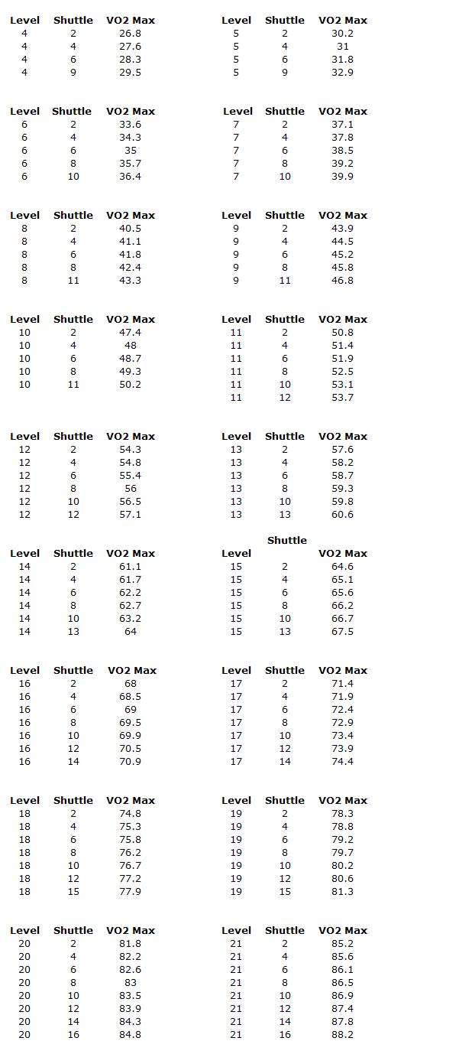 [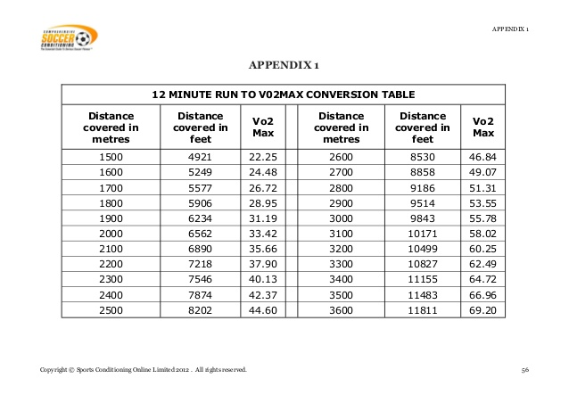](https://www.google.co.uk/url?sa=i&rct=j&q=&esrc=s&source=images&cd=&cad=rja&uact=8&ved=0ahUKEwi81fD5o-HXAhVMbRQKHb7-CRMQjRwIBw&url=https://www.slideshare.net/mbasaran3/csc-soccerfitnesstesting1&psig=AOvVaw3SLxX9iVsBPgnvXaqyoU3s&ust=1511958885867605)

 [](https://www.google.co.uk/url?sa=i&rct=j&q=&esrc=s&source=images&cd=&cad=rja&uact=8&ved=0ahUKEwi81fD5o-HXAhVMbRQKHb7-CRMQjRwIBw&url=https://www.slideshare.net/mbasaran3/csc-soccerfitnesstesting1&psig=AOvVaw3SLxX9iVsBPgnvXaqyoU3s&ust=1511958885867605)

1. **Sub-maximal tests e.g. Queen's College Step Test**

**7**

**Session**

Test protocol:

* The athlete [warms up](http://www.brianmac.co.uk/warmup.htm) for 10 minutes
* The assistant sets up the metronome to the required steps/minute pace (Male 24 and Female 22)
* The assistant gives the command “GO”, starts the stopwatch and the athlete commences the test
* The assistant ensures the athlete maintains the required steps/minute pace
* The assistant stops the test after 3 minutes and records the athlete’s heart rate for 15 seconds (PR)
* VO2 max can be predicted using the online calculator (link below)

[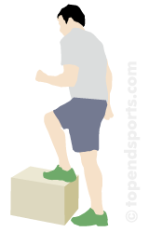](http://www.google.co.uk/url?sa=i&rct=j&q=&esrc=s&frm=1&source=images&cd=&cad=rja&uact=8&docid=jvQoRBz90uJprM&tbnid=8vsjloe27K-7dM:&ved=0CAUQjRw&url=http://2ptc1.wordpress.com/what-is-queens-college-step-test/&ei=u_l9U9j2Gaqu7AaJn4CoCg&bvm=bv.67229260,d.ZGU&psig=AFQjCNGuxqRz8-JcDeYlllPGtmCpNiVUZA&ust=1400851244090614)

My 15 seconds HR was .

Enter your score into the calculator at <http://www.brianmac.co.uk/queens.htm>

For an estimated VO2 max value:

Ml/kg/min

[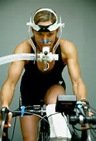](https://www.bing.com/images/search?view=detailV2&ccid=X8wD8Q80&id=CDEEEFCA22506FDA849A5B643B432B7A41461D9D&thid=OIP.X8wD8Q80BPlf6EFEt3r51QDMEy&q=Vo+Max+Test&simid=608017055728927431&selectedIndex=0)

1. **Direct Gas Analysis Method**

* Tests take place in a sport science laboratory and involve exercising with increasing intensity on a treadmill, cycle ergometer or rower.
* The participant continues until exhaustion while expired air is calculated by computer software (e.g. Metabolic Cart equipment).
* The volume and concentration of oxygen in the expired air is then measured and compared with the percentage of oxygen in the atmospheric air to see how much has been used during the task.

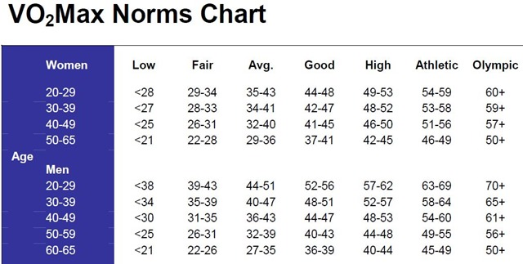



**Exam practice:**

A Rugby fitness coach is testing the Aerobic Capacity (VO2 max) of his players. Evaluate the use of different methods of testing VO2 max. [8]

7

**Session**

# Lactate Sampling

#### Definition:

#### Advantages/ reasons for use

#### Description of method:

Any drawbacks?

#### How does it measure energy expenditure?

**7**

Session

# RER

Definition

#### Advantages/ reasons for use

#### Description of method

Any drawbacks?

#### How does it measure energy expenditure?

**7**

Session

# INDIRECT CALORIMETRY

#### Definition

#### Advantages/ reasons for use

#### Description of method:

Any drawbacks?

#### How does it measure energy expenditure?

**Practice makes perfect**

1. The picture below shoes the proportions of carbohydrates and fats used for energy during a race of increasing intensity.

100%

50%

Carbohydrates

Fats

High

Low

Intensity of exercise

Using your knowledge of energy systems, outline and explain the relationship between energy sources and intensity of exercise. (7 marks)

*………………………………………………………………………………………………………………………………………………………………………………………………………………………………………………………………………………………………………………………………………………………………………………………………*

1. At the 2008 Beijing Olympic Games, David Davies won the silver medal in the swimming 10 kilometre marathon event, in a time of 1 hour 51 minutes and 53.1 seconds. Explain how the majority of energy used during the race would be provided in this type of event. (7 marks)

*………………………………………………………………………………………………………………………………………………………………………………………………………………………………………………………………………………………………………………………………………………………………………………………………*

**7**

Session

# VO2 MAX TEST

Definition:

#### Advantages/ reasons for use

#### Description of method:

Any drawbacks?

#### How does it measure energy expenditure?

**Exam practice:**

**7**

Session

A Rugby fitness coach is testing the Aerobic Capacity (VO2 max) of his/her

players.

Evaluate the use of different methods of testing VO2 max. [8]

**Sample of a student plan**

|  |  |  |
| --- | --- | --- |
| ***AO1 – knowledge*** | ***AO2 – application*** | ***AO3 – Evaluation*** |
| ***VO2 Max definition***  ***Identify tests:***   1. ***Direct Gas Analysis*** 2. ***Max tests – e.g. Cooper run, Multi-stage fitness test, Harvard Step Test*** 3. ***Queens College Step test (sub-maximal)***   ***Key terms in quantitative research – validity? Reliability?*** | ***Usefulness of VO2 max in Rugby – examples. Link to OBLA.***  ***Describe/ explain test protocols – differences?*** | ***General testing points:***  ***E.g. _ testing needs to be repeated in same conditions (reliability)***  ***Direct gas analysis:***  ***+ e.g. accurate results***  ***_ e.g. lab conditions not sport specific***  ***Other tests:***  ***+ e.g. low cost/relatively simple/ sub-max tests interfere less with training/ popular with players***  ***_ e.g. Lack reliability as normative data are used/ Lack validity/ specificity/ players may not make maximal effort in max tests/ lack motivation/ causes fatigue*** |

**Sample of student work – not the whole answer!**

*VO2 Max can be defined as the maximum volume of oxygen that can be taken in and utilised by the body per minute. One way to measure VO2 max is by direct gas analysis in a laboratory. Using this method we would usually make a player run on a treadmill at increasing intensity until exhaustion and the air expired is analysed by computer software, such as Metabolic Cart. The volume and concentration of expired oxygen is calculated and compared against atmospheric air in order to establish how much oxygen has been used for the task. This method is a very accurate measure of VO2 max but the testing procedure may lack validity for Rugby performance because straight line running on a treadmill is very different to the way that energy is re-synthesised during a Rugby match. For example, in a Rugby match energy will also be expended in short sprints followed by short recover or by the upper body muscles and this is not measured in the laboratory conditions described.*

**………………………………………………………………………………………………………………………………………………………………………………………………………………………………………………………………………………………………………………………………………………………………………………………………………………………………………………………………………………………………………………………………………………………………………………………………………………………………………………………………………………………………………………………………………………………………………………………………………………………………………………………………………………………………………………………………………………………………………………………………………………………………………………………………………………………………………………………………………………………………………………………………………………………………………………………………………………………………………………………………………………………………………………………………………………………………………………………………………………………………………………………………………………………………………………………………………………………………………………………………………………………………………………………………………………………………………………………………………………………………………………………………**

**Continuous Training & Fartlek for Aerobic Endurance**

**8**

Session

Continuous

Fartlek



Task to tackle:

1. Give a brief description of the continuous and fartlek training sessions you took part in today.
2. In the space below, sketch an approximate graph showing HR response to the continuous work in blue and Fartlek work in red.

**9**

Session



**Altitude training**

**Background task to tackle!**

**In the box below sketch a diagram to show how diffusion gradients enable internal and external respiration.**

**How does altitude training work?**

**The partial pressure of O2 drops as altitude increases (by up to 50% at an altitude of 5000m). Therefore there is a reduction in the diffusion gradient between the air and the lungs and between the alveoli and blood. Therefore haemoglobin is not fully saturated, which results in the lower O2 carrying capacity of the blood. As less O2 is delivered to working muscles there is an earlier onset of fatigue. This results in a decrease in performance (of aerobic activities).**

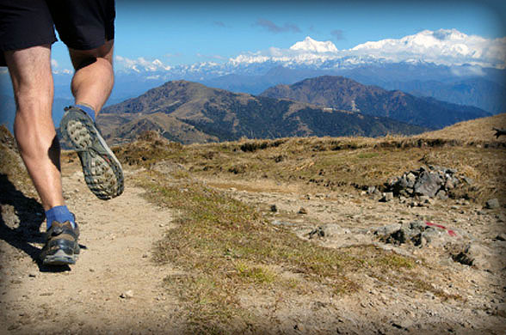

|  |
| --- |
| **Advantages** |
|  |
|  |
|  |
| **Dis-advantages** |
|  |
|  |
|  |
|  |
|  |

Impact on the aerobic energy system?

**Dietary manipulation techniques**

**9**

Session

|  |  |  |
| --- | --- | --- |
| **What is it?** | **Role?** | **Effectiveness?** |
| Creatine | ***.......................................................***  ***......................................................***  ***.....................................................*** | ***.......................................................***  ***......................................................***  ***.....................................................*** |
| Protein supplements | ***.......................................................***  ***......................................................***  ***.....................................................***  ***......................................................*** | ***.......................................................***  ***......................................................***  ***.....................................................***  ***......................................................*** |
| Sodium Bicarbonate | ***.......................................................***  ***......................................................***  ***.....................................................*** | ***.......................................................***  ***......................................................***  ***.....................................................*** |
| Caffeine | ***.......................................................***  ***......................................................***  ***.....................................................*** | ***.......................................................***  ***......................................................***  ***.....................................................*** |

Watch the panorama clip from e-stream:

1. What do protein shakes contain?
2. How are they supposed to help performance?
3. Is there any evidence that protein shakes work?



**9**

Session

# Glycogen loading

# (Carbo-loading)

Which athletes find it useful?

#### Advantages/ reasons for use

#### How is it done/ what does it involve?



Disadvantages:

• Water retention which results in bloating

• Heavy legs

• Affects digestion

• Weight increase

• & mood swings during the depletion phase

• Leads to poor quality

**Recovery**

**10**

**Session**

**EPOC**

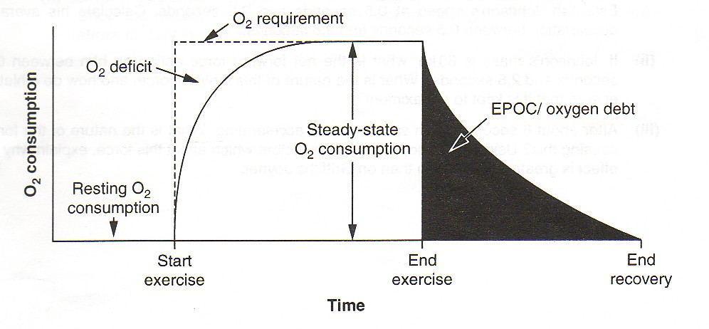

Alactacid Stage

(Fast Stage)

Lactacid Stage

(Slow Stage)

How much oxygen does it need?

What happens?

What about Glycogen?

What about CO2?

How much oxygen does it need?

What happens?

10

**Session**



**Be the umpire!** Read the following question and then mark Kevin’s and Mr Bonney’s answers. Circle the phrases / sentence that you think are worth a mark and give a total for each.

The recovery process is concerned with returning the body to its pre-exercise state. Identify and describe the processes that take place during oxygen debt / EPOC. (6 marks)

**Kevin’s answer**

**The footballer needs to get rid of waste products like lactic acid when they finish playing. This is why footballers should cool down before they go to the bar. Carbon Dioxide is got out of my muscles by breathing out a lot. This takes one hour.**

Mr Bonney’s answer

The process of recovery or Excessive post exercise oxygen consumption is split into two stages. The first stage, known as the Alactacid stage, is concerned with replenishing the muscles stores of Phosphocreatine. This usually takes three minutes and 2-4 litres of oxygen. Also, the oxygen stores in the myoglobin are replaced needing 0.5 litres of oxygen and 1-2 minutes of deep breathing.

The second stage, known as the Lactic acid stage requires 5-8 litres of oxygen to remove lactic acid from the muscle cells. The lactic acid can be converted to pyruvic acid and used for energy in the aerobic energy system creating carbon dioxide and water. It can also be converted to glycogen, glucose or protein. The whole process usually takes up to one hour.

**Recovery**

11

**Session**

RECOVERY PRACTICAL

**TASK 1:** Fill in the gaps in the paragraph with the following words:

RESPIRATORY RATE- LACTACID- EPOC- ALACTACID -ANAEROBIC

What we already know: When exercise is performed PC stores are depleted and lactic acid builds up in muscle. Oxygen is required to break down the lactic acid and replenish the PC stores. Therefore, for a period of time after exercise the heart and remain elevated and this is called . There are 2 types:

1. Component – occurs early in recovery and is used to replenish ATP/PC stores.
2. Component – occurs when oxygen uptake in recovery is used to break down lactic acid.

## A Tale of Two Teams…

* Split the group in to two teams; 1. REST TEAM 2. ACTIVE TEAM
* During practical all students must work at maximum intensity during work intervals.
* The work intervals are 30 seconds and the recovery intervals are 30 seconds.
* The active team should perform a thorough **aerobic warm-up** prior to exercise. The rest group does not.
* Students in the REST group should rest completely in the relief intervals. Students in the ACTIVE group should **perform light aerobic exercise in the relief intervals.**
* Those of you in the ACTIVE team should perform a **thorough aerobic cool-down.**
* **The 3 exercises used are:**
  + **Burpees**
  + **Tuck jumps**
  + **Sprint shuttles**

Hypothesis: Performing an active recovery between stations and allowing 5 minute rest between circuits will result in a slower decline in performance from circuit 1 to circuit 2.

What reason is there for making this hypothesis?

Graphs to show the estimated pattern of PC depletion and repletion during intermittent exercise.

11

**Session**

TASK 2: Roughly estimate the line of PC depletion/ repletion for each team.

**Results:**

11

**Session**

|  |  |  |
| --- | --- | --- |
|  | **REST TEAM** | **ACTIVE TEAM** |
| Team average Burpees Completed |  |  |
| Team average Tuck jumps completed |  |  |
| Team average sprint shuttles completed |  |  |
| **BREAK** | **BREAK** | **BREAK** |
| Team average Burpees thrusts Completed |  |  |
| Team average Tuck jumps completed |  |  |
| Team average sprint shuttles completed |  |  |

**TASK 3:** Plot a line graph showing the performance of the two teams during the practical:

80

**Burpees Tucks Sprints BREAK Burpees2 Tucks 2 Sprints 2**

0

# Alactacid and Lactacid debt after Anaerobic Exercise

11

**Session**

**The graphs show that PC repletion is accelerated by active recovery. Lactic acid removal is also accelerated by active aerobic (light) exercise.** This occurs for several reasons including the dilation of the blood vessels and an increase of blood through “lactate using organs” such as the liver.

**Implications of recovery for designing and planning training sessions:**

|  |  |
| --- | --- |
| **Implication** | **Explanation** |
| 1 |  |
| 2 |  |
| 3 |  |
| 4 |  |

# Exam Practice:

After 60 minutes of exercise, the athlete rests and enters the recovery period/EPOC. Outline the two main physiological processes that will take place during this time. (4 marks)

………………………………………………………………………………………………………………………………………………………………………………………………

………………………………………………………………………………………………………………………………………………………………………………………………

………………………………………………………………………………………………………………………………………………………………………………………………

………………………………………………………………………………………………………………………………………………………………………………………………

**Top tip:**

Questions on EPOC often involve a description of the fast and slow replenishments.

12

**Session**

# PNF Stretching

#### What does it involve

#### How does it work – (refer to muscle spindle apparatus & golgi tendon organs)

Which athletes find it useful?

#### Physiological Adaptations (Reasons for use?)

**PNF (Proprioceptive Neuromuscular Facilitation)**

12

**Session**

|  |  |  |
| --- | --- | --- |
| Steps | Description of stage | Explanation / physiological effects |
| **pnf-stretch taken from The Stretching HandbookStep 1** | the muscle is  p_ _ _ _ _ ely stretched | ................................................  ..............................................  ................................................  ................................................. ................................................  ..............................................  ................................................  ................................................. |
| **pnf-stretch taken from The Stretching HandbookStep 2** | then it contracts iso_ _ _ _ _ _ ally against a resistance while in a stretched position for at least _ _ seconds | ................................................  ..............................................  ................................................  ................................................. ................................................  ..............................................  ................................................  ................................................. |
| **pnf-stretch taken from The Stretching HandbookStep 3** | when passively stretched again there is an increase in the range of motion | ................................................  ..............................................  ................................................  ................................................. ................................................  ..............................................  ................................................  ................................................. |

Practice questions:

1. Explain how lactate is removed from the blood by the body. *(4 marks)*

*………………………………………………………………………………………………………………………………………………………………………………………………………………………………………………………………………………………………………………………………………………………………………………………………*

1. It is important as a games player to have a goodVO2 max. What is meant by the term VO2 (max)? *(2 marks)*

*………………………………………………………………………………………………………………………………………………………………………………………………………………………………………………………………………………………………*

1. Suggest **five** structural and/or physiological causes of the difference inVO2 (max) between a trained and an untrained performer. *(5 marks)*

*………………………………………………………………………………………………………………………………………………………………………………………………………………………………………………………………………………………………………………………………………………………………………………………………*

1. The triathlon is an athletic event that involves performers undertaking a long distance swim, immediately followed by a cycle race and then finally a run of several kilometres.

What would be the major *energy sources* used by a triathlete? *(3 marks)*

*………………………………………………………………………………………………………………………………………………………………………………………………………………………………………………………………………………………………………………………………………………………………………………………………*

**Re-Cap Test**

Q1

**…………………………………………………………………………………………………………………………………………………………………………………………………….……………………………………………………………………………………………………………………………………………………………………………………………………**

Q2

**……………………………….…………………………………………………………………………………………………………………………………………………………………………………………………….……………………………………………………………………………………………………………………………………………………………………**

Q3

**……………………………………………………………….………………………………………………………………………………………………….…………………………………………………………………………………………………………………………………….**

Q4

**………………………………………………………………………………………………..**

**………………………………………………………………………………………………………………………………………………………………………………………………………………………………………………………………………………………………………**

**Re-Cap Test**

Q1

**…………………………………………………………………………………………………………………………………………………………………………………………………….……………………………………………………………………………………………………………………………………………………………………………………………………**

Q2

**……………………………….…………………………………………………………………………………………………………………………………………………………………………………………………….……………………………………………………………………………………………………………………………………………………………………..**

Q3

**……………………………………………………………….………………………………………………………………………………………………….…………………………………………………………………………………………………………………………………….**

Q4

**………………………………………………………………………………………………….**

**……………………………………………………………………………………………………………………………………………………………………………………………………………………………………………………………………………………………………….**

**Practice answers:**

1. Methods of Lactate removal

4 marks for 4 from:

1. Converted to protein
2. Converted to glucose/ cori cycle/glycogenesis
3. Urine/sweat
4. Metabolised to CO2 and H20
5. VO2 Max s marks for 2 from:
6. The maximum volume of oxygen that can be taken in and used by the muscles per minute.
7. Measured in Ml/Kg/Min
8. 5 marks for 5 structural or physiological differences from:

|  |  |  |
| --- | --- | --- |
|  | Trained | Untrained |
| A. | Higher no. of capillaries | Lower no. of capillaries |
| B. | Higher capillary density/size | Lower capillary density/size |
| C. | Higher max cardiac output | Lower max cardiac output |
| D. | Greater myoglobin content | Lesser myoglobin content |
| E. | Greater glycogen/triglyceride stores | Lesser glycogen/triglyceride stores |
| F. | Greater size and no. of mitochondria | Lesser size and no. of mitochondria |
| G. | Greater oxidative enzymes | Fewer oxidative enzymes |
| H. | Increased lactate tolerance | Less tolerance to LA |
| I. | More cardiac hypertrophy/stroke volume | Less cardiac hypertrophy/ stroke volume |
| J. | More hypertrophy of ST fibres | Less hypertrophy of ST fibres |
| K. | Greater haemoglobin | Less haemoglobin/RBCs |

1. Energy sources – 3 marks for 3 from:
2. Glucose/Glycogen
3. Fats/Fatty acids/Triglycerides
4. ATP