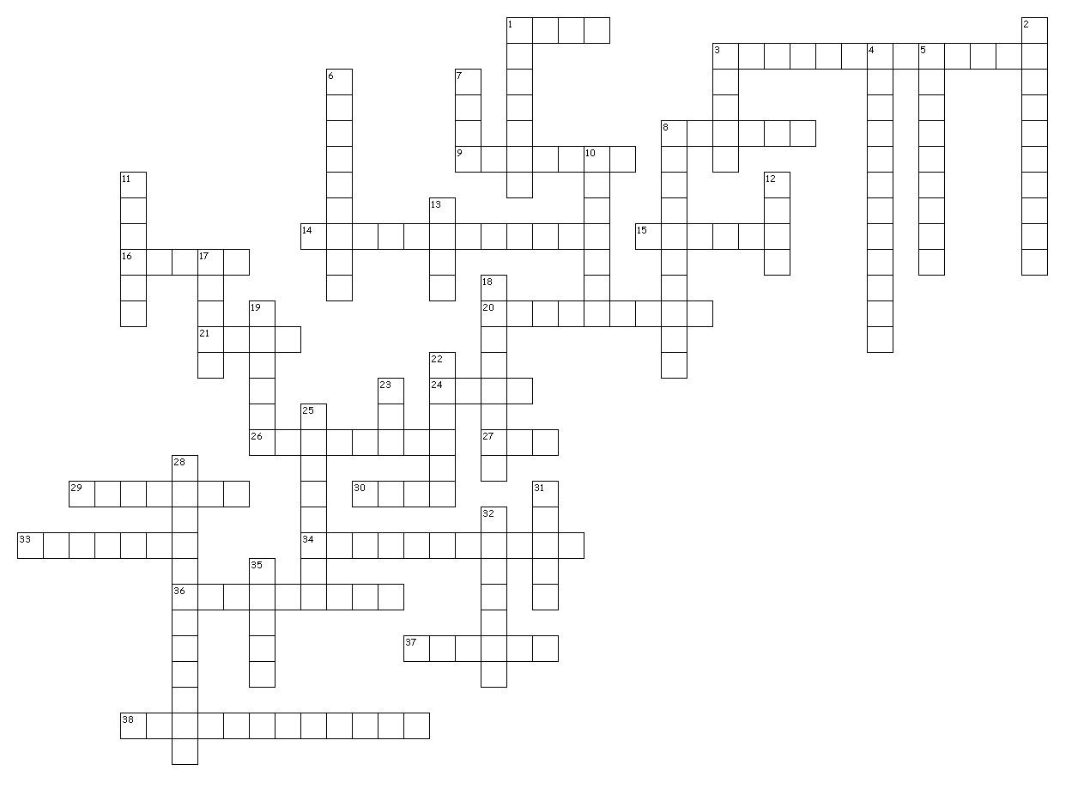

Across
1. unit of efficiency
3. distance when working out moment
8. can change form
9. moving energy
14. distance in a direction
15. directionless
16. number of Newton’s laws
20. total force
21. used to find distance on a v-t graph
24. power unit
26. steady speed
27. maximum efficiency
29. needed a to use v = u + at
30. used when finding a component
33. a principle required for equilibrium
34. stationary or at a constant velocity
36. forces that oppose motion
37. unit of weight
38. relationship between force
and acceleration
Down
1. laws of motion
2. motion in 2D
3. equals velocity times force
4. slowing down
5. a type of moment
6. gravitational is an example
7. when a force is moved
8. how well a device uses energy
10. u in v = u + at
11. force, velocity and acceleration
are examples
12. resultant force required
for equilibrium
13. increasing this decreases
acceleration
17. the forces involved in Newton’s
3rd must be this
18. it can slow things down
19. force of gravity
22. force in N when 3kg accelerated by 4m/s²
23. force in N to do 40J of work
moving 400cm
25. equals velocity on a s-t graph
28. applies to energy
31. unit of work
32. associated with 9.8
35. ke in J when 4kg moves at 2m/s

