Displacement time example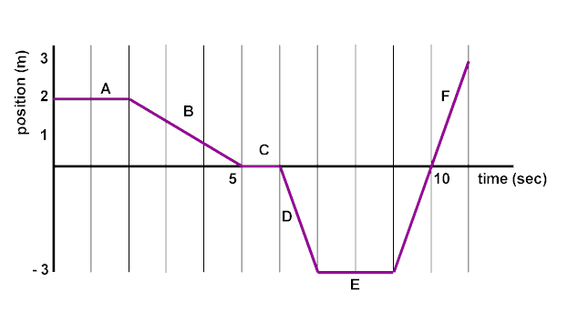

1When were they travelling in a positive direction? AND WHEN A negative direction?

F moving in a positive direction,

B and D moving in a negative,

A, C and E stationary

**2**What was they at rest in a negative location?

E

**3**During what two intervals did they travel at the same speed?

D and F (although opposite directions)

**4**What total distance did they travel?  What was his net displacement?

Travelled 11m, but ended up on 1m away from the start point (displacement)

**5**What was his average **speed** in the first 5 seconds? last 5 seconds?

2m in 5 seconds, speed = distance /time = 2/5 = 0.4ms-1

**6**What was his average **velocity** during the first 8 seconds?  and from 6 to 10 seconds?

Velocity=displacement/time, s=-5, t=8 v=-5/8= -0.625ms-1

**Example #1: "non-accelerated motion"**

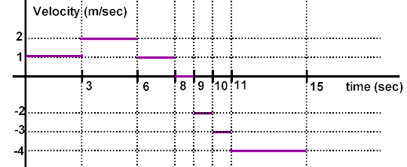

1. When was they travelling in a positive/negative direction?

Positive between 0 and 8 seconds, Negative between 9 and 15 seconds

1. When was they at rest?

Between 8 and 9 seconds

1. During what time intervals did they travel at the same speed?

They travelled at 1ms-1 between 0s and 3s, 6s and 8s

They travelled at 2ms-1 between 3s and 6s, 9s and 10s

1. During what time interval did they travel the greatest distance?

Between 11 and 15 seconds they travelled 16m

1. During what time intervals did they travel the least non-zero distance?

Between 6 and 8 seconds they travelled 2m

Between 9 and 10 seconds they also travelled 2m

1. What total distance did they travel in the first 8 seconds?

Area under graph = 11m

1. What total distance did they travel in the last 6 seconds?

Area under graph = 21m

1. What was his average speed in the first 8 seconds? last 6 seconds?

First 8 seconds travelled 11m: speed=dist/time = 11/21 = 0.52ms-1

Last 6 seconds travelled 21m: speed=dist/time = 21/6 = 3.5ms-1

1. What was his net displacement during the entire 15 seconds?

+11 -21 = -10m

1. What was his average velocity during the entire 15 seconds?

Velocity=displacement/time = -10/15 = 0.67

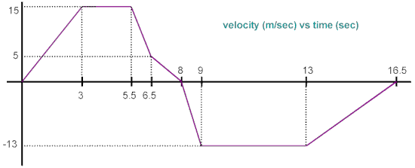

G

F

E

D

C

B

A

1. During what time intervals did they travel at a constant velocity?

B and F

1. During what time interval did they travel the greatest distance?

F

1. During what time interval did they travel the least non-zero distance?

D

1. What total distance did they travel in the first 8 seconds?

(½ 15*3)+(15*2.5)+(5*1)+(½ *10*1)+(½*1.5*5) = 73.75m

1. What total distance did they travel in the last 8**.**5 seconds?

(½*13*1)+(4*13)+(½*13*3.5) 82.25m

1. What was his average speed in the first 8.0 seconds? Last 8**.**5 seconds?

First 8s speed = dist/time = 73.75/8 = 9.2 ms-1

Last 8.5s speed = dist/time = 82.25/8 = 9.6ms-1

1. What was his net displacement during the entire 16**.**5 seconds?

+73.75 - 82.25 = -7.5m

1. What was his average velocity during the entire 16**.**5 seconds?

Velocity = displacement /time = -7.5/16.5 = -0.45 ms-1

Sketch a Displacement-Time and Velocity- time graph for the following:

Ensure the axis are clearly marked (don’t include values)

### Ball in free fall downwards for a few seconds

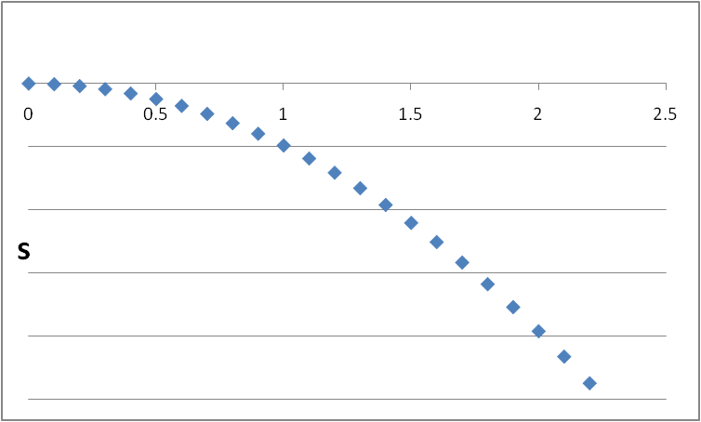 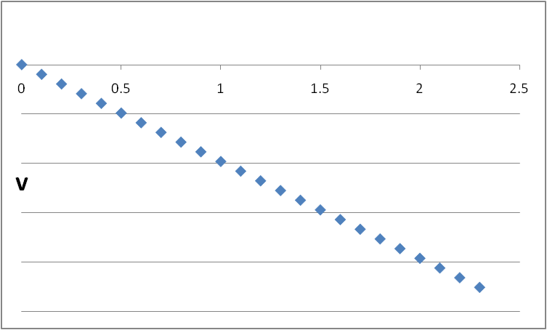

time

time

### Ball in free fall with an initial upwards velocity (sketch until it has an equal downward velocity)

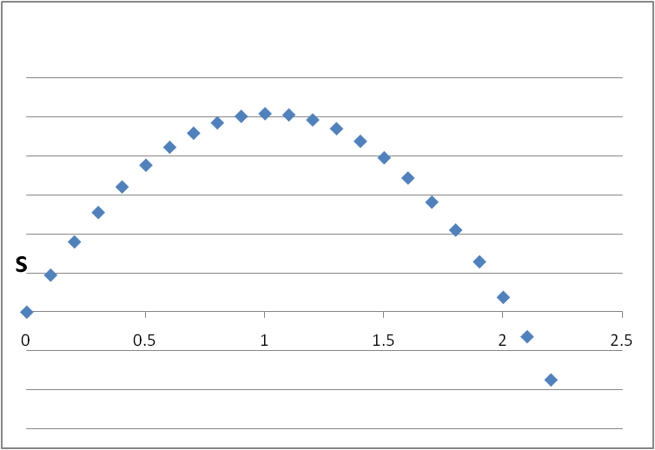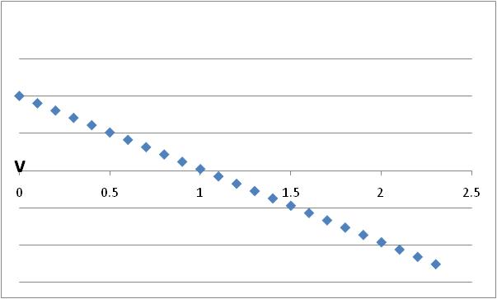

time

time

### Bouncy Ball being dropped and bouncing a couple of times

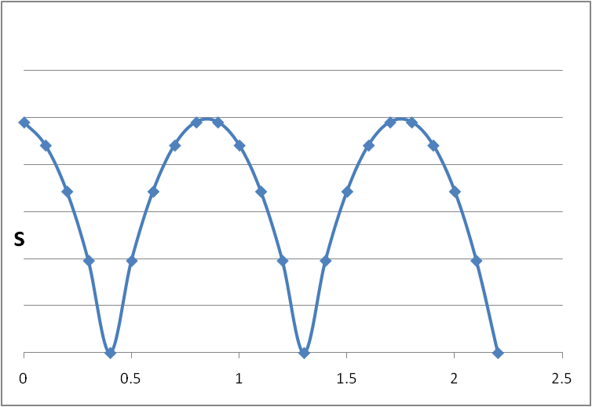 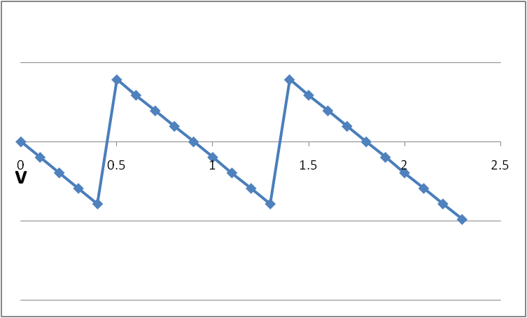

time

time

S vs t shows the ball starting at a +ve displacement…

It could have started at zero and bee below the x-axis

V vs t is the same regardless