*Godalming College Physics Department*

**Measurement of resistivity of a wire**

While conducting this experiment, you will be assessed for CPAC1: Following written instructions, including your ability to set up the circuit and CPAC2: Selecting suitable apparatus. Your lab report will be assessed for CPAC5: ‘y=mx+c’ analysis, percentage uncertainties and referencing standard values.

### **Theory**

The electrical resistance of an object depends on its dimensions and the resistivity of the material of which it is made. The relationship between these parameters is:-

 Where *R* = resistance ()

** = resistivity (m)

*l* = length of object (m)

and *A* = cross-sectional area of object (m2)

This can be rearranged as:-

(+0)

Comparing with  it can be seen that if you plot a graph of *R* against *l* it would be a straight line of gradient  which passes through the origin.

### **Apparatus**

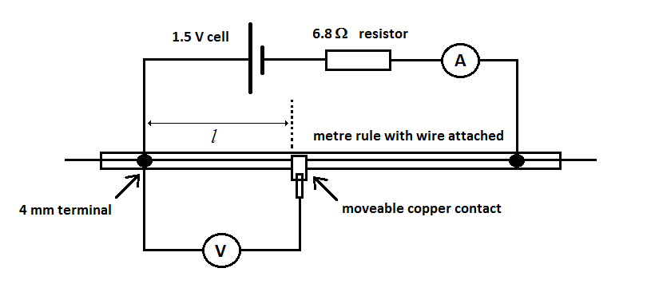

### **Method**

Before assembling the circuit, measure the diameter of the wire in several places. Write below the most suitable instrument to use for this measurement.

Assemble the circuit as shown. Use 2 digital multimeters and **select appropriate ranges** for the values observed. By placing the moveable copper contact onto the wire, you will measure and record the potential difference, V, across a number of lengths of resistance wire, *l*.

**Ask your teacher to check your circuit before proceeding – do not fully connect the cell until checked.**

Also record the current in the wire from the ammeter. This is unlikely to vary during the course of the experiment, but should be checked at regular intervals.

Note that *l* is the distance from the point where the right hand edge of the metal of the terminal connects to the wire to the left hand edge of the copper strip.

### **Results & Analysis**

For each length of wire, calculate and tabulate a value of resistance from R = V / I.

Plot a graph of R on the y-axis against *l* on the x-axis. Draw a best fit line through the points and measure the gradient.

From the analysis, the gradient of the line should equal 

Using the value of A calculated from the average diameter of the wire (πr2 or πd2/4), calculate a value of * *from the gradient of the graph.

### **Discussion & Conclusion**

The wire used in this experiment is made of the alloy Constantan.

Look up the resistivity of constantan to compare with your result. Don’t forget to reference the source of your accepted value. Calculate the percentage difference between your value and the accepted value.

Which single reading is most likely to contribute the greatest source of experimental uncertainty?

Using a middle value from your table, calculate the total percentage uncertainty in your resistivity value and compare this with the percentage difference.