# Godalming College Advanced Level Physics

Measurement of the Planck Constant from the Stopping Voltage

### Theory

When monochromatic light falls on the cathode of a photocell, the maximum energy of the emitted photoelectrons can be measured by the voltage that needs to be applied to stop the electrons reaching the anode (i.e. reduce the current in the circuit to zero). The equation for the stopping voltage, V0 is:

eV0 = hf - φ

Where e is the charge on the electron, h is the Planck constant, f is the frequency of the incident photons and φ is the work function of the metal surface.

**Apparatus**

The circuit is mainly contained within a commercial ‘Plank’s Constant apparatus’ unit. The connection of this to the other components is shown below. Note the use of a special coaxial lead to connect the picoammeter to the unit. In addition, you will need a set of colour filters.

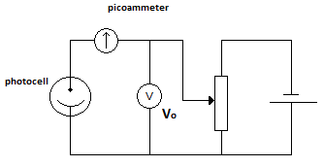

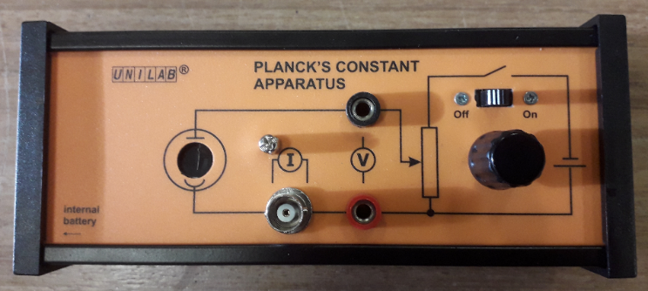

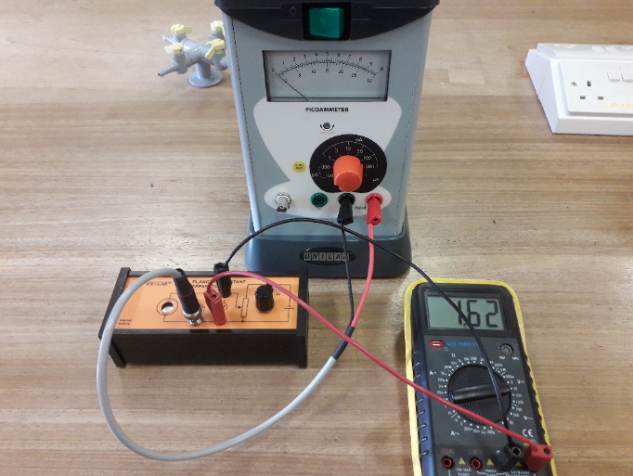

### Method

Ideally, the experiment should be conducted on a side bench with a good source of natural light. First zero the picoammeter - with the circuit disconnected, set the meter to the most sensitive range, turn on the device and press the auto zero button. If the meter does not settle exactly on zero, use the reading shown as your zero point value. Now connect the circuit as shown in the diagrams above and turn on the battery for the stopping voltage. Place each coloured filter in turn on top of the photocell and adjust the potential divider until the current shown on the picoammeter falls to the zero point. Record the stopping voltage for each colour. When you have finished, don’t forget to turn off the battery in the photoelectric unit.

### Analysis

The equation given in the theory section for the stopping voltage is:

eV0 = hf - φ

By dividing through by the electron charge, e, we obtain:

A graph of V0 against f will produce a straight line of gradient h/e, from which h can be evaluated.

The frequency can be found from the wavelength of the light by using c = f λ. The speed of light in a vacuum is 3.00 x 108 m s-1. The electron charge is a known constant (1.6 x 10-19 C).

Assume the following wavelength values for the filter colours:

Tokyo Blue 450 nm

QFD Blue 480 nm

Green 510 nm

Orange 570 nm

Red 630 nm

### Discussion

The wavelength values above are not necessarily those of the colours named. They come from the transmission data provided with the filters and correspond to the lower wavelength end of the bandwidth. Explain what this means and why this is an appropriate value to use. Remember to reference the source of any research.

Look up the accepted value for the Planck constant, remembering again to reference the source of your research.

Calculate the percentage difference between this and your value of h.

Estimate the percentage uncertainty in your measured values and compare this with the percentage difference.

### Conclusion

State your value for the Planck constant.