# Timing Oscillations of a paperclip chain



N.B. The link length is shorter than the length of a single paper clip as the clips overlap in the chain.

**Timing oscillations is an important U6 practical skill.** The period of oscillation, T, is the time taken for a complete to-and-fro motion. (E.g. middle → left → middle → right → middle or middle → top → middle → bottom → middle, where middle is the position where the oscillator is at rest).

There are a number of systems for which oscillations can be timed. Two, that are in the compulsory laboratory experiments, are the Simple Pendulum and a Vertical Spring.

To illustrate the situation for the experiment that you are going to plan:

The paper clip chain will hang vertically when suspended. This is the rest position from which timings are made. When pulled slightly to one side (but not too far) the chain will oscillate as one.

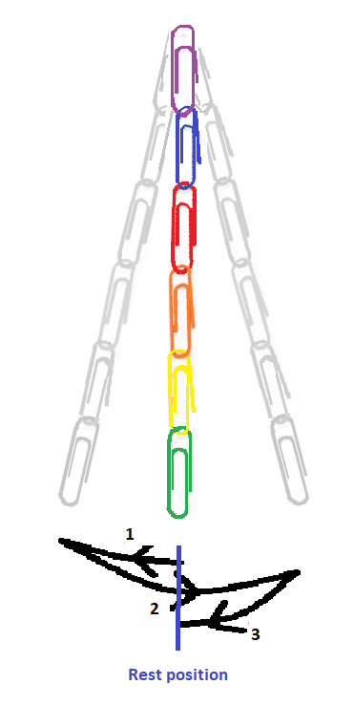

One oscillation is a complete to-and-fro motion i.e. 1 – 2 – 3