**Stationary Waves on a Stretched String**

This is a ‘waves’ experiment based on the following apparatus:

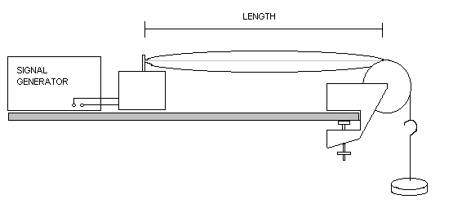

The diagram shows a standing wave on the string in its fundamental mode. This means there is one loop on the string, or n = 1, where n is the number of loops.

In general the frequency at which a standing wave builds up (in resonance) is given by:

f = nc

2***l***

Where n is the number of loops, c is the speed of waves on the string and ***l*** is the length of string between the vibrator and the pulley.

Providing the tension in the string is not changed, the wave speed remains constant and can be found with a ‘y = mx + c’ analysis from investigating either of the other variables (n and ***l***).

**Variation of frequency with number of loops**

This part of the experiment is straightforward! The resonant frequency is simply directly proportional to the number of loops on the string. Re-writing the equation in a different order gives:

f = c x n

2***l***

Which shows that the gradient of a graph of f against n will be c / 2***l***.

|  |  |
| --- | --- |
| n | f / Hz |
| 1 | 11.7 |
| 2 | 23.8 |
| 3 | 34.7 |
| 4 | 46.7 |
| 5 | 58.9 |
| 6 | 69.8 |
| 7 | 81.7 |
| 8 | 94.1 |

The table shows a set of results obtained with a string length of 1.2 m.

Plot a graph of f on the y axis against n on the x axis and draw a best fit line.

Measure and record below the gradient of the graph.

The theory shows that the gradient is given by: gradient = c

2***l***

Re-arrange this equation to make c the subject and then calculate the wave speed from the gradient of your graph.

**Variation of frequency with length of string**

The frequency of the standing wave is inversely proportional to the length of the string. The equation can now be written as:

f = nc x 1

2 ***l***

In order to produce a straight line graph it is necessary to tabulate a set of 1 / ***l*** values.

The following table was produced with a 2 loop standing wave (n = 2).

|  |  |  |
| --- | --- | --- |
| ***l*** / m | (1/***l***) / m-1 | f / Hz |
| 1.20 |  | 23.8 |
| 1.10 |  | 25.3 |
| 1.00 |  | 28.2 |
| 0.90 |  | 30.9 |
| 0.80 |  | 34.7 |
| 0.70 |  | 40.5 |
| 0.60 |  | 46.4 |
| 0.50 |  | 56.3 |

Complete the empty column in the table with a set of values of 1 / ***l*** to 2 decimal places.

Now plot a graph with f on the y axis and 1 / ***l*** on the x axis and draw a line of best fit.

Measure and record below the gradient of the graph (with units, if you can think what they are).

The theory shows that the gradient is given by: gradient = nc

2

If you remember that n = 2, it should be obvious in this case what the wave speed is!

You now have two experimental values for the speed of waves on the string. The final part of the analysis is to compare these two results. What is the most appropriate value to put in the denominator of a percentage difference calculation?

Calculate the percentage difference between your 2 values.