[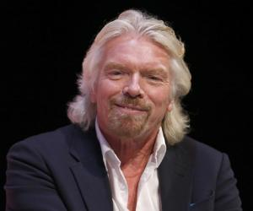](https://www.thefamouspeople.com/profiles/images/richard-branson-3.jpg)

Richard Branson is one of the wealthiest men in the world with a net worth of over 4.2 Billion.

Business tycoon of Virgin group

[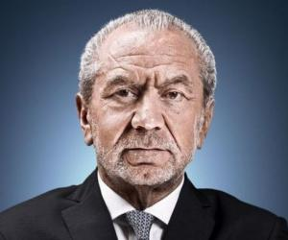](https://www.thefamouspeople.com/profiles/images/alan-sugar-2.jpg)

Lord Sugar is one of the best known Business men in the UK, setting up his own company at the age of 21 Amstrad- which he sold for millions.

Now best known as a Business mentor

[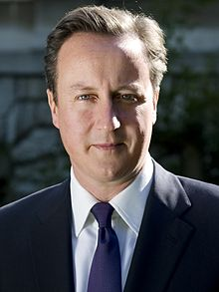](https://en.wikipedia.org/wiki/File:David_Cameron_official.jpg)

David Cameron- Former Conservative PM from 2010-2016

Now is still a member of parliament.

One of the youngest elected prime ministers

[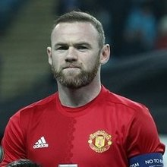](https://en.wikipedia.org/wiki/File:Zarya-MU_(6).jpg)

Wayne Rooney is an international footballer who now plays for a team in the US after many successful years at Manchester United.

Wayne was chosen to join a professional football academy at the age of 9

Attended a private primary and secondary school but left school before 16 with no qualifications. From a middle class family

Left school at 16 with low exam results but worked part time from the age of 12.

From a lower working class family

Attended a state primary school but didn’t achieve any GCSE’s until adulthood. He comes from a working class family

Attended a top public school- Eton and went to Oxford University. He comes from a wealthy upper class family.