**Godalming College**

*Booklet checked by*

*Grade: U/S 1 2 3*

*Comments:*

**Sociology Department**

**Why are there class based differences in the Education system?**

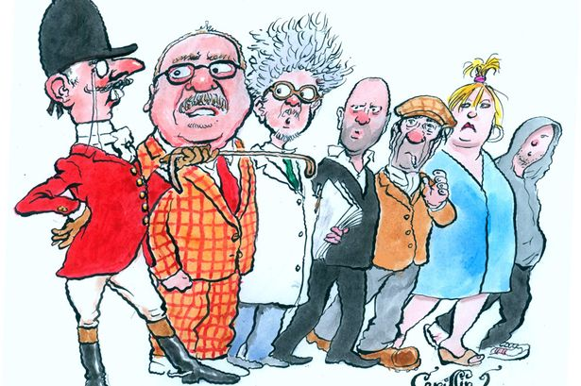

**The Sociology of Education (Paper 1)**

**Workbook 2**

|  |  |  |
| --- | --- | --- |
| **Name** | **Set** | **Group** |

**AQA Specification**

**Students are expected to be familiar with sociological explanations of the following content:**

* The role and functions of the education system, including its relationship to the economy and to class structure
* Differential educational achievement of social groups by social class, gender and ethnicity in contemporary society
* Relationships and processes within schools, with particular reference to teacher/pupil relationships, pupil identities and subcultures, the hidden curriculum, and the organisation of teaching and learning

**Learning objectives**

Tick the boxes when you feel confident you have a high level of understanding of the following:

|  |  |
| --- | --- |
| **Objective** | **Tick if met** |
| Be able to describe the pattern of class differences in educational achievement |  |
| Understand the difference between internal and external factors affecting achievement, providing detailed examples of each and evidence to support explanations |  |
| Be able to evaluate and analyse the role of different external and internal factors, both separately and combined, providing research and evidence to support points |  |

SECTION 1 – CONCEPTS OF CLASS AND SUCCESS

**What is Social Class?**

Social class is a concept that is widely used but sometimes difficult to pin down. Many sociologists have used the concept in very different ways, and identified a range of class categories – upper class, lower class, underclass, bourgeoisie, petit bourgeoisie, proletariat, lumpen proletariat, working class, middle class, upper middle class, lower middle class and so on. This will depend upon the underlying theory of the sociologist in question.

Using the Diagram below identify the range of indicators one could use to identify someone’s social class background. A few possibilities have been given to start you off.

**Social Class**

**Clothing**

**Language**

**School**

**Wealth**

Any or all of these indicators might contradict each other, so sociologists will often focus on a single aspect of class.

**THREE VIEWS OF SOCIAL CLASS**

There is no one set way of measuring class. Class can be described as a **social construction**.

**What do we mean by the term social construction?**

The definition of class can change over time and also across cultures. Over the years there have been a number of official ways that class is measured. The current official way of measuring class is the National Statistics Social Economic Classification (NS-SEC). This is described below along with some other Sociological explanations.

Generally, your class is based on your occupation, not level of wealth. The two are often linked however. These also link with level of education.

**1.NS-SEC**

The system of class in modern British society is measured, not by wealth and income, but by **occupational status**. Although this is related to income, the main focus of measurement in this scale is the type of job carried out and how a person is paid for the work they do. Previous class measurements have focused on skill, or ‘manual’ and ‘non manual’ labour. This class scale was developed to reflect the range of occupations in modern society and to recognise that skill and wages are not necessarily correlated in the way they once were. For example, a plumber would once have been categorised as a semi-routine or routine worker. Now plumbers can be small business owners, earn high wages and have much in-demand skills.

|  |  |
| --- | --- |
| **1** | **Higher managerial, administrative and professional occupations** |
|  | **1.1 Large employers and higher managerial and administrative occupations** |
|  | **1.2 Higher professional occupations** |
| **2** | **Lower managerial, administrative and professional occupations** |
| **3** | **Intermediate occupations** |
| **4** | **Small employers and own account workers** |
| **5** | **Lower supervisory and technical occupations** |
| **6** | **Semi-routine occupations** |
| **7** | **Routine occupations** |
| **8** | **Never worked and long-term unemployed** |

There are a number of sub categories between the sections above.

**What problems can you see with the NS-SEC measure?**

**2. The Marxist View of Class**

This is based upon wealth, and, in particular, the ownership of the means of production (i.e., industries) which economically dominate our society. It again assumes a hierarchy in society, but takes a very different form. In this case the division is between the Bourgeoisie (ruling class) and the Proletariat (working class).

**3.Pierre Bourdieu- 3 types of Capital**

This view describes how differing levels of cultural, social and economic capital can affect our life choices. Unlike the other two categorisations for class it does not just focus on the status of the individual based upon their job, economic position, or position of power. Instead Bourdieu attempts to show us how different factors in our lives, such as the values and attitudes of our parents (cultural capital) could affect our class.

**Take the Test….**

Go to <http://www.bbc.co.uk/news/magazine-22000973> and find out which class you are…..

**WHY DOES CLASS MATTER WHEN IT COMES TO EDUCATION?**

When students from lower working class backgrounds have been compared to middle class children of the same ability, it has been found that;

* They are more likely to start school unable to read
* They will do less well in SATS
* They are less likely to get places in the best state schools
* They are more likely to be placed in lower streams and sets
* They get poorer exam results – 75% of children from upper middle class backgrounds get 5 or more A*-C grades at GCSE compared to less than 33% from working class backgrounds
* They are more likely to leave school at the minimum age of 16 (but they have to stay in some form of education and training until they are 18) with no qualifications. Around 50% of working class children stay in post 16 full time education, compared to 90% of middle class children
* They are less likely to go to University – in 2008, 70% of children who went to University were from middle class backgrounds, 5% of children were from unskilled backgrounds.

**Activity:** Look at the list above. What possible reasons can you think of that explain why middle class students are more successful in the education system?

|  |  |
| --- | --- |
| **What goes on at home:** | **What goes on in the school:** |
|  |  |
| **How would a Functionalist explain the difference:** | **How would a Marxist explain the difference:** |
|  |  |

**Social class differences in educational achievement**

Social class is a key factor in the achievement of young people in education. Statistically middle class students fair better within he education system than their working class counterparts. Results from a UK-wide longitudinal study published in 2007 by the Centre for Longitudinal Studies found many children from disadvantaged backgrounds were already a year behind their more privileged counterparts at the age of 3.

Reasons for class differences can be explained in the following ways:

**EXTERNAL -** Factors that occur **OUTSIDE** the school. These are….

1. Material explanations- social and economic reasons
2. Cultural explanations- values, attitudes and lifestyles

**INTERNAL** - Factors that occur **INSIDE** the school. These are….

1. The way in which the school process works – how students are labelled and stereotypes, setting and streaming, language used and the hidden curriculum

An understanding of the **COMBINATION** of outside and inside factors is very important to being able to explain the reasons why working classes underachieve in education. The relationship between internal and external factors.

SECTION 2 OUT OF SCHOOL FACTORS CONTRIBUTING TO EDUCATIONAL ACHIEVEMENT WHY DO SOME STUDENTS FAIL WITHIN THE SCHOOL SYSTEM?

**Three out of school explanations:**

1. Material Deprivation – Poverty and the lower classes
2. Cultural Deprivation – Consensus perspective issues with the norms and values of the lower classes
3. Cultural Capital – Conflict perspective issues with the ideological hegemony of the upper/middle classes

**THE GOOD HOME**

**“The ‘Good Home’ is an aid to success in our school system. It is small; the parents are ambitious for their children; the father is at least a skilled manual worker; and if it is a working-class home, the mother has preferably ‘married down’. The father is somewhat ineffectual, perhaps rather feckless; but one of both parents are demanding, even ruthless in their expectations of achievement. relationships in the home are emotionally bleak. The family is unstable and has moved often; the mother goes to work. The children grow up to be rather withdrawn and solitary, conscientious and given to self-blame. They are ‘good grammar school material’.**

**F Musgrove - The Family, Education and Society (RKP, 1966) p.72**

**1. MATERIAL DEPRIVATION - POVERTY**

Sociologists of poverty have identified the **cycle of deprivation** or **cycle of disadvantage** ‑ this suggests that the "hard core" in society who are in poverty remain largely the same from one generation to another, i.e., deprived children in their turn become parents of deprived children.

Material deprivation is closely linked to the problem of educational failure, partly as cause and partly as effect.

Whilst this emphasis upon material deprivation as a cause of educational failure has lost force in the UK since the Second World War, with the increased prosperity of the working classes as a whole, it has not gone away. There has also been the developments arising from the 1944 Act with increased provision of free secondary education for all (through, for example, raising the school leaving age), and the institution of student grants and other sources of financial support for the poorest. Successive education acts, at least until the 1980s, attempted to enforce equal access to educational resources.

Poverty has been acknowledged as particularly prevalent amongst lower class families with children (hence the existence of the Child Poverty Action Group). Further, as poor families might create educational failure and this might lead to poorer job and career prospects; this could become a problem reproducing itself as a vicious circle. Rowntree identified 5 stages in the family life cycle where people might be more or less likely to risk poverty.

The Family Lifecycle

|  |  |  |  |
| --- | --- | --- | --- |
|  | ***Stage in lifecycle*** | ***Typical Circumstances*** | ***Poverty status*** |
| ***[a]*** | ***Childhood*** | ***Low family income and children to rear*** | ***In Poverty*** |
| ***[b]*** | ***Working youngster*** | ***Earns more than is paid to parents for keep*** | ***Not in Poverty*** |
| ***[c]*** | ***Young married*** | ***Children to support*** | ***In Poverty*** |
| ***[d]*** | ***Middle age*** | ***Children earning or have left home*** | ***Not in Poverty*** |
| ***[e]*** | ***Old age*** | ***Income falls, living on a pension*** | ***In Poverty*** |

When young children are in the family – consuming but not contributing to the family income - it is likely to be outstripped by expenditure. Children have to attend school and are restricted in any work they undertake. This could be crucial for some families on the margins of financial viability. Some of the children from these poorest families may be unable to take advantage of any opportunity that the education system might offer them.

How does the cycle of poverty impact upon someone’s life chances?

How might their education be affected?

**The hidden costs of ‘free’ state schooling**

The Aviva Family Finances report 2013 stated that the cost of sending a child to a state school, amounted to an average of £1614 each year per child for the basic school related expenses. These costs include paying for items such as;

School uniform

PE kit

Trips

Class materials

Stationary

Swimming lessons

School lunches

Travel

Photographs

Charity contributions

Extra curricular activities

Try to work out how much was spent on your schooling each year. If you went to private school add in the fees too:

**Task: Now read the BBC article (**[**https://www.bbc.co.uk/news/uk-northern-ireland-41115589**](https://www.bbc.co.uk/news/uk-northern-ireland-41115589)**) and see if it has given you any new insights to factor into your calculations…**

**How does material deprivation affect achievement?**

There is a clear link between those eligible for free school meals and educational achievement.

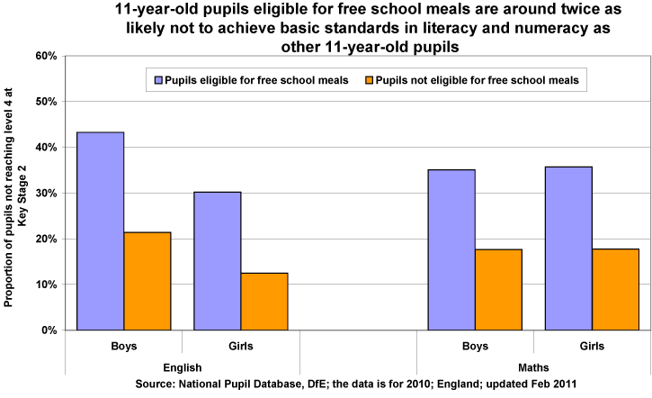

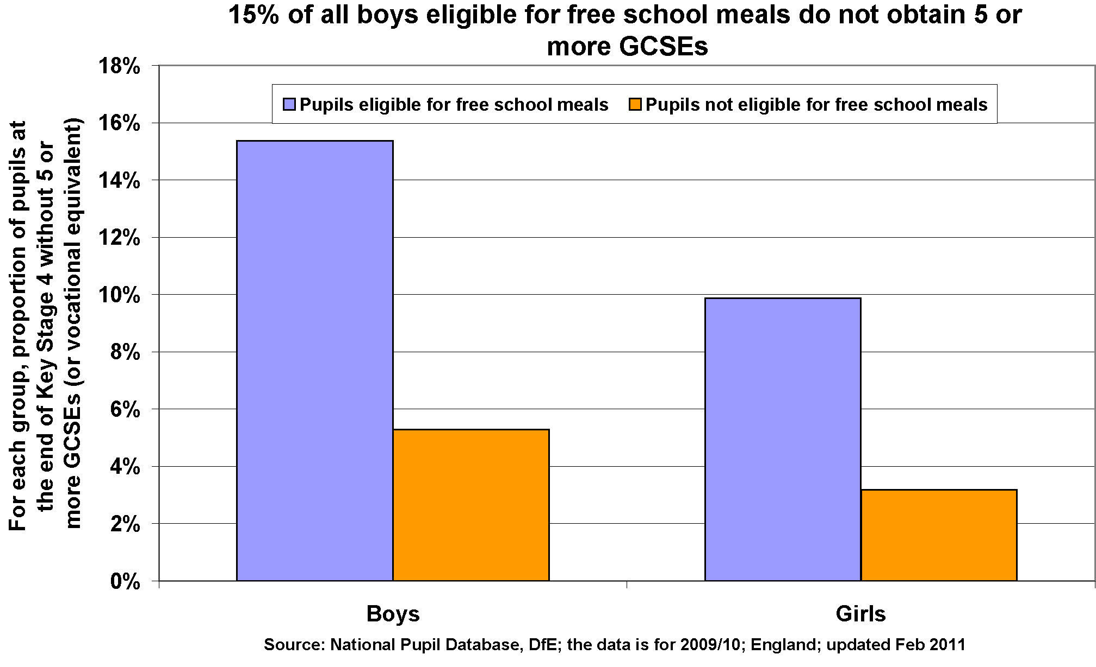

**We can see that this is a trend that continues in 2015 , with just under 10% of children on free school meals achieving the EBacc compared to nearly 27% of all other pupils.**

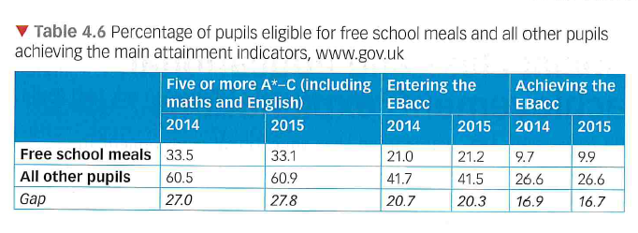

**What causes the link between free school meals and attainment?**

* Waldfogel and Washbrook (2013) – children from lower income backgrounds are more likely to live in damp and crowded accommodation and a home that is unclean and unsafe. This makes study at home difficult. This may also mean poorer diet and higher levels of illness.
* Cooper and Stewart (2013) – being poor may affect a child’s cognitive and social-behavioural abilities.
* Poorer parents are less likely to have access to preschool and nursery facilities which have been shown to significantly affect a child’s achievement in later life.
* Low income and employment means that educational resources, toys and books may not be afforded, including computers and money for school trips, private tuition and extra-curricular activities.
* Young people from poorer families are more likely to have part time jobs which may conflict with school work.
* Schools in poorer areas may be much more disadvantaged than those in affluent areas, suffering from many more social problems and parents will be less able to raise funds for the school.
* Parents may not be able to support children in further and higher education and possible debt may put off those from poorer backgrounds from attending University.

Affects from material deprivation may be cumulative, and various aspects may be linked.

**Links with policy:**

**Activity:** Returning to the content of the previous booklet, consider how policies since 1980 have disadvantaged working class pupils- try to give specific examples.

|  |  |
| --- | --- |
| Policy example | Impact on working class pupils |
| Marketization |  |
| Parentocracy |  |
| New Academies/Free Schools |  |
|  |  |

What studies from the previous booklet could we include here to support evidence of disadvantage?

What policies might be introduced to minimise the impact of poverty on educational success or failure?

2. CULTURAL DEPRIVATION

These arguments were popular in the 1960s and have taken on a new lease of life recently. They are often linked to functionalist approaches, and stress the dysfunctional culture of the working class home (as far as educational success or failure is concerned).

**Cultural deprivation**” is a kind of cultural “poverty” (as opposed to real, material poverty) and tends to view any culture which is not that of the teacher (white, middle class, etc.) as bad or inferior.

Douglas’ study of over 5000 parents in the 1960s concluded that parental interest was the single most important factor shaping success or failure. in *The Home and the School* (1964) he found parents who are culturally deprived:

* might not value school work sufficiently
* might not understand the demands of the work
* might not sufficiently enforce attendance or homework
* might not encourage children to stay in education beyond the minimum leaving age.
* might not read books, for example, and therefore not encourage their children to do the same.

This could be a result of their own feelings of failure from the education system, creating a vicious circle of failure within families.

CLASS SUBCULTURES

Subcultural theories - Sugarman

These the work of Herbert Hyman in the USA and Barry Sugarman in the UK have tended to emphasise the way that the values and norms of the working class household cannot sufficiently support the needs of the educational system. Working class values and norms stand as obstacles to educational success and there is a tendency to regard working class values as in some sense inferior and inadequate.

|  |  |  |
| --- | --- | --- |
|  | Types of Working Life | Attitude and Outlook |
| Middle class | 1. Relatively low starting pay - gradually increases 2. Career structure -- encourages planning for the future and investment, e.g., in training 3. Relatively secure 4. Emphasis on individual effort to improve lot | 1. Relatively optimistic - believes that success can follow hard work 2. Deferred gratification - working for exam results and putting off immediate pleasures 3. Individualism rather than Collectivism - individually competitive   VALUES SUPPORT THE NEEDS OF THE SCHOOL |
| Working class | 1. Full earning capacity attained relatively quickly 2. Few promotional prospects - little point in investment in training, etc. 3. Relatively insecure 4. Emphasis on collective effort to improve lot through Trade Unions, etc. | 1. Fatalistic - accepting the situation rather than striving to improve it 2. Present-time oriented concerned with immediate gratification - the pleasures of the moment rather than deferred enjoyment - no sustained effort for future exams and early leaving 3. Collectivism rather than Individualism - not the competitive ethos demanded by the school   VALUES DO NOT SUPPORT THE NEEDS OF THE SCHOOL |

**Evaluation:**

>Subcultural theories of education may offer some insight but they have been criticised in a number of ways. They may simply reflect the prejudices and opinions of middle-class sociological researchers, blaming the victim of deprivation or discrimination for their own failure.

What other problems can you see with this approach?

Language and educational achievement

Language presents a particular issue in deprivation theory and will be addressed in a supplementary booklet.

Bernstein (1971) found success in education depended highly on language- for reading, writing, speaking and understanding. Cultural deprivation could occur if children do not develop language skills in the home. This could ultimately disadvantage them at school. Bernstein argued there were two types of language:

Elaborate code- used mainly by middle class people. Involves a far greater range of words and the ability to communicate and understand. This sort of language tends to be used in a more formal context.

Restricted code- Bernstein argues all people use the restricted code but lower-working class people tend to use this language predominately, and are constrained to its use. This is the more informal language used between friends and family. It tends to include slang and everyday language.

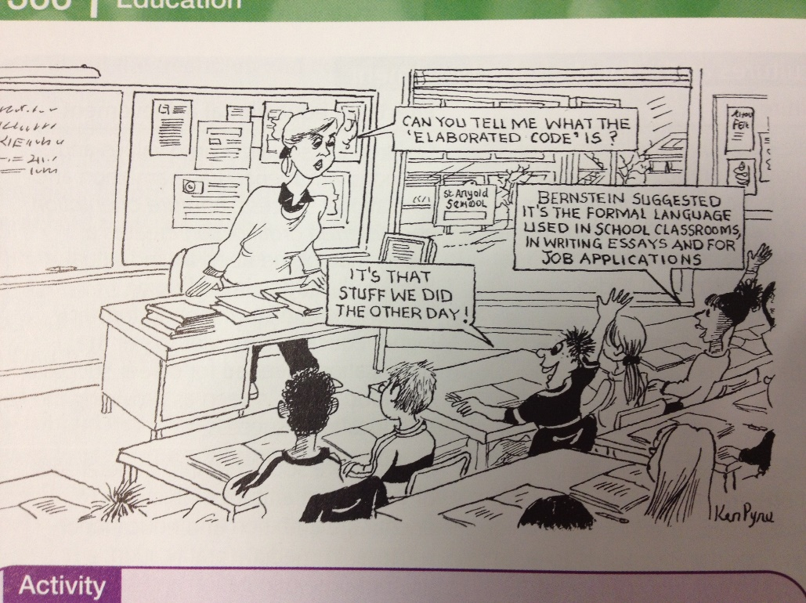Source Browne ‘Sociology for AS AQA’

Bernstein argues that working class children tend to do less well in the education system because the language of the school tends to be more elaborate. Middle class students who are used to using the elaborate code at home will find understanding the content of textbooks, writing essays and examination questions easier to learn than their working class counterparts.

How does the cartoon above explain how access to elaborate code might provide advantages in education?

3. CULTURAL CAPITAL - Pierre Bourdieu (Marxist/Conflict)

**Bourdieu** presents a very different type of culturalist explanation from a Marxist perspective. He believes that the main function of the education system is cultural and social reproduction, transmitting privilege and wealth from one generation of the ruling class to another.

**Cultural capital** refers to that culture which higher-class children possess before even entering the system and which they can **invest** into it. It dovetails with other forms of educational capital – economic and social. Cultural capital can be described as **‘high status knowledge’** – knowledge and culture which is seen as important and thought of well. This is useful in the school system and will help achieve success.

**Main points:**

1. Bourdieu assumes that both middle class and working class cultures are **equally valid**
2. He believes that middle/upper class are able to define their culture as *‘worthy of being possessed’* partly **through** **the power of the education system**
3. The dominant culture (**cultural capital**) can be translated into wealth and power through the education system
4. “***The success of all school education depends fundamentally on the education previously accomplished in the earliest years of life***.” -- in other words pre-school socialisation plays a large part in determining educational success
5. Middle-class children have a higher success rate in education than working-class children **because their culture is closest to the dominant culture**.
6. This culture is reflected in style rather than content
7. departures from accepted style in the way in which work is presented is penalized
8. teacher language and the general language of the school contains a range of meanings, not all of which will be accessible to working class students
9. The education system performs the essential function of **elimination** --the working class are eliminated through
10. **failure in examinations** - cultural disadvantages weigh against them
11. **Self-elimination**-- a “realistic” response to an unequal system (as Willis’ lads?)

Thus, the education system, though appearing to be meritocratic and neutral is, in reality, an institution that is concerned with *‘****the reproduction of the established order’*** by ensuring working class failure and middle class success.

How is the cultural capital approach different to the cultural deprivation approach?

Which do you prefer and why?

**Evaluations - evidence**

* Keddie (1973) states that cultural deprivation is a myth and argues it is a form of victim blaming. Argues that working classes are culturally different and not deprived – does this link with Bourdieu’s ideas?
* Mortimore and Whitty (1997) state that material deprivation has a greater effect on achievement than cultural ones. Robinson says that addressing child poverty is the most important thing that can be done to solve the issue – how would a Marxist respond to this?
* Sullivan (2001) argued that cultural capital only explains part of the picture. She states that greater resources and aspirations of the middle classes are the most significant factor.

**Summary of External – out of school – factors: Make sure you have a summary of this section and are clear of the differences between material deprivation, cultural deprivation and cultural capital.**

SECTION 3- IN SCHOOL (INTERNATL) FACTORS CONTRIBUTING TO EDUCATIONAL ACHIEVEMENT

Factors that occur in the school, or internal factors, are an important aspect of understanding class differences in educational achievement.

Many of these ideas are based on the Interactionist perspective. It is important to understand what Interactionism is and how it relates to the explanations outlined, to add depth and evidence to the argument.

**What is Interactionism?**

Sociologists that look at the way in which people interact in society are known as Interactionists – they are very similar to Interpretivists. Interactionist Sociologists look at the meanings people give to actions and how people internalise what they see around them, which helps them to develop their own identity and understanding of who they are.

Interactionists argue that much of the time people have the free will to create their own identities and behave as they wish, although they often recognise that they are guided by the ‘rules’ of society. Interactionism can be thought of much like a game of football – there are rules to the game (norms, values, expectations etc) but the way in which the game is played is up to the individual.

Interactionists tend to emphasise the importance of human ideas which create society. These ideas start with the individual and therefore Interactionists are interested in the way in which individuals create meaning and actions and are not so focused on the structure of society, like Marxists and Functionalists.

Interactionists generally feel that we develop our self-identity through the way in which we believe others see us. The interactions we have with others help us understand who we are. Much of the time we are acting in society, we are putting on a front to the world about who we believe we are based on how we have understood their behaviour towards us.

**Labelling and the self-fulling prophecy**

Because Interactionists are interested in individuals, within an education context, they like to look at the small-scale (micro) interactions within the school, often involving student and teacher.

Interactionists emphasise the idea of teacher labelling and say that this can have a significant effect on the way in which a student views themselves and their abilities – thus causing them to succeed or fail at school.

**Activity:** Write a defintion for the two words below and then provide examples of how a labelled might be applied to a student and the consequent self-fulfilling prophecy

|  |  |
| --- | --- |
| **Definition** | **Examples** |
| **Labelling** |  |
| **Potential Self-Fulfilling Prophecy** |  |

**Labelling: The ‘Ideal Pupil’**

**Becker (1971)** was an Interactionist Sociologists who looked at labelling in 60 Chicago high schools. He stated that teachers judged a pupil based on how closely they fitted their idea of the ideal pupil.

**What do you think makes the ‘ideal pupil’?**

Becker stated that middle class children were closest to the ideal and working classes, furthest from it. However, some teachers have different ideas of what makes an ‘ideal pupil’.

|  |
| --- |
| Outline Hempel-Jorgensen’s (2009) study on what made the ideal pupil in two different primary schools, p.27 of Webb.  Compare this to Dunne and Gazeley’s (2008) study of labelling in secondary schools, p.28 |

**The Self Fulfilling prophecy**

Outline the steps that occur within the self-fulfilling prophecy: (p.28 Webb)

1.

2.

3.

A famous interpretivist study was carried out in 1968 to demonstrate the idea that how a pupil was treated, could have a major effect on whether they succeeded or failed at school.

Rosenthal and Jacobson carried out and experiment and were able to gain access to a Californian primary school. They told the school the children would be sitting an IQ test, which would identify students who they believed would ‘spurt’ ahead. This was not true – the test was a normal IQ test, however the teachers believed them. The researchers then picked 20% of the students at random and told the teachers these students were the ones who would ‘spurt’ ahead. When returning a year later, nearly half of these students randomly identified had made significant progress.

*How does this demonstrate the self-fulfilling prophecy?*

*Why, from an Interactionist view, do students succeed or fail depending on teacher expectation?*

**Other Internal reasons for working class underachievement:**

**Setting and Streaming**

**Setting and Streaming:** separating students into different ability subject groups (setting) or for all subject groups (streaming).

How is this a form of labelling and the self-fulfilling prophecy?

**Activity:** Outline key studies for setting and streaming

|  |  |
| --- | --- |
| Study | Description |
| **The A-C Economy** Gillborn and Youdell (2001) |  |
| **Educational Triage**  Gillborn and Youdell |  |

**Abolishing streaming**

Stephen Ball (1981) looked at what happens when streaming is abolished in his study of Beachside Comprehensive. He found that teachers continued to categorise students and merely used more differentiation –gave different work set at different levels of ability to different students. They were still more likely to label middle class students as cooperative and able.

**Pupil Subcultures**

A subculture is a culture within a culture – they share some norms and values with the rest of society and have some of their own.

A pupil subculture is a group of students who share similar interests, behaviours and values.

Using the definition, above what examples of pupil subcultures can you think of?

**Lacey** (1970) used the terms differentiation and polarisation to explain how and why subcultures develop in school.

**Differentiation:**

Teachers categorising students depending on ability – setting and streaming is a form of differentiation. Higher ability students are given more status and those in lower ability sets and streams and given lower status.

**Polarisation:**

The way in which pupils respond to differentiation by moving to towards one of two ‘poles’ or extremes. Lacey argued this was in the form of either a pro-school or an anti-school subculture.

**Pro school subcultures**

Pupils placed in high streams remain committed to the values of the school, gaining status in a socially acceptable manner, through academic success.

**Anti-school subculture**

Often consists of those placed in lower streams and sets – often tending to be working class – due to a loss of self-esteem as the school as undermined their self-worth by putting them in a position of inferiority. The pupils then seek to improve their status, however this is often in a way that is socially unacceptable, rebelling against the values of the school. Pupils in an anti-school subculture often seek to gain status from their peers rather than the school as this is an organisation which they feel has rejected them.

Joining an anti-school subculture creates more problems for pupils.

**Activity –**Outline Hargreaves (1967) study to support Lacey’s ideas, p31 of Webb et al textbook

What other responses to pupils have to labelling and streaming according to Woods (1979)? p.31

**Ingratiation:**

**Ritualism:**

**Retreatism:**

**Rebellion:**

**Identity and the school**

In school factors are important factors that can explain differential educational achievement according to class.

Sociologists are also interested in how school interacts with the class identities that pupils form outside the school.

Using Louise Archer et al’s (2010) study ‘University’s not for me, I’m a Nike person’ (which can be found at the end of this booklet), explain how this is a significant factor in underachievement.

**Nike Identities (Archer et al 2010)**

The way in which the working classes seek to gain status in society using heavily branded clothing. Appearance and style was a way of earning symbolic capital and constructing a meaningful class identity.

However, again this often clashes with the culture of the school, although it gained approval from peers. Some teachers interpreted such branding as a threat or a rebellious act.

Archer argues that this affects working class students understanding of higher education also. University was seen as ‘undesirable’ because it would not suit their preferred style of habitus. It was also seen as unrealistic as was seen as a risky investment and not somewhere where they would ‘fit in’.

**Habitus**

Archer et al use Bourdieu’s ideas to understand this relationship, including the idea of habitus

<https://www.youtube.com/watch?v=RjEjS1DMFpE> <https://www.youtube.com/watch?v=87BPL62wyyU>

Watch the clips and explain what is meant by ‘Habitus’ in your own words.

**Habitus**

Bourdieu argues that each social class possess their own cultural frame work or set of ideas, which he calls **Habitus.** This cultural framework contains ideas about what counts as good and bad taste, good books, newspapers, TV programmes etc. The habitus is learned through socialisation in the family.

The dominant class is able to use their power to impose their own habitus in the education system, so what counts as educational knowledge is not the culture of society as a whole, but the culture of the dominant class – the middle and upper classes.

This is linked to **cultural capital** – educational success is based on possession of cultural capital and access to habitus of culture of the dominant social class.

**Symbolic Capital**

This is what is gained from achieving in school as a result of possessing the habitus of the school. Middle class students are those who possess the habitus school and as a result are recognised and valued by the school and the symbolic capital they gain, reinforces the status of the middle classes as superior, and the working classes ‘inferior’. Bourdieu argues that by defining working class culture as inferior, inequality is reproduced, which keeps the working classes ‘in their place’. He calls this ‘Symbolic violence’.

**How does this affect achievement?**

School is a middle class organisation, run by middle class people and has a middle class culture. Middle class habitus clashes with the habitus of the working class and therefore they are unable to fit in as easily at school and are disadvantaged as soon as they start.

**Evaluation of Labelling and in school factors**

Do all working class students fail?

Does labelling theory adequately explain where the stereotypes come from?

What would a Marxist say?

What would a Functionalist say?

What would a Feminist say?

**Evaluation – evidence.** Read the studies on p33-34 of Webb, and outline how they evaluate internal factors….

|  |  |
| --- | --- |
| **Ingram (2009)** |  |
| **Evans (2009)** |  |

**SECTION 4 - THE RELATIONSHIP BETWEEN INTERNAL AND EXTERNAL FACTORS**

Activity: Read the box below and answer the questions that follow.

**The Brutal Truth**

**….but what do we mean by a good school? Examination results are the only criteria we accept, and politicians imply these have something to do with the quality of teaching, sound leadership, strong discipline, clarity of aims and so on. These can all make a difference. The brutal truth, however, is that the surest way to turn a bad school into a good school is to change the pupils who attend it…..**

**Parents, particularly middle class parents, look at exam results and choose schools accordingly. Some don’t bother with results; they see well scrubbed, nicely dressed and well behaved pupils and say that’s the one for their child. They are right: home background, as youd expect when you think about how much more time children spend at home than school, is another guide to attainment….a school can change the head, sack teachers, crack down on truancy and bad behaviour…these things may make the school happier, more peaceful, more business-like. They may even improve exam results. They will make no long term difference at all unless the intake changes…rebranding the school may make a difference…a bright new wrapper always helps…but as long as schools have differing pupil intakes, come will be deemed good and some will be deemed ‘bad’.**

**Peter Wilby, Parents admissions trauma is down to gross inequality outside the school gates , The Guardian 5th March 2009.**

1. Describe in your own words what Wilby means by ‘The Brutal Truth’
2. How do you think Wilby would respond to the view that good schools can make a difference to the life chances of students?
3. Suggest what Wilby thinks are the main factors that affect whether or not is judged good or bad
4. What does Wilby suggest might be the main factor influencing educational achievement?

In order to fully understand class based differences in achievement, we must understand how internal and external factors combine.

* Habitus – identities are formed outside the school but when expressed within the school may cause conflict
* Languages used at home can cause teacher labelling
* Stereotypical views of working class pupils home life can also cause teachers to label
* Poverty can lead to truancy and subcultural formation, which is linked to underachievement
* Wider national policies and trends may affect internal school processes. For example, league tables and the A-C economy.

You may also be able to make your own links between external and internal factors from what you have learned.

**Archer, L., Hollingworth, S. And Halsall, A. (2007) 'University's not for Me - I'm a Nike Person':**

**Urban, Working-Class Young People's Negotiations of 'Style', Identity and Educational Engagement, *Sociology,* 41, 2: 219-237**

Despite the government's wish to increase the numbers of working class young people entering Higher Education, the numbers of working class students currently going to university is low. Many leave education for good at 16. This research, which is part of a larger study on young, urban, working-class people, considers ways in which members of the social group invests in a style and identity which help to shape their view that 'university's not for me .. .'. The aim of the study was to explore the identities and aspirations of young people in London schools, who had been identified by teachers as 'at risk' of dropping out of education or 'unlikely to progress into post-16 education'. Archer et al argue that the identity taken up and acted out by urban working class youth is one based on knowing they are looked down on by their middle class peers, by the school system and by wider society. They argue that urban, working-class youth actively negotiate a position of social disadvantage which is based on a certain style: ' ... I'm a Nike person .. .'. However, this adopted style merely reinforces the reality of their marginalised and disadvantaged social status and results in a lot of conflict with teachers and the school system. For example, in a discussion about wearing trainers in school, one girl commented:

*"It's just shoes, I don't understand the rule Shoes don't affect my learning* " (Jordan, white

working class girl).

Archer et al also argue that holding the view that 'university's not for me' means that these young people are less likely to be successful in education. The researchers also argue that working class urban youths' style differs from that of middle class youth and is one of the contributory factors in relation to the reproduction of educational inequalities.

The research took place over two years in six London schools. The schools were spread out across the city: two in the North, one in the East, one in central London and two in the West. They wanted to include a range of schools from different areas and with a diversity of pupils which were selected on the basis of data on pupil achievement from the Department for Education. All of the selected schools had a high proportion of underachieving pupils and were from disadvantaged areas. The access was obtained by initially contacting head-teachers who then acted as gatekeepers to the Year 10 and 11 form tutors and who also put the researchers in touch with some support staff. Pupils who were 'at risk' of dropping out of school were identified by the schools and the research team then wrote to their parents/guardians as well as the pupils themselves to gain permission for the interviews. Following this initial contact all of the pupils who agreed to take part were included in the study. The data was collected from interviews with fifty-three pupils from Years 10 and 11, discussion (focus) groups, photographic diaries and semi­structured interviews with teachers. Most of the fifty-three young people, whose age range was 14-16 years old, were interviewed four times. Some of the sample group left the study as a result of moving away or changing their contact details. The sample was comprised of twenty three girls and thirty boys. In relation to ethnicity the breakdown was thirty-six white UK, one Black African/Caribbean; six mixed ethnicity; four Asian; three Middle Eastern and three White other. The young people all lived in socially disadvantaged areas where there was high poverty, crime and drugs. They attended schools which were undersubscribed and considered less attractive than other schools in the area. Many of the interviewees had experienced repeated failure from the constant testing (SATS) they had endured during their school careers and described themselves as 'stupid' or 'not exactly a star student'.

In addition to the semi-structured interviews, eight pupils were asked to keep photographic diaries (they were invited to take photographs of anything that was either meaningful to them, reflected their identities or their daily lives), and a further 36 pupils took part in discussion groups - five pupils in each. The interviews varied in length from half an hour to one and a half hours. This enabled Archer et al to collect data that was, in the main, qualitative. The interviews were conducted on the school premises although a few took place in local cafes or other places identified by the pupils. These were usually when a pupil had left school or were frequently absent. Some interviews took place in Pupil Referral Units (PRUs) when pupils were moved into them by the schools over the two years.

In relation to ethics, parents of the pupils involved were asked for consent since the pupils were under 16 years old. The pupils' identities were anonymised by the use of pseudonyms which the pupils chose themselves. All of the interviews and discussion groups were audio recorded and a professional transcriber was employed to type them up.

Archer et al found that the style of the urban young working-class youth was linked to their class identity. A style which gave them a sense of self-worth and value and which enabled them to resist the worthlessness they might otherwise experience from attending 'crap' schools in 'rubbish areas'. They saw the style as 'cool' which was partly related to its association with black masculinity which was distinct from that of the middle class and symbolised 'hardness' and 'street cred'.

*"You wouldn't really expect [upper class] people to come out in Nike tracksuits and stuff, we expect them to have that Gucci designer stuff. But people like* us ... *we're Nike"* (Sean, Year 10 male).

**Key words and summaries of key studies**

|  |  |
| --- | --- |
| **Material deprivation** |  |
| **Cultural Deprivation** |  |
| **Theory associated with cultural deprivation** | |
| **Cultural capital** |  |
| **Theory associated with cultural capital** | |
| **Bourdieu** |  |
| **Sugarman** |  |
| **Douglas** |  |
| **Waldfogel and Washbrook** |  |
| **Rowntree foundation** |  |
| **Bernstein** |  |
| **Archer et al** |  |
| **Labelling** |  |
| **Self Fulfilling Prophecy** |  |
| **Setting and Streaming** |  |
| **Subcultures** |  |
| **Woods** |  |
| **Habitus** |  |
| **Symbolic capital** |  |
| **Nike Identities** |  |
|  |  |
|  |  |
|  |  |

**Possible exam questions (A level)**

Outline two cultural factors that may affect social class differences in educational achievement [4 marks]

Outline two ways material deprivation may have an impact on achievement [4 marks]

**_________________________________________________________________________**

Outline three ways in which pupils may respond to labelling and streaming [6 marks]

Outline three ways a pupil’s identity could influence how well they do at school [6 marks]

Outline three reasons why labelling in schools may lead to the formation of anti-school subcultures [6 marks]

Outline three ways in which government educational policies have attempted to reduce inequality in achievement between social classes [6 marks] [*O’Leary revision book*]

**__________________________________________________________________________**

Item A: Some sociologists argue that a major role of the education system is that it should provide equal opportunities for all pupils to succeed so that they can be allocated to their most appropriate role in the economy. However, statistics of achievement suggest that schools systematically fail the majority of working class pupils. Sociologists critical of this view have put forward a number of reasons why working class students end up in working class jobs.

Applying material from item A, analyse two ways in which the education system legitimises or reproduces social inequalities [10 marks]

Item A: In general, middle class pupils achieve better examination results than working class pupils, many of whom are in receipt of free school meals. According to Feinstein, as early as 22 months, working class children are already lagging behind middle class children in their intellectual development. Many of these children have parents who also underachieved at school.

Applying material from Item A, analyse two factors outside schools that contribute to working class underachievement [10 marks]

Analyse two in school factors that lead to the underachievement of working class pupils [10 marks]

Analyse two in school reasons that lead to the underachievement of working class pupils [10 marks]

Analyse two factors inside of schools that may contribute to the formation of the ‘ideal pupil’ identity [10 marks]

(*Please note, 10 mark questions will be accompanied by an item*)

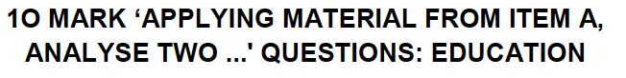

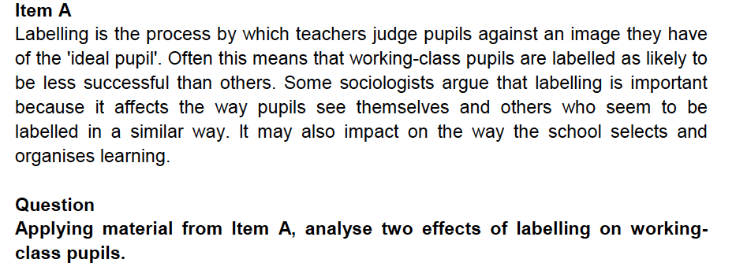

**___________________________________________________________________________**

Item B: Since the 1980s successive governments have implemented a range of policies aimed at introducing market forces into the state education system. It is claimed that marketization policies such as league tables and increasing diversity in the types of schools that parents can choose to send their children to, would increase competition and so raise standards. However, some sociologists have been critical of such policies and have argued that the educational market favours middle-class parents.

Applying material from Item B and your own knowledge, evaluate the claim that marketization policies in education have increased inequality between social classes [30 marks]

Item B: There are major social class differences in educational achievement and some sociologists argue that these are the result of internal factors and processes within schools. These include teacher labelling, the self-fulfilling prophecy, streaming and the creation of pupil subcultures. However, other sociologists claim that factors outside the school, such as parental attitudes and parental income, are the main causes of working class underachievement.

Applying the material from Item B and your knowledge, evaluate the view that social class differences in achievement are the result of what goes on within schools [30 marks]

Applying the material from Item B and your knowledge, evaluate the claim that factors outside of school are the main cause of working class underachievement [30 marks]

Applying the material from Item B and your knowledge, evaluate the claim that teaching labelling is the main cause of working class underachievement [30 marks]

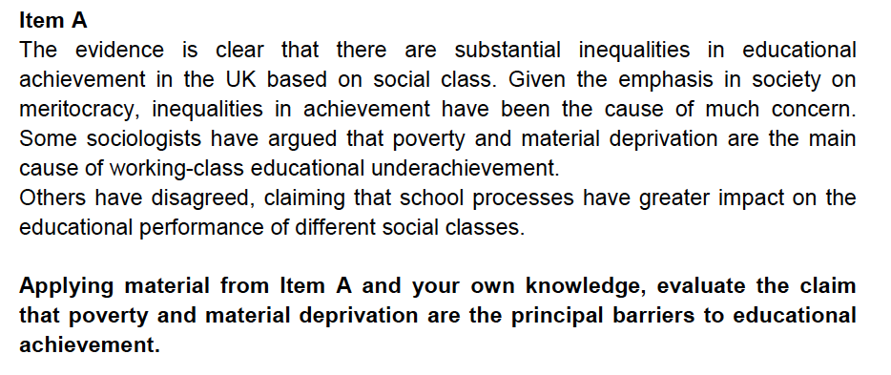

[30 marks]