**Godalming College**

Booklet Checked by: _____________

Grade: U/S 1 2 3

Comment: _______________________________________________________________________________________________________________________________________________________

**Sociology Department**

FAMILY DIVERSITY

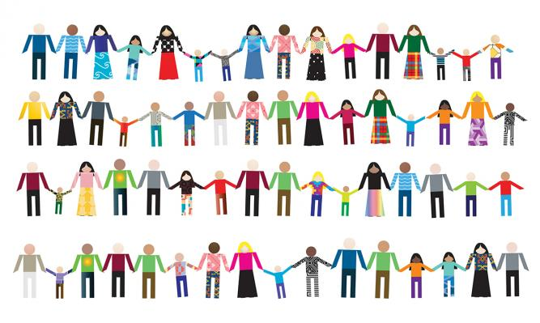

**WORKBOOK 4 (Paper 2 Family)**

|  |  |  |
| --- | --- | --- |
| **Name:** | **Set:** | **Group:** |



**The AQA Specification:**

* Changing patterns of marriage, cohabitation, separation, divorce, childbearing and the life course, including the sociology of personal life, and the diversity of contemporary family and household structures.

**DIVERSITY IN THE FAMILY**

WHAT YOU NEED TO KNOW

Outline, explain, analyse and evaluate sociological explanations for:

- The wide range of different family forms in the UK today

- Different types of family diversity

- The impact of family diversity on society

Outline, explain, analyse and evaluate whether there is family diversity in the UK today

Families in the UK have become increasingly diverse, this is as a result of changing patterns in society and demographic changes (which will all be explored later in the booklet). The aim of this booklet is to explain the key changes that have occurred and offer explanations for them.

**What is meant by the term DIVERSITY?**

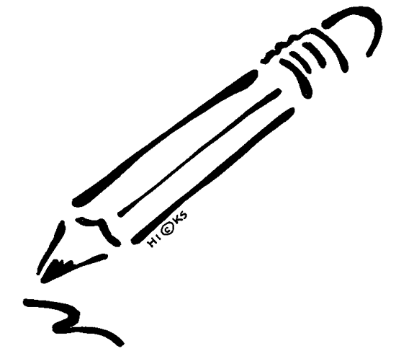

From your own knowledge and use of resources such as the internet, brainstorm what is meant by the term diversity:

DIVERSITY

Now, thinking about the family come up with as many ideas of how you think the family could be diverse, fill up the space below:

**The Stereotypical British Family**

When we are talking about diversity it means that there are differences. Difference from what, you may ask. In most cases it is difference from the dominant stereotypical British family; the nuclear family.

For some sociologists diversity is seen as evident throughout families in the UK, for others diversity is not that evident and the nuclear family is still dominant, for some, particularly politicians of the New Right diversity is viewed as a source of problems in society.



Below, draw a picture of the dominant stereotypical family of the UK.

**What problems can you see with this stereotypical image of the family?**

**Who would agree with this image of the family?**

**Who would be opposed or challenge this image of the family?THE DEBATE**

**DIVERSE**

**vs**

**NUCLEAR**

**The dominance of the nuclear family?**

The nuclear family structure consisting of two generations; parents and children, where the children are either the biological off spring of the parents or the children are legally adopted, is the dominant family structure in the UK today.

**Statistic:** In 2013 75% of children were living in a couple headed household. As compared to 25% who were living in a lone parent household (2% being lone fathers).



What do these statistics not tell us?

**Functionalism**

**Parsons** regards the nuclear family structure as the best ‘fit’ for the needs of an industrialised society.

It is universal- **Murdock** (who you will remember from your perspectives workbook) saw the nuclear family as universal- whereby it could be found in all cultures, either as a family in its own right or as part of a more complex extended network.

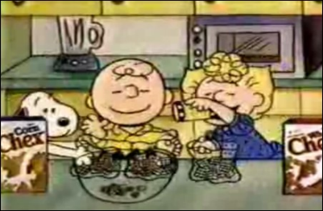

The nuclear family is presented as ‘normal’- **Leach** regarded the nuclear family as the ‘cereal packet’ image of an ideal family in the 1960s of a heterosexual couple and two children who were close in age.

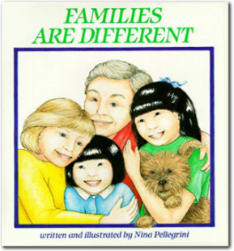**Robert Chester** (1985)- most people will at some point in their life live in a nuclear family structure. He finds theories of diversity misleading, believing that for most British people the basic features of family life have stayed the same. He calls the family now ‘neo-conventional’, by which he means that although there may be changes to the roles within the family e.g. men no longer being the main breadwinner, little has changed to the actual structure. (See p.226 of AQA A Level Sociology Book One, Webb)



|  |
| --- |
| What do you imagine the life course/cycle of a typical individual in the contemporary UK? Draw a picture of this below |

|  |
| --- |
| Postmodernists, Alan and Crow would argue we don’t pass through ‘typical’ life cycles in our families anymore, why is this? |

**Feminism**

Ann Oakley (1984)- saw the nuclear family as being ‘conventional’. It consists of a legally married heterosexual couple with children.



Oakley is critical of the sexual division of labour of men and women in the home because of the burden it places on women. So why do you think she still thinks the nuclear family is conventional?

**The New Right**

These theorists adopt a conservative and anti-feminist approach to the family. They firmly oppose family diversity, believing there is only one correct family type; the nuclear family. They argue it is necessary and functional because it is ‘natural’ and based on fundamental biological differences between men and women.

They argue the decline in the nuclear family is the cause of many social problems.

Benson’s (2006) study shows that cohabitating couples (20%) are more likely to separate after having a child than married couples (6%).

Amato (2006) children in nuclear family are less likely to experience poverty, education failure crime and health problems.

|  |
| --- |
| Do you think the decline in the nuclear family is to blame for many social problems in society? |

**Is the family diverse?**

**Rapoport and Rapoport (1982)**

The Rapoport’s offer a Postmodern approach to exploring the nature of the family. They argue that only a minority of families resemble the nuclear family ideal (a married couple with dependent children) as forwarded by Functionalist theorists and Ann Oakley.

They argue that family life in the UK is characterised by diversity because people live in range of different family types with diverse internal set ups.

**Key idea:** The family structure someone lives in is not the only way of looking at the nature of family life. People may live in a similar nuclear structure but this does not take account of differences both within and outside that family.



**Rapoport and Rapoport (1982) conducted a study on family diversity in the 1980s and identified five elements of difference (p.227-228 of Webb textbook):**

|  |
| --- |
| **Organisational diversity** |
| **Cultural diversity** |
| **Class diversity** |
| **Stage in the lifecycle diversity** |
| **Cohort diversity** |

**Eversley and Bonnerjea (1982)- added a 6th form of diversity to Rapoport and Rapoport’s study:**

|  |
| --- |
| **Regional diversity** |

In addition to these 6 forms of diversity **Willmott** in his 1988 study found many families which on the outside could be viewed as being nuclear or single-parent etc. were part of complex extended structures. He identifies 4 types of extended family:

|  |
| --- |
| **Extended family of residence** |
| **Local extended family** |
| **Dispersed extended family** |
| **Attenuated extended family** |

**CULTURAL DIVERSITY**

Cultural diversity refers to differences in family structure and lifestyles between ethnic and religious groups largely arising from immigration into the UK, and particularly the large-scale immigration that occurred between the 1950s and early 1970s.

Using p.311 of Browne make notes on characteristics of families within different cultural groups:

|  |
| --- |
| **Caribbean families (include Berthoud’s study)** |
| **South Asian families (include Ballard’s study)** |

**POSTMODERNISM AND FAMILY DIVERSITY**

Using pp.228-232 of the AQA A Level Sociology book one (Webb – can be found in the library or in the classroom), summarise the Postmodern view of family diversity below:

|  |  |
| --- | --- |
| Overview of postmodern approaches to family diversity | (Including David Cheal) |
| Judith Stacey (1998) |  |
| Individualisation thesis (Beck and Giddens) |  |
| Giddens- choice, the pure relationship ‘Confluent love’ |  |
| Beck and Beck Gernsheim- the negotiated family |  |
| The zombie family |  |
| Criticisms of individualisation thesis: personal life perspective- Smart p.292 |  |
| Connectedness thesis |  |

**Other forms of diversity**

|  |  |  |
| --- | --- | --- |
| **Trend** | **Study** | **Summary** |
| Decline in marriage/ changes in expectations of marriage | Allan and Crow (2001), p.213 Webb |  |
| Increase of beanpole families | Brannen (2003), p.222 Webb |  |
| Lone parenting | Cashmore (1985), p.219 Webb |  |
| Sexual diversity | Weeks et al (1999), p.217 Webb |  |
| Young people more likely to stay living at home | Heath (2004) p.312 Browne |  |
| LATs (living apart together) | Duncan and Phillips (2013) p.218 Webb |  |
| Increase of adults who are not having children | p.218 Webb  Add some statistics |  |

**Exam Question Examples**

**AS and A Level 10 mark Questions**

Outline and explain two ways in which increased family diversity undermines the claims of the New Right. [10]

**A Level 10 mark Questions**

Item A: The different cultural traditions, migration patterns and economic circumstances of different minority groups are reflected in the ethnic differences in family and household patterns seen in the United Kingdom today. These include differences in the proportion of people from different ethnic groups who live in single person, nuclear family, lone-parent and extended family households

Applying material from Item A, analyse two reasons for ethnic differences in family and household patterns [10 marks]

**AS and A Level 20 mark essays**

*Other possible 20 mark questions that are missing items*

Evaluate the view that demographic changes are leading to more family and household diversity in the contemporary UK [20 marks]

Evaluate the view that the changing position of women in society has led to more family and household diversity in the contemporary UK [20 marks]

Evaluate the view that the family has become increasingly diverse [20 marks]

**Essay plan: Is the nuclear family still dominant?**

Item: In the mid twentieth century, the nuclear family was seen as the most common and also the most desirable family type. This is evidenced in the work of functionalists. Since then there have been many change to families and households in Britain and a greater diversity of family types, so that some sociologists now argue there is no longer a single dominant type of family and even families that may appear nuclear may vary considerably.

**Applying material from the item and your knowledge, evaluate the view that there is no longer a single dominant type of family in Britain today [20 marks]**

Paragraphs in 20 mark questions:

The Sociology sandwich is exactly the same as the burger idea we use for 10 marker, but it needs you to include more analysis/evaluation (using other studies, theories or methodology) to counter the point you are making. Each paragraph should have the elements of this ‘sandwich’ before you move onto your next point.



**Key areas of the question that you need to address:**

|  |
| --- |
| What does the question want? |
| **Introduction:** needs to address the debate and define key concepts in the question. Provide a brief overview of who would argue there is no longer a dominant family and who would argue that the nuclear family is still dominant. |
| How could you use the **item** (this needs to be referred to at least twice during the essay) |
| What key concepts will need to be included? |

|  |  |
| --- | --- |
| **Arguments for families being diverse(Any arguments in this side should be argued against using the other side)** | **Arguments for the nuclear family being dominant** |
|  |  |
|  |  |
|  |  |
| Conclusion (is there no longer one dominant family) | |

Notes:

|  |  |
| --- | --- |
| Factors for the argument | Factors against the argument |
| This is a broadly postmodern argument that families are now diverse- even if they look nuclear on the outside they will have diverse internal set ups because families don’t follow traditional life courses anymore.   * Rapoport and Rapoport * Wilmott * Giddens * Beck   Studies on differences in ethnicity/class etc. | This is a functionalist and new right argument:   * Parsons * Murdock * Chester * Leach * Amato   You also need to include relevant statistics.  Consider how the nuclear family is still regarded as conventional. |