**Godalming College**

Booklet Checked by: _____________

Grade: U/S 1 2 3

Comment: _______________________________________________________________________________________________________________________________________________________

**Sociology Department**

**INTERVIEWS**

[](http://www.google.com/url?sa=i&rct=j&q=&esrc=s&source=images&cd=&cad=rja&uact=8&ved=2ahUKEwiD06r82eTaAhXHSBQKHaXjBRkQjRx6BAgBEAU&url=http%3A%2F%2Fwww.treeline-inc.com%2Fblog%2F1102-turn-down-job-offers-not-job-interviews.html&psig=AOvVaw1DBe7QFlw5s_3LXl6Huo4y&ust=1525270511938400)

WORKBOOK 5 - RESEARCH METHODS FOR PAPERS 1 AND3

|  |  |  |
| --- | --- | --- |
| Name: | Set: | Group: |

**What the specification says**

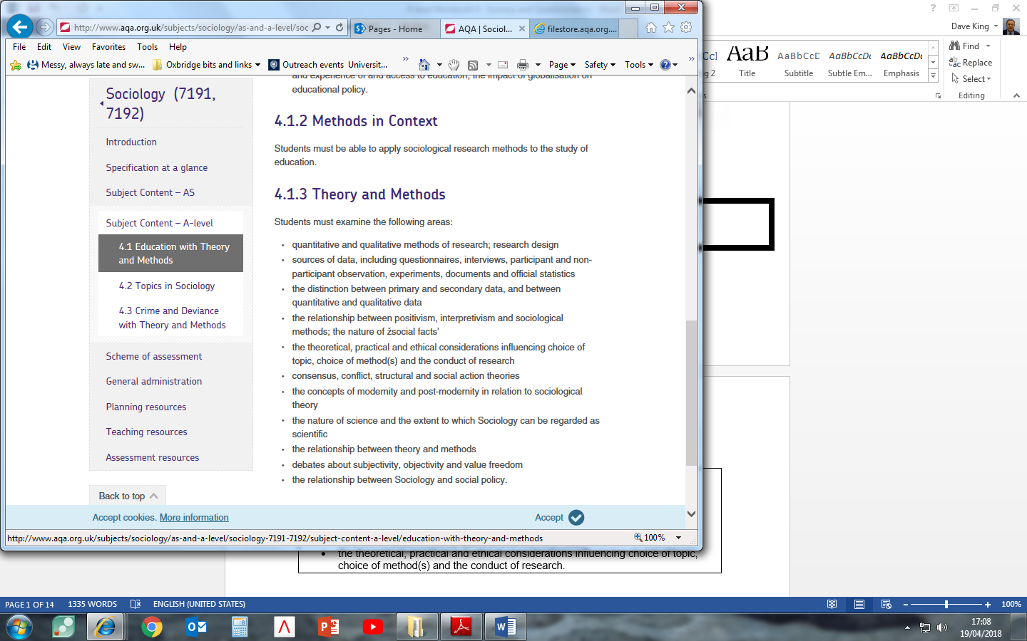

|  |  |
| --- | --- |
| **Interview** |  |
| **Unstructured Interview** |  |
| **Structured Interview** |  |
| **Semistructured Interview** |  |
| **Interview schedule** |  |
| **Rapport** |  |
| **Interviewer effect** |  |
| **Interviewer bias** |  |

**INTERVIEWS**

Interviews are one of the most widely used methods of gathering data in sociology. There are a variety of different ways interviews can be conducted. In interviews the degree of structure of questions can vary:

1. The most **structured interview** is the sort where the order and wording of the questions are predetermined and each respondent is asked exactly the same questions in exactly the same way from a tightly structured **interview schedule** (very like reading a questionnaire), with standardised questions following the same order every time.

2. The **focused or semi-structured interview**, as its name suggests, is the sort where the questions are focused on particular topics but where the interviewer can choose the words he/she uses to ask them as well as the order in which they are asked. (A **flexible interview schedule** used here simply lists general areas of interest the interviewer is to get the respondent to talk about or allows the interviewer to ask questions in any order.)

3. The completely **unstructured** involves the interviewer simply engaging the respondent in conversation, and then following up particular points of interest as they develop. It may be that no **interview schedule** at all is used. American sociologist Howard Becker describes this kind of interview well with the phrase ‘conversation with a purpose’.

Interviews may also be seen as formal or informal depending on the manner and environment in which the interview is conducted.

In this booklet, we will focus on all three types of interviews, including their advantages/disadvantages as well as exemplary case studies. One key issue that affects all interviews relates to **interviewer bias** (see box below).

|  |
| --- |
| **Interviewer bias –** refers to the way answers in an interview may be influenced or distorted in some way by the presence or behaviour of the interviewer. Interviews involve face-to-face interaction between people, and the success of interviews often relies on the personal skills of the interviewer. The results of an interview will also partly depend on the way participants define the situation, and their perceptions of each other. This is sometimes referred to as **interviewer effect** – the appearance of the interviewer may in itself have an effect upon the respondent without any particular input from them (a variant on the so-called **Hawthorne Effect**). For example, the interviewer’s personality, sex, age, ethnic identity, tone of voice, facial expressions and dress (e.g. suit or jeans) all impose a particular definition of the situation on the respondent, and this may influence the responses given. Status differences – for instance along the lines of ethnicity and age – between the respondent and the interviewer can lead to bias too. For example, and adult carrying out interviews with school students may not be given honest answers. The interviewer may give the impression, however unwittingly or unintentionally, of wanting to hear a certain answer.  In such circumstances, it is possible that the interviewees might adapt their responses to impress the interviewer by giving answers they think the interviewer wants to hear and would approve of, rather than giving their real opinions. This is perhaps unsurprising, as nearly everyone likes to obtain the approval of the person they are talking to.  **Overcoming interviewer bias?**  One way of minimizing interviewer bias/effect is to try and match the social characteristics of the interviewer and the people being interviewed.  To overcome interviewer bias and try to ensure that interviewers do not distort findings and produce valid data, interviewers are trained to be **non-directive** in their questioning. This means not to offer opinions, or show approval or disapproval of answers received. While it is important to establish **rapport** – a friendly and understanding relationship – it is equally important to remain sensible and business-like.  However, by contrast with this style of non-directive interviewing, Becker (1970) believes that a more aggressive style of interviewing is more likely to squeeze information out of respondents which may not otherwise have volunteered. This involves ‘playing dumb’, playing the devil’s advocate by taking positions on issues, or deliberately ‘provoking’ people in the hope of prompting the respondents to say more. This has its own problems of introducing more elements from the interviewer than the interviewed, but may lead to uncovering elements that the respondent would rather avoid (is there an ethical issue here?).  A further way of overcoming interview bias is to avoid face-to-face interviews altogether, and resort to telephone interviews or even interviews via email. |
| **QUESTION**  When interviewing parents, what effect might differences in age, gender or ethnic differences between the interviewer and interviewee have on   1. response rate and 2. the validity of the answers given? |

**STRUCTURED INTERVIEWS**

Use your textbook and any other sources to help fill in the following

|  |
| --- |
| **QUESTIONS**  1. Identify and explain what types of topics are suitable for using structured interviews.  2. What topics might be less suitable for using structured interviews? What method would you use instead? |

**PET- STRUCTURED INTERVIEWS**

|  |  |  |  |  |  |
| --- | --- | --- | --- | --- | --- |
| **Define the**  **method** |  | | | | |
| **Example(s)** |  | | | | |
| **Circle correct** | **Quantitative** | **Qualitative** | **Positivist** | **Realist** | **Interpretivist** |
|  | **Strengths** | | **Weaknesses** | | |
| **Practical** |  | |  | | |
| **Ethical** |  | |  | | |
| **Theoretical** |  | |  | | |

**SEMI-STRUCTURED INTERVIEWS**

In a semi-structured interview, the interviewer is again present and has a clear list of issues to be addressed and questions to be answered. However, the questions can be asked in any order (i.e., they are flexible) and the interviewer has much greater control of proceedings than in a structured interview. In contrast to structured interviews, then, the interviewer has the freedom to ‘probe’. Respondents can be asked to clarify their answers to provide examples, and to develop what they have said.

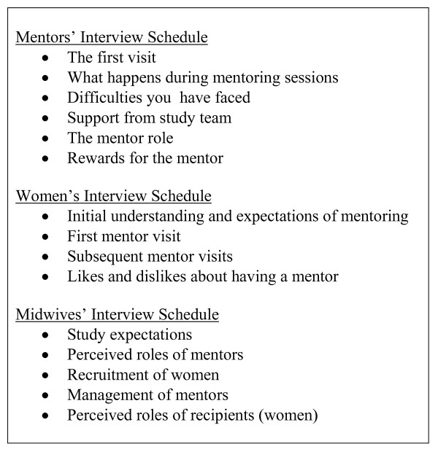

***An example of a flexible schedule on midwifery***

Here is an example of semi structured interviewing in the family - Hauari and Hollingworth’s study on fatherhood.

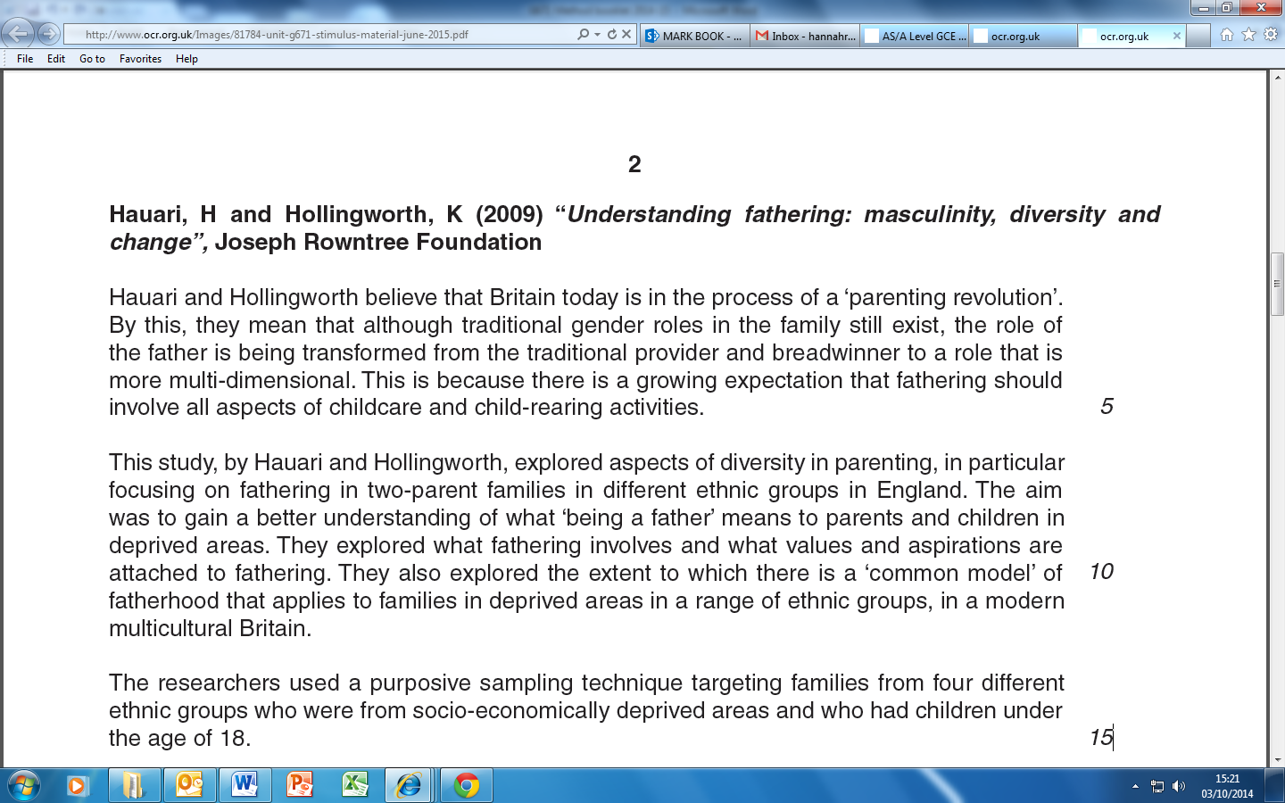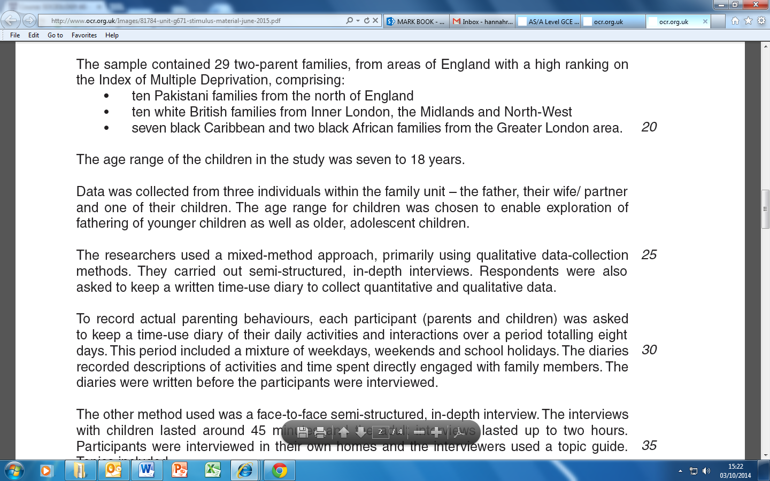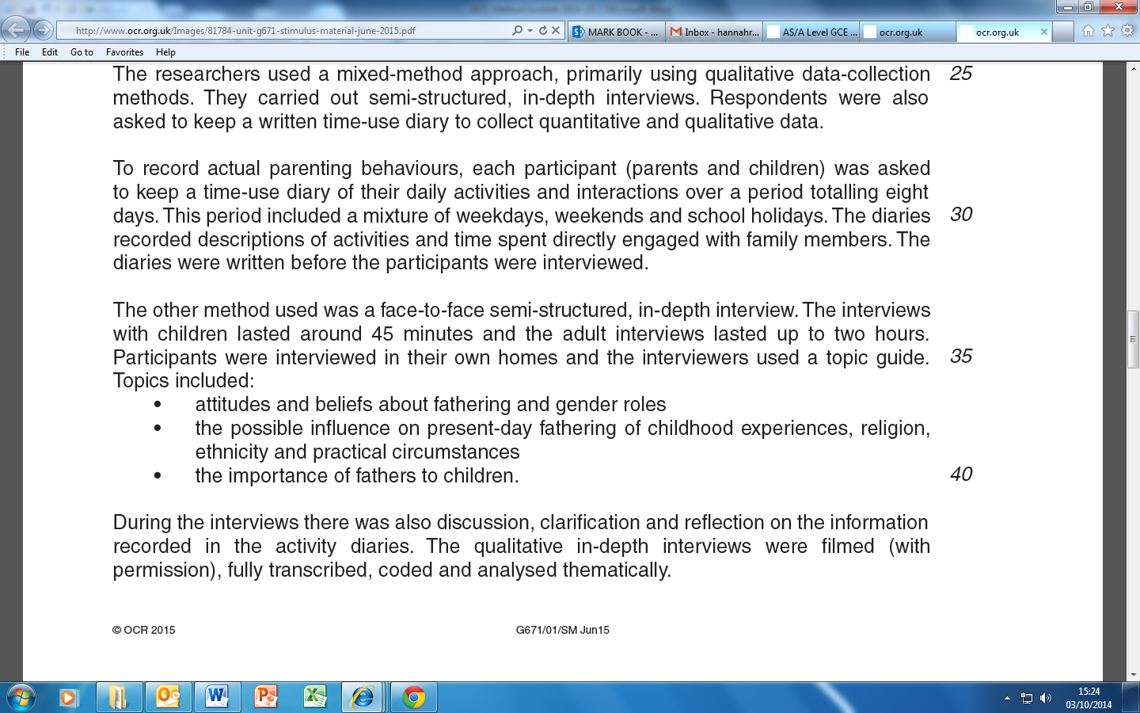

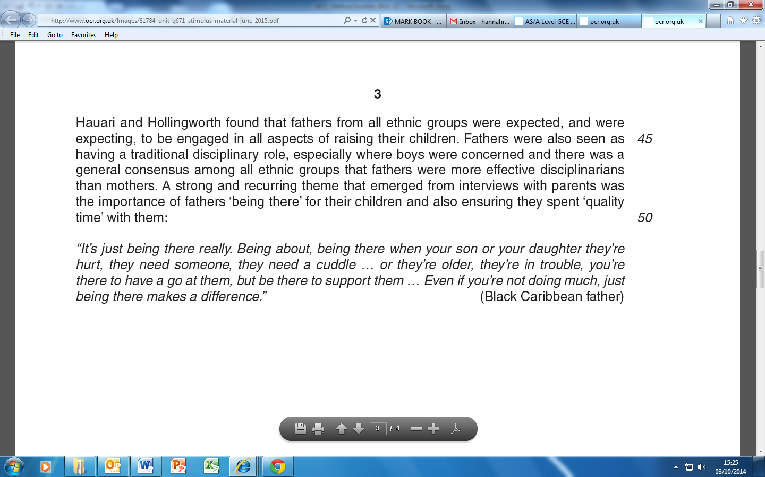

|  |
| --- |
| **QUESTIONS**   1. Why did the researchers choose semi-structured interviews for studying fatherhood? 2. What kind of ethical issues can you identify with this application of semi-structured interviews? Can you think of alternative methods? |

**PET- SEMI STRUCTURED INTERVIEWS**

|  |  |  |  |  |  |
| --- | --- | --- | --- | --- | --- |
| **Define the**  **method** |  | | | | |
| **Example(s)** |  | | | | |
| **Circle correct** | **Quantitative** | **Qualitative** | **Positivist** | **Realist** | **Interpretivist** |
|  | **Strengths** | | **Weaknesses** | | |
| **Practical** |  | |  | | |
| **Ethical** |  | |  | | |
| **Theoretical** |  | |  | | |

**UNSTRUCTURED INTERVIEWS**

An unstructured interview is like a guided conversation. The interviewer has topics in mind to cover but few, if any, pre-set questions (the **interview schedule**). The interviewer will seek to put the respondent at ease, in a relaxed, informal situation, and will then ask open-ended questions which may trigger off discussions or further questions. The interviewer aims to obtain further depth or detail than is possible in a postal or other self-completion questionnaire or in a structured interview, and to draw out the respondent’s feelings and opinions. See the example of Dobash and Dobash at the end of the booklet.

Unstructured interviews may also be carried out with a group of people. This can help to trigger off discussion, encourage a dialogue to explore issues, and gain more in-depth qualitative information. These **group interviews** sometimes take the form of **focus groups**, when the group interview focuses on a particular topic, and people are free to talk to one another as well as the interviewer. In a group interview, the interviewer’s role is to question, whereas in a focus group the researcher’s role is to feed in ideas or questions for the participants to discuss and draw out their feelings, experiences, and opinions. The researcher also has to make sure the group remains focussed on the topic under discussion.

**Paul Willis (1977): *Learning to Labour***

**Activity:** Watch the video on Paul Willis discussing the methodology he used in his study of the growth of anti-school subcultures and then answer the following questions:

|  |
| --- |
| What is the purpose for Willis of sociological research? |
| Why did the 'lads' become the focus of Willis' research? How did he **select** them as a group? |
| Identify the different methods that Willis uses in his research |

|  |
| --- |
| What **types of** **data** does Willis produce with these methods? |
| In what ways does Willis see his research as **valid**? |
| Does he regard his study as **reliable**? Does he see reliability as important? |
| What prevents the sociological researcher **'going native'** for Willis? |
| Why is Willis dismissive of problems associated with the **'Hawthorne Effect'**? |

Willis also used focus groups as another interview technique. Define what this is below:

|  |
| --- |
| Define focus group/group discussion interview |

**PET- FOCUS GROUPS**

|  |  |  |  |  |  |
| --- | --- | --- | --- | --- | --- |
| **Define the**  **method** |  | | | | |
| **Example(s)** |  | | | | |
| **Circle correct** | **Quantitative** | **Qualitative** | **Positivist** | **Realist** | **Interpretivist** |
|  | **Strengths** | | **Weaknesses** | | |
| **Practical** |  | |  | | |
| **Ethical** |  | |  | | |
| **Theoretical** |  | |  | | |

**PET- UNSTRUCTURED INTERVIEWS**

|  |  |  |  |  |  |
| --- | --- | --- | --- | --- | --- |
| **Define the**  **method** |  | | | | |
| **Example(s)** |  | | | | |
| **Circle correct** | **Quantitative** | **Qualitative** | **Positivist** | **Realist** | **Interpretivist** |
|  | **Strengths** | | **Weaknesses** | | |
| **Practical** |  | |  | | |
| **Ethical** |  | |  | | |
| **Theoretical** |  | |  | | |

**A LEVEL Exam Practice:**

10 marks

Outline and explain two reasons why a sociologist would choose to use unstructured interviews in sociological research [10 marks]

Outline and explain two reasons that a positivist sociologist might offer for not using unstructured interviews in their research. [10 marks]

Outline and explain two advantages of structured interview techniques [10 marks]

Outline and explain two reasons for the use of a flexible interview schedule [10 marks]

Outline and explain two problems with unstructured interviews [10 marks]

Outline and explain two reasons why sociologists would use focus groups in sociological research [10 marks]

Outline and explain two advantages of choosing unstructured interviews as a source of data compared with structured interviews. [10 marks]

20 marks

*Using the material in Item C and your own knowledge...*

...evaluate the problems of using unstructured interviews in sociological research [20 marks]

...evaluate the advantages of using a structured interview in sociological research [20 marks]

...evaluate the advantages of using semi-structured interviews in sociological research [20 marks]

...evaluate the problems of using focus groups in sociological research [20 marks]

**AS Exam Practice:**

4 marks

Outline two reasons why a sociologist would choose to use an unstructured interview in sociological research [4]

Outline two problems with using a structured interview [4]

Outline two advantages of doing a structured interview [4]

Outline two problems with semi-structured interviews [4]

Outline two problems with unstructured interviews [4]

Outline two reasons why sociologists would use focus groups in sociological research [4]

16 marks

Evaluate the problems of using unstructured interviews in sociological research [16]

Evaluate the advantages of using a structured interview in sociological research [16]

Evaluate the advantages of using semi-structured interviews in sociological research [16]

Evaluate the problems of using focus groups in sociological research [16]

**Method in Context - Investigating educational underachievement among boys**

|  |
| --- |
| **Item B**  **Investigating educational underachievement among boys**  Boys are more likely than girls to underachieve in school. This may be due to factors inside school. However, other factors may be responsible such as female-headed lone-parent families or absent fathers.  Some sociologists may use group interviews to study the causes of boys’ underachievement. These are largely unstructured and allow the interviewer to build a relationship with his or her interviewees. This method also allows the interviewer to observe interactions within the group at first hand. However, there are many practical problems with group interviews and schools may wish to have a say in how the interviews are conducted or in the selection of interviewees. |

Applying material from **Item B** and your knowledge of research methods, evaluate the strengths and limitations of using group interviews for investigating the causes of educational underachievement among boys. **[20 marks]**

**Proposed plan:**

|  |
| --- |
| **Introduction – WWWE**   * **W**hat? – What is the method in the question? Define and apply detail about the method. * **W**ho? – Who would use it? (Positivist, Interpretivist, Realist) * **W**hy? – Why would they use it? – Relating to the context in the question – in this case truancy. * **E**valuate – Who wouldn’t use it? Why? |
| **Main body**   * Aim for at least **3 strengths and 3 weakness.** * Consider and include all elements of **PERVERT** within your response. * Refer back to the **context** (in this case educational underachievement among boys) |
| **Conclusion**   * **Summarise strengths and weaknesses** (in relation to the **context**) * Would an **alternative method** be more suitable? Apply **methodological approaches** to this response (Positivism, Interpretivism and Realism) |

**Appendix**

**Case Study: Dobash and Dobash: Violence Against Wives 1980**

Dobash and Dobash attempt to describe and explain wife battering in modern society. They argue that contrary to general belief, the family is not a secure, happy and peaceful place. They write:

The fact is that for most people, and especially for women and children, the family is the most violent group to which they are likely to belong. Despite fears to the contrary, it is not a stranger but a so-called loved one who is most likely to assault, rape, or murder us.

Violence against wives is seen as an extension of men's domination and control over women which has been historically and socially constructed.

Religious, literary and legal writings are seen as presenting women only in terms of their relationships to men, i.e., wives, mothers and daughters. This, coupled with the power given to men through many social institutions (e.g. political, economic) has resulted in family life being an area of male authority over women.

Socialisation ensures that women's actions are restricted and orientated to serve men. Dobash and Dobash write:

*Females are 'born' to be wives. To be a 'real' woman requires becoming a wife and to be a complete wife means being a good mother. Nothing less is really acceptable and little more is tolerated. Women are circumscribed by this, the only truly legitimate status they are allowed, and all of their activities are in some ways restricted by it and defined in terms of it. Women in their position as wives become relatively separated from the world and isolated in the home, where they are meant to be subordinate to their husbands and to serve the needs of others. This situation is part of the cultural legacy of the patriarchal family. There have, of course, been numerous historical changes in the status of women and in the institution of marriage: wife beating is no longer strictly legal and an absolute patriarchy can no longer be said to exist. Most of these changes, however, have done little to modify the patriarchal ideals and hierarchical nature of family organisation. They continue. The beliefs are taught to all children and there are numerous means by which we institutionalise and legitimate the control that husbands have over their wives.*

Dobash and Dobash therefore feel that little information is really available about violence against wives. The *'common sense'* explanations such as, *'she must have deserved it*', *'they obviously like it'*, etc. are completely unacceptable. They argue:

*What is required is in-depth information about the violence itself and the relationship in which it occurs, as well as an analysis of the society in which wife beating occurs and the cultural beliefs and institutional practices that contribute to this pattern.*

**The pilot study**

In order to do this they first conducted a pilot study:

*…both to aid in the development of an interview schedule for a more extensive study of wife beating and to allow for the discovery of factors not included in our initial conception of the problem.*

These interviews were with battered women and people who had worked with violent families (for example social workers, police officers, organisers of refuges for battered women). Using ***'orientating questions'*** and later an ***interview guide*** (a loosely structured interview schedule), they asked **open-ended questions** on topics such as socialisation into the use of violence, differentials of status between husband and wife, use of alcohol, and husband/wife expectations.

**Selecting the sample**

The main study involved 109 interviews with women who had experienced battering. 67 of these were living in refuges for battered women in Edinburgh and Glasgow, 26 were living in refuges in smaller towns in Scotland and 16 had recently left a refuge. The women came from working-class and middle-class backgrounds, ranging in age from 16 to 60.

The majority of women were between 21 and 30. Most of them had two or three children. Women were usually interviewed within a few days of their arrival at the refuge. No one who was asked refused to take part. They write:

*We purposely chose a sample of battered women who were willing to speak in considerable detail about what is for many people an unspeakable and unsharable problem.*

**Carrying out the interviews**

The majority of the interviews were conducted by two female research assistants who spent many months in continual contact with the refuge.

*The research assistants were not mere interviewers but rather became permanent fixtures in the life and activities of the refuges. They spent considerable time in the refuges apart from the time engaged in interviewing and often were sympathetic listeners to women concerned about their present predicament and future prospects. The researchers were not strangers but people with histories that were learned by the newcomers to the refuges from those who were already residing in them for a period of time and who had been previously interviewed by ourselves or Cavanagh and Wilson [other researchers in the same area]. This continual contact with the refuges had the unintended but important consequence of developing considerable trust between the interviewers and the women, which in most cases meant good rapport during interviews.*

*All the interviews were taped and varied in length between 2 and 12 hours. An informal approach was adopted with standardised questions, which interviewers could change or clarify if they felt it was appropriate.*

*This open-ended technique increases the probability of the interviewer's understanding 'the context of the answers, perceptions or motivations' of respondents.*

*Most interviews began by the women being asked about their family background, their education, childhood and any early experiences of violence. This introduced the conversation into the realm of courtship and marriage, with some time being spent exploring any changes in their relationship. Women were specifically asked about the first, the worst and the last experience of violence they had experienced. For example: 'Can you tell me about the first time your husband hit you?' They write:*

*We then asked specific questions regarding the violent event. Each of these discrete episodes, the first, worst, and last, was discussed in terms of when it occurred, the circumstances preceding the violence, the physical nature of the attack, its location, the presence of others during the attack, the extent and severity of injuries, and the immediate responses and feel ings of the husband and wife. When women were allowed to talk about these incidents in their own words, as well as to answer our more specific questions, they gave very detailed accounts of even those incidents that had occurred many years earlier.*

In cases where the women did not talk freely and in detail about their experiences an interviewer would probe further. For example:

Can you remember what actually led up to the first time he hit you then?  
I mean, as you say, it was …

*It's only now that I remember back. It's just that we used to sit and quarrel and he'd end up going for me. I don't know. I used to feel he was very jealous and I couldn't wear makeup or anything if I got all dressed up and that. That's how the arguments used to start. I hadn't even sort of gone out, but I'd maybe feel like doing myself up. He'd start hitting me, you know.*

And can you remember what happened that first time? How he hit you? Was it just a punch?

*He just punched me under the chin actually. I seen stars.*

Was it just the once the first time?

*Uh-huh.*

Did you hit him back?

*I was too astounded. I'd never been hit before, so I was just standing there for the short time that I had to take it.*

And can you recall what time of day this was?

*It was always, nearly always, night-time.*

And did it happen in your house?

*Well, at the time, yes, it was a house.*

Can you recall, was it the living room, or the kitchen, or the bedroom?

*It was in the living room.*

And was it just the two of you or were the kids there?

*No, there was people in the house at the time.*

There were other people there? Were they relatives or friends?

*No, just friends.*

And what did they do when he hit you?

*They all started edging up, quite honestly, 'cos the girls started screaming, a couple of girls that were in, and the men that were his pals stood. They were used to seeing things like that.*

They didn't try and pull him off you?

*They used to tell him to stop, but he didn't take any notice. I don't think they really bothered.*

And were you hurt at all after that? I mean, apart from the shock?

*Well, I couldn't believe in that he just hit me, you know. I didn't feel the same towards him after that.*

Questions were also asked about what actually happened during a violent episode and the beliefs and values the participants had in connection with marriage and conjugal roles.

**Findings**

The use of the open-ended questions allowed Dobash and Dobash to provide a detailed account of the experiences of battered women and to gain some understanding of the meanings of their experiences. This, coupled with the use of some standardised questions enabled them to quantify some of the more common experiences and identify patterns. They discovered that during early courtship the majority of the women in the study had warm, attentive, loving relationships. Where conflict between couples did exist, it commonly centred around the man's sexual jealousy. For example:

Did he ever hit you before you got married?

*No. He once got very angry with me. He didn't hit me, but he got very angry. I thought it was because he was fond of me and he was jealous, but I didn't realise until afterwards that it was nothing to do with fondness. It was quite different. He asked me a lot of questions about who I had been out with before I knew him and he made me bring from the house a whole pile of letters and photographs and he stood over me as I stood over an open drain in the road and I had to put them in one by one - tear them up and put them in.*

It is the man's sense of possessiveness and exclusivity that seems to develop more strongly during the courtship, and as the relationship moves closer to marriage he has a greater sense of his right to take over the woman and even, as in this case, to try to obliterate, if only in a symbolic sense, all her relationships with anyone other than himself.

23 per cent of the sample did actually experience violence before marriage, but most believed this would cease once they were married. For the majority of the women (77 per cent) there was no indication of the violence to come. Any displays of anger at this stage were often perceived by the women as an indication of how serious the man was about her, rather than any detrimental part of the relationship. Once married the majority of the women spent more time with their husbands and had less contact with family and friends. The husbands however tended to increase the amount of time spent with friends.

**Table 1: How frequently the man went out with his own friends throughout the relationship**

|  |  |  |  |  |  |  |
| --- | --- | --- | --- | --- | --- | --- |
|  | Before  Marriage | | First Year  marriage | | Later  Marriage | |
| Frequency | N | % | N | % | N | % |
| 6-7 times per week | 14 | 13 | 18 | 17 | 42 | 39 |
| 1-5 times per week | 39 | 36 | 59 | 54 | 47 | 43 |
| 1-5 times per month | 8 | 7 | 6 | 5 | 0 | 0 |
| 1-6 times per year | 3 | 3 | 4 | 4 | 1 | 1 |
| Never | 45 | 41 | 22 | 20 | 19 | 17 |
| Total | 109 | 100 | 109 | 100 | 109 | 100 |

As one woman explains, this changing pattern had a very real effect on their relationship.

When we were first married you couldn't find a nicer person, considerate. He couldn't seem to do enough for you. He really was a nice person then. He used to take me to the late-night cinema on Saturday night at the Odeon; apart from that, a few times out to visit his friends in the evening and never anywhere else. I didn't mind going out to the cinema, but I wasn't keen about going to see his friends (because her husband refused to include her in the conversation and his friends ignored her). After we were married he would have to almost be forced to take me out for a drink …

He saw his friends quite a lot … He used to have two days off and quite often he would say, 'I'm just going to see so-and-so for an hour and I'll be back.' And it would be more like six or seven hours before he turned up again. (When she told him that she didn't like this, he replied) that this was his only day off and he should get to do what he liked with it.

Also, marriage meant that child rearing, domestic chores and any emotional support was left solely as the responsibility of 'the wife'.

**The violent event**

The first violent episode usually consisted of a single blow, with little physical injury. It was preceded by an argument, often associated with the husband's possessiveness and his ideas about his wife's responsibility to him. Classically, this incident was followed by shock, shame and guilt, from both parties. The husband begged forgiveness and promised that it wouldn't happen again, while wives often attempted to understand the action in terms of their own behaviour. (The idea that she brought it on herself.)

Tables 2 and 3 give us a picture of how sources of conflict and the nature of the attacks change from the first, worst and last attacks.

**Table 2: Sources of conflict leading to violent episodes**

|  |  |  |  |  |  |  |  |  |
| --- | --- | --- | --- | --- | --- | --- | --- | --- |
|  | Violent episode | | | | | | | |
| Source of conflict | First | | Worst | | Last | | Typical | |
|  | N | % | N | % | N | % | N | % |
| Sexual Jealousy | 31 | 31 | 28 | 30 | 21 | 22 | 48 | 45 |
| Expectations about domestic work | 37 | 37 | 32 | 34 | 31 | 32 | 17 | 16 |
| Money | 7 | 7 | 12 | 13 | 11 | 11 | 18 | 17 |
| Status problems | 3 | 3 | 3 | 3 | 6 | 6 | 3 | 3 |
| Sexual refusal | 6 | 6 | 1 | 1 | 2 | 2 | 2 | 2 |
| Wife’s attempts to leave | 5 | 5 | 7 | 7 | 15 | 15 | 0 | 0 |
| Relatives and friends | 3 | 3 | 1 | 1 | 2 | 2 | 4 | 4 |
| Husband’s drinking behaviour | 1 | 1 | 1 | 1 | 2 | 2 | 7 | 6 |
| Children | 5 | 5 | 6 | 6 | 6 | 6 | 4 | 4 |
| Other | 2 | 2 | 4 | 4 | 2 | 2 | 3 | 3 |
| Total | 100 | 100 | 95 | 100 | 98 | 100 | 106 | 100 |

**Table 3: Types of physical force used during violent episodes[1]**

|  |  |  |  |  |  |  |  |  |
| --- | --- | --- | --- | --- | --- | --- | --- | --- |
|  | Violent episode | | | | | | | |
| Physical force | First | | Worst | | Last | | Typical | |
|  | N | % | N | % | N | % | N | % |
| Slap or push/pull into non-injurious object | 73 | 29 | 48 | 12 | 68 | 21 | 78 | 15 |
| Punch face and/or body | 85 | 34 | 126 | 33 | 102 | 31 | 226 | 45 |
| Push/pull into injurious object | 27 | 11 | 67 | 17 | 48 | 15 | 19 | 4 |
| Kick, knee or butt | 39 | 16 | 82 | 21 | 60 | 18 | 140 | 28 |
| Attempt to drown, smother or strangle | 9 | 4 | 20 | 5 | 18 | 5 | 9 | 2 |
| Hit with object/weapon | 13 | 5 | 24 | 6 | 17 | 5 | 26 | 5 |
| Other (bite, stand on, rape) | 3 | 1 | 12 | 3 | 18 | 5 | 8 | 1 |
| Total | 249 | 100 | 389 | 100 | 331 | 100 | 506 | 100 |

These tables alone do not provide us with detailed information about the experience of the attack. Dobash and Dobash therefore rely on the descriptions provided by the women:

*He punched me, he kicked me, he pulled me by the hair. My face hit a step. He had his bare feet, you know, with being in bed, and he just jumped up and he pulled on his trousers and he was kicking me. If he had his shoes on, God knows what kind of face I would have had. As it was I had a cracked cheek-bone, two teeth knocked out, cracked ribs, broken nose, two beautiful black eyes - it wasn't even a black eye, it was my whole cheek was just purple from one eye to the other. .And he had got me by the neck and, you know, he was trying, in fact, practically succeeded in strangling me. I was choking, I was actually at the blacking-out stage. I was trying to pull his fingers away, with me trying to pull his fingers away, I scratched myself, you know, trying to get: his fingers off. He hit me and I felt my head, you know, hitting the back of the lock of the door. I started to scream and I felt as if I'd been screaming for ages. When I came to, he was pulling me up the stair by the hair, I mean, I think it was the pain of him pulling me up the stair by the hair that brought me round again. I can remember going up the stair on my hands and knees and the blood - I dinnae know where it was coming from - it was just dripping in front of my face and I was actually covered in blood. I just got to the kitchen door and he just walked straight to his bed. I just filled the sink with cold water, put a dish towel in it, and held it up to my face. I remember I went through to the living room and I fell asleep and I woke up in the morning with this matted dish towel, and, God I couldn't move. There wasn't a bit of me that wasnae sore.*

Few women (only four out of the sample) responded to violence with physical force. The size and strength of the men may have made retaliation very difficult, or there may be complex psychological reasons why the women felt unable to fight back. The types of injuries inflicted upon the women are shown in table 4.

**Table 4: Types of injuries resulting from the first, worst, and last violent episode[2]**

|  |  |  |  |  |  |  |
| --- | --- | --- | --- | --- | --- | --- |
|  | Violent episode | | | | | |
|  | First | | Worst | | Last | |
|  | N | % | N | % | N | % |
| Bruises to face or body | 101 | 74 | 182 | 64 | 148 | 70 |
| Abrasions | 0 | 0 | 2 | 1 | 3 | 1 |
| Burns | 0 | 0 | 4 | 1 | 5 | 3 |
| Cuts | 18 | 13 | 48 | 17 | 27 | 13 |
| Hair torn out | 5 | 3 | 13 | 5 | 10 | 5 |
| Fractured bones or broken teeth | 6 | 5 | 11 | 4 | 9 | 4 |
| Internal injuries, miscarriages | 4 | 3 | 8 | 3 | 2 | 1 |
| Knocked unconscious | 2 | 1 | 14 | 5 | 7 | 3 |
| Total | 136 | 100 | 282 | 100 | 211 | 100 |

Dobash and Dobash found that the majority of attacks (75 per cent) lasted 30 minutes or less. Twenty five per cent of the sample had experienced attacks of 45 minutes to five hours in length. All attacks took place in the home, usually at night-time (between 10 and 12 p.m.) on a Friday or Saturday night (80 per cent).

A key question is why don't women leave if things are so bad? Dobash and Dobash explored reasons for women staying in order to answer this. From their sample, 88 per cent of the women had left at some stage, but went back because of their impossible financial situation - and problems with self-esteem and confidence. Children often rated highly as reasons for both leaving and staying. A fundamental issue for most women was that they would not accept their children being beaten - even if they have been beaten themselves for many years. This was the final straw for most women, and marked the point when they left.

Dobash and Dobash also discovered that most violence goes unreported. From the sample, **32,000** assaults were experienced by the women, of which **517** were reported to the police. Most women remained silent about the violence, even when it was severe, and rarely sought medical attention. This often meant that broken bones healed crookedly, and many women suffered from long term or permanent disfigurement. Table 5 indicates the people most likely to be informed of an attack.

**Table 5: Third parties contacted by women after violent episodes**

|  |  |  |  |  |  |  |
| --- | --- | --- | --- | --- | --- | --- |
|  | Violent episode | | | | | |
| Third party | First | | Worst | | Last | |
|  | N | % | N | % | N | % |
| Parent, other relative | 37 | 33 | 47 | 19 | 42 | 11 |
| Friend | 20 | 18 | 20 | 8 | 33 | 9 |
| Neighbour | 13 | 11 | 24 | 10 | 23 | 6 |
| Doctor | 21 | 13 | 53 | 22 | 43 | 12 |
| Minister | 3 | 3 | 5 | 2 | 3 | 1 |
| Social Worker | 6 | 5 | 35 | 14 | 63 | 17 |
| Police | 2 | 11 | 35 | 14 | 47 | 13 |
| Women’s Aid | - | - | 14 | 6 | 93 | 25 |
| Other | 1 | 1 | 13 | 5 | 24 | 6 |
| Total Contacts | 113 | 100 | 245 | 100 | 371 | 100 |
| Number of Women Making Contacts | 52 |  | 88 |  | 105 |  |

**Dobash and Dobash: Violence against Wives (1980)**

What information did Dobash and Dobash argue was needed in order to fill the gap in knowledge about domestic violence?

**Why did they include a pilot study?**

**What was the nature of the sample?**

Size:

Age:

Sampling frame:

(Where did they draw their sample from?)

Describe the structure of the interviews

**The findings of the study**

|  |
| --- |
| The nature of the early relationship |
| Number/proportion who had experienced violence prior to marriage: |
| Male and Female contact with friends as marriage developed |
| Nature of the first violent incident |
| Top 3 sources of conflict |
| 2 main types of injuries inflicted on the women |
| What did Dobash and Dobash discover about the duration and timings of the attacks experienced by their sample? |
| What was the primary reason given for women returning to an abusive relationship? |
| What was the most important issue in decisions as to whether to stay or go? |
| How many assaults were experienced by their sample? How many were reported to the police? Approximately what percentage is this? |

1. Dobash and Dobash note: *We recorded up to five different types of physical force in any single violent episode. These figures reflect only the different types of physical force used and not the number of times each type was used*.
2. Dobash and Dobash note: *We recorded up to five different types of physical injuries in any single violent episode. These figures reflect only the different types of injuries, and not the number of times a particular type of injury was received*.