**Godalming College**

Booklet Checked by: _____________

Grade: U/S 1 2 3

Comment: _______________________________________________________________________________________________________________________________________________________

**Sociology Department**

**OBSERVATION TECHNIQUES**

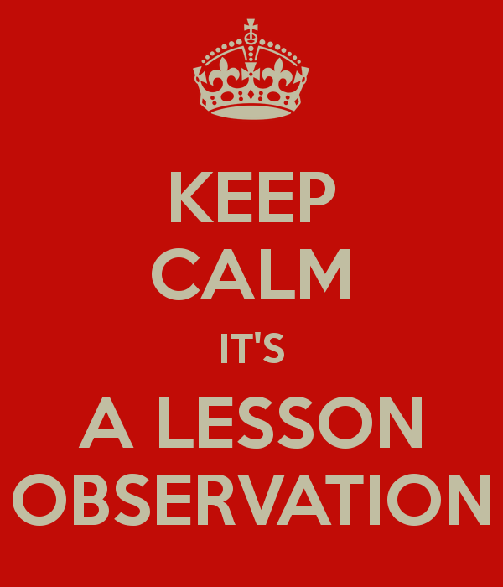

WORKBOOK 6 - RESEARCH METHODS FOR PAPERS 1 AND3

|  |  |  |
| --- | --- | --- |
| Name: | Set: | Group: |

**What the specification says:**

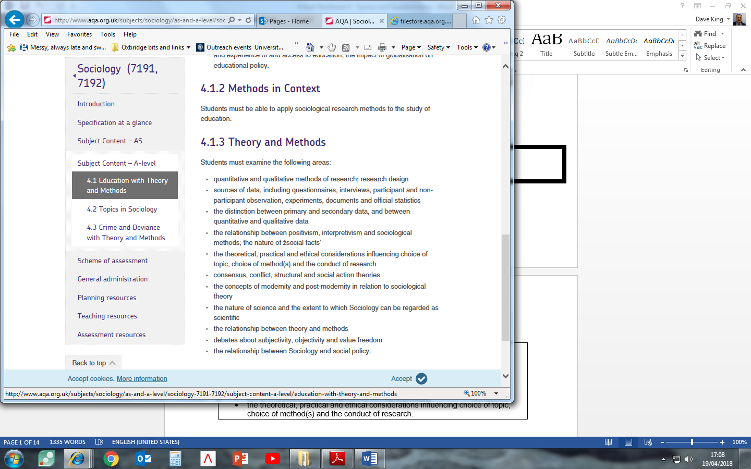

**OBSERVATION**

Perhaps the most obvious way to ‘do sociology’ is to watch people going about their everyday activities: We might observe people in exactly the same way that bird-watchers observe birds and then attempt to describe and explain their social behaviour. However, in some ways sociological observers face similar problems to bird-watchers. For example, if birds are aware of the presence of an observer they are likely to fly away and, similarly, people's behaviour can be affected if they are aware of being ‘watched’. Because of this the researcher usually has to join in, to some extent, with the group being studied.

Some sociologists in some situations may be able to conduct non-participant, or direct observation where they do not participate at all and are a ‘fly on the wall’. This may be possible at large events where many people are present so that the sociologist can easily blend in, or from behind a two-way mirror for example. Some sociologists, however, as you will see later, believe that we can only really understand human behaviour if we join in with it, thus discovering what it actually feels like to be that sort of person.

To wrap up this brief introduction, we can distinguish between two different types of observation**: Participant observation** and **non-participant observation**. In this booklet, we will mainly, but not exclusively, focus on participant observation. In particular, we will examine some useful examples where this method has been used, and explore the advantages and disadvantages that come with using this method.

**PARTICIPANT OBSERVATION**

This approach was first developed outside sociologyby anthropologists who study the variety of different societies and cultures in the world. In the early part of this century they began to live in the societies they were interested in. One of the most famous examples of this approach is Bronislaw Malinowski's research in the South Pacific Trobriand Islands where he lived during the First World War. Later in the 1920's and 1930's in America sociologists in Chicago borrowed this approach and applied it to their city. They studied the lives of different groups including tramps, members of criminal gangs and the rich.

In America in the 1950s and 1960s interactionism grew in importance as a dominant sociological perspective. Sociologists became increasingly interested in ‘getting inside the heads’ of their subjects. Participant observation gave researchers a method to view the world through the *eyes* of other people. Rather than testing hypotheses against evidence and searching for the causes of social events, the idea was that ***verstehen***(an understanding developed through empathy or close identification) and qualitative research are what sociology should be about.

For example, in his famous book, *Asylums*, Erving Goffman worked in a psychiatric hospital and carried out participant observation byparticipating in the lives of the patients and talking to them.

**The Stages of Participant Observation**

The stages of participant observation can be summed up in terms of *getting in*, *staying in*, and *getting out* of the group concerned. Let’s have a look at these issues before we examine a case study that illustrates the method of participant observation well.

**Getting In**

Joining a group raises several questions about the researcher’s role. The researcher may adopt an **overt role**, whereby he declares his true identity to the group and the fact that he or she is doing research. Alternatively, the researcher may choose to adopt a **covert role** (concealing his or her role as a researcher), or a cover story (partially declaring his or her role as a researcher, but concealing elements of it. James Patrick’s study A Glasgow Gang Observed (1973) offers an example of this. James Patrick was a teacher at an approved school in Scotland. He took up the invitation by Tim - a sixteen-year-old juvenile offender - to come and see for himself 'whit the score wis' in the 'Young team' (a Glasgow street gang of which Tim was leader).

Patrick, posing as Tim's friend from the approved school, took up this challenge. Having been briefed by Tim on the appropriate style of dress and considering himself aware of the local dialect and slang (an assumption which was to prove his first mistake), Patrick met and joined the gang.

To participate successfully, especially when adopting a covert role, the researcher would need to share some of the characteristics of the group, such as gender, age or ethnicity.

**Staying In**

The observer has to develop a role which will involve gaining the trust and cooperation of those observed, to enable continued participation in and observation of the group. Initially, this will involve learning, listening and getting a sense of what is going on. In Whyte’s study entitled *Street Corner Society* (1955), the main informant Doc plainly advised Whyte to ‘keep your eyes and ears open but keep your mouth shut’. Problems when staying in the group can arise when taking extensive notes, which might be seen as disruptive. Another question concerns how far you wish to immerse yourself within the group without either losing the trust of the group or your objectivity as a researcher (see box on ‘going native’). Staying in might also mean engaging in activities you disagree with. James Patrick, in his study on gangs in Glasgow, found the level of violence so abhorrent that he decided to stop his covert observation sooner than initially planned. In his study, Whyte did some ‘personating’ – illegally voting twice in an election – as this was common practice in the group he was studying.

**Getting Out**

Getting out of the group involves issues as such leaving the group without damaging relationships, becoming sufficiently detached to write an impartial and accurate account, and making sure members of the group cannot be identified. There may be possible reprisals against the researcher if criminal activities are involved. For instance, when Patrick’s study was published, he faced threats to his personal safety.

|  |
| --- |
| **‘Going Native’ –** The personal involvement which participant observation demands can reduce objectivity. An observer can identify so strongly with the group that the behaviour of its members is invariably seen in a positive light. In rare cases, this identification is carried to its extreme – observers ‘go native’, join the group and never return to their former lives |

**Types of Participant Observation: Overt and Covert Research**

**Overt Role**

|  |  |  |
| --- | --- | --- |
| Advantages | Disadvantages | Examples |
|  |  |  |

**Covert Role**

|  |  |  |
| --- | --- | --- |
| Advantages | Disadvantages | Examples |
|  |  |  |

**Sudhir Venkatesh: *Gang Leader for a Day* (2009)**

**Background –** In 1989 Sudhir Venkatesh, a graduate student at the University of Chicago, entered the Lake Park housing project armed only with a questionnaire and a desire to learn more about the lives of the people who lived in ‘The Projects’ (the general name given to Public Housing provision across the USA). He was almost immediately surrounded by a group of young black men he later came to understand belonged to the Black Kings – a well-organized gang that controlled a significant part of the drug trade in a territory dominated by the Robert Taylor Homes – one of the largest public housing projects in the world and home to a wide variety of some of the very poorest Chicago blacks.

During this initial encounter (and period of incarceration as a virtual prisoner of the gang), Venkatesh got to ask only one of his questions – ‘How does it feel to be black and poor?’ – before being forced by his ‘captors’ into the realization that to make sense of this question it was pointless to ask it; to understand what it was like ‘to be black and poor’ he had to experience what it was like to be both of these things – and to do this he needed access to the lives of the people in the Projects. He had, in other words, to live the lives they led (or as close to such an experience as it was possible for ‘an outsider’ to have).

To this end Venkatesh spent around 7 years in his study, producing a vivid description of the lives and relationships of the black residents, gang members and non-members alike, of Robert Taylor Homes. The study of a way of life of a group of people, which often involves an attempt to see the world from their point of view, is referred to as an **ethnography**.

Venkatesh revealed a complex mix of subculture (the Black Kings were a highly organized gang with a clear hierarchy, recruitment rituals, and socialization processes) and culture – the gang were embedded in the day-to-day life of the Projects. Although their primary purpose was to make money through selling drugs (mainly crack cocaine), they also performed a range of secondary functions within their territory – from the provision of protection for Project residents from other gangs, through the organization of social activities (such as Basketball games), to policing the Projects (involving things like the provision of shelter for ‘the homeless’).

**Activity:** Watch the video ‘Gang Leader for a Day’ (https://www.youtube.com/watch?v=yRq1AhFAN-4) and answer the following questions relating largely to practical, ethical and theoretical issues

|  |
| --- |
| 1. What was the context and aim of the research? 2. Why might the question ‘How does it feel to be black and poor?’ in his initial encounter have gotten Venkatesh into difficulties? What are the ethical issues with such a question? 3. How did Venkatesh solve the practical difficulty of gaining access? 4. At an early stage in the research JT seems to have used the idea that Venkatesh was “writing his life story” as a way of justifying Venkatesh’s presence in the Projects. Whether or not JT actually believed this is what Venkatesh was actually doing is not made clear, although Venkatesh does make passing reference to it at various points. Can you identity any ethical issues with this? 5. What is the advantage of spending seven years to study a group? What does it say about the validity of the data? 6. The individuals in the field were aware of Venkatesh’s status as a researcher. Explain how the known presence of the researcher might have an effect of the validity of the data. |

**Activity:** Using the following list, note at the side whether the point would be classified as a Practical Ethical or Theoretical issue (PET) and a + for it being a positive evaluation point and a X for a negative evaluation point

|  |  |  |
| --- | --- | --- |
| **Evaluation of observational methods** | **PET** | **+ or X** |
| Allows respondents to talk for themselves – does not impose a “researcher-led” structure on answers |  |  |
| May produce a more valid picture of social reality than some other techniques |  |  |
| Allows a fluidity in the research process that is not possible with most positivistic approaches |  |  |
| Much information is based on first-hand information (primary data) |  |  |
| Allows access to groups that other techniques could not |  |  |
| Within the group a range of possibilities can occur, e.g., “observer as participant” or “participant as observer” |  |  |
| Can be a useful source of hypotheses for further research |  |  |
| Can lead the researcher into problematic situations |  |  |
| Too much involvement can produce a subjective analysis (‘going native’) |  |  |
| Usually deals with small groups so generalisations are difficult to establish |  |  |
| Researcher’s presence may disturb the normal patterns of group interaction |  |  |
| Undercover (covert) participant observation can be considered ‘unethical’ and can threaten the project if found out |  |  |
| Difficult to record data – memory/selective issues |  |  |
| High level of researcher skills required |  |  |
| Comparisons are problematic due to lack of reliability |  |  |
| Time consuming |  |  |
| Access to restricted groups can be limited due to researcher’s characteristics – the attitudes of possible subjects |  |  |

**PET of PARTICIPANT OBSERVATION**

|  |  |  |  |  |  |
| --- | --- | --- | --- | --- | --- |
| **Define the**  **method** |  | | | | |
| **Example(s)** |  | | | | |
| **Circle correct** | **Quantitative** | **Qualitative** | **Positivist** | **Realist** | **Interpretivist** |
|  | **Strengths** | | **Weaknesses** | | |
| **Practical** |  | |  | | |
| **Ethical** |  | |  | | |
| **Theoretical** |  | |  | | |

**NON-PARTICIPANT OBSERVATION**

In the case of non-participant observation, the researcher need not participate to observe people’s behaviour. A non-participant observer is like a birdwatcher in a hide, observing people without joining in. For example, a researcher may secretly observe children’s behaviour in a school playground from an upstairs room in the school. They may use a *behaviour schedule* – a checklist of activities which are noted when they occur. This is also called STRUCTURED OBSERVATION whereby particular behaviours or activities are recorded which allows for the observation data to be coded (counted using categories) to determine the number of times something happens.

Compared to the aforementioned method of participant observation, non-participant observation has a number of advantages and disadvantages.

**Activity:** Watch the video on street life (<https://www.youtube.com/watch?v=Y-s0pIHTac4>)

|  |
| --- |
| 1. Describe the things that are going on. 2. Why might non-participant observation be a useful approach for studying street life? 3. What theoretical and ethical issues might arise from this approach? |

|  |
| --- |
| **Case Study: ‘WHY KIDS KILL’ Dispatches- Glasgow shown on Channel 4 28.01.2008** |

The study wanted to find out the scale of violence in areas where gang violence was common. Dispatches have been asking kids about their experiences of the ‘teenage wars on our streets and possible solutions.’ It provides a good counterpoint to other studies on gang life explored in this booklet that use covert and overt participant observation (James Patrick’s ‘A Glasgow Gang Observed’ and Sudhir Venkatesh’s study ‘Gang Leader for a Day’).

|  |
| --- |
| Which methods are used by the investigators? |
| How many youths were included in the main body of the research? |
| What sorts of questions were asked? |

This research is not sociological in the ‘traditional’ sense; nonetheless, it helps us understand some of the practical, ethical and theoretical issues with **non-participant observation.**

The study contained **overt** **non-participant observation** with the use of filming the youths when questioned were asked

|  |
| --- |
| What data did this provide? |
| What were the benefits of using this method? |
| What problems could with using this method? |

The study also contained **covert non-participant observation** with the use of CCTV evidence

|  |
| --- |
| What data did this provide? |
| What were the benefits of using this method? |
| What problems could with using this method? |

**PET of NON PARTICIPANT/STRUCTURED OBSERVATION**

|  |  |  |  |  |  |
| --- | --- | --- | --- | --- | --- |
| **Define the**  **method** |  | | | | |
| **Example(s)** |  | | | | |
| **Circle correct** | **Quantitative** | **Qualitative** | **Positivist** | **Realist** | **Interpretivist** |
|  | **Strengths** | | **Weaknesses** | | |
| **Practical** |  | |  | | |
| **Ethical** |  | |  | | |
| **Theoretical** |  | |  | | |

**A LEVEL Exam Practice:**

**10 mark questions**

Outline and explain two reasons why sociologists choose to use structured observation [10]

Outline and explain two problems with participant observation [10]

Outline and explain two reasons why sociologists would choose to use participant observation in their research [10]

Outline and explain two advantages that some sociologists see in using participant observation in their research [10]

Outline and explain two reasons why interpretivist sociologists choose to use ethnographic method [10]

**20 mark questions (these would include an item)**

*Using the material in Item C and your own knowledge...*

... Evaluate the advantages of the use of covert methods in sociological research [20]

... Evaluate the usefulness of using observation technique in sociological research [20]

... Evaluate the advantages of using non participant observation in sociological research [20]

**_________________________________________________________________________**

**AS LEVEL Exam Practice:**

**4 mark questions**

Outline two reasons why sociologists sometimes choose to use structured observation [4]

Outline two problems with participant observation [4]

Outline two reasons why sociologists would choose to use participant observation in their research [4]

Outline two advantages that some sociologists see in using participant observation in their research [4]

**16 mark questions**

Evaluate the advantages of using participant observation in sociological research [16]

Evaluate the problems of using covert observation in sociological research [16]

Evaluate the advantages of using non participant observation in sociological research [16]

**Methods in Context – Investigating the ways in which classroom interactions reinforce traditional gender identities.**

|  |
| --- |
| **Item B**  **Investigating the ways in which classroom interactions reinforce traditional gender identities.**  Some sociologists have pointed to the ease with which traditional gender identities can be reinforced in classroom interaction. Verbal abuse and other more subtle processes such as the ‘male gaze’ can have an impact on gender identity. Sociologists have found that some male teachers may even collude with male pupils in ‘putting down’ girls.  Sociologists may use non-participant observation to investigate the ways in which classroom interactions reinforce traditional gender identities. Observing classroom behaviour first hand enables researchers to see what actually goes on rather than getting a verbal account after the event. There is also the potential for greater insight through direct experience of classroom interaction. However, it is very difficult for the observer to avoid being noticed and this can affect the behaviour of teachers and of pupils. |

Applying material from **Item B** and your knowledge of research methods, evaluate the strengths and limitations of using non-participant observation for the study of the ways in which classroom interactions reinforce traditional gender identities. **[20 marks]**

**Proposed plan:**

|  |
| --- |
| **Introduction – WWWE**   * **W**hat? – What is the method in the question? Define and apply detail about the method. * **W**ho? – Who would use it? (Positivist, Interpretivist, Realist) * **W**hy? – Why would they use it? – Relating to the context in the question – in this case classroom interactions reinforce traditional gender identities * **E**valuate – Who wouldn’t use it? Why? |
| **Main body**   * Aim for at least **3 strengths and 3 weakness.** * Consider and include all elements of **PERVERT** within your response. * Refer back to the **context** (in this case classroom interactions reinforce traditional gender identities) |
| **Conclusion**   * **Summarise strengths and weaknesses** (in relation to the **context**) * Would an **alternative method** be more suitable? Apply **methodological approaches** to this response (Positivism, Interpretivism and Realism) |

**APPENDICIES**

**JAMES PATRICK: A GLASGOW GANG OBSERVED**

James Patrick was a teacher at an approved school in Scotland. He took up the invitation by Tim - a sixteen-year-old juvenile offender - to come and see for himself *'whit the score wis'* in the 'Young team' (a Glasgow street gang of which Tim was leader).

Patrick, posing as Tim's friend from the approved school, took up this challenge. Having been briefed by Tim on the appropriate style of dress and considering himself aware of the local dialect and slang (an assumption which was to prove his first mistake), Patrick met and joined the gang.

Patrick argues that his work offers a descriptive account of life in a gang, which he met on twelve occasions between October 1966 and January 1967. He writes:

*In all I spent just under 120 hours in the field; and as my involvement with the gang deepened, so the hours lengthened until towards the end of January I was in the company of the gang during one weekend from seven o'clock on Friday evening until six on Sunday morning.'*

*I have deliberately allowed some years to pass between the completion of the fieldwork and publication. The main reasons for the delay have been my interest in self-preservation, my desire to protect the members of the gang, and my fear of exacerbating the gang situation in Glasgow which was receiving nationwide attention in 1968 and 1969. Reasons of personal safety also dictate the use of a pseudonym.*

*What follows is not a study of Glasgow, or of Glasgow youth in general, or of a particular community within the city. It is a small-scale piece of research which is in no way a statistical survey and so the conclusions may well be of a restricted character,*

***Q. Representative? Generalisation?***

Before meeting the gang Patrick had to prepare for making an entry.

*I began to concentrate on making my physical appearance acceptable to the group. I was prepared to give my age as seventeen, although this point was never questioned. In fact I was able to pass myself off as a mate of a fifteen-year-old boy; my exact age remained indeterminate but apparently acceptable. Clothes were another major difficulty. I was already aware of the importance attached to them by gang members in the school and so, after discussion with Tim, I bought the suit I have described in the first paragraph. Even here I made two mistakes. Firstly, I bought the suit outright with cash instead of paying it up, thus attracting both attention to myself in the shop and disbelief in the gang when I innocently mentioned the fact. Secondly, during my first night out with the gang, I fastened the middle button of my jacket as I am accustomed to do. Tim was quick to spot the mistake. The boys in the gang fastened only the top button; with this arrangement they can stand with their hands in their trouser pockets and their jackets buttoned.*

***Q. Problems of fitting in? Consequences?***

Once he was accepted into the gang, Patrick began recording his observations; and these make illuminating reading about life in a gang. Here are some examples of the types of incidents he records.

**Saturday afternoon**

*Tim began walking, with the others trailing behind him. We had been walking for some time,* ***'jist dossin’****, when Tim had an idea.* ***'Let's get right intae that Lib'ry'****, he said, pointing to one of Glasgow's Public Libraries. .*

*Running into the building, we ignored the Lending Section because of its turnstile, and burst into the Reading Room. Dan McDade and Billy Morton began setting fire to the newspapers on display, as Tim and the others pushed books off tables and emptied shelves of encyclopedias and reference books. I 'kept the edge up' at the outer door and shouted* ***'Polis****!' as soon as I dared. Dave Malloy was trying to set alight the newspapers being read by old-age pensioners or down-and-outs. One old man beside the door, wearing woollen gloves with the finger pieces cut out, was reading with his face screwed up against the print which he deciphered with the aid of a magnifying glass. Jimmy Barrow's last act was to knock this glass from his hand as he ran past. En route to the street, a male attendant in a green uniform was punched and kicked out of the way. Some, behind me, could hardly run for laughing.*

***Q. What this tells us about gang life?***

**Weapons**

*The Malloys[1] boasted of being able to outwit any policeman who searched them; Tim, for instance, claimed to have been* ***'raked'*** *one night while* ***'kerryin****" and to have escaped arrest for possessing an offensive weapon. The trick he had picked up from his elder brothers, none of whom had ever been caught in possession. Before leaving the house, John used to tie a short blade to his wrist with a piece of string; he then concealed it by rolling down his shirt sleeve over the knife which rested alongside his forearm. Tim adopted the same technique, but in addition, was fond of carrying his favourite weapon - an open, lock-back razor. Harry Johnstone thought this* ***'sleekit'****. At nights when they met, Harry would ask Tim,* ***'Are ye kerryin'?, 'Me kerryin'? Are ye kiddin'?'*** *Yet in a fight, I was told,* ***'a wee blade comes oot oan the sleekit - a wee loak-back or somethin'****.'*

***Q. Dilemmas faced by Patrick as a covert observer? Inevitable for covert observation?***

**Rivalry between gangs**

*Both sides now wanted a showdown. Tim's* ***'goin' oan the creep'*** *was considered by some of the more peripheral members of the Young Team as despicable as* ***'chibbin lassies'****, but they were circumspect in not voicing their opinions too loudly. The only solution, Tim thought, was* ***'tae battle it oot****.' During Christmas week, the gang talk became more frenzied. The pros and cons of various battlefields were discussed. It was up to the Barnes Road[2] to make the first move.* ***'They says they're comin' up tae oor pitch, bu' they're aye sayin' it an' they never dae****.' In this climate of mounting excitement every boy in the area within the aegis of the Fleet and all other associated gangs had been alerted and told to be armed. As one of their number, I was handed a hatchet.*

*My reluctance to carry weapons, noticed earlier, now aroused hostility. The situation had not been helped by may* ***'takin' a back seat durin' the action*** *'. Dave Malloy was my principal accuser; whenever the conversation allowed it, he never failed to make a jeering remark at my expense. The sneering had turned to pushing and jostling and a* ***'square-go'*** *between us was on the cards. Without Tim's constant interventions on my behalf I would have been unable to sustain my role.*

**The party**

*At the party in January, Tim was presented with twenty-odd pills and took four right away. A few of these half-red, half-black pellets were pressed upon me and I was invited to sample these* ***'Black Bombers'****. Putting two in my mouth I stuck them to the inside of my cheek and drank deeply from a can of lager. Only one of the pills stayed in place and I spat it out at the first available opportunity. But by then only the capsule was left and the white powder covered my tongue.*

*This experience provided me with the opening I needed and for once Tim spoke at length on the subject. After* ***'bein' in the clouds'****, he dreaded* ***'the horrors'*** *of the following morning.* ***'Ye imagine every-thin' yir afrighted fur. Chibbin' some-wan tae death in the street wi' everyboady at the windaes watchin' who's dain' it - and the polis chasin' ye, and you runnin' fur miles an' miles****.'*

***Q. Problems of recording data? Memory? Reliable?***

**UNVEILING ISLAMOPHOBIA:**

**THE VICTIMISATION OF VEILED MUSLIM WOMEN, Irene Zempi, (2014)**

In a post-9/11 climate, Islam and Muslims are under siege. Islam is understood as a violent and backward religion and culture, Muslim men are perceived as the embodiment of terrorism and extremism, and veiled Muslim women are viewed as the personification of gender oppression. Veiled Muslim women are also seen as dangerous and threatening to notions of public safety and national cohesion by virtue of being fully covered in the public sphere. Such stereotypes mark veiled Muslim women as ‘ideal’ targets to attack when they are seen in public.

Drawing on qualitative data elicited through individual and focus group interviews with veiled Muslim women, individual interviews with key stakeholders and policy-makers as well as an ethnographic approach, this study sheds light on the lived experiences of veiled Muslim women as actual and potential victims of Islamophobia in public places. The study investigates the nature and impact of this victimisation upon veiled Muslim women, their families and wider Muslim communities. It also examines the factors that contribute to the under-reporting of this victimisation and outlines the coping strategies which are used by veiled Muslim women in response to their experiences of Islamophobia.

The study demonstrates that Islamophobic victimisation is understood as ‘part and parcel’ of wearing the veil rather than as single ‘one-off’ incidents, and this reflects the tendency of veiled Muslim women not to report such incidents to the police. The study also reveals how repeat incidents of supposedly ‘low-level’ forms of hostility such as name-calling, persistent staring and a sense of being ignored place a potentially huge emotional burden on victims. The threat of Islamophobic abuse and violence has longlasting effects for both actual and potential victims including making them afraid to step out of their ‘comfort zone’. Ultimately, the study offers a model of vulnerability of veiled Muslim women as potential victims of Islamophobia in public places based on the visibility of their Muslim identity coupled with the visibility of other aspects of their identity alongside factors such as space as well as media reports of local, national and international events related to

Islam, Muslims and the veil.

In addition to individual and focus group interviews, the study also included an ethnographic element, which involved wearing the veil in public places in Leicester. This aspect of the research was conducted over set periods of time during the daytime only. As such, it was a complementary approach to the study which provided insights beyond the scope of a more conventional approach.

In total, I wore the veil for four weeks as part of my daily routine in public places in the city of Leicester such as streets, shopping centres and public means of transport. Although my aim was to be ‘natural’ in terms of visiting places that I would normally visit, for example, when doing my shopping in Leicester city centre, I decided not to wear the veil if it was late at night (mainly for safety reasons). The setting of public space was an open setting, which means that I assumed a covert role since I did not disclose the fact that I was a researcher to members of the public. This approach carries both advantages and risks. On the one hand, using a covert role meant that members of the public were not aware of my status as a researcher and as a result they could behave naturally in front of me. This covert role was essential to the success of the ethnographic research. It is highly likely that people’s awareness of my status as a researcher would influence how they treated me, which would potentially mask the true dimensions of public expressions of Islamophobic prejudice. On the other hand, the ethnographic part of the study was fraught with difficulties, and indeed in certain circumstances with danger. After wearing the veil for a few days I felt that I was under constant threat and as a result I had to be alert all the time whilst wearing the veil in public. The various situations that I encountered because of my perceived Muslim identity placed me in situations of, perhaps, inevitable verbal abuse and potential physical attacks, situations that were probably ‘normal’ for both victims and perpetrators. I encountered public expressions of hostility such as persistent staring, angry looks, being ignored, Islamophobic comments such as ‘Terrorist’, ‘Muslim bomber’ and ‘Go back to Afghanistan’, and as a result, I felt vulnerable to physical attacks, particularly when the streets were not crowded.

Definitions: *Niqab* is a veil that covers a woman’s hair and face, leaving only the eyes clearly visible. There are different ways of wearing the *niqab* but the great

majority of the women interviewed for this thesis wore a black *jilbab* with a black *niqab* to cover their face. The *niqab* can also be worn with a separate eye veil.

**Participant Observation in the Context of Education**

**Learning to labour**

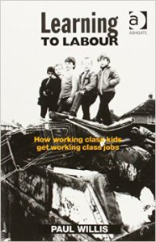Learning to Labour by Paul Willis (1977) is an ethnographic study of twelve working class ‘lads’ from a school in Birmingham conducted between 1972 and 1975. He spent a total of 18 months observing the lads in school and then a further 6 months following them into work. The study aimed to uncover the question of how and why “working class kids get working class jobs” (1977: 1) using a wide range of qualitative research methodologies from interviews, group discussions to participant observation, aiming to understand participants’ actions from the participants’ point of view in everyday contexts.

**Sampling**

Willis concentrated on a particular boy’s group in a non-selective secondary school in the Midlands, who called themselves ‘lads’. They were all white, although the school also contained many pupils from West Indian and Asian backgrounds. The school population was approximately 600, and the school was predominantly working class in intake. He states that the main reasons why he selected this school was because it was the typical type of school attended by working class pupils.

**Data Collection**

Willis attended all school classes, options (leisure activities) and career classes which took place at various times. He also spoke to parents of the 12 ‘lads’, senior masters of the school, and main junior teachers as well as careers officers in contact with the concerned ‘lads’. He also followed these 12 ‘lads’ into work for 6 months. He also made extensive use of [unstructured interviews](https://revisesociology.com/2016/01/23/interviews-in-social-research-advantages-and-disadvantages/). Participant observation allowed Willis to immerse himself into the social settings of the lads and gave him the opportunity to ask the lads (typically open) questions about their behaviour that day or the night before, encouraging them to explain themselves in their own words…which included detailed accounts of the lads fighting, getting into trouble with teachers, bunking lessons, setting off fire extinguishers for fun and vandalising a coach on a school trip.

**Findings**

One of Willis’ most important findings was that the lads were completely uninterested in school – they saw the whole point of school as ‘having a laff’ rather than trying to get qualifications. Their approach to school was to survive it, to do as little work as possible, and to have as much fun as possible by pushing the boundaries of authority and bunking as much as they could. The reason they didn’t value education is because they anticipated getting factory jobs which didn’t require any formal qualifications. They saw school as a ‘bit cissy’ and for middle class kids. Willis does not include an account of how he approached the ‘lads’ and built rapport with them. However considering the responses of the ‘lads’ during discussions and interviews, seeing that the ‘lads’ openly talk about their views and experiences and allow access to work at a later stage of the research, Willis seems to have built rapport effectively.

**Practical Issues with Learning to Labour**

* The research was very time consuming – 2 years of research and then a further 2 years to write up the results.
* It would be very difficult to repeat this research today given that it would be harder to gain access to schools (also see reliability)
* Funding would also probably be out of the question today given the time taken and small sample size.

**Ethical Issues with Learning to Labour**

* An ethical strength of the research is that it is giving the lads a voice – these are lads who are normally ‘talked about’ as problems, and don’t effectively have a voice.
* An ethical weakness is that Willis witnessed the lads getting into fights, their Racism and Homophobia, as well as them vandalising school property but did nothing about it.
* A second ethical weakness is the issue of confidentiality – with such a small sample size, it would be relatively easy for people who knew them to guess which lads Willis had been focusing on.

**Theoretical Issues with Learning to Labour**

* Validity is widely regarded as being excellent because of the unstructured, open ended nature of the research allowing Willis to sensitively push the lads into giving in-depth explanations of their world view.
* Critics have tried to argue that the fact he was obviously a researcher, and an adult, may have meant the lads played up, but he counters this by saying that no one can put on act for 2 years, at some point you have to relax and be yourself.
* Something which may undermined the validity is Willis’ interpretation of the data – he could have selected aspects of the immense amount of data he had to support his biased opinion of the boys.
* Representativeness is poor – because the sample size is only 12, and they are only white boys.
* Reliability is low – It is very difficult to repeat this research for the reasons mentioned under practical factors.

https://revisesociology.com/2016/01/25/learning-to-labour-by-paul-willis-summary-and-evaluation-of-research-methods/

1. two brothers
2. a rival gang