**Godalming College**

Booklet Checked by: _____________

Grade: U/S 1 2 3

Comment: _______________________________________________________________________________________________________________________________________________________

**Sociology Department**

SECONDARY SOURCES

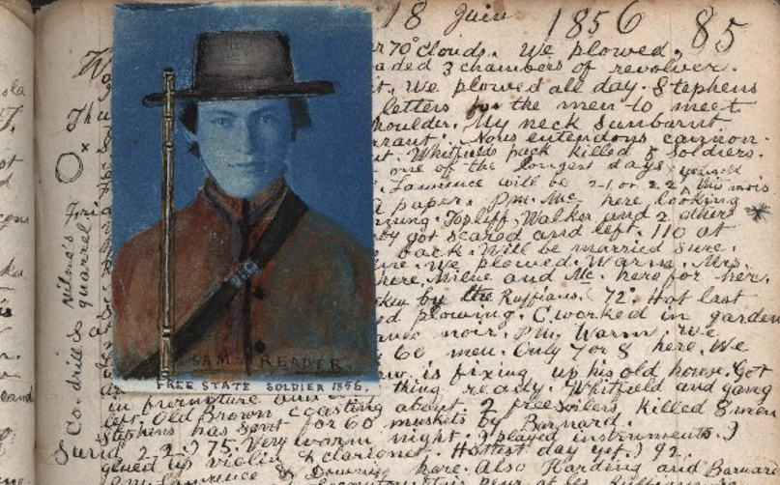

WORKBOOK 8- RESEARCH METHODS FOR PAPERS 1 AND 3

|  |  |  |
| --- | --- | --- |
| Name: | Set: | Group: |

**What the specification says**

|  |
| --- |
| AQA Specification  Research Methods  Students must examine the following areas:   * The distinction between primary and **secondary data**, and between quantitative and qualitative data * **Secondary sources of data**: documents, different types of document, e.g. personal, public and historical |

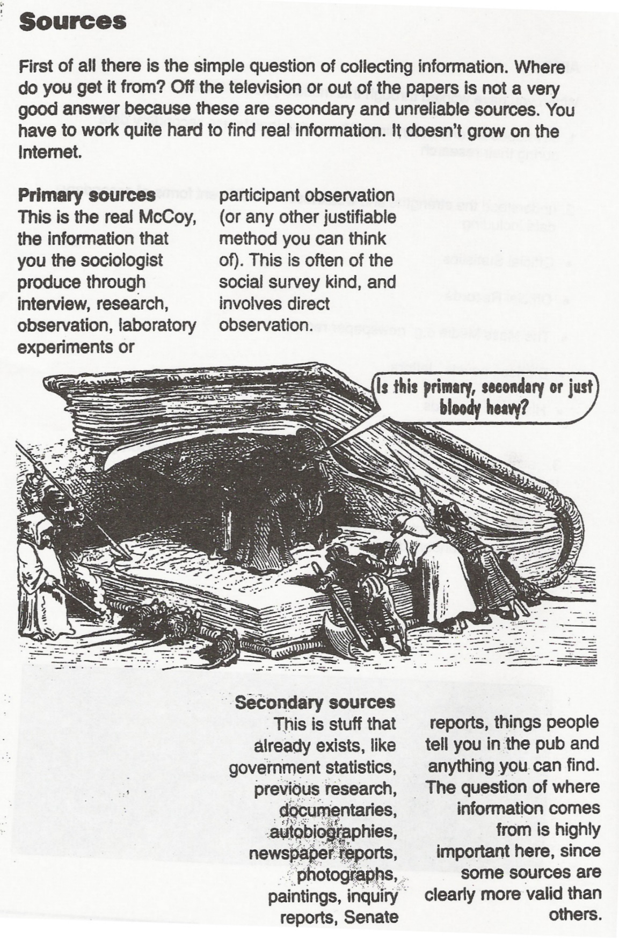

**SECONDARY SOURCES**

As established above, secondary data are those which already exist and are collected from secondary sources. Below is an overview of the main forms of secondary data. We will look at a selection of these throughout the booklet. We have already looked at one form: official statistics, in the earlier statistics booklet.

Secondary data can take either **quantitative** (statistical) or **qualitative** (non-statistical) forms. We can therefore distinguish between different types of documents. Some of these documents (personal/life documents) will be examined in depth in this booklet.

**Quantitative Secondary Sources (other than statistics)**

**Content Analysis**

As the name suggests, Content Analysis is used by sociologists to systematically investigate the content of documents. It explores the content of various media (books, magazines, TV, film etc.) in order to discover how particular issues are presented. Although such documents are usually qualitative, content analysis allows the sociologist to produce quantitative data from these sources. At its most basic, content analysis is a **statistical** exercise that involves categorising some aspect or quality of people’s behaviour and counting the number of times such behaviour appears (a simple content analysis might involve counting the number of minutes men and women appear on screen in a programme such as ‘Eastenders’). In this way, content analysis helps us to build-up a picture of the patterns of behaviour that underlie (and are usually hidden from view) the social interaction portrayed in the media.

It explores the content of secondary data (data which already exists) to create primary data.

As a technique it involves the researcher working out some kind of **CODING SCHEME** (or SCHEMA), that is the group of criteria by which characters are coded for belonging to a particular category.

A **content analysis** of a **television programme** such as EastEnders might involve two basic **categories** (**men** and **women**).

A very **simple form of content analysis** might simply involve **counting** the number of minute’s men and women appear on screen.

A **more-complex form** might involve the use of **categories** like:

1. Where is each character most-often seen? (For example, in the pub as a customer or an employee; in their own home and so forth).
2. What does each character mainly do? (For example, are they always pictured at work or at home and so forth).

|  |  |
| --- | --- |
| **STRENGTHS** | **WEAKNESSES** |
|  |  |

**(You may wish to use the material on Content Analysis in the appendix for more info)**

**PET: CONTENT ANALYSIS**

|  |  |  |  |  |  |
| --- | --- | --- | --- | --- | --- |
| **Define the**  **method** |  | | | | |
| **Example(s)** |  | | | | |
| **Circle correct** | **Quantitative** | **Qualitative** | **Positivist** | **Realist** | **Interpretivist** |
|  | **Strengths** | | **Weaknesses** | | |
| **Practical** |  | |  | | |
| **Ethical** |  | |  | | |
| **Theoretical** |  | |  | | |

**Qualitative Secondary Sources**

Qualitative secondary sources include newspaper, radio and TV reports, websites, novels, literature, art, autobiographies, letters, diaries, parish registers, historical documents, previous sociological studies, school records, social work files, police records, minutes of meetings as well as some official government reports. As John Scott (1980) argues, when it comes to assessing documentary sources, the general principles are the same as those for any other type of sociological evidence. He puts forward for criteria for evaluating documents (Webb textbook p.153-154): authenticity, credibility, representativeness and meaning.

A newer form of personal document can be seen to be the massive amount of information now placed on social media sites, such as Facebook, which have become repositories for information about our lives.

**Personal/life documents** – usually refer to private documents for a person’s own use, which record part of a person’s life. Imagine all the pieces of paper and documents that you have created during your life so for letters, diaries, stories, drawings, photographs, as well as all the material you have produced during your education. If these were discovered of some point for in the future they could provide ‘clues’ as to the time, place and society you lived in: its technology, education system and values for example, as well giving an idea of the sort of person you were. These are the sort of materials referred to as **personal** or **life documents**, and which can be used by sociologists as secondary data. The use of life documents has a long history in Sociology and was popularised by Thomas and Znaniecki in their study *The Polish Peasant in Europe and America* (1919). The researchers made use of 764 letters, a lengthy statement by one Polish peasant about his life, reports from social work agencies, court reports, and articles from Polish newspapers. From such sources they tried to understand and explain the experience of migration for the hundreds of thousands of Polish people who moved to America in the early years of the twentieth century. We will be looking at a more recent example of life documents towards the end of the booklet.

**Public documents** – they refer to those documents that are produced for public knowledge, and include a range of material like all manner of reports and statistics from government, council, charities, voluntary organisations, businesses and the media. *The Report of the Hillsborough Independent Panel* (2012), ordered by the House of Commons to investigate the circumstances surrounding the stadium disaster in Sheffield in 1989, is one recent example of a public document and easily accessible to the public. Another example of a public documents is the Black Report (1980), an enquiry into inequalities in health.

**Historical documents** – In a sense, all documents are historical, but conventionally we are referring to documents which relate to, or were written by, people who are dead. For studying the past, historical documents are often the major and sometimes the only source of information. Max Weber’s classic study *The Protestant Work Ethic and the Spirit of Capitalism* (1905) could not have been written without a range of historical documents. For example, he illustrates the spirit of capitalism with quotes from two books by Benjamin Franklin and written in the mid-eighteenth century. Other examples of historical documents are Phillipe Ariès, who used child-rearing manuals and paintings in his study on the rise of the modern notion of childhood (1962).

**Activity**

Using either the facebook page of a friend (who has given you consent to look at it) or the page of a celebrity or public group, apply John Scott’s criteria for evaluating documents to it and make some notes below:

**Authenticity:** is the page what it claims to be? Is it free from errors?

**Credibility:** is the page believable? Is the information true or is there information missing?

**Representativeness:** is the evidence typical? Could you use it to apply to similar people?

**Meaning:** Do you need special skills to interpret? Would it be possible to interpret it differently by different people?

**Other types of secondary data: Photo diaries**

**Case Study: Archer, L., Hollingworth, S. and Halsall, A. (2007) 'University's not for Me - I'm a Nike Person': Urban, Working-Class Young People's Negotiations of 'Style', Identity and Educational Engagement, *Sociology,* 41, 2: 219-237**

Despite the government's wish to increase the numbers of working class young people entering Higher Education, the numbers of working class students currently going to university is low. Many leave education for good at 16. This research, which is part of a larger study on young, urban, working-class people, considers ways in which members of the social group invests in a style and identity which help to shape their view that 'university's not for me .. .'. The aim of the study was to explore the identities and aspirations of young people in London schools, who had been identified by teachers as 'at risk' of dropping out of education or 'unlikely to progress into post-16 education'. Archer et al argue that the identity taken up and acted out by urban working class youth is one based on knowing they are looked down on by their middle class peers, by the school system and by wider society. They argue that urban, working-class youth actively negotiate a position of social disadvantage which is based on a certain style: ' ... I'm a Nike person .. .'. However, this adopted style merely reinforces the reality of their marginalised and disadvantaged social status and results in a lot of conflict with teachers and the school system. For example, in a discussion about wearing trainers in school, one girl commented:

*"It's just shoes, I don't understand the rule Shoes don't affect my learning* " (Jordan, white working class girl).

Archer et al also argue that holding the view that 'university's not for me' means that these young people are less likely to be successful in education. The researchers also argue that working class urban youths' style differs from that of middle class youth and is one of the contributory factors in relation to the reproduction of educational inequalities.

The research took place over two years in six London schools. The schools were spread out across the city: two in the North, one in the East, one in central London and two in the West. They wanted to include a range of schools from different areas and with a diversity of pupils which were selected on the basis of data on pupil achievement from the Department for Education. All of the selected schools had a high proportion of underachieving pupils and were from disadvantaged areas. The access was obtained by initially contacting head-teachers who then acted as gatekeepers to the Year 10 and 11 form tutors and who also put the researchers in touch with some support staff. Pupils who were 'at risk' of dropping out of school were identified by the schools and the research team then wrote to their parents/guardians as well as the pupils themselves to gain permission for the interviews. Following this initial contact all of the pupils who agreed to take part were included in the study. The data was collected from interviews with fifty-three pupils from Years 10 and 11, discussion (focus) groups, photographic diaries and semi­structured interviews with teachers. Most of the fifty-three young people, whose age range was 14-16 years old, were interviewed four times. Some of the sample group left the study as a result of moving away or changing their contact details. The sample was comprised of twenty three girls and thirty boys. In relation to ethnicity the breakdown was thirty-six white UK, one Black African/Caribbean; six mixed ethnicity; four Asian; three Middle Eastern and three White other. The young people all lived in socially disadvantaged areas where there was high poverty, crime and drugs. They attended schools which were undersubscribed and considered less attractive than other schools in the area. Many of the interviewees had experienced repeated failure from the constant testing (SATS) they had endured during their school careers and described themselves as 'stupid' or 'not exactly a star student'.

In addition to the semi-structured interviews, eight pupils were asked to keep photographic diaries (they were invited to take photographs of anything that was either meaningful to them, reflected their identities or their daily lives), and a further 36 pupils took part in discussion groups - five pupils in each. The interviews varied in length from half an hour to one and a half hours. This enabled Archer et al to collect data that was, in the main, qualitative. The interviews were conducted on the school premises although a few took place in local cafes or other places identified by the pupils. These were usually when a pupil had left school or were frequently absent. Some interviews took place in Pupil Referral Units (PRUs) when pupils were moved into them by the schools over the two years.

In relation to ethics, parents of the pupils involved were asked for consent since the pupils were under 16 years old. The pupils' identities were anonymised by the use of pseudonyms which the pupils chose themselves. All of the interviews and discussion groups were audio recorded and a professional transcriber was employed to type them up.

Archer et al found that the style of the urban young working-class youth was linked to their class identity. A style which gave them a sense of self-worth and value and which enabled them to resist the worthlessness they might otherwise experience from attending 'crap' schools in 'rubbish areas'. They saw the style as 'cool' which was partly related to its association with black masculinity which was distinct from that of the middle class and symbolised 'hardness' and 'street cred'.

*"You wouldn't really expect [upper class] people to come out in Nike tracksuits and stuff, we expect them to have that Gucci designer stuff. But people like* us ... *we're Nike"* (Sean, Year 10 male).

|  |
| --- |
| **QUESTIONS**   1. Explain why photographic diaries can be a useful method for researching identities and aspirations of young people   2. Why would a Positivist be sceptical about using photographic diaries as sources of data? |

[**Assessing the Usefulness of Secondary Qualitative Data to Research Education**](https://revisesociology.com/2015/12/20/analyzing-secondary-qualitative-data-education/)

Posted on [December 20, 2015](https://revisesociology.com/2015/12/20/analyzing-secondary-qualitative-data-education/) by [Karl Thompson](https://revisesociology.com/author/notsoclevermonkeys/)

How useful is secondary qualitative data when researching education? This post considers some of the theoretical, practical and ethical limitations of Public and Personal Documents which are produced in the context of education – such as OFSTED reports, school prospectuses, school reports and messages sent between pupils.

|  |  |
| --- | --- |
| **Public Documents** | **Personal Documents** |
| Ofsted and Inspection Reports  School Websites  School prospectuses  School policy documents  School text books | School reports on pupils  Pupils written work  Pupils’ and teachers’ diaries  Notes and text messages passed between pupils |

**Practical Issues with using documents when researching education**

Since the 1988 education act many Public documents on education are freely available to the public – OFSTED reports on schools are easily obtainable, and schools publish a wide variety of information about themselves in their prospectuses and on their websites.

Schools also publish a huge variety of policy documents – such as student codes of conducts, equal opportunities policies and information about how they implement every child matters and safeguarding policies – all of which are likely to be made available to researchers on request, since they are a matter of public record. These are useful as they give an account of the ‘official’ picture of schools in Britain from the perspective of management.

**Theoretical Issues with using documents when researching education**

In terms of validity, while school web sites and prospectuses can be trusted to provide some basic information about what subjects are on offer, GCSE results and extra-curricular activities, the credibility of such sites is undermined by the fact that they produced to advertise the school in a positive light, and all of these web sites put a positive spin on the school or college. For example, although schools are required to publicise their results, they do have some freedom to emphasise the way they report them so they can portray themselves in the best possible light.

[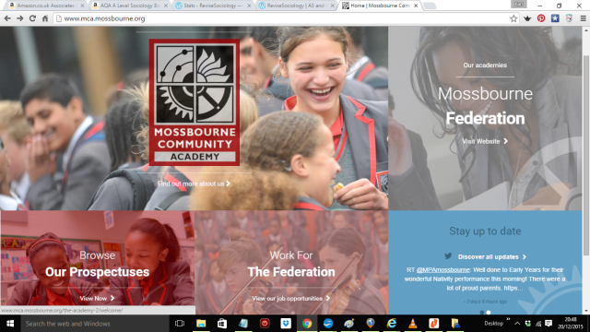](http://www.mca.mossbourne.org/the-academy-2/welcome/)

To what extent do school web sites provide a valid picture of school life?

*Suggested activity: Visit the web sites of your past school and present college – to what extent do they give you an accurate picture of what life was actually like in that school?*

*Extension activity: Look at the web site from another school in your area. Pick one that is very different in terms of results and so on. Are the impressions you get of the two schools that different, or are they quite similar, which would suggest that school web sites are designed to a formula and really tell you very little about a particular school.*

[OFSTED](https://www.gov.uk/government/organisations/ofsted) reports may provide greater insight into what’s going on in a school than the statistical snap shot of the yearly GCSE results, but OFSTED inspections only last for three days, and are typically only done every four years, so it is quite easy for a school to put on an act for this short a period and produce a performance which is better than usual.

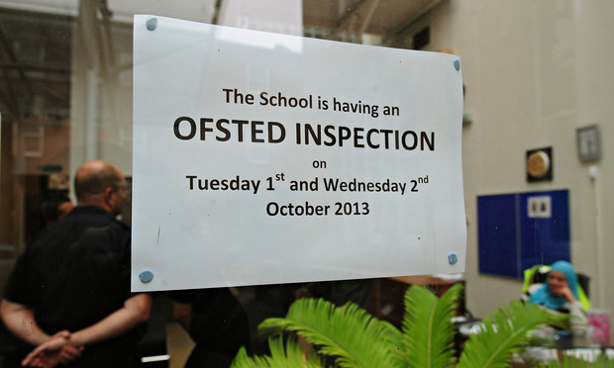

Might some schools be able to put on a better performance than usual during a brief OFSTED inspection?

Conversely, there are [some schools that feel as if they have been harshly judged by OFSTED inspectors](http://www.northdevonjournal.co.uk/Factually-inaccurate-unfair-Ofsted-says/story-26247124-detail/story.html), and question the validity of OFSTED reports, feeling that the grade they’ve been awarded does not reflect the reality of school life. This is partly because OFSTED inspectors only really get to see one lesson by each teacher, which is not representative, but also because the focus of different OFSTED inspectors will be different in different schools, raising the prospect that schools are not being judged by the same standard.

Policy documents produced by schools, such as student codes of conduct might be useful for seeing how schools function in an ideal-world, but they lack validity in that they tell you nothing about how many students actually stick to the code of conduct or what’s done with students who break the code of conduct. If you wanted to get more of an insight into this, a researcher would have to gain access to individual reports of each student, which would be more difficult to obtain.

**Representativeness and Public Documents in Educational Research**

All schools and colleges are required to publish prospectuses and results, so these should cover a 100% sample of educational institutions, but the same cannot be said of OFSTED reports – schools graded outstanding go into ‘light touch’ mode and may not be observed for several years.

**Using Personal Documents to Research Education**

*Suggested starter activity – Have a browse of this interesting blog –* [*‘Scenes from the Battleground’*](https://teachingbattleground.wordpress.com/) *– which has had over a million hits and is written by a teacher. What impression does this give you school life?  How valid and representative do you think it is?*

Personal documents in the context of education include school reports on pupils, pupils written work, pupils’ and teachers’ diaries and Notes and text messages passed between pupils

**Practical Issues**

For a start, these will be very difficult to access. Things like teacher mark books, records of conversations with students, and disciplinary records may not be available because of the ethical requirement to safeguard children’s privacy. The same could also be true of the written work of pupils.

Where private messages and texts are concerned, it is unlikely that researchers will be allowed access to students personal mobile phones or tablets, and even if they could gain access, threads of conversation may have been deleted shortly after they took place, and the more ‘anti-school’ such messages are, the more likely they are to have been deleted.

**Validity and Personal Documents**

The kind of personal documents which are readily available are likely to be of a public nature (social media accounts for example) and because they are public, they would have been subjected to impression management so they are acceptable – so while this can give us an insight into what teachers and staff think is socially acceptable, using these to give us a picture of what people actually think about school life is problematic. The more ‘personal’ and private a document is, then the higher the validity is likely to be – however, the number of people who write down in-depth personal accounts of their school experiences is tiny.

**Representativeness**

If one could gain access to social media accounts and personal messaging services, representativeness should be good as the majority of students have access and make use of these services.

As mentioned above, hardly anyone keeps diaries any more, and so representativeness here is a problem.

If a researcher is lucky enough to gain access to disciplinary records, these may not be representative of the actual underlying patterns of student disobedience – teacher bias may increase the number of certain types of students who have undergone disciplinary procedures.

**Ethical Issues when using public and private documents in educational research**

There are no particular ethical problems with using publicly produced documents,

When using private or personal documents, there are some ethical concerns. If the researcher is given access to teacher mark books, records of conversations with students, and disciplinary records this won’t necessarily be with the informed consent of the pupils for example.

**PET: QUALITATIVE SECONDARY DOCUMENTS**

|  |  |  |  |  |  |
| --- | --- | --- | --- | --- | --- |
| **Define the**  **method** |  | | | | |
| **Example(s)** |  | | | | |
| **Circle correct** | **Quantitative** | **Qualitative** | **Positivist** | **Realist** | **Interpretivist** |
|  | **Strengths** | | **Weaknesses** | | |
| **Practical** |  | |  | | |
| **Ethical** |  | |  | | |
| **Theoretical** |  | |  | | |

**Exam Questions**

1. **Marks**

Outline and explain two problems are presented in historical research for sociologists [10]

Outline and explain two problems associated for sociologists in the use of secondary data [10]

Outline and explain two problems associated for sociologists in the use of life documents

Outline and explain two reasons sociologists use personal documents in sociological research [10]

**20 marks (these would include an item)**

*Using the material in Item C and your own knowledge...*

... Evaluate the theoretical advantages of using personal documents in sociological research [20]

... Evaluate the practical disadvantages of using historical documents in sociological research [20]

**Methods in Context – Investigating the ways in which schools reinforce traditional gender identities.**

|  |
| --- |
| **Item B**  **Investigating the ways in which schools reinforce traditional stereotypical roles.**  Some feminist sociologists have identified that pre-school books and reading schemes used within schools portray males and females in their ‘traditional’ stereotypical roles, with women being the caring figure, while males are portrayed as more powerful. They argue that this could be influences educational experiences later on such as decisions relating to subject choice.  Sociologists may use content analysis of qualitative secondary sources such as books to investigate the ways in which school reading schemes reinforce traditional stereotypical roles. Exploring the meanings attached to gender differences can be particularly useful however there is a danger of the researcher interpreting the books in a biased way. |

Applying material from **Item B** and your knowledge of research methods, evaluate the strengths and limitations of using qualitative secondary sources for the study of the ways in which schools reinforce traditional stereotypical roles [20 marks]

**Proposed plan:**

|  |
| --- |
| **Introduction – WWWE**   * **W**hat? – What is the method in the question? Define and apply detail about the method. * **W**ho? – Who would use it? (Positivist, Interpretivist, Realist) * **W**hy? – Why would they use it? – Relating to the context in the question – in this case the ways in which schools reinforce traditional stereotypical roles. * **E**valuate – Who wouldn’t use it? Why? |
| **Main body**   * Aim for at least **3 strengths and 3 weakness.** * Consider and include all elements of **PERVERT** within your response. * Refer back to the **context** |
| **Conclusion**   * **Summarise strengths and weaknesses** (in relation to the **context**) * Would an **alternative method** be more suitable? Apply **methodological approaches** to this response (Positivism, Interpretivism and Realism) |

**APPENDIX**

**Content Analysis and the News - Useful Concepts**

Content Analysis is a highly successful technique to investigate the content of the media. It is relatively easy to do, as the media is ready made, as well as easy and cheap to access (and thus build up a sample)

It allows researchers to measure or add up the frequency of a given message.

Provided the method is agreed by a team of researchers before hand, replication is possible

Content Analysis is a particularly useful technique when trying to assess news values by evaluating, in broadcast news (amongst other measurables):

* The running order of news stories
* The repetition/persistence of news stories in the news agenda
* The time allocated to news stories

And in print media:

* The volume of space taken up (measured in column centimetres or cm2 or similar)

This creates statistical data which is difficult to challenge when addressing issues of media bias.

**News Values** as listed by Steve Chibnall (Law and Order News)

According to Chibnall’s research the following factors shape the news agenda and create the news programmes we see:

* **Immediacy -** *news is about what just happened*
* **Dramatization –** *news must be dramatic (millions of people slowly starving is not dramatic)*
* **Personalization -** *for example, important political issues get trivialized, e.g., reducing the current General Election to “Theresa” vs “Jeremy”.*
* **Simplification-** *an editor of the Daily Express defined a bad news story as one that cannot be absorbed at first reading*
* **Titillation-** *for example, “Shock, Horror, Probe”. It fascinates and titillates and then reassures us by finally condemning the act*
* **Conventionalism-** *the journalist does not just report the news, but ‘translates’ it so that it can be understood by ‘normal people’*
* **Structured access-** *those in authority get more access to the media, hence news tends to be about what those in authority define as news*
* **Novelty-** *there must be an angle which another paper or programme has not got –*the idea of a “scoop”

**Contemporary Issues – Social Media**

Content Analysis of news on social media is both more difficult and but also easier.

The principal problem for contemporary research is the issue of access.

News sources have become much more varied and likely to be less easy to track by individual researchers (and it is even a problem deciding what may be regarded as “news” – hence recent panics around the concept of “Fake News”). Large corporations may also make direct access to their own data less accessible.

But, importantly, the use of online media creates its own data trail and easily creates important and useful statistical data as well as qualitative material. Frequency of searches for key terms on Google or hashtags tending on Twitter gives some indication of the measurable data created by internet sources and have proved the basis of research. Google will regularly share stories on the most frequent search terms accessed (although they do not share online browsing histories … imagine if they shared yours!).

Key elements in analysing news media

|  |  |
| --- | --- |
| Coding Scheme | List if categories to look for. (Therefore when a researcher is coding a piece of media they simply use the pre-arranged categories to measure the frequency of the message) |
| Language Bias | This is a popular starting point. Does the media contain words or phrases that may contain a biased, one sided viewpoint – e.g. headlines (bias is clear, and somewhat necessary, in newspaper headlines to capture the public’s attention and persuade them to buy ) |
| Selectivity | news items, transmitted or published are created by a process of selection (editing)  Construction of the news involves decisions made by media personnel as to the relative importance and merits of each story  (At some points of the year – the silly season – when parliament recess for summer, some stories are given attention they wouldn’t merit at other times, except as light-hearted, short items at the end of a broadcast) |
| Scheduling | decision about what is the most important story is reflected in the order of the items – reflected through the headlines in broadcasts, newspaper headlines |
| Frequency | over a period of time should be possible for a researcher to see any patterns that exist, in the type of items given precedence over others |