**SOCIOLOGY ENRICHMENT ACTIVITIES**

The Sociology department would love for you to continue to stay engaged over the coming weeks and months. The following are suggestions, they are not compulsory, but we would love for you to engage in any that you find interesting.

Pick a task below, whilst watching/reading consider the following questions

1. What does the source show about the nature of society at the time?
2. What are the main concerns of the people presented?
3. What view would different theories take on what you have looked at? Consider feminism, Marxism, functionalism, interactionism and left and right realism for themes related to crime.

You are welcome to email any reflections to us. We will add more ideas in the coming weeks.

**Option 1**

**Back in Time for the Factory**

Follows modern day women who experience working in a British garment factory in 1968. This series of documentaries follows what it was really like when the Equal Pay and Sex Discrimination acts were introduced.

<https://estream.godalming.ac.uk:444/View.aspx?id=14417~5e~WDi4rJrXiJ>

You could also watch **Made in Dagenham**, which charts the same time <https://estream.godalming.ac.uk:444/View.aspx?id=8497~4C~FdpGz8xw>

**Option 2**

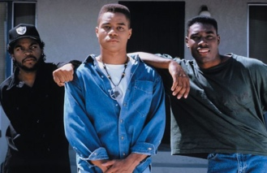**Boyz in the Hood**

Three childhood friends in a tough South Central LA neighbourhood struggle to make sense of the gang violence that surrounds them.

<https://estream.godalming.ac.uk:444/View.aspx?id=14612~5b~ssoqmCL6QZ>

**Option 3**

**The Met, Policing London**

A man is attacked and dies in Trafalgar Square, the Trident team try to dismantle one of London's most dangerous gangs, and response officers have to deal with a drunk driver.

<https://estream.godalming.ac.uk:444/View.aspx?id=16125~5c~UfE46wWsnR>

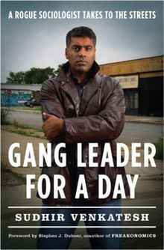

**Option 4**

**Gang Leader for a Day**

Read more detail of this case study we looked at last year. Book currently on kindle for £4.99