**Simplest Method of Making Anaglyph Images with Photoshop**

[vicgi](http://www.webdesign.org/search.php?author=11008)[ImageReady Animation](http://www.webdesign.org/photoshop/imageready-animation/page-1.html)Oct 21, 2010

[1](http://www.webdesign.org/photoshop/imageready-animation/simplest-method-of-making-anaglyph-images-with-photoshop.18993.html)

**Introduction**

**Anaglyph images** are images with 3D effect when viewed with a 2 color red and cyan glasses. The Internet has many tutorials on teaching how to make anaglyph images. But in my opinion the methods are unnecessarily too complicated. In this article I will present a simple 1-2-3 step for making anaglyph image using the very basic functions of Photoshop.

**Step - 1**

Take two pictures along a straight line with some distance. Unlike the case of making lenticular prints, the precision requirement of making anaglyph is not very tight. You can take your pictures by moving the camera on a flat surface. Try to use a rigid ruler to guide the camera when you move the camera from left to right. The distance between the first picture on the left and the second picture on the right should be about 2.5 inch (or 65mm).

In this tutorial we are going to use the following two pictures.

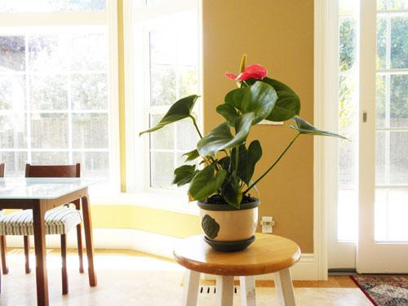

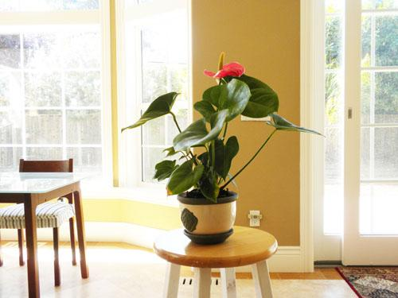

**Step 2**

Open both pictures into Photoshop. Put the left picture into the clipboard and paste it over to the right picture so the left picture is on top of the right picture as show.

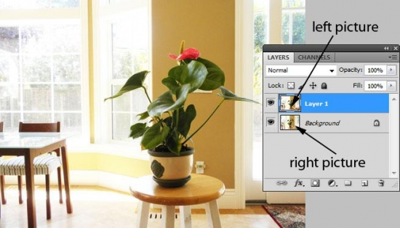

**Step 3**

Double click the Layer 1 (the left picture layer) to bring up the [Layer Style] dialog, then un-check the B and G check boxes under [Advanced Blending].

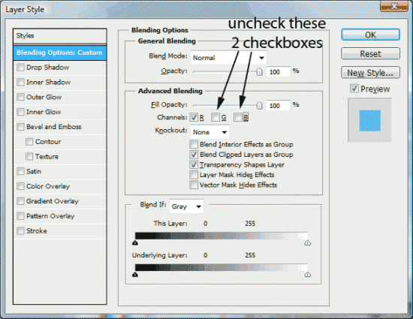

And voila! Your anaglyph image is done. Now you can view the picture with a pair of red-cyan glasses.

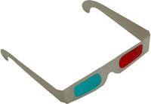

Simplest Method of Making Anaglyph Images with Photoshop


Read more: <http://www.webdesign.org/photoshop/imageready-animation/simplest-method-of-making-anaglyph-images-with-photoshop.18993.html#ixzz2HNmJ5VrX>

