## BTEC Health and Social Care Extended Certificate Enrolment work

### Task 1

Outline the main life stages and put them in the following table with the age range which accompanies them:

|  |  |
| --- | --- |
| Life Stage | Age range |
|  |  |
|  |  |
|  |  |
|  |  |
|  |  |
|  |  |

Find definitions to the following terms

**Growth**

..........................................................................................................................................................

..........................................................................................................................................................

..........................................................................................................................................................

..........................................................................................................................................................

**Development**

..........................................................................................................................................................

..........................................................................................................................................................

..........................................................................................................................................................

### Task 2

Read the paragraph and thing how Sarah has grown and developed in the table after:

Sarah is a 1 year old girl who is developing normally. Her health visitor has come to visit her for a one year check. When she was born, Sarah weighed around 3kg, the health visitor finds that she now weighs 9kg. Sarah’s mother mentions that Sarah has recently begun to use words such as ‘dada’ and ‘moo,’ the health visitor says that this is normal language development and Sarah won’t move on to two-word phrases until around 2 years old. Next, the health visitor measures Sarah and finds that she is 74cm long; the health visitor reassures Sarah’s mother that this is normal for her weight and age. Finally, the health visitor gives Sarah some toys to play with and monitors her abilities; Sarah can build a tower with three blocks, point to a picture of a sheep in a book and can sit herself up after lying down.

How has Sarah…

|  |  |
| --- | --- |
| Grown? | Developed? |
|  |  |

### Task 3

The 6Cs are a set of values for all health and social care staff. These 6 values are essential in providing the best care for individuals and their different needs.

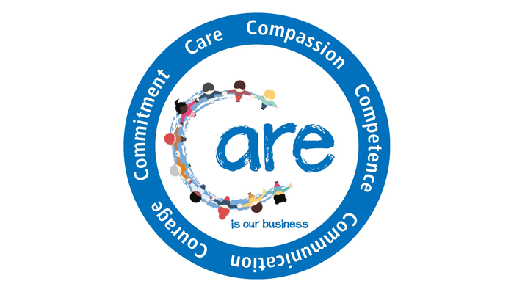

**Design a Poster about the 6 C’s of Health and Social Care for a team of Nurses starting their new roles at Frimley Park Hospital.**

These links will help you to research the 6 C’s and create an eye-catching poster explaining the importance of the 6 C’s for meeting the care and support needs of individuals.

<https://www.england.nhs.uk/6cs/wp-content/uploads/sites/25/2015/03/introducing-the-6cs.pdf>

<https://www.england.nhs.uk/blog/jane-cummings-4/>

### Task 4

 Research the NHS and what it means to work in the health sector. Then identify some of the different roles offered by the NHS for those looking to start a career working for Britain’s biggest employer.

<https://www.england.nhs.uk/>

<https://www.healthcareers.nhs.uk/explore-roles>

<https://www.healthcareers.nhs.uk/>

…………………………………………………………………………………………………………………………………………………………………………………………………………………………………………………………………………………………………………………………………………………………………………………………………………………………………………………………………………………………………………………………………………………………………………………………………………………………………………………………………………………………………………………………………………………………………………………………………………………………………………………………………………………………………………………………………………………………………………………………………………………………………………………………………………………………………………………………………………..…………………………………………………………………………………………………………………………………………………………..…………………………………………………………………………………………………………………………………………………………..…………………………………………………………………………………………………………………………………………………………..

List in the table below some of the skills and attributes required for the following health and social care roles:

|  |  |  |
| --- | --- | --- |
| **Job Role:** | **Health or Social Care role:** | **Skills and Attributes required for role:** |
| Paediatric Nurse |  |  |
| Pharmacist |  |  |
| Care Assistant |  |  |
| Psychologist |  |  |
| Occupational Therapist |  |  |
| Dental hygienist |  |  |
| Social Worker |  |  |
| General Practitioner |  |  |
| Care Worker |  |  |

Finally, complete the NHS quiz using the link below to find out your ideal health career: <https://www.healthcareers.nhs.uk/findyourcareer>

The quiz should take only 5 minutes to complete. Write down your findings below:

…………………………………………………………………………………………………………………………………………………………………………………………………………………………………………………………………………………………………………………………

…………………………………………………………………………………………………………………………………………………………..…………………………………………………………………………………………………………………………………………………………..…………………………………………………………………………………………………………………………………………………………..…………………………………………………………………………………………………………………………………………………………..