BTEC Applied Science (NQF) Unit 3

D Enzymes in action

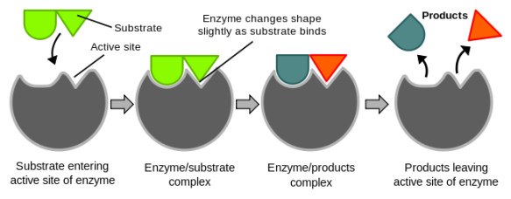

## D1 Protein structure

* Peptide linkage.
* Active sites.
* Denaturation.

## D2 Enzymes as biological catalysts in chemical reactions

* Collision theory.
* Formation of enzyme-substrate complex.
* Specificity of enzymes brought about by the need for matching of substrate and active site.
* Lowering of activation energy.
* Changing substrate concentration changes the rate at which substrate molecules will join active sites.
* Importance of measuring initial rates of reaction.

## D3 Factors that can affect enzyme activity

* Temperature.
* pH.
* Substrate and enzyme concentration

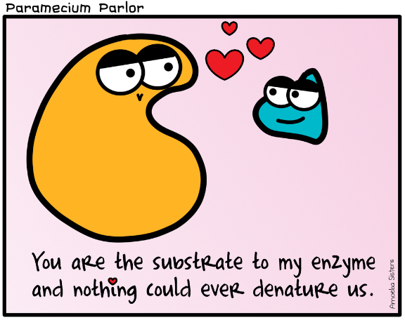

# D1: Protein structure

Proteins are _______________ made up of long chain molecules of repeating units. The monomer of protein is called an __________ ________.

Draw the structural formula of a generalised amino acid, label the amino group, the carboxyl group and the R group (side chain).

Amino acids join together in a process called ____________________. They become joined by a bond called a ____________ - ___________. This bond forms between the _________ group of one amino acid and the ___________ group of another. When two amino acids join together a ______________ molecule is formed.

Watch the animation to show the formation of a protein

<http://www.biotopics.co.uk/as/aminocon.html>

Draw a diagram to show condensation of two amino acids to form a dipeptide.

## The levels of protein structure

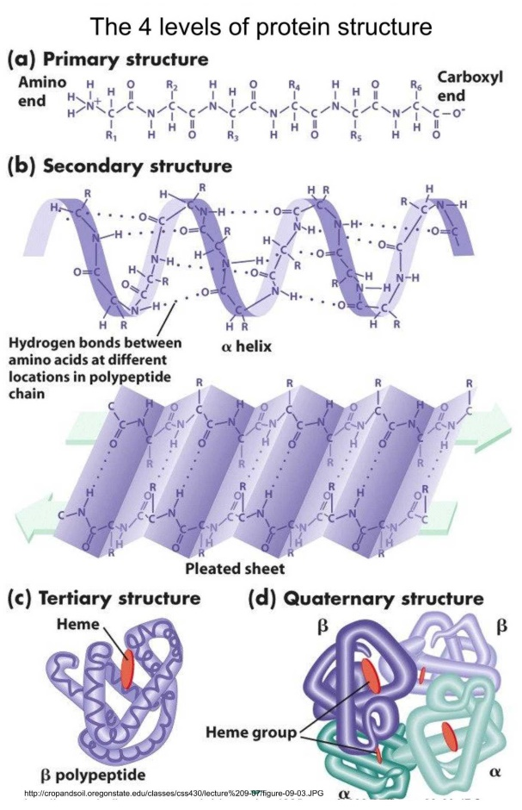

The resulting polypeptide from the condensation of many amino acids is said to have a **primary level of structure**. The ___________ and _________ of amino acids determines the primary level of protein structure.

The primary structure determines the ultimate shape and hence structure of the protein.

The hydrogen bonds cause the polypeptide to either __________ into an alpha helix or _________ into a beta pleated sheet. The helix or the pleated sheet are examples of the **secondary level of protein structure**

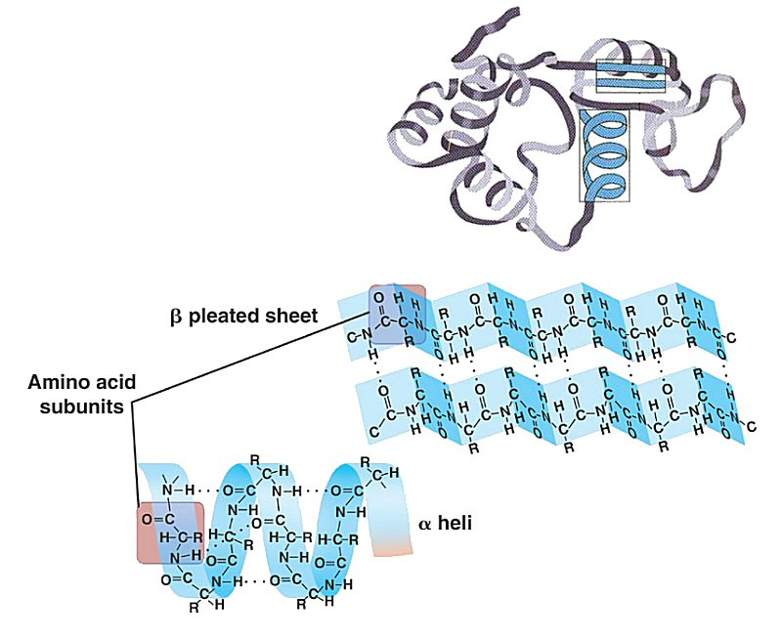

**The tertiary level of protein structure** involves the further twisting and folding of the secondary structure due to two other types of bond.

**The quaternary level of protein structure** is the result of **______ than 1 polypeptide** being held together by **bonds**. Sometimes there is a part of the molecule which is **___________**. Eg Haemoglobin is a protein with quaternary level of structure there are **4 polypeptide** **chains** each with a **Haem group** containing **iron**.

The bonds involved in quaternary level of protein structure are **peptide, hydrogen, ionic and disulphide.**.

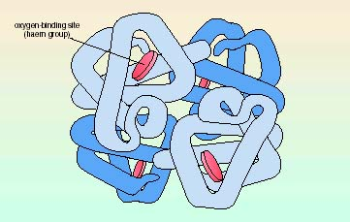

A very useful website to consolidate your work.

<http://www.chemguide.co.uk/organicprops/aminoacids/proteinstruct.html>

The shape of a protein is very important because

# D2: Enzymes as biological catalysts in chemical reactions

## Enzymes – a very important function of proteins

Enzymes are biological catalysts. This means they ____________ the speed of metabolic reactions.

Name two metabolic reactions controlled by enzymes

1. ______________________

2. ______________________

Your phenotype (what you look like) is also affected by enzymes.

[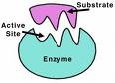](http://www.chemistry.wustl.edu/~edudev/LabTutorials/HIV/images/enzyme.jpg)From GCSE you know that an enzyme has an __________ ________ into which the ___________ makes temporary bonds.

The active site has a _______________ shape (due to the ____________ level of protein structure) which is __________________ to the shape of the substrate molecule.

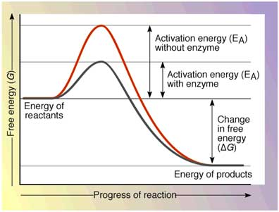

Enzymes speed up the rate of a reaction by __________________ the activation energy to start the reaction off.

Use the graph to explain what is meant by activation energy.

___________________________________________________________

___________________________________________________________

___________________________________________________________

In addition to meeting **the activation energy** in order for things to react they also have to collide in the **correct orientation.**

## Initial rate

When measuring the rate of a reaction you want to know how the speed of the reaction is affected by the thing you are changing. You know the most about the reaction at the start – you know how much of everything you have put in. During the reaction the concentration of substrate _______________ and the concentration of the enzyme _______________. Overall the rate of the reaction over time will ________________________. So it is most accurate to measure the ‘initial rate’ this is the rate of the reaction at the start:

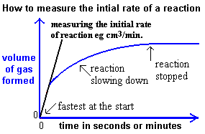

## Models of enzyme action

When the substrate fits into the active site of the enzyme an ___________/____________ complex forms.

If the enzyme is involved in joining molecules by holding them close together in its active site it reduces any repulsion between them so they bond more easily.

If the enzyme is catalysing the breakdown of a molecule, then fitting the molecule into the active site of the enzyme puts a strain on the intramolecular bonds and so the molecule breaks up more easily.

Watch the following animation to illustrate enzyme action

<http://highered.mcgraw-hill.com/sites/0072495855/student_view0/chapter2/animation__how_enzymes_work.html>

Watch the following animation to recap activation energy and compare the lock and key and induced fit models of enzyme action.

<http://www.sumanasinc.com/webcontent/animations/content/enzymes/enzymes.html>

This shows the **lock and key model** suggested by early scientists. Note the precise complementary shapes of enzyme’s active site and substrate.

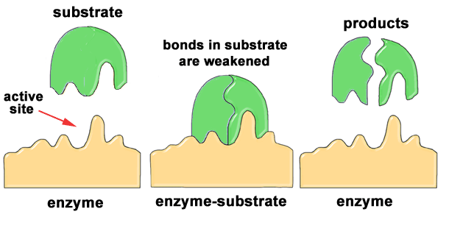

**Enzyme properties**

Use words from the list to complete the gaps in the following passage.

Specific tertiary structure denatured pH temperature sensitive reused small

Enzymes will only work on one substrate (or group of substrates) because they are ______________ due to their ______________ ______________.

As enzymes are catalysts they can be __________ and so are only needed in _____________ quantities.

Enzymes work in limited ranges of ____________ and _____________ this is because they are ______________ to conditions in their environment again due to their tertiary level of protein structure.

If the conditions surrounding an enzyme are not suitable the enzyme will become _________________.

# D3 Factors that can affect enzyme activity

### Temperature effects on egg albumen

Hypothesis

Hazard

Risk

Variables:

Independent

Dependant

Control

Method

Diagram:

Table of results

What do your results show?

How is the experiment fair?

How could you change this experiment in the future (*Extend it*)?

### Factors which affect enzyme activity: pH effects on egg albumen

Hypothesis

Hazard

Risk

Variables:

Independent

Dependant

Control

Method

Diagram:

Table of results

What do your results show?

How is the experiment fair?

How could you change this experiment in the future (*Extend it*)?

### The effect of temperature on the activity of the enzyme lipase

Hypothesis

Hazard

Risk

Variables

Independent

Dependant

Control

Method

1. Set up water baths at different temperatures
2. Put a solution of lipase into a test tube into each water bath
3. Into another test tube in the water bath put 5cm3 of milk and 4 drops of phenolphthalein and 7cm3 of sodium carbonate
4. When each test tube has reached temperature put 1cm3 of lipase into the test tube with milk and start the stopwatch.
5. Stir the solution until it goes colourless
6. Record the time taken

Diagram:

Table of results

|  |  |  |  |  |
| --- | --- | --- | --- | --- |
| Temperature | Trial 1 | Trial 2 | Trial 3 | Average |
|  |  |  |  |  |
|  |  |  |  |  |
|  |  |  |  |  |
|  |  |  |  |  |
|  |  |  |  |  |
|  |  |  |  |  |

Draw a graph of your average results with the independent variable on the x-axis and the dependant variable on the y-axis (and attach it to the back of this pack)

What do your results show?

How is the experiment fair?

How could you change this experiment in the future (*Extend it*)?

### Factors which affect enzyme activity: Substrate concentrations (H2O2 conc on catalase and measuring vol in set time)

Hypothesis

Hazard

Risk

Variables:

Independent

Dependant

Control

Method

Diagram:

Table of results

What do your results show?

How is the experiment fair?

How could you change this experiment in the future (*Extend it*)?

### Factors which affect enzyme activity: Temperature and casein on milk

Hypothesis

Hazard

Risk

Variables:

Independent

Dependant

Control

Method

Diagram:

Table of results

What do your results show?

How is the experiment fair?

How could you change this experiment in the future (*Extend it*)?

### Glucose yeast and limewater

Hypothesis

Hazard

Risk

Variables:

Independent

Dependant

Control

Method

Diagram:

Table of results

What do your results show?

How is the experiment fair?

How could you change this experiment in the future (*Extend it*)?