# Glossary

## Dependant variable

The variable you are investigating and measuring in the experiment (it is *dependant* on the others)

## Control variable

The variables you keep constant

## Independent variable

The variable you change in the experiment

## Hazard

The equipment or substance which can cause harm

## Risk

The harm the hazard could cause and the likelihood of it happening

## Systematic error

The error which is built into the method or equipment you are using e.g. a balance which hasn’t been calibrated correctly.

## Random error

Due to not following the method correctly – can be minimised by repeating experiments.

## Misreading error

Observe the wrong colour change

## Accuracy

How close the data is to the true value

## Reliability

How trustworthy the results are – you can repeat experiments to identify anomalous results

## Precision

How close the repeat readings are to each other

[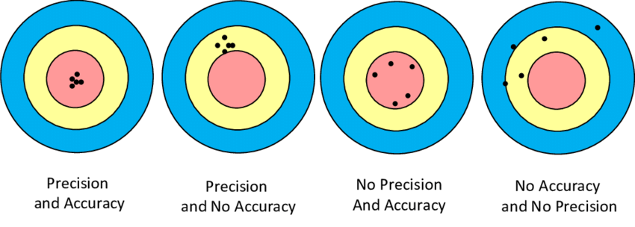](https://www.google.co.uk/url?sa=i&rct=j&q=&esrc=s&source=imgres&cd=&cad=rja&uact=8&ved=2ahUKEwiQm9iihJDdAhUp4YUKHeiiCe8QjRx6BAgBEAU&url=https://www.researchgate.net/figure/Precision-Reliability-and-Accuracy-Validity_fig4_287597852&psig=AOvVaw12EDYZ2gODXlMP6H76N1vC&ust=1535555534403143)

## Secondary evidence

Data you have not got from an experiment yourself e.g. you looked it up somewhere!

# Planning an experiment

## Hypothesis

What you think will happen and *why*

## Equipment

What you need and *why*

## Health and Safety

Any Hazards and how you minimize the risks

## Variables

Dependant

Independent

Control

## Method

How you will do things

What equipment you will use

Roughly how much you will measure of things

What you will measure

Make sure you say *why* you are doing these things

## Results table

Need to include units!

# After you have some results:

## Draw a graph

Make sure you have titles and units on the axis

## Interpret graph

Explain what the overall trend of the graph is and any anomalies

## Discuss the reliability of your results

Did you do enough repeats? Were your control variables controlled?

## How could you extend the experiment

How could you change this experiment in the future (eg if all carried out at one temperature, could you change the temp and do it again? Different pH?)