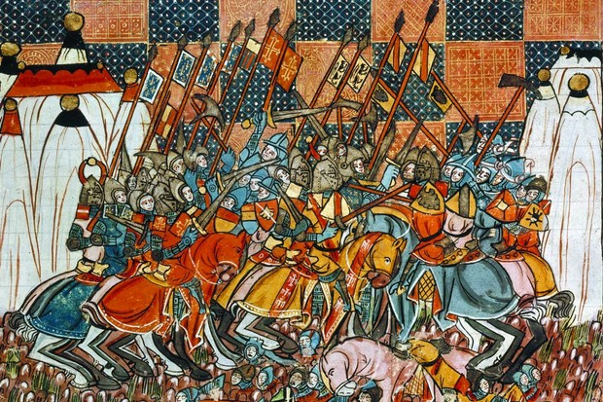

**Crusaders: did they fight for God or gold?**

Waging holy war in the Middle Ages could be a lucrative business. Medieval historian Dan Jones tells the story of the crusaders who returned from the front line with their souls cleansed – and their pockets full

On the morning of 1 July 1097, tens of thousands of Christian pilgrim soldiers of the First Crusade scrambled to make a desperate stand against a horde of advancing Turkish horsemen.

The crusaders were only a few days into a three-month march through 800 miles of hostile terrain when the Turks took them by surprise, attacking early in the morning while the crusaders were still in camp, near an old Roman settlement in Anatolia called Dorylaeum. One eyewitness to the battle, a French priest called Fulcher of Chartres, recalled the terror he felt when the Turks descended, as he and his companions “huddled together like sheep in a fold, trembling and frightened”. The fighting raged for six hours until eventually – miraculously – it became clear that the Turks did not have the numbers to prevail. The Christian cavalry, commanded by a wily Norman nobleman called Bohemond of Taranto, held the tormentors at bay for long enough to allow reinforcements to arrive from several miles away. These fresh troops forced the Turks into a disorderly retreat, which soon became a rout. After it was finished, the crusaders buried their dead and gave thanks for their victory.

The battle of Dorylaeum was remembered for years afterwards as a demonstration of God’s approval for crusading and an example of the first crusaders’ extraordinary resilience and motivation. It was also remembered as a day that had proven unexpectedly lucrative. One writer recorded the slogan shouted from man to man on the front line at Dorylaeum: “Stand fast all together,” they had yelled as the Turks swooped, “trusting in Christ and in the victory of the Holy Cross. Today, please God, you will all gain much booty!”

This had proved prophetic. For not only did the crusaders record an inspirational military victory; they also gleefully looted the camp of the Turkish leader, Qilij Arslan, and enriched themselves by plundering the bodies of the 3,000 enemy soldiers who had been killed. They had trusted in Christ and, just as promised, gained much booty. Their pithy, two-pronged war cry captured the two great preoccupations of the crusader age: faith and gold.

**A hotchpotch of enemies**

Most historians date the crusades from the preaching of the First Crusade by Pope Urban II at Clermont in 1095 to the fall of the last Islamic strongholds in al-Andalus (southern Spain) in 1492. They were a series of interconnected Christian ‘holy wars’ fought against a wide variety of foes.

The First Crusade was called to aid Greek Christians of the Byzantine empire in their wars against the Turks of Anatolia, and subsequently to seize Jerusalem from its rule by Fatimid Shia caliphs based in Cairo. But over the generations many more crusades were raised – against Arabs, Turks and Kurds, Sunni and Shia Muslims, Berbers from north Africa, pagans in Latvia, Cathars in southern France, Mongols in eastern Europe. War was also waged on a hotchpotch of other real and perceived enemies of Christ – including both Byzantine and Holy Roman Emperors and several Christian kings.

*“The victors’ two-pronged war cry captured the two great preoccupations of the crusader age: faith and gold”*

The purpose of all these crusades was ostensibly twofold. Popes authorised warfare in Christ’s name because they thought it was their duty to protect Christian people and lands from non-believers. Ordinary medieval people took crusade vows, sewed distinctive cloth crosses to their garments and joined crusader armies because they were promised that in doing so they would earn forgiveness for their earthly sins, thereby easing their passage into heaven.

These two aims were repeated throughout the history of crusading. When Urban II launched the First Crusade, chroniclers recalled that he spoke of avenging insults to “the sanctuary of God” (ie Jerusalem) by declaring “wars which contain the glorious reward of martyrdom”. The great Cistercian abbot Bernard of Clairvaux helped preach the Second Crusade, which began in 1147, calling upon the knights of western Europe to join “a battle [where] you may fight without danger, where it is glory to conquer and gain to die”. When Pope Gregory VIII preached the Third Crusade in 1187, after Jerusalem had fallen to the sultan Saladin, he asked crusaders to be “courageous, because it is better to perish in a fight than to behold… the profanation of holy things”.

There were, by contrast, very few occasions when churchmen encouraged crusaders to think of material gain. In fact, crusade preachers more often spoke of the miserable hardships of crusading, the expenses that would be incurred by those who joined the movement, and the necessity of, as Gregory VIII put it, rejecting “luxury and ostentation and wearing simple clothes as would befit people doing penance for their sins”. The official line, at least, was that crusaders were expected to comport themselves humbly and expect their reward in the next world rather than on earth.

**Combining profit with piety**

Yet throughout its history, crusading was founded on doublethink. The truth was that, just as those men who called the crusades managed to square Christ’s peaceable teachings with the idea of waging wars of conquest in his name, so too were they quietly relaxed about the prospect of crusaders going off to fight as penitent pilgrims while still hoping to come home with their pockets full, as well as their souls cleansed.

In the decades before the crusades began, several western writers noted that Christian warriors thought about their personal wealth at least as much as their spiritual health. Describing trade between Christians and pagan peoples of the Baltic in the 1070s, the chronicler Adam of Bremen wrote that “men cared as much for [trading] furs as for their immortal souls”. Around the same time, in the southern Mediterranean, a writer called Geoffrey Malaterra was describing the Norman conquest of Arab Sicily; he noted that these Normans attacked Sicily’s Muslim rulers not just for religious purposes but for “material benefit”. Eleventh-century kings who conquered lands from Muslim rulers in Spain used their war spoils to make large donations to the Cluniac monastic order. The instinct to combine profit with piety predated crusading, and when the church decided to institutionalise war on non-Christians, it survived intact.

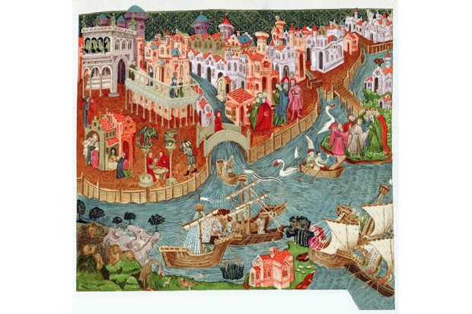

***Venice shown in a c14th-century manuscript. The Italian trading city profited hugely from participating in the crusades. (Photo by Universal History Archive/Getty Images)***

Of course, not all crusaders got rich. Many who joined the First Crusade were maimed, killed or bankrupted themselves due to the expense of the journey. Yet there were a significant number of others who did very well out of the enterprise. When the first crusaders entered Jerusalem in July 1099 and put the city to the sword, one of the Norman leaders, Tancred of Hauteville, sent his personal bodyguards to the Haram al-Sharif (Temple Mount), where they spent two days relieving the shrine of the Dome of the Rock (known by the crusaders as the Temple of the Lord) of its most precious ornaments.

Tancred pilfered what one chronicler called “an incomparable quantity of gold and silver”. He wasn’t alone. All over the city, crusaders seized “gold and silver, horses and mules and houses full of all sorts of goods”. So much for Christ’s plea to “sell what you have, give to the poor, and you shall have treasure in heaven” (Matthew 19:21). The crusaders in 1099 put that firmly out of their minds.

From this point on, the possibility of financial reward remained one of several strong motivators for crusaders. In 1107–11 the first king to travel from Europe on crusade was Sigurd I of Norway. The sagas that tell of his epic journey to Jerusalem, via Muslim-held cities of modern Spain and Portugal are full of gleeful references to the amount of booty Sigurd’s sailors seized along the way. When Sigurd left the Holy Land, his ships were laden with so much treasure that they displayed it on their masts and sails, where it caught the light to dazzling effect.

Many more followed suit. In the aftermath of 1099, four crusader states were established along the Palestinian and Syrian coast: the kingdom of Jerusalem, the counties of Edessa and Tripoli and the principality of Antioch. They offered estates to be farmed, villages to be taxed, port cities to be developed and merchant routes connecting the Mediterranean world with the faraway markets of India and China. Very quickly, the more resourceful powers of western Europe realised how much potential lay in these acquisitions. They made a beeline to the east to carve out their own roles in this exciting new world, establishing lordships, bishoprics and trading stations.

*“Across the city crusaders seized 'gold and silver, horses and mules, and houses full of all sorts of goods”*

Prominent in this were the three great trading cities of northern Italy: Genoa, Pisa and Venice. All three possessed significant naval power, which they could lend to crusader campaigns to conquer or defend coastal cities in the east, such as Acre, Tyre and Beirut. They were keen to establish their reputations as prominent members of the Christian world. And they each knew that if they engaged with crusading, they would be rewarded not only with the forgiveness of sins promised by successive popes, but also in economic terms.

Few episodes illustrate this more effectively than the siege of Tyre – a stoutly defended city in modern Lebanon – which took place in 1124. More than 100 Venetian ships, commanded by the doge [duke] of Venice, Domenico Michiel, sailed to the east to take part in the siege. Their presence was vital to Tyre’s capture and their reward was quite magnificent: a third of the city’s revenues were granted to the Venetians, and a self-governing Venetian trading colony was established, with its own laws, regulations and tax exemptions.

Tyre would remain in Christian hands for more than 160 years, and during that time the republic of Venice profited handsomely. This was by no means unique. In every major city up and down the coast, Italian merchant colonies were a familiar sight, their willingness to pour investment into the crusading cause amply and visibly rewarded.

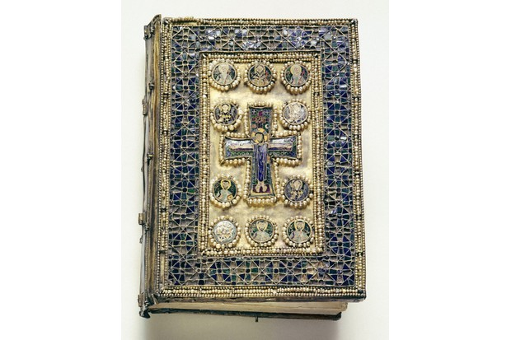

***This enamelled Byzantine liturgical book, encrusted with pearls, was almost certainly looted during the Fourth Crusade (1202–04). (Image by Bridgeman)***

**Conquer and prosper**

Needless to say, the tension between crusaders’ dedication to the “victory of the holy Cross” and the pursuit of “booty” could have unpleasant and even fatal consequences for those on the receiving end. The most notorious example of this, perhaps, occurred in the Fourth Crusade of 1202–04 and once again involved the republic of Venice.

The citizens of Venice agreed to build – at great cost – a massive fleet to transport the armies of the Fourth Crusade to Egypt, where they planned to conquer the wealthy city of Alexandria. In the end, however, the crusading fleet diverted to the Christian cities of Zara (modern Zadar) and Constantinople. Both of these were treated savagely, and Constantinople was pillaged, to the disgrace of Christendom but the lavish profit of Venice. Visitors to St Mark’s basilica can still see four magnificent gilded bronze statues of horses which were taken from Constantinople at that time.

Venice was hardly a lone villain. Throughout the 13th century, bitter complaints were levelled at the international ‘military orders’ of religious warriors – Templars, Hospitallers and Teutonic knights – who were sworn to live lives of austere, pious hardship, devoting all their efforts to the crusade. It was very often muttered that, far from being poor knights of Christ, the members of these orders enjoyed lives of great wealth and comfort, thanks to their broad-ranging tax exemptions and the lavish donations they received from their supporters.

In a sense, this was quite true. The Teutonic knights profited handsomely from their deployment around the Baltic, where they fought a perpetual crusade to clear pagans from the land and claim it for themselves and other Christian settlers. The Templars, meanwhile, were brought down in 1307–12, in part because of the sheer envy that their vast wealth aroused in the mind of the French king Philip IV.

It is important to reiterate that not everyone who went on crusade during the Middle Ages came home rich. Many lost everything, including their lives. At the same time, few crusaders were motivated solely by one factor. Humans are complicated, and crusading bound together passionately held Christian faith with a real belief in the need to defeat Christ’s enemies and atone for earthly sins.

Yet in the cocktail of reasons for crusading often lay a base but timeless human instinct: the desire to get rich quick.

**Prize fighters: 3 money-mad crusaders**

1**. The Norse plunderer**

Sigurd ‘Jerusalemfarer’ was a Christian king of Norway who led a band of Vikings on an armed pilgrimage from Scandinavia to Jerusalem between 1107 and 1111. On their journey Sigurd’s men plundered Muslim strongholds in Lisbon, Ibiza, Formentera and Menorca and banqueted with Roger II of Sicily. Once in the east, Sigurd was feted by king Baldwin I of Jerusalem, who took him to bathe in the river Jordan and worship at Christ’s tomb. Sigurd was given a fragment of the True Cross to take back to Norway, and he also shared in the vast amount of booty taken when his men helped wrest the city of Sidon from Muslim rule.

2**. Golden campaigner**

Although John of Gaunt was born long after the kingdom of Jerusalem was destroyed in 1291, the uncle of Richard II of England still considered himself a crusader. He managed to have his campaign to claim the crown of Castile in 1386–87 classified as a crusade. Although he never secured that prize, he signed a peace accord to end his campaign that awarded him so much gold it took 47 mules to transport it all back to England. This wealth helped fund the crusade adventures of his son Henry Bolingbroke (the future Henry IV), who joined the Teutonic knights fighting pagans in the Baltic.

3. **Ransacker-in-chief**

Although he was in his 90s and completely blind, Enrico Dandolo (below) was a formidable ruler of the republic of Venice during the Fourth Crusade of 1202–04. When French crusaders could not pay the bill for Venetian shipping, Dandolo insisted on diverting to the Christian cities of Zara and Constantinople.

*Dan Jones‘ latest book, Crusaders: An Epic History of the Wars for the Holy Lands, is published by Head of Zeus in September. He will be discussing the crusades on our podcast and at our History Weekends.*