*Crusades*. Bruges, 15th century. (Bridgeman Images)

[Feature](https://www.historytoday.com/site-sections/feature)

**Weapons of War in the Crusades**

Turkish archers versus Frankish heavy cavalry. The Crusades marked a period of technological breakthroughs in the art of war that would decide the conflict.

[**Nicholas Morton**](https://www.historytoday.com/author/nicholas-morton) | Published in [History Today](https://www.historytoday.com/archive/history-today/latest) [Volume 68 Issue 5 May 2018](https://www.historytoday.com/archive/history-today/volume-68-issue-5-may-2018)

A French royal crusading army was on the point of collapse and a very long way from help. By January 1148 it was midway in its journey across Anatolia – a graveyard of armies – and had just suffered a serious defeat while crossing a mountain pass. The vanguard had advanced too far ahead from the main army and the Turks had swept into the gap, charging down the lines of marching crusaders and causing substantial casualties. Louis VII of France was almost killed, surviving only by climbing a rock and fending off a multitude of attackers.

The battle may have been a fiasco, but it had an interesting postscript. Reflecting on his predicament and recognising his inexperience in dealing with Turkish forces, Louis VII turned over control of his army to the Knights Templar. These professional warriors, experts in Near Eastern warfare, immediately re-organised the entire force. The host was divided into small, tightly disciplined defensive groups, each under the command of a designated officer. This proved effective and the army’s survivors managed to resist several Turkish attacks, even winning some encounters, before reaching the relative sanctuary of the Byzantine city of Adalia.

Louis VII’s experiences on the Second Crusade were not uncommon for crusading armies setting out for the Near East. Wars in that region were conducted in a very different manner from those of Western Christendom and, as soon as they crossed into Turkish territory, crusade commanders needed to start learning how to deal with a fundamentally different kind of conflict.

The Turks were not the crusaders’ (or Franks’) sole enemies and there were times when the two fought side-by-side. Yet, overall, theirs was the primary military contest of this era. Consequently, it is vital to compare the longstanding martial traditions of these two very different peoples. Christendom’s knights were the product of agricultural societies whose noblemen had both the purchasing power and technological sophistication to fight as heavily armoured cavalrymen, mounted on expensive, immaculately trained warhorses. Their cavalry squadrons were then supplemented by the rather less well equipped formations of infantrymen, raised by their respective lords. Military campaigns were generally conducted through long grinding sieges, heavy raids on an enemy’s agricultural infrastructure and, occasionally, hard-fought pitched battles. The Franks’ great strength was in close combat, where the fortunes of war were decided face-to-face.

The Turks fought in a very different manner. They had conquered Anatolia and the Near East during the 11th century and their roots lay in the predominantly nomadic societies of the Central Asian steppe. Theirs was a life of movement, where children of both sexes were trained from an early age to ride and shoot. Their favoured weapon was the bow, fashioned from layers of horn and bone taken from their herds. Their armies reflected that culture, deploying forces made up almost entirely of mounted archers, who used their hunting techniques to harry and corral their enemies, wearing them down in a series of encounters spread over many days until they eventually broke. Traditionally, the Turks were only lightly armoured – their ponies could only bear light burdens – and they were poorly equipped for hand-to-hand combat. By the 12th century, however, decades had passed since the Turks had conquered the Near East and their culture was in transition. They had adopted many of the practices associated with the agricultural societies that they had overthrown, borrowing strategies and armaments from the Islamic Abbasid caliphate and the Anatolian territories of the Byzantine Empire.

**New challenges**

With the advent of the Crusades, the Turks and Franks suddenly found themselves confronting one another across the battlefield and both experienced challenges dealing with their new opponents. The heavily armoured and slow-moving crusader armies often proved entirely unable to get to grips with the fast-moving Turkish horse-archers. Shortly before Louis VII attempted his crossing of Anatolia, the German king, Conrad III, had similarly set out with his crusading army to traverse this Turkish territory, only to be shot to pieces by the Turks, who rained arrows relentlessly upon them. They prevented the Germans from gathering food while nimbly avoiding their counter-attacks. The Turks never tried to block Conrad’s path, rather they sought to slow him down and cut off his resources. Eventually Conrad was forced to retreat.

The Turks’ military advantages were formidable, but their weaknesses were equally conspicuous. If they could be compelled to fight in hand-to-hand combat, they nearly always suffered badly. Some of the crusaders’ greatest victories occurred when their heavy cavalry managed to catch the Turks unawares, without giving them a chance to take evasive action. In such scenarios the Christian knights nearly always won. This had happened during the First Crusade, when the commander Bohemond of Taranto launched a surprise attack on the Turkish ruler, Ridwan of Aleppo, and with only a few hundred knights destroyed a far larger Turkish army.

The weather could also affect the Turks’ performance. High winds in particular could diminish the impact of their archery. In 1108, the Arab Muslim commander Sadaqa had attempted to turn this to his advantage during one of the many Arab attempts in Iraq to drive back their Turkish overlords. Sadaqa deployed his forces so that the Turks would need to shoot directly into the wind if their arrows were to reach the Arab cavalry. This could have caused major problems had the wind not abruptly changed directly before the battle, blowing from the opposite direction and thereby enhancing the Turks’ position. The Turks’ bows could also be adversely affected by rain and several crusade commanders learned very quickly that the glue holding the lengths of bone and horn together would come apart if it became wet.

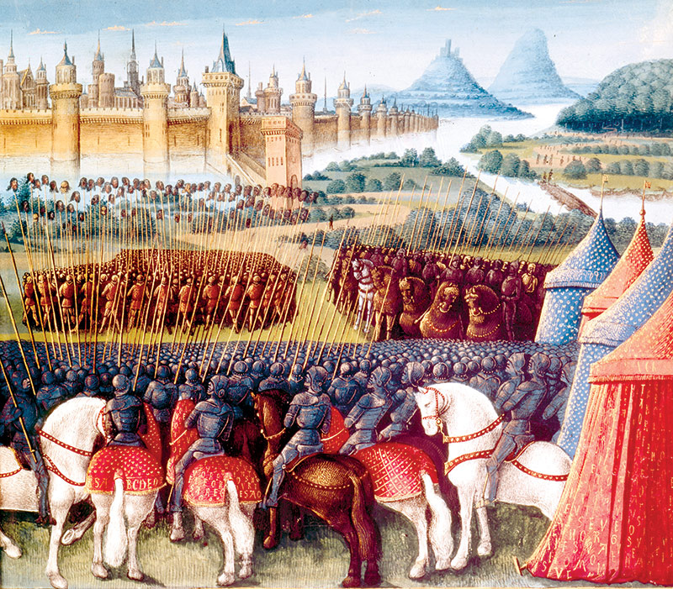

The Siege of Antioch during the First Crusade in 1098, 15th-century manuscript. (Bridgeman Images)

The challenge therefore confronting both Turkish and Frankish commanders was to devise strategies that would enhance their own advantages and diminish their weaknesses, while blunting their enemies’ strengths and exploiting their shortfalls. The Franks, for example, realised at an early stage that their heavy cavalry could win battles provided that they could time their attacks to prevent the Turks from evading their onslaught. Consequently, many commanders attempted to take the Turks unawares. In several cases they advanced with a flying column of cavalry during the night and then charged directly into the enemy camp at first light. This kind of strategy was used repeatedly during both the crusades: a classic case being in 1115 at the battle of Tell Danith, when a small cavalry contingent from the Principality of Antioch charged into the encampments of a huge Turkish force, stampeding them before they could bring their superior numbers to bear.

**Shock and disorder**

Other innovations were devised to enhance the power of the Frankish Crusader charge. On one occasion a commander ordered his knights to tie burning torches to their lances, to cause ‘shock’ and disorder among their enemies. From an early moment the Franks also deployed their heavy cavalry in companies who would then attack sequentially. The first wave would seek to engage and pin down their enemy, then subsequent companies would either corral or overrun those who had already been immobilised in hand-to-hand combat. In 1120, at the Second Battle of Tell Danith, Baldwin II, ruler of the Kingdom of Jerusalem (the southernmost crusader state), used this approach. He allowed his infantry to become locked in combat with the Turks, then waited for as many as possible to become trapped in the chaos before unleashing his cavalry forces. They flung themselves against the Turks, who were in no position to evade their onset.

The Turks in turn learned to enhance their skirmishing tactics. A particularly effective approach was to attack a crusader army in a staggered series of waves. The idea was that the first wave of attackers would assault the Frankish lines, seeking to provoke their heavy cavalry charge. They would then fall back in front of the Frankish charge, offering minimal resistance and encouraging the knights into a pursuit that would separate the heavy Christian cavalry from the main body of their army. A second wave of Turkish riders would then surround the knights when their mounts became tired, shooting their horses first and then destroying the surviving huddle of dismounted riders. This strategy was used to devastating effect in 1119, when the army of the principality of Antioch was destroyed at the battle of the Field of Blood using precisely these tactics.

**The best offence is defence**

Both sides also attempted to compensate for their weaknesses. For the Franks, the most significant of these concerned discipline. By medieval standards, the armies of the crusader states were exceptionally well organised, with both cavalry and infantry working in tightly arrayed formations. The kind of chivalric nonsenses conducted by western European knights yearning for a glorious reputation, such as single-handedly and magnificently charging an enemy army, were deeply frowned upon. So, too, were those knights who broke formation to seek plunder. The purpose of this rigid and disciplined approach was to create an army that could stand firm against the Turks’ attempts to break their formations through relentless probing attacks.

Frankish armies were generally deployed so that lines of infantry companies, equipped with locked shields, formed a tough outer shell. This sheltered the cavalrymen and their precious horses from Turkish arrows until the knights could burst out along predetermined channels through the infantry at the Turks. This proved highly effective and, at times, Christian armies marched in this formation for days – under permanent attack, but taking very few casualties.

Other Frankish innovations and adaptations included the development of their own light cavalry archers, known as Turcopoles, neutralising their opponents’ advantages in mounted archers. They also began to strengthen their own contingents of infantry archers, especially crossbowmen. Crossbows could prove effective, particularly if the crossbowmen were protected by a screen of shields, allowing the Franks to compete more effectively in a missile duel.

During the course of the 12th century, the Turks likewise steadily began to compensate for their deficiencies in hand-to-hand combat. Saladin, especially, began to assemble contingents of heavy cavalry, designed to rival their Frankish counterparts. These addressed one of the Turks’ greatest shortfalls and a later author, reflecting on this period, commented: ‘Now by use and exercise, and frequent meeting with the Christians, they had more fully took on the discipline of knighthood and they used Latin styles in armour, shields and helmets … and all manner of weapons.’ The Turks also seem to have equipped their forces with enormous maces and clubs. Such weapons were not intended to slice through hardy Frankish chainmail but to inflict shockwaves that would pass through the armour to break bones and crush internal organs. They proved so effective that they were adopted in turn by the Franks themselves and the Knights Templar started to arm their warriors with ‘Turkish maces’.

**Sticky situation**

Other commanders developed different techniques for defeating Frankish cavalry. In 1122 the Turkish leader Balak managed to defeat a force of Frankish knights by leading them into marshy ground, where their horses sank into the mud and were immobilised. Another, more repeatable, approach was devised in 1167, when Saladin’s uncle, Shirkuh, fought a Frankish army in Egypt, in the desert south of Cairo. When the Franks and their Egyptian allies charged Shirkuh’s army, he had his men simply part their ranks in the face of the oncoming charge, causing the Franks to pass between their companies without making contact. Then, when the Frankish charge lost its momentum and their horses became exhausted, they staged their own attack.

Other devices to counter sudden attacks by flying columns of Frankish knights included the steady development of field fortifications around Turkish encampments, which would block any attempt to take their forces unawares. Likewise, during sieges on Frankish castles, trenches were often dug across the main gates so that the garrison cavalry could not suddenly burst forth and storm through the Turks’ siegeworks.

The Turks’ adaptations proved highly effective in countering the Franks’ military advantages. The Franks’ own innovations only partially compensated for their opponents’ long-term strengths. The Turks’ great mobility and their ability to deploy forces largely made up of mounted troops posed consistent problems. This was the case particularly when the Franks wanted to take the offensive. In such circumstances, the Turks could range all around the Frankish army’s well-defended ranks. They might not have been able to damage the Frankish army by direct assault, but they could prevent the egress of forayers or foragers seeking to find food for the army. Likewise, when the Frankish army reached a town or fortress it wished to attack, the Turks could prevent them from dispersing their forces to establish comprehensive siegeworks.

More importantly, if an attack went really badly and a Frankish army was defeated, then the survivors would find it extremely difficult to return to friendly territory – mostly on foot – being pursued at every step by Turkish light cavalry. King Baldwin III of Jerusalem’s campaign against the town of Bosra in the spring of 1147 is a case in point. He had been assured that the town was eager to rebel, but after a tortuous march to reach the walls – under attack from the Turks for much of the journey – he found that the town was already in his enemies’ hands and that it was impossible to lay siege, so the army had to retreat under persistent attack. The army did not break, but it was a close run thing. The lesson arising from the campaign was clear: waging offensive war against large numbers of Turkish light cavalry posed serious, even insurmountable, problems.

**Face-off**

During this protracted struggle, both Turkish and Frankish commanders observed one another closely, probing for exploitable weaknesses. Innovation and adaptation played a vital role in this contest and yet there were many other factors in play affecting the fortunes of war. Perhaps the most decisive of these was the imbalance in numbers. The Frankish knights may have been extremely powerful, but they were never numerous. The Kingdom of Jerusalem – the largest crusader state – never deployed more than 1,300 in any encounter during this period. Still worse, they were difficult to replace. The Frankish population in the crusader states was always small and often – following a defeat or even a hard-fought victory – their leaders had to wait for reinforcements from Western Christendom. The Turks, by contrast, found it easier to replace their losses. The Jazira region, situated between the Tigris and Euphrates rivers and the foothills of Anatolia, was home to numerous Turkic tribes, who could be called upon to bulk out the armies deployed by the rulers of Damascus or Aleppo, the crusaders’ main neighbours.

Another dimension to the conflict was the role of religion. At the time of the First Crusade, the Turkish conversion to Islam was still at a relatively early stage. They had only recently conquered Syria and central Anatolia and their position was still precarious. The defeats by the armies of the First Crusade only weakened their position, instigating a series of rebellions by Armenian Christians and Arab Muslims. Nevertheless, as the 12th century progressed, the Turks were able to crush all meaningful Arab resistance and seize control over their few remaining towns. In addition, where some early Turkish rulers still practised distinctive steppe traditions, such as carving the heads of their fallen enemies into drinking vessels and conducting colossal drinking binges, later rulers adopted a far more Islamic identity. The Turks’ ongoing Islamification had military consequences. It made it easier for them to engage with their Muslim subjects and to call upon them for military assistance. Rulers such as Nur al-Din, Turkish ruler of Aleppo, and Saladin, a Kurdish ruler leading mainly Turkish troops, came to rely on Jihad propaganda, helping to drive recruitment to their forces while imbuing them with a sense of religious purpose.

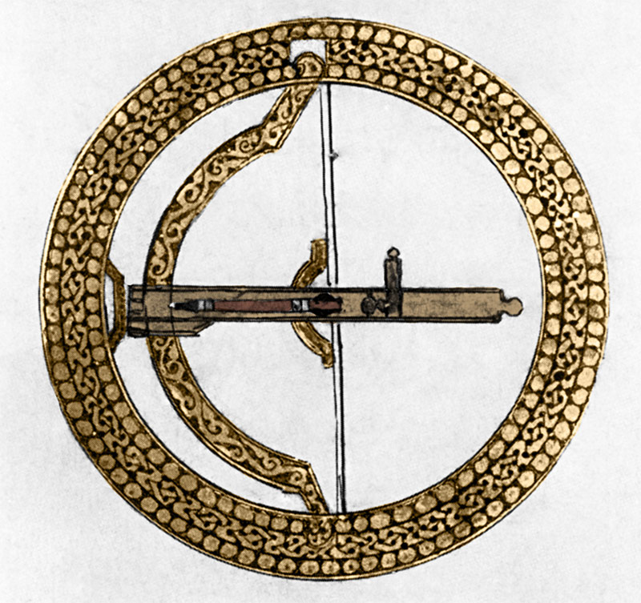

Illustration of a ‘shield-bow’ from a treatise compiled for Saladin after the fall of Jerusalem, 12th century. (akg-images)

Besides religion there was the factor of the ongoing consolidation of the Turkish forces arrayed against the Franks. In the wake of the First Crusade, the Franks faced an assortment of Turkish rulers (most governing little more than a single city or town) and tribal groups, alongside Arab emirs and the Fatimid Shia Muslim rulers of Egypt. This was ideal, because the Franks could hope to defeat any one of their relatively weak enemies singly, particularly by using alliances to create divisions in their ranks. By the 1170s, however, the situation had changed. The remaining Arab emirates were gone. The Fatimid caliphate had been overthrown by Turks. More importantly, Turkish leaders such as Zangi, his son Nur al-Din or, later, Saladin, waged bitter internal wars against their Turkish neighbours, that fundamentally changed the formerly divided political landscape, resulting in the rise of massive territorial power blocs, that could more than compete with their Frankish neighbours.

While the Turkish forces were massing to the east and south, the crusader states were also steadily building their resources. Settlers founded new towns, castles were built to secure existing conquests and newly constructed harbours facilitated trade, both local coastal commerce and the long-distance Silk routes spanning from the Far East to Western Christendom. Even so, they struggled to maintain the pace set by their Turkish neighbours.

**Decisive defeat**

The final act in the struggle between these two powers took place in 1187, when Saladin laid siege to the town of Tiberias, on the shores of the Sea of Galilee. The Franks also mustered their full strength. The battle that followed was in some respects a summary of the adaptations that both sides had developed in preceding centuries. It opened with the Franks staging a defensive march in close formation towards Tiberias, under persistent attack from Turkish light cavalry. Nevertheless, having subjected the Frankish column to hours of attacks, Saladin was able to block the crusaders’ line of march, engaging them in hand-to-hand combat and ultimately driving them back to an old Iron Age fort known as the Horns of Hattin. During the clash, a large company of Frankish knights attempted to charge Saladin’s army, but – just as Shirkuh had back in 1167 – Saladin simply parted his ranks and allowed the Frankish knights to pass through, wasting their momentum.

The Franks were then encircled and, despite hours of bitter fighting, it was only a matter of time before their total collapse. The army was annihilated, leaving the rest of the Kingdom of Jerusalem (and therefore the crusader states) virtually defenceless against Saladin. In the months that followed he conquered the vast majority of the kingdom, including Jerusalem, which fell in October 1187.

This round in the crusaders’ war to retain the Holy Land was over. In a conflict spanning nine decades, both sides had dramatically adapted their style of warfare. True, such modifications represent only one factor in the broader question of why the Franks ultimately failed to retain control of Jerusalem. Even so, in the long run, the Turkish (and in Saladin’s case, Kurdish) leaders proved more able than their Frankish counterparts to remould their warcraft to defeat their foes, devising strategies that were used to devastating effect in the final denouement at Hattin.

**Nicholas Morton** is Senior Lecturer in History at Nottingham Trent University.