[The Crusades](https://www.historytoday.com/site-sections/crusades)

**Saladin's Triumph: The Battle of Hattin, 1187**

Frankish disunity and impetuosity produced a disaster that lost Christendom the holy city of Jerusalem.

[**Norman Housley**](https://www.historytoday.com/author/norman-housley) | Published in [History Today](https://www.historytoday.com/archive/history-today/latest) [Volume 37 Issue 7 July 1987](https://www.historytoday.com/archive/history-today/volume-37-issue-7-july-1987)

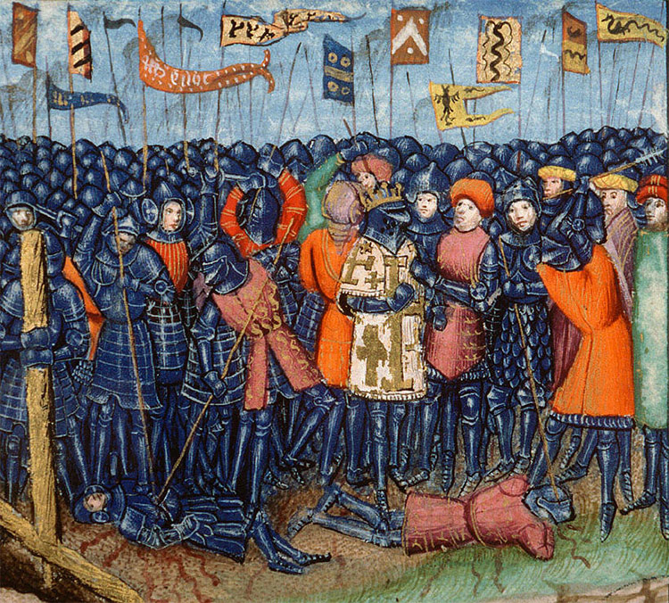The Battle of Hattin, from a 15th-century manuscript.In a battle fought near the western shore of the Sea of Galilee on July 4th, 1187, the Sultan Saladin inflicted a terrible defeat on the field army of the Latin Kingdom of Jerusalem, killing or capturing the vast majority of its soldiers. Historians have questioned the long-term significance of many medieval battles, but nobody has denied that the Battle of Hattin had a decisive impact on the history of the crusader states in Palestine and Syria.

Hattin led to Saladin's conquest of nearly all the lands held by the Franks, including his occupation of Jerusalem on October 2nd. It also precipitated the Third Crusade, which succeeded, by the terms of the Treaty of Jaffa in 1192, in re-establishing the Latin Kingdom in the form of a narrow coastal strip, containing most of the important Palestinian ports. But the defensive framework of the 12th century Kingdom, a brilliant combination of fortresses and geographical features, had gone, and it can be argued that the long-term military viability of the Frankish settlement had gone with it.

In addition to being a turning point, Hattin is also a fascinating battle in its own right, for the decision to fight on what were, from the Franks' viewpoint, exceptionally unfavourable, even suicidal terms, continues to excite debate amongst historians.

Let us start with Saladin, the victor of Hattin and, with the exception of the 13th century Mamluk Sultan Baybars, the most resourceful and dangerous adversary the rulers of the crusader states ever faced. At the time of the Hattin campaign Saladin was 49 years old, and had already enjoyed a career marked both by a remarkable string of political and military successes, and by a consistent and passionate pursuit of the twin goals of Muslim unity and the expulsion of the Franks. His father had served Zengi, the Islamic champion who had conquered Edessa from the Franks in 1144; and Saladin similarly became a valuable lieutenant to Nur al-Din, Zengi's second son. In 1168 Saladin accompanied his uncle Shirkuh to Egypt when the Fatimid Caliph al-Adid asked for Nur al-Din's help against the encroachments of the Franks under their last great king, Amalric. Shirkuh's death was followed by Saladin's investiture as vizir of Egypt in 1169.

As the Shi'ite caliph, al-Adid was taking a great risk in appointing a Muslim who adhered to Sunni orthodoxy, and Saladin immediately began to consolidate his position by building up his own household. In 1169 the most ambitious of Amalric's thrusts into Egypt was repulsed, and with the Frankish threat largely removed, Saladin was able in 1171 to carry out a bloodless suppression of the Fatimid caliphate. For the Franks, these events were disastrous, signifying the political and religious unification of Syria and Egypt, the two great centres of Muslim power which had, until now, been actual or potential enemies.

Nonetheless, the threat to the Latin Kingdom took some years to materialise. Nur al-Din's demands that Egyptian resources be placed at his disposal in Syria were countered with the argument that the Selchukid and Sunni position in Egypt had first to be strengthened. This caused conflict between Saladin and his patron, which was prevented from becoming serious only by the death of Nur al-Din in May 1174. The fragile unity which Nur al-Din had imposed upon Syria was now threatened, and Saladin acted with energy, occupying Damascus in October. From this point onwards Saladin portrayed himself as the true heir to Nur al-Din, slowly gathering in the cities and lands held by his former patron until, with the acquisition of Aleppo in 1183, and Mosul in 1186, he was effectively master of Syria and northern Iraq. In achieving this goal Saladin had overcome massive obstacles, notably the opposition of Zengi's lineal descendants and, more generally, Turkish resentment of his Kurdish origins. To overcome these difficulties he laid great stress on the benefits which political unification would bring to Islam, a claim facilitated by his investiture with political authority over Egypt and Syria by the Sunni caliph in 1175. Saladin took up certain key ideological themes which had originated with Zengi or Nur al-Din, but which he refined and developed.

Two of these themes were of particular importance. One was the idea that Saladin's government sponsored orthodox Islamic practices. Taxes which were contrary to Islamic law were repealed, unorthodox religious customs and beliefs proceeded against, Islamic learning actively encouraged, and justice rigidly enforced. Above all, the Sultan him- self led a conspicuously orthodox and spartan existence. Through a primitive but effective propaganda machine, the contrast was drawn between Saladin's government and that of the lax and degenerate Zengid princes. The complementary theme was Saladin's dedication to the cause of the holy war (jihad), which meant the expulsion of the Franks from Jerusalem and Palestine, a city and territory whose sanctity to Islam was increasingly emphasised.

Of the two themes, orthodoxy took priority, so that Saladin refused to levy taxes for the jihad if they were illegal; but the pursuit of holy war against the Christians was just as vital an aspect of the Sultan's policy. Baha ad-Din, Saladin's retainer and biographer, claimed of his master's dedication to the holy war that:

*If [Saladin] takes Tiberias he will not be able to stay there, and when he has left it and gone away we will retake it: for if he chooses to stay there he will be unable to keep his army together, for they will not put up for long with being kept away from their homes and families.*

This was a very strong argument and it was fully in accordance with traditional Frankish strategy when confronted with a major Muslim invasion. Guy therefore took Raymond's advice. But during the evening of July 2nd, Gerard of Ridefort had a private meeting with Guy at which he persuaded the King to change his mind, and to order an advance the next morning.

What made the Master of the Templars do this, and what made Guy accept his arguments? Almost certainly, the minds of both men had been so poisoned by the political conflict of the years from 1180-87 that they could only see Raymond's advice as designed to bring them personal ruin, and events in those years certainly helped to corroborate this judgement, which was probably unfair. Guy's refusal to fight Saladin, in very similar circumstances, in 1183, had led to Guy's humiliation and Raymond's greatest success. What was to stop the Count from trying to bring about Guy's downfall with precisely the same arguments in 1187?

Moreover, the financial commitment made by Guy in 1187 was even greater than four years earlier, for the King judged the crisis facing his realm to be so severe that he spent the large sums of money sent during the preceding decades by Henry II of England, and stored at Jerusalem. Henry had ordered that this treasure be kept intact pending his own arrival on crusade, and if the army, including the 4,000 mercenaries paid with English money, were to disband without a battle, Henry would claim that his money had been wasted, thus providing valuable support for Raymond's own attack on the King. Gerard had the added annoyance of being prevented from revenging his defeat in May, by the very man whose acquiescence had made that Muslim raid possible. A wide range of circumstances from recent history therefore combined to make Guy, who was by no means a stupid man, commit a blunder which lost him his Kingdom. Historians continue to debate the precise significance of each factor, but there is no doubt that at the root of Guy's change of mind lay his hatred and suspicion of Raymond of Tripoli, which made the King abandon tried and proven Frankish strategy in favour of a fantastic gamble. Contemporary chroniclers, both Frankish and Muslim, were therefore quite right to see internal disputes as the chief reason for the Kingdom's ruin.

What followed was, in a sense, anticlimactic, since a Frankish victory in these circumstances would have called for extraordinarily good discipline, leadership and luck, none of which the Franks possessed. The army set out at sunrise on Friday, July 3rd, and marched for some six or seven hours under ceaseless harassment from Muslim mounted archers. At midday Raymond of Tripoli, who led the vanguard, appears to have decided that the army had not covered enough ground to reach Tiberias before nightfall. To pitch camp on the plateau without access to water would be madness, but the army was only about five kilometres from the springs at Kafr Hattin.

The King agreed to change the course of the march, but this turned out to be a grave mistake. The Muslims blocked the way to Kafr Hattin, the change of direction caused confusion, and there were particularly heavy attacks on the Templars in the rear. Guy therefore ordered the army to pitch camp for the night at Meskenah. According to a source favourable to Raymond, the Count was appalled at this decision, which was just what he had wanted to avoid: 'Alas, alas, Lord God, the war is over, we are lost men and the Kingdom is done for'; but it is difficult to see what alternative Guy had. Saladin, his goal achieved, brought up supplies of arrows and water for his troops from Tiberias, and surrounded the Christian camp so well that, as one chronicler put it, not even a cat could have escaped. The scene in the two camps was vividly described by Ibn al-Athir: the Christians exhausted, despondent and tormented by thirst, their enemies, who 'could smell victory in the air', encouraging each other and eagerly awaiting the next day's events.

On July 4th the Frankish army made another attempt to reach the water at Kafr Hattin, but at about 9 a.m. fierce Muslim attacks began. The Franks adopted traditional and normally successful tactics, using their infantry and horsemen in conjunction to beat off the enemy attacks. But on this occasion the infantry could not hold ranks; exhausted and dying of thirst, they scattered and ran up the slopes of Qarn Hattin. Saladin ordered that a westerly wind be made use of by setting fire to the brushwood, which added to the confusion and torment of the Franks.

Raymond and the vanguard, cut off from the bulk of the army, managed to break out and escape, which confirmed the suspicion entertained by some that the Count had acted treacherously. But most of the Christian knights were surrounded. With great courage, they fought on until the King's red tent, and the Christians' greatest relic, the True Cross, were captured. After this, Saladin was able to take prisoner those who survived, including the King and Reynald of Châtillon, whom the Sultan immediately killed in punishment for his raid on the Muslim caravan. Ibn al-Athir commented that 'the number of dead and captured was so large that those who saw the slain could not believe that anyone could have been taken alive, and those who saw the prisoners could not believe that any had been killed'. By nightfall the greatest field army ever assembled in the Latin Kingdom had been wiped out and ideal conditions established for Saladin's occupation of almost all the Kingdom of Jerusalem.