**The Tide Turns in Vietnam: The Tet Offensive**

**Growing impatient with the slow chug of a stagnant war, in 1968 the North Vietnamese authorities planned a major offensive. The Tet Offensive did not deliver the anticipated fatal blow, but it did help turn the tide of the Vietnam War.**

[**Pierre Asselin**](https://www.historytoday.com/author/pierre-asselin) | Published 30 January 2018

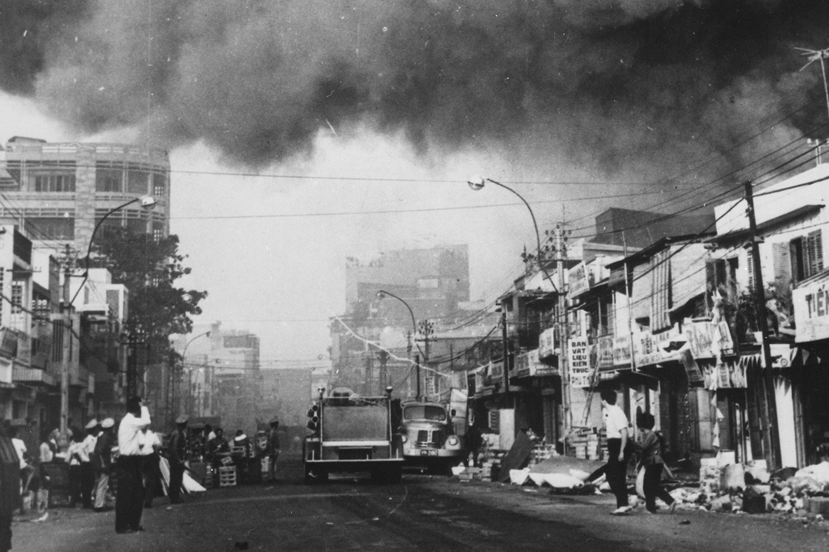

**Black smoke covers areas of Saigon during the Tet Offensive**

Bottom of Form

The Tet Offensive of early 1968 constituted the biggest military setback suffered by communist forces – that is, the combined armies of the National Front for the Liberation of Southern Vietnam (NLF, or Viet Cong) and the People’s Army of Vietnam (PAVN, the North’s regular army) – in the Vietnam War. Launched on 30 January, it was supposed to decimate the ‘puppet’ armed forces of South Vietnam. It was also supposed to bring about a general uprising of the population, producing a decisive strategic victory that would presage the end of the war. It achieved none of these things. These communist forces suffered in excess of 100,000 casualties, including more than 40,000 dead, during the initial and follow-up attacks on South Vietnam’s most important urban centres. Contrary to popular belief in the West, in launching the offensive communist authorities in Hanoi sought to win not just a psychological or moral triumph, but an outright, unmitigated military victory. Yet in retrospect, though it was the costliest offensive launched by the North, it was also the most fortuitous, as the Hanoi regime snatched a propaganda victory from the jaws of military defeat.

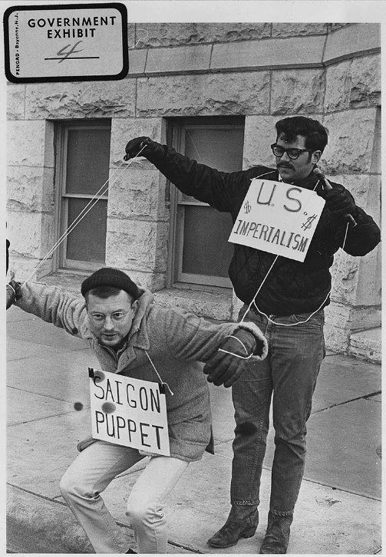

**Protesters in front of Wichita City Building, Kansas, 1967.**

By the beginning of 1967, communist forces had been fighting US, South Vietnamese and other allied forces for nearly two years. Despite successfully holding their own against their better equipped and better supplied enemies, Viet Cong and PAVN troops had failed to deliver, in Vietnamese communist parlance, the ‘decisive victory’ necessary to change the ‘balance of forces’ – the barometer used by communist leaders to measure the war’s progress – in their favour. To the communist leaders in Hanoi, it seemed the war had reached a stalemate, with no imminent end in sight. That bothered them.

No one in Hanoi was more upset about the impasse in the South than Communist Party Secretary Le Duan. The hardline Le Duan had usurped power from the more moderate Ho Chi Minh in a bloodless palace coup in late 1963. After stripping his predecessor of his powers, Le Duan consolidated his own authority by appointing trusted allies to key posts within the Party and sidelining Ho’s supporters, including General Vo Nguyen Giap, architect of the victory at Dien Bien Phu, which had sealed the fate of the French in Indochina in 1954.

Le Duan was tough, dogmatic and uncompromising. He had been hardened by long, dreadful stints in colonial prisons and years fighting in southern Vietnam during the Indochina War. He was impetuous – ‘adventurist’ in communist parlance – and obsessed with defeating the US and its allies. Consumed by these thoughts, he refused to consider a diplomatic solution, or even the possibility of ‘waiting out’ his enemies. He wanted victory, which he defined as national reunification under his own governance, expeditiously. In his view, the Vietnamese had waited long enough to see their country reunited under a proud, competent and fully sovereign leadership.

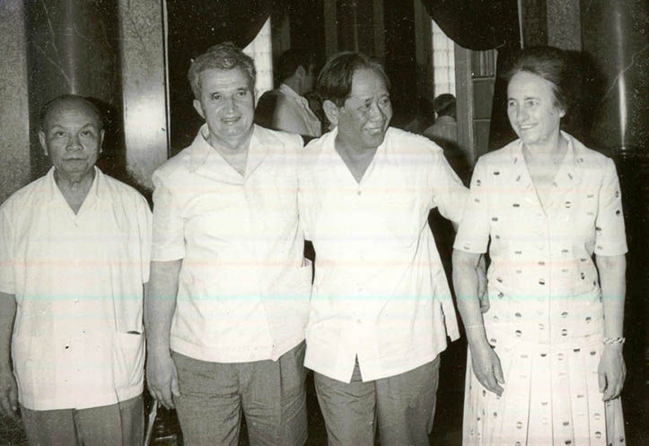

**Le Duan and Trường Chinh with Nicolae and Elena Ceaușescu, May 1978.**

In the summer of 1967, Le Duan called upon the PAVN General Staff to assist him in devising a military plan to bring about a ‘decisive victory, and thus the end of the war on acceptable terms, in coming months. The minimum objective of the plan was to demonstrate to policymakers in Washington that they would never be able to meet their objectives in Vietnam and that their military venture was doomed to end in failure.

Le Duan and his top military brass settled on a plan calling for a ‘general offensive’ that would be sudden enough to surprise the enemy and overwhelming enough to inspire a ‘general uprising’ of the southern population. Le Duan thought that a big, dramatic showcase of the resourcefulness, bravery and strength of communist armies would embolden the southern masses and prompt them to rise as one to demand the end of US intervention and the immediate surrender of the ‘treacherous’ regime in Saigon. His comrades in the Party warned him that it was presumptuous to assume that southern civilians would respond to a communist show of force in this way, that the people in the South may not be ready for a generalised, synchronised uprising. Le Duan would have none of it. Once people recognised that communist armies in the so-called General Offensive – General Uprising of Tet 1968 (Tổng công kích – tổng khởi nghĩa Tết Mậu Thân 1968) were on ‘the right side of history’, they would rally to support them. The Party needed to have faith in the Vietnamese people, in their ability to recognise the inevitability of the triumph of ‘peace-loving’ communist armies and of the defeat of their ‘warmongering’ enemies in this ‘just struggle’ of the Vietnamese people, as authorities in Hanoi insisted in their domestic and international propaganda.

The communist plan specifically called for concerted, coordinated attacks on cities across the South, including the capital Saigon, Da Nang and Hue to end the regime’s authority over them. Upon realising that Saigon no longer exercised control over the South’s major cities and that the communist armies were now in charge, the masses would instinctively take to the streets to express their gratitude and demand the immediate end of US interference in Vietnamese affairs. The Saigon regime would collapse and the Americans, with no one to fight for or with, would leave.

The plan hinged on decimating the South Vietnamese armed forces. Attacks on US forces were part of it, but only in remote regions, with the intention of pinning them down and preventing them from coming to the rescue of their embattled indigenous allies. Le Duan had long believed that striking forcefully at the South Vietnamese armed forces, while keeping their US counterparts bogged down elsewhere, represented the best way to exploit the vulnerability of the former while neutralising the superior strength of the latter. A siege of the US garrison at Khe Sanh, situated just south of the demilitarised zone,

In October 1967 Hanoi agreed to launch the attack on lunar New Year’s Day, 30 January 1968, with the aim of taking the enemy by surprise. That day – Tet – is Vietnam’s most celebrated holiday. Le Duan was convinced his armies would catch the enemy off-guard as the two sides had previously observed an informal truce during the holiday. The timing of the campaign would also allow communist forces to take advantage of the vulnerability of South Vietnamese units depleted by troops and officers taking leave to be with family. Le Duan had a keen sense of history. The Vietnamese emperor Quang Trung had taken advantage of the New Year celebrations in 1789 to defeat a Chinese army occupying Hanoi and secure Vietnam’s independence. He also happened to have a keen understanding of the US political calendar and its impact on the war. His offensive would take place at the beginning of a presidential election year. Through the campaign, he would effectively endeavour to sway domestic opinion in favour of the candidate who seemed to offer the least resistance to his goals. He would do this by demonstrating to the American people the might of his own forces, the futility of the military effort pursued by their leaders and the Vietnamese people’s desire to resolve their own issues themselves.

In early January 1968, Party leaders gave final sanction to the campaign, ratifying a document known as Resolution 14, because it was adopted during the 14th plenary session of the Communist Party’s Central Committee. To ensure that the element of surprise was not compromised, Hanoi instructed its military commanders in the South to withhold the exact day and time of the start of the attack from their own troops. In preparation for the offensive, some of those troops assumed the identity of merchants or relatives of residents and infiltrated southern cities. Weapons were concealed among cargoes of foodstuff, or in the coffins of fake funeral processions and stored at designated safe locations, usually a sympathiser’s private residence.

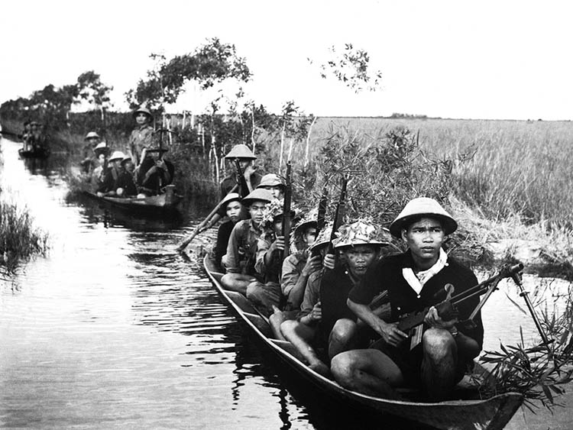**Guerrilla forces from North Vietnam's Viet Cong move across a river in 1966.**

On 21 January 1968, communist forces laid siege to the American garrison at Khe Sanh. On 30 January, hours before the main offensive on southern cities was to begin, Hanoi ordered its military commanders in the South to wait another 24 hours before proceeding. One commander did not receive that order and instructed his troops to proceed. The cities of Da Nang, Nha Trang, Pleiku, Ban Me Thuot, Hoi An, Qui Nhon and Kontum all came under attack by communist forces one day before the generalised offensive actually began. Though that should have alerted the US and its allies to the possibility of further concerted attacks against vulnerable targets, it did not. Accordingly, communist forces still maintained the element of surprise when the Tet Offensive formally got underway in the early hours of 31 January.

The first and main phase of the Tet Offensive involved more than 80,000 Viet Cong and PAVN troops, who attacked a total of 100 urban centres, including the large cities and provincial capitals of South Vietnam. In several places, it took some time for allied forces to realise an attack was underway; the sound of shots fired by communist forces was drowned out by the cacophony of exploding firecrackers used to usher in the New Year. Almost everywhere the attackers quickly secured their assigned target; and, almost everywhere, they could not hold on when South Vietnamese and US forces counterattacked. The initial series of assaults on southern urban centres was followed by two other waves of attack in March and May. Consisting primarily of further concerted assaults on southern cities, they produced no significant gains, only more casualties. Some of the local victories in the Tet Offensive were meaningful, but none translated into long-term gains.

**\***

The Tet Offensive was an unmitigated military disaster for Hanoi. Le Duan had grossly overestimated the prospects of success. No uprising of the masses, much less a general uprising, materialised. Thus, the core objective and rationale for the entire effort were never met. The human cost of the offensive for Hanoi was horrendous. At least 165,000 civilians died during the campaign and between one and two million were displaced from their homes.

If all of this were not bad enough for Le Duan and his armies, a gruesome event took place in the city of Hue during the offensive that seriously compromised their moral standing. Communist troops, most of them from the North, summarily executed some 2,800 people on charges of being enemies of the people. Victims included not only members of Saigon’s armed and police forces, but also those with only indirect ties to the regime, including doctors, nurses, schoolteachers and foreign missionaries. In a war that produced its fair share of atrocities, the Massacre at Hue stands out because of the number of victims, their innocence and the means used by the communist forces to murder them. Victims’ bodies were dumped in mass graves. Later investigations revealed some were still alive when they were buried. The Massacre at Hue fed subsequent rumours to the effect that a bloodbath would ensue if and when communist forces triumphed in the war. Those rumours motivated South Vietnamese soldiers to fight harder and even produced a wave of eager volunteers for the army just as Saigon issued a general mobilisation order.

Yet circumstance allowed Le Duan to snatch victory from the jaws of defeat as the generalised attack sent shock waves not just in South Vietnam but around the world. The impact in the US was particularly notable, amplified by the fact that, just weeks before, President Johnson had launched his ‘Success Offensive’ to great fanfare. It was a public relations effort to rally domestic opinion behind the war by exalting the merits and successes of the US intervention in Vietnam. According to the widely publicised account of General William Westmoreland, the commander of US forces in Vietnam, who returned to the United States in late 1967 expressly to participate in the public relations campaign, the military and political situation in South Vietnam had improved so much recently that ‘the end’ was beginning to ‘come into view’ and victory was ‘within our grasp’. The Tet Offensive not only exploded the myth of US progress in the Vietnam War; it also shattered the credibility of the Johnson administration, the military brass and the president himself.

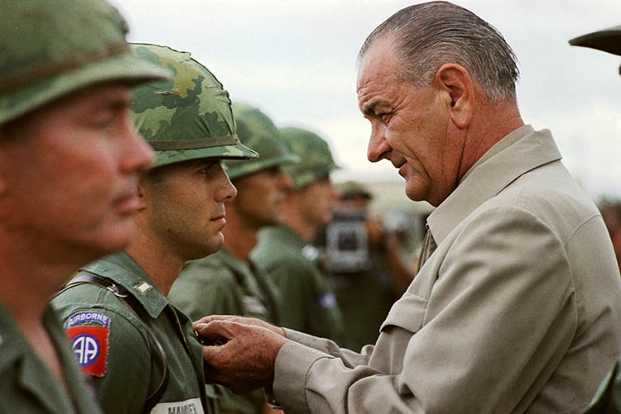**President Lyndon B. Johnson awards the Distinguished Service Cross to First Lieutenant Marty A. Hammer, in Vietnam, 1966.**

The Tet Offensive also served to collapse the moral position of the Johnson administration. During the attack on Saigon, a man presumed to be Viet Cong, wearing a shirt and a pair of shorts, hands tied behind his back, was shot in the head, execution-style, by National Police Chief Nguyen Ngoc Loan. The incident would have gone down in history as another bloody episode in a bloodier war had it not been caught on camera. It looked to the world as if America was working in tandem with men such as Loan and fighting on behalf of a doomed regime that could not even help itself. The net effect of all this was to energise the antiwar movement in the United States. On 30 March 1968, President Johnson declared on American television that he would not seek another term in office. The announcement was tantamount to an admission of defeat. Costly and bloody, the Tet Offensive proved a turning point in the history of the American War in Vietnam.

**\***

The Tet Offensive tempered Le Duan’s impetuousness, but only for a period. Heartened by its unforeseen consequences in the US and around the world, he tried his luck again during the next presidential election year, 1972. In March that year, Hanoi mounted the Spring Offensive, a colossal effort that also fell very short of its objectives and cost in excess of 40,000 PAVN and Viet Cong lives. Intractably committed to victory on his terms, Le Duan sanctioned another go-for-broke campaign in 1974-5. He could no longer abide the slow chug of stagnant war: it had been nearly 30 years since Ho Chi Minh had proclaimed the independence of Vietnam on 2 September 1945, but the nation was still divided, unable to enjoy the benefits of complete sovereignty. Also, by this time the last US forces had pulled out of Vietnam and Hanoi was convinced that they would not return ‘even if we offered them candy’, in the words of North Vietnamese prime minister Pham Van Dong. This time, communist armies were victorious. Soon, Vietnam was formally reunified under Le Duan’s governance. It had taken seven years longer than expected, but he finally had his moment of triumph. The country had paid a terrible price for it.

**Pierre Asselin** is the author of *Vietnam’s American War: A History* (Cambridge University Press, 2018).