<https://www.commondreams.org/views/2017/10/09/why-us-lost-vietnam-war>

*Publlshed on*

*Monday, October 09, 2017*

*by*

[*Common Dreams*](https://www.commondreams.org/)

**Why the US Lost the Vietnam War**

The U.S was not simply outfought.  It was out-thought.

by

[Robert Freeman](https://www.commondreams.org/author/robert-freeman)

[32 Comments](https://commons.commondreams.org/t/why-the-us-lost-the-vietnam-war/45679)

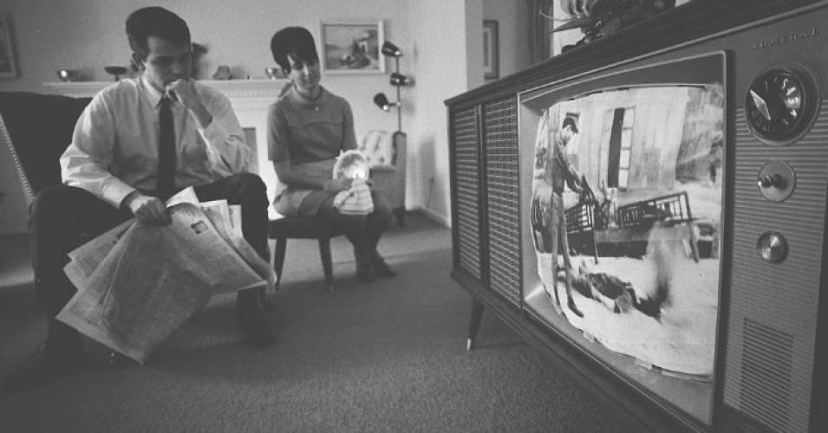

An American man and woman watching footage of the Vietnam War on television in their living room, February 1968. (Photo: Warren K. Leffler/U.S. News & World Report/via Wikimedia)

For all of the self-satisfied voyeurism surrounding the Vietnam War, it’s hard to find a concrete idea about why the U.S. lost.  For more than a decade, the U.S. had declared that it would not let Vietnam fall to the communists.  Yet, Vietnam fell to the communists.  Why?

The absence of a clear explanation is not an accident.  None of the institutions that led the U.S. into the War or prosecuted the War want to be tarred with having lost the War.   They would rather its loss be left ambiguous, murky.  Or worse, blamed on others.

But in fact, there are very specific, concrete reasons why the U.S. lost the War.  If we are to ever reach a true peace about the War—and certainly, if we are to ever stop repeating its mistakes and continuing to lose newer wars—it is essential that we understand why the U.S. lost.

**"If we are to ever reach a true peace about the War—and certainly, if we are to ever stop repeating its mistakes and continuing to lose newer wars—it is essential that we understand why the U.S. lost."**

Failings occurred in state policy, intelligence, and, of course, the military.  The easiest thing to explain are the policy, or political factors.  In earlier pieces, [here](https://www.commondreams.org/views/2017/09/24/there-no-rehabilitating-vietnam-war) and [here](https://www.commondreams.org/views/2017/09/30/choosing-quagmire-essential-context-vietnam), these were dealt with these in depth.

Briefly summarizing, they began when, in 1946, Truman refused Ho Chi Minh’s request for help in evicting the French colonial occupiers.  He helped the French, instead.  This all but assured that the U.S. would never “win the hearts and minds” of the Vietnamese people.

The errors continued when, in 1955, Eisenhower set up a “South” Vietnam in order to evade the national elections that had been agreed to in settling the French defeat.  Eisenhower stated bluntly, “Our guys would have lost.”

Still more mistakes were to come.  Eisenhower foisted an alien ruler on his new country, a wealthy, Catholic, urban, mandarin from New Jersey, Ngo Diem.  The Vietnamese were poor, Buddhist, rural peasants.   Then, U.S. stood by as Diem took people’s land and gave it to his wealthy friends.  Ho Chi Minh took land from the French and distributed it to the people.

All of these moves only served to harden the Vietnamese people’s conviction that “South” Vietnam and its government were simply puppets for a different Western colonial occupier.  No such lackey regime could ever achieve political legitimacy.  And without political legitimacy, there could never be a long-term solution to the War.

Compounding the political failings were the failures of intelligence.  The most obvious of these was the confusion of nationalism with communism.  Vietnam was first and foremost a struggle for national independence.  The Vietnamese wanted the foriegn occupiers out of their country. The Americans should have understood this.  They had once fought a war of national independence to get the foreign occupiers out of their country.

But the U.S. was fixated on anti-communism and Ho was a communist.  The U.S. believed it had “lost” China in 1949.  It had only fought Korea to a draw in 1953.  Eisenhower ominously had the “dominoes” falling through Cambodia, Thailand, Burma, all the way to India.

By perceiving all events through anti-communist lenses, U.S. leaders were unable to modify their strategies and tactics to accommodate the demand for local self-determination.  The tragedy is that in 1961 the CIA repudiated the domino theory, but it was impossible to reverse the policy momentum that its simplistic imagery had spawned.

An equally important intelligence failing was the confusion of partisan with insurgency warfare.

The U.S. concept of the War was that it was “partisan”—that it was being fought by outside invaders from the North. In fact, from the beginning, the War was an “insurgency,” fought from within the South itself, against U.S. imposed regimes.  The insurgents were the Viet Cong.

This misunderstanding totally undermined U.S. efforts since the strategy needed to fight one war was completely different from the strategy needed to fight the other.  The more the political situation deteriorated in the South, the more the U.S. bombed the North. The greater the Viet Cong hold on the rural population in the South, the more the U.S. bombed the North.

This backfired because it drove the North to enter the war in the South precisely to expel the foreign occupiers who were using the South as the staging ground for bombing the North.  That was the beginning of the end.

It cannot go without being said that intelligence reports going to Washington were worse than useless.  They were profoundly damaging.  Everything from battle reports and field-level body counts to situation assessments and reviews of strategic progress were routinely lied about.

This made it impossible to devise appropriate strategies or even perform meaningful assessments of the War’s progress.  The reason lay in the incentive structure of the military.

Military officers were rewarded for successful performance of duties, not for failing performance. So, they had a built-in incentive to embellish their reports.  Low level lies were routinely rolled up into higher-level lies, all the way up the chain of command.

Also, loyalty within the officer corps ensured that contrary voices were forced out of the service.

So, the entire hierarchy of military reporting created false reports of progress. Once begun, it proved impossible to stop.  The “light at the end of the tunnel” never seemed to go out.

But it never came any closer, either.  The lying was so entrenched it was impossible to even discover until it was too late.  And when it was discovered the liars tried to impugn the truthtellers by questioning their patriotism.

If political and intelligence failings contributed to the U.S. defeat, military failures were central to it.  Vietnam was, after all, a war.

One of the most spectacular failures was the air war.  “Rolling Thunder” was the name given the U.S. campaign of bombing the North.  The idea was to interdict supplies from the North from reaching the insurgency in the South.  But interdiction failed.  The reasons are clear and were known at the time.

First, the level of economic development of the North was very low, meaning there were few concentrations of useful targets to bomb. Second, when the air campaign began, the North dispersed even these targets throughout the countryside to protect them from bombing. Third, targets that were damaged were quickly rebuilt. Bridges over rivers were sometimes rebuilt nightly.

Fourth, and most importantly—and this cycles back on the intelligence failing mentioned above—since the War was primarily an “insurgency war,” fought by Vietnamese from within the South itself, against the South’s own government, the vast majority of the War’s material requirements were provided locally.

In 1965, the CIA reported that 31% of the weapons captured from the Viet Cong were of American manufacture!  And at the height of the bombing in 1967, the CIA estimated that even if bombing intensity were *doubled*, it would still only interdict 20% of the supplies flowing south.

In other words, bombing would have had to be increased *ten-fold* to completely shut off supplies from the North. This was not politically, economically, or even militarily possible.  Thus, it was not even conceptually possible to defeat fighting in the South by bombing the North.  The military was unphased.

Air Force general Curtis LeMay famously quipped, “We should bomb them back into the Stone Age.”  And he tried.  The U.S. dropped three times more tons of bombs on Vietnam than were dropped by all sides on all theaters of all World War II combined.  Clearly, it didn’t work.

Finally, the fundamental U.S. military strategy in the War was fatally flawed.

From the beginning of the escalation, in 1965, the U.S. military chose a strategy of attrition. Attrition means progressively destroying the other side’s forces until they can no longer fight. For attrition to work, three conditions must apply.

First, you must be able to control the timing and terms of engagement. Otherwise, you cannot ensure progressive destruction of the enemy’s forces.  Second, the enemy’s losses must exceed his replacement rate. Otherwise, he can simply replace lost troops faster than they are being destroyed. And third, your own losses, while they may be far lower than those of the enemy, must still be tolerable within your own war-making context.

Amazingly, none of these conditions applied.  Even more amazing, even though they didn’t apply *and the U.S. military knew at the time that they didn’t apply*, the military never changed its fundamental strategy until it was too late.

In almost 90% of the cases, firefights were engaged at the timing and in locations chosen by the enemy. Intelligence estimates during the War indicated that some 200,000 North Vietnamese young men attained draft age every year, far higher than the rate at which they were being killed.  And that still didn’t consider Viet Cong recruiting in the south.

Finally, despite killing more than nine enemy soldiers for every American lost, the costs to the U.S. became unbearable. As more and more U.S. soldiers came home in body bags and as the lying and savagery of the War became known, the American public turned against the War and demanded it be stopped.

Against the U.S. strategy of attrition, the North Vietnamese pursued a strategy of “enervation” or protracted war. This meant tiring the enemy of his will to fight. It meant dragging out the War, harassing the enemy, avoiding serious engagement except where the likelihood of success was high, withdrawing before serious losses were sustained, and counting on the American public to tire of a seemingly endless but unwinnable war.

This is the strategy Vietnam had used to defeat the French. It worked equally well to defeat the Americans.

The U.S. had almost inconceivable superiority in firepower, mobility, communications, and depth of resources—the conventional assets that it assumed would ensure its victory.  Nixon famously groused to Kissinger that his massively escalated bombings were not working: “This fourth-rate country has got to have a breaking point.”

But the U.S. approach to the War—all parts of it, political, intelligence, and military—were deeply, fundamentally, irretrievably flawed.  It could not win the support of the local population.  It could not win on the ground.    And, after the Tet Offensive in early 1968 demolished the upbeat fiction in the U.S. that the War was being won, it could not even sustain the will of its own population to continue the War.

The U.S was not simply outfought.  It was out-thought.

The military, which was the lead actor in the War, is quick to blame others for its loss.  It was the liberal media that turned the people against the War.  It was the pampered protesters, the college students, who soured the country.  It was the arm-chair warriors in the Pentagon who tied the military’s hands behind its back.  And so on.  And on.  And on.  Anybody but itself.

These political, intelligence, and military reasons for the U.S. loss in Vietnam are not hard to identify.  They are made of the deadly combination of ignorance, deceit, and incompetence.  We simply need the clarity of intellect and the courage of will to name them.

But steeped as they are in the still more deadly elixir of arrogance, profiteering, and denial, they all but assure that the U.S. will continue to lose its major wars.  Iraq and Afghanistan stand as examples.  There’s no way to know when or how the losing ends, but until we come to grips with the lessons of Vietnam the suspicion must be that it won’t.  *That* is the true tragedy of Vietnam.

[](https://www.commondreams.org/author/robert-freeman)

[**Robert Freeman**](http://www.commondreams.org/author/robert-freeman) is the author of [*The Best One Hour History*](https://www.amazon.com/s/ref=nb_sb_noss?url=search-alias%3Dstripbooks&field-keywords=the+best+one+hour+history&rh=n%3A283155%2Ck%3Athe+best+one+hour+history) series, which includes World War I, The French Revolution, The Vietnam War, and other titles.