**The war that America could never win? Opposition, dissent and the Vietnam War**

As GIs struggled to overcome their communist enemies in the jungle, another very different adversary brought the fight to the streets of America. Jonny Wilkes explores the hidden enemy for *BBC History Revealed*…

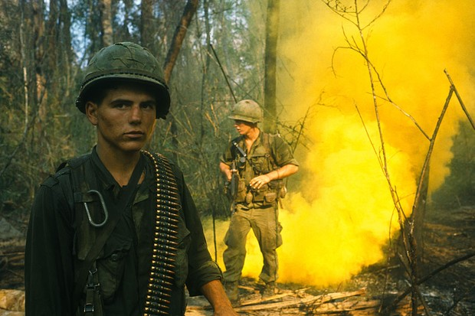

March 27, 2020 at 3:55 pm

Somewhere in the line of veterans – a single file of bedraggled hair, faded fatigues, wheelchairs and crutches – as they slowly snake towards the Capitol Building is Barry Romo. The former lieutenant of the 196th Light Infantry Brigade enlisted believing in fighting communism, and wishing to emulate his father’s deeds in World War II, but now he is joining comrades to protest the war in Vietnam. Today, 23 April 1971, is the end of a week of demonstrations, street theatre, candlelit vigils, arrests and camping on the Mall in Washington DC, and there is one last act of defiance, and sacrifice, for Romo to perform.

He looks down at his medals, which he will soon be rid of. He remembers when his patrol in Tam Kỳ province was ambushed by the Viet Cong and he, just 19 years old, ran out in the open rice paddy to wave down a medevac chopper. He received a Bronze Star for saving the wounded. He remembers when his platoon sergeant stepped on an American ‘Bouncing Betty’ mine and had his intestines and stomach blown out. He remembers his beloved nephew being shot in the throat and it taking 48 hours before the body could be retrieved.

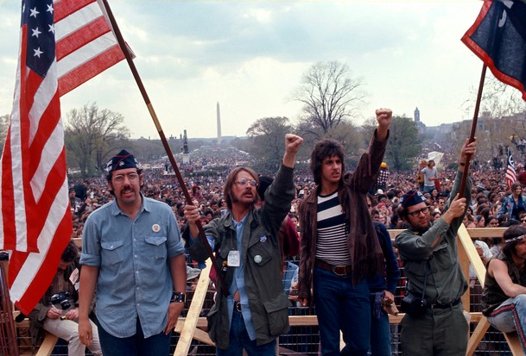

Hippies, veterans and celebrities alike descended on the Mall, Washington, DC to protest the war. (Photo by Don Carl STEFFEN/Gamma-Rapho via Getty Images)

It is almost his turn. Romo looks at each man stepping to the microphone to say a few words before turning and hurling their medals, ribbons and dogtags at the Capitol, stood behind a quickly constructed fence to keep protestors out. Many curse the government, others apologise, and one limping man throws his cane. Rejecting these symbols of bravery is a powerful display of how the war has no meaning. Romo says of his medals: “These ain’t shit!” This day, the veterans capture the spirit of a massive movement, in which millions fight against a war America cannot win.

**Why was US involvement in Vietnam opposed?**

US involvement in Vietnam had not always been so strongly opposed, with dissent before 1965 confined to colleges. In a time of Cold War politics, the Americans held to the ‘Domino Theory’: the fear that if one country fell to communism then its neighbours would follow. In 1954, Vietnam had been divided in two and since then, the ruling communists in the North had tried to unify the country. Add that to instability in the South as the communist National Liberation Front (the NLF, but better known as the ‘Viet Cong’) looked to overthrow the government and it was inevitable that US foreign policy would dictate that assistance – in the form of thousands of ‘military advisers’ – must increase.

The decision to deploy troops in 1965 revealed a fatal flaw in American foreign policy: hubris. By considering North Vietnam as nothing more than a pawn in their Cold War chess game with the Soviet Union, the US underestimated the enemy, with tragic and long-lasting consequences.

Victory for the North Vietnamese and Viet Cong meant uniting the country under a communist flag, so they fought for their very identity. Such zeal meant they endured colossal death tolls – they lost ten men for each American killed – without losing the will to drive out the imperialist invaders.

Their guerrilla tactics suited the terrain far more than the US reliance on superior firepower. In the dense jungles and swamps, American grunts faced ambushes from an enemy they could not even see, who then disappeared into the vegetation or by using a complex tunnel network. These would be cleared by a lone soldier, a ‘tunnel rat’, armed with just a torch, knife and pistol. Then, if Viet Cong positions could be captured, there was the risk of ingenious booby traps, from flags rigged to explode when lowered to pits of sharpened ‘punji’ sticks.

American bombing, including napalm and defoliants, failed to destroy the communists, who remained well supplied by the Soviet Union and China (along the Ho Chi Minh Trail through Laos and Cambodia). Even their rifle of choice, the AK-47, performed better than the Americans’ standard-issue M14, which jammed in the tropical conditions.

Not knowing who the enemy was (Viet Cong fighters could easily hide among any supporters in South Vietnam), demoralised American troops were left carrying out search-and-destroy missions. These ‘Zippo Raids’ devastated whole areas and dehumanised the Vietnamese, leading to untold civilian deaths. A hidden enemy in a war of attrition meant the Americans sent home body bags rather than news of victory.

“If we quit Vietnam tomorrow, we’ll be fighting in Hawaii and next week we’ll have to be fighting in San Francisco,” warned President Lyndon B Johnson. Then, when two US destroyers were (allegedly) attacked by North Vietnamese torpedo boats in August 1964, the resulting Gulf of Tonkin Resolution gave LBJ authority to escalate involvement without declaring war.

Although public opinion sided with the government in 1965, and stayed favourable for years, dissent became evident from the outset. People’s attitudes towards Vietnam differed immediately from previous conflicts, where early days were dominated by propaganda and patriotism. Instead, anti-war sentiment bloomed from, or connected with, other social movements of the 1960s. It was a time of counterculture, civil rights activism and the exploration of freedoms.

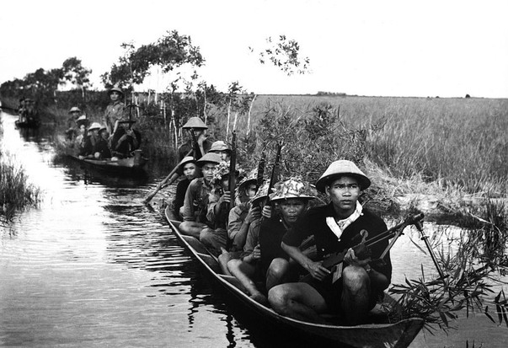

A group of Viet Cong patrolling in a rice paddy. (Photo by Keystone-France/Gamma-Keystone via Getty Images)

So as the bombings of North Vietnam got underway (Operation Rolling Thunder), organisations like Students for Democratic Society headed marches, while ‘teach-ins’ at dozens of campuses discussed the justification and morality of the war. A similar idea would spring up later near military bases – called ‘GI coffeehouses’ – for disgruntled grunts.

**Mind the credibility gap**

**How the media fought the war**

Vietnam is referred to as the ‘first television war’, when raw images depicting the horrors of war replaced the strictly controlled government propaganda seen in previous conflicts. Uncensored coverage of a battle’s aftermath or lines of bodies blared into American homes, most of which had TVs, every day.

Yet, prior to 1968, reporting remained positive, or at least not overly negative. The armed forces recognised a need to ‘sell’ the war back home, and many contentedly believed the “good guys shooting Reds” stories. That changed with the Tet Offensive. Although the US had repelled the series of surprise attacks, the media saw Tet as a failure and the American public grew convinced the war was far from over (going against the official message from the White House). In his damning broadcast, Walter Cronkite – polled as being “the most trusted man in America” – said “We are mired in stalemate”.

From then on, the media was in conflict with the government, giving more exposure to the anti-war movement and shocking images, such as the My Lai Massacre and the ‘Napalm Girl’. Presidents Johnson and Nixon failed to close the ‘credibility gap’, as Americans increasingly distrusted everything that they said.

In late July, LBJ changed the war irrevocably by announcing an immediate increase of troop levels from 75,000 to 125,000, on the advice that aerial superiority had done little to hinder the communist guerrillas. Putting boots on the ground, however, meant doubling the draft to 35,000 a month, which young men refused by burning their draft cards. Opposition to the draft would intensify as anger spread at the system’s unfairness, with it affecting the poor and African American populations hardest. Those who did enlist faced a conflict of attrition – being bogged down in jungles and guerrilla assaults by the Viet Cong. Firepower caused the deaths of many North Vietnamese and VC, as well as civilians, but for the people back home, the main images in the media would be of American body bags.

**Flower power**

By 1967, as half a million men and billions of dollars poured into Vietnam, disillusionment had turned the protests into a global movement. Marches took place around the US, as well as London, Paris and Rome, and featured prominent figures. On 15 April, Martin Luther King joined 400,000 in a march in New York; the President’s trip to Los Angeles on 23 June was met by a massive riot; and on 21 October, 100,000 gathered at the Lincoln Memorial, Washington DC. Here, and before clashes with soldiers at the Pentagon, the famous photo of hippies putting flowers into the barrels of rifles got snapped.

***LBJ went from the president who signed civil rights legislation to the man killing Vietnamese civilians***

For LBJ, he went from being the president who signed civil rights legislation to the man who was killing Vietnamese civilians with toxic chemicals, like ‘Agent Orange’ and napalm. He cancelled public appearances, knowing everywhere he went he would be met with the chant: “Hey, hey LBJ! How many kids did you kill today?” Things only got worse the next year.

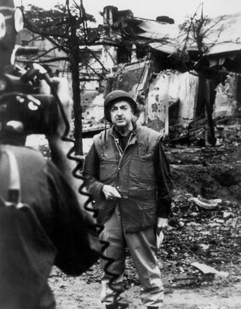

American news broadcaster Walter Cronkite reported on the horrors from Vietnam. (Image by Getty Images/CBS archive)

On 31 January 1968, the Viet Cong and North Vietnamese launched strikes against more than 100 military and civilian targets, including the Saigon headquarters of US forces commander General Westmoreland and the Embassy. Although the Tet Offensive caught the troops by surprise and ended with a bloody three-week battle for the city of Hue, South Vietnam, it ultimately became a tactical US success. But it did not matter, as Tet was a media catastrophe. How could the enemy pull off such a daring offensive? How could the war nearly be over, as the government insisted? Had the army been weakened? High casualty numbers, negative news stories and images from Tet – notably the filmed execution of a Viet Cong suspect – shocked Americans and led to major changes.

Westmoreland, *Time*‘s Man of the Year in 1965, had to be replaced, Secretary of Defense Robert McNamara resigned and LBJ suspended the bombing of North Vietnam. With Americans feeling betrayed by their government, the President’s popularity tumbled, with one poll stating 50 per cent of Americans did not approve of his handling of the war. When broadcast behemoth Walter Cronkite described Vietnam as a “stalemate”, LBJ responded: “If I’ve lost Cronkite, I’ve lost middle America.”

**Did you know?**

Tear gas used on protestors at the 1968 Democratic National Convention in Chicago reportedly affected the presidential candidate Hubert Humphrey while he was in the shower.

Sure enough, LBJ announced he would not seek re-election that year, a huge win for the anti-war movement. The Democratic National Convention in Chicago that August became a target for the Yippies (a radical youth group), who put forward a pig, Pigasus the Immortal, as candidate to mock the state of politics. Clashes with police resulted in the arrests of a group of activists, the ‘Chicago Seven’, whose five-month trial created a cause célèbre.

Any expectation of the new president being a ‘dove’ rather than a pro-war ‘hawk’ was lost when Richard Nixon won the election on a promise to achieve an “honourable end” in Vietnam. He even asserted that a “silent majority” of Americans still supported the war. That said, he knew public opinion had shifted, so he introduced a policy of phased troop withdrawals and started to hand over responsibility to the South Vietnamese army. President Nixon called it “Vietnamization”.

Although a popular move, complete withdrawal would take three years, so morale among the men left behind collapsed. Drug abuse, desertions and ‘fragging’ (killing their own officers) rose, while racism and violence towards the Vietnamese worsened. As accusations of atrocities spread, those returning from their year-long tour of duty faced an angry public, with the more radical protestors spitting at them and calling them ‘baby killers’. Soldiers joined their own anti-war groups, like Vietnam Veterans Against the War.

**Did you know?**

Actress and anti-war activist Jane Fonda made a controversial visit to North Vietnam, earning her the nickname ‘Hanoi Jane’.

The war ongoing, demonstrations not only continued, they got bigger. A couple of months after Woodstock, some 2 million workers, students and children stopped what they were doing on 15 October 1969 to participate in rallies around the country. The Peace Moratorium proved to be the largest demonstration during Vietnam – its success saw the event repeated a month later. Nixon incurred further wrath in December by introducing a draft lottery, the first since World War II. He hoped it would make the system fairer, but it inspired a new wave of protests and thousands of men either to flee to Canada or head to college for deferment.

**Slaughtered support**

With so many groups protesting for so many reasons, the movement fragmented. Several defining events, though, served to unite people in the final drive to end the war. In late 1969, news of the My Lai Massacre – complete with uncensored photographs – broke. On 16 March 1968, Charlie Company from Americal Division’s 11th Infantry had been sent to the hamlet of My Lai, believing it to be full of VC or their sympathisers. There they raped, mutilated and slaughtered as many as 500 unarmed women, elderly and children. The atrocity only stopped when the passing Warrant Officer Hugh Thompson landed his helicopter between the troops and surviving civilians. The revelations of the massacre and its cover-up caused further outrage. Supporters of the war had long claimed moral authority over the evils of communism; the My Lai Massacre weakened that position.

My Lai also galvanised many veterans, who felt just as betrayed and disgusted, into actions such as the Winter Soldier Investigations, where they gave accounts of war crimes. The most symbolic gesture they could carry out, though, would be throwing away their medals earned in what they saw as an immoral war, which almost 1,000 veterans (including Barry Romo) did in 1971.

**Did you know?**

Shortly after the Tet Offensive, General Westmoreland requested 200,000 more troops to finish the war once and for all. The media saw it as proof of the army’s weakness.

My Lai was not the only secret to hit the headlines. Demonstrations erupted after news broke of Nixon’s clandestine bombing and invasion of Cambodia – far from bringing the war to a close, it appeared he had expanded operations. At Kent State University, Ohio, on 4 May 1970, members of the National Guard opened fire on a gathering of students, killing four and wounding nine.

Nixon callously responded to the shooting by saying, “When dissent turns to violence, it invites tragedy,” which, alongside the photographs of the aftermath, again caused uproar. The following day, 450 colleges went on strike.

**War is over**

Distrust in the government’s message had grown since Tet, but this ‘credibility gap’ turned into a ravine on 13 June 1971 when the *New York Times* published the first instalments of the so-called Pentagon Papers. The leaked top-secret study detailed US activity in Vietnam since the 1940s, and revealed that successive presidents had deceived the public – LBJ, for example, had planned escalation as early as 1964. Nixon tried to stop publication, but a Supreme Court decision sided with the newspapers. The movement had reached its zenith and public pressure was too great. Congress repealed the Gulf of Tonkin Resolution, and Nixon – whose attention turned away from Vietnam as he became embroiled in the Watergate scandal – went on to end the draft and, in January 1973, he signed the Paris Peace Accords.

**Make love not war**

**On the march**

The anti-war movement attracted millions of people, but was far from being a united group with a single voice. It brought together students, hippies, artists, clergy, celebrities, women’s rights activists and veterans, and became inextricably linked to other movements of the 1960s, such as civil rights.

Early protests focussed on ‘teach-ins’ on campuses and the burning of draft cards – Muhammad Ali got stripped of his heavyweight boxing title for refusing the draft – but as death tolls rose, acts of civil disobedience began. These included preventing Dow Chemical, the makers of napalm, to hold job fairs, and guerrilla street theatre performances of mock search-and-destroy missions.

The movement became more vociferous with mass marches in cities in America and around the globe. They became associated with music from the likes of Joan Baez, Bob Dylan and John Lennon or speeches by leading figures, such as Martin Luther King. While mostly peaceful, gatherings occasionally spilled into violence – as well as Kent State, rioting broke out at the Democratic National Convention in 1968, which resulted in the arrests and media-spectacle trial of the ‘Chicago Seven’ protestors. Members of the anti-war movement – most notably the veterans who threw away their medals – faced accusations of treason, but momentum shifted towards them as support for the war waned.

The US entered Vietnam a global superpower intent on defeating communism, invincible and righteous. They left abjectly humiliated, with more than 58,000 Americans dead and feeling the effects for decades, be it from a crippled economy, veterans suffering from psychological trauma or an established distrust in the government. The very word ‘Vietnam’ has plagued US foreign policy arguably to this day. Yet the war came to be defined in another way – by people standing up and holding their leaders to account. And they sometimes paid a terrible price to prove that a war could no longer be won without enough public support.

**Jonny Wilkes is a freelance writer specialising in history**

[***This article was first published in the September 2017 edition of BBC History Revealed***](https://www.historyrevealed.com/)