**Godalming College**

Booklet Checked by: _____________

Grade: U/S 1 2 3

Comment: __________________________________________________________________________________________________________________________________________________________

**Sociology Department**

CHILDHOOD

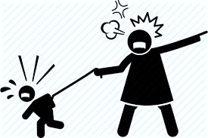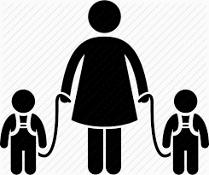

**FAMILY Paper 2 Workbook 1**

|  |  |  |
| --- | --- | --- |
| Name: | C:\Users\dak.GODALMING.001\AppData\Local\Microsoft\Windows\Temporary Internet Files\Content.IE5\KWYSY2DH\father-holding-baby-in-air-silhouette[1].jpgSet: | Group: |

**GLOSSARY**

|  |
| --- |
| Age |
| Generation |
| Life course |
| Millenial |
| Rites of passage |
| Childhood |
| Affective Individualism |
| Cross cultural |
| Child-centredness |
| Familism |
| Welfare View |
| Control View |
| Toxic Childhood |
| Child free |
| Paranoid Parenting |
|  |

**The AQA Specification:**

***Students are expected to be familiar with sociological explanations of the following content:***

* ***the nature of childhood, and changes in the status of children in the family and society***

**If at any point you are unclear of any material it is VITAL that you discuss this with your subject tutor. You will not achieve well in your AS examinations without this knowledge and will not be able to continue onto A2 Sociology.**

All the key terms you need to know feature at the end of this workbook. We recommend that you maintain your own key studies summaries, as covered within class, to aid your revision.

**AQA Guide**

|  |  |
| --- | --- |
| The nature of childhood, and changes in the status of children in the family and society | * How childhood is socially constructed. * Different sociological views on the nature and experience of childhood. * How childhood is experienced differently across gender, ethnicity and social class. * Cross cultural differences and how the experience of childhood has changed historically. |

**CHILDHOOD AND AGE**

**Theorising about Age**

Age might seem to be a purely natural category, and therefore something which sociologists have little to say about. However, sociologists have pointed out that while ageing is a natural process, how age is regarded, how it affects life chances and the way it is used as a basis for differentiating between people, is a social process. Sociologists have therefore been interested to investigate age-based inequalities and to find out how differentiation and stratification on the basis of age occurs.

**Age Identities**

We have two main ways of conceiving of our own age

1. **Chronological age** – years and months
2. **The life course** – a series of stages through which the individual necessarily passes

Even in biological terms, it is clear that the former may consist of entirely arbitrary divisions based not on biological, emotional or psychological maturity, but on cultural factors. The age of criminal responsibility or legal sexual expression for the young, or of compulsory retirement from work for the old, is determined by legal and cultural factors, not the physical or emotional wellbeing of the individual.

**Mannheim** made a distinction between age and generation identifying generations in themselves – that is simply people born at a similar time, and generations for themselves - that is people who might share a common binding cultural experience. For example, generations that experienced the Great Depression, the Second World War, etc are alleged to have been brought together by a common experience of overwhelming historical events. “Millennials”, who have grown up with the internet (like yourselves) may have a radically different experience of education to older people, for example nomophobia (fear of losing or failing to have contact with one’s mobile phone may be more likely to be acute for younger people.

Another way of conceptualising issues of age is to consider the life course – a series of experiences, defined by age group, which everyone will experience as they pass from one stage to another sometimes marked by ***rites of passage***. Specific ceremonies that mark the transition from one life stage to another – e.g., marriage, graduation, retirement celebrations and so on.

Featherstone and Hepworth have questioned this idea from a postmodernist point of view. To them the wide range of variations between individuals in contemporary society make such generalisations virtually redundant. Even the lifecourse has been deconstructed.

Q. Do you agree that these key stages of life are no longer a fair guide?

**THE SOCIAL STRUCTURING OF AGE IN BRITAIN**

Several sociologists have identified a range of issues and concerns associated with different age groups in society, for example.

|  |  |  |
| --- | --- | --- |
| **AGE STAGE** | **RELATION TO SOCIAL STRUCTURE** | **SOCIAL ISSUES CONNECTED TO AGE** |
| 1. **Childhood** | Parents/state | Neglect , pre-school, abuse, poverty |
| 1. **Youth** | Parents, school, peers work /training | Dis/order authority, control, commitment |
| 1. **Youth/adulthood** | Committed relationship or not, children, career | Stability, divorce responsibility, equality |
| 1. **Middle age** | Continued parental role but commitment / responsibilities reduced | Achievement and failure |
| 1. **Early old age (the “young old”)** | Retirement , leisure | Irrelevance, wealth or not |
| 1. **Late old age (the “old old”)** | Retirement, single living | Irrelevance, community care, cost |

**How would you define childhood using the table above? What are the key elements that distinguish childhood from other age groups? Note your ideas around the cloud below.**

**CHILDHOOD**

**CHILDHOOD THEN**

**Has childhood a history?**

Childhood is both a biological reality and a social construction. As the latter it has a history

**Historians on childhood**

1. **Philippe Aries - Centuries of Childhood**

French historian and a pioneer in the history of childhood. He thinks that in the past, children past infancy were simply seen as "**little adults**" with no distinctive period of childhood.

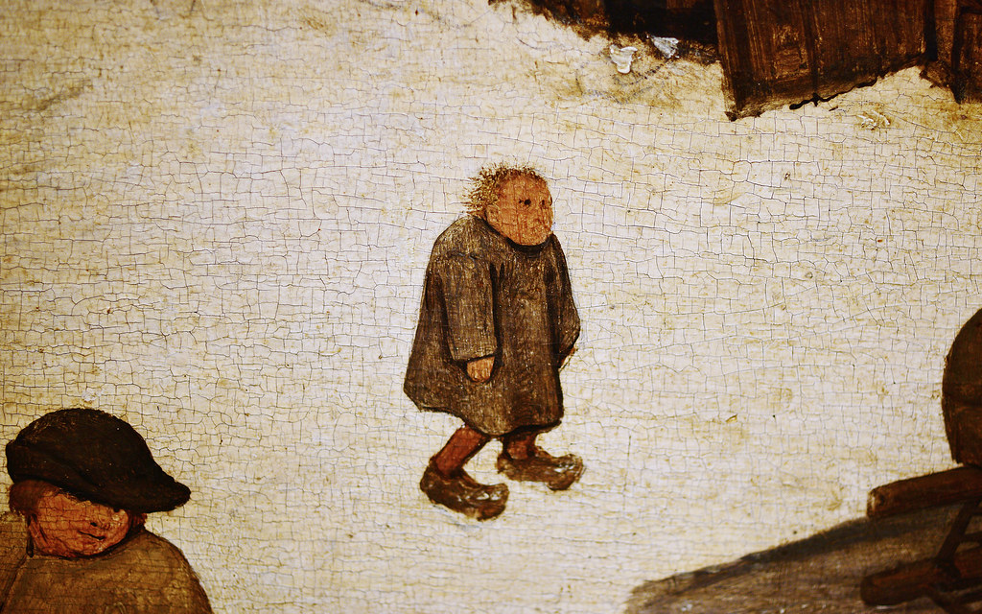

*"****In medieval society the idea of childhood did not exist****; this is not to suggest that children were neglected, forsaken or despised. The idea of childhood is not to be confused with affection for children: it corresponds to an awareness of the particular nature of childhood, that particular nature which distinguishes the child from the adult, even the young adult. In medieval society, this awareness was lacking. That is why, as soon as the child could live without the constant solicitude of his mother, his nanny or his cradle-rocker, he belonged to adult society. That adult society now strikes us as rather puerile: no doubt this is largely a matter of its mental age, but it is also due to its physical age, because it was partly made up of children and youths."[p 125]*

Medieval attitudes were a result of demographic factors (rates of infant mortality, average life expectancy, etc.), the nature of work, the existence of specialised agencies to regulate society and the changing functions and structure of the family.

*"Medieval civilisation ...* ***knew nothing as yet of modern education****. That is the main point: it had no idea of education. Nowadays our society depends, and knows that it depends on the success of its educational system. It has a system of education, a concept of education, an awareness of its importance. New sciences such as psycho-analysis, paediatrics and psychology devote themselves to the problems of childhood, and their findings are transmitted to parents by way of a mass of popular literature. Our world is obsessed by the physical, moral and sexual problems of childhood.*

*"This preoccupation was unknown to medieval civilisation, because there was no problem for the Middle Ages: as soon as he had been weaned, or soon after, the child became the natural companion of the adult."[p 395]*

**ACTIVITY 1 - Using Webb et al p180 (and Sociology in Focus p113-114 - 2nd edition) to help you outline the factors that Aries identifies that have shaped the creation of “the modern cult of childhood”.**

**Schooling**

**The workplace**

**Clothing**

**Specialists**

**What criticisms have been made of Aries’ work?**

**CHILDHOOD NOW**

Age is both a biological and a social construction for sociologists.

Childhood is shaped by more than simple biological immaturity. It has its own norms, values and expectations associated with it. It has legal constraints on the behaviour of children and of adults toward them.

**Does childhood vary between cultures?**

This aspect of childhood is best seen in historical and cross cultural studies. It is very clear that children in other contemporary societies have very different expectations and rights, just as they did in the past. **Raymond Firth** in his study of Tikopia in 1963 found that children would carry out dangerous tasks, such as using sharp tools and fishing in the open sea when they felt ready to do so, rather than when adults decided they were competent and safe. This is in stark contrast to modern Britain. (See Sociology in Focus 2nd edition pages 112-113)

**Benedict (1934)** – children from non-industrial societies are different from western children in three ways:

1.) **Responsibility** - **Punch (2001)** found that once children in Bolivia reach 5, they are expected to take work responsibilities in the home and community. **Holmes (1974)** noticed that in Samoan society, ‘too young’ is no reason to prohibit an activity

2.) **Obedience** **to authority** – **Firth (1970)** observed that among the Tikopia, doing what you are told by an adult is regarded as a concession to be granted by the child

3.) **Sexual behaviour** – **Malinowski (1957)** observed that among the Trobriand Islanders, adults took an attitude of ‘tolerance and amused interest’ towards children's sexual activities.

**Q. Can you think of any other examples of cross cultural differences?**

**Q. Do you agree with the idea that Western ideas of childhood have become globalised See Webb et al p 180)? Give reasons for your answer.**

**The debate on contemporary childhood.**

Contemporary debates around childhood have tended to focus on the future of childhood with two main positions. Either

1. **Childhood is disappearing** as the boundaries between adults and children become increasingly blurred. The omnipresence of the mass media is particularly involved in this, or
2. **Childhood retains a specially protected status**, perhaps even to the extent that it has become **increasingly monitored and controlled** (so-called “cotton wool children”) by **parents who hover over their children’s every action** (“helicopter parenting”) and as a consequence we live in a child-centred society with child-centred families

Both of these attitudes appear in the increasingly challenging moral panics about risks to children in recent years, with focus on danger and abuse both within and outside the family. The rest of this booklet focuses on these areas.

**A Child-Centred Society?**

**Using the material in Browne (5th edition) on pages 336-337, identify the main arguments for the idea that society has become more child-centred over the 20th and 21st centuries.**

Standards of living

Working Hours

Family Size

Welfare State

Marketing

**Child Centred?**

Paediatrics

“Stranger Danger”

Education

Complexity

**Q. What problems can you identify with the argument that we have become more child centred?**

**Children and the Law**

In modern Britain childhood is a **legal construction**. You can see this in two main ways, setting age limits for particular activities and laws on the welfare of children (through the Children Act, various education acts and so on).

1. **The Law: Evidence for a child-centred legal system**

**THE CHILDREN ACT (1989)**

The main principles of the 1989 act of parliament were as follows

* **the welfare of the child is the paramount consideration**
* **wherever possible, children should be brought up and cared for within their own families**
* **parents with children in need should be helped to bring up their children themselves; this help would be provided as a service to the child and his family and should:**
  + **be provided in partnership with the parents:**
  + **meet each child's identified needs;**
  + **be appropriate to the child's race, culture, religion and language;**
  + **be open to effective independent representations and complaints procedures;**
  + **draw upon effective partnership between the local authority and other agencies, including voluntary agencies.**
* **children should be safe and be protected by effective intervention if they are in danger**
* **when dealing with children, courts should ensure that delay is avoided, and may only make and Order if to do so is better than making no order at all**
* **children should be kept informed about what happens to them, and should participate when decisions are made about their future**
* **parents will continue to have parental responsibility for their children, even when their children are no longer living with them. They should be kept informed about their children and participate when decisions are made about their children's future**

Parental responsibility is defined in Section 3(1) of the 1989 Children Act as ***all the rights, duties, powers, responsibilities and authority which, by law, a parent has in relation to a child and his property’*** and care and supervision orders to safeguard the child from harm are allowable only against this framework.

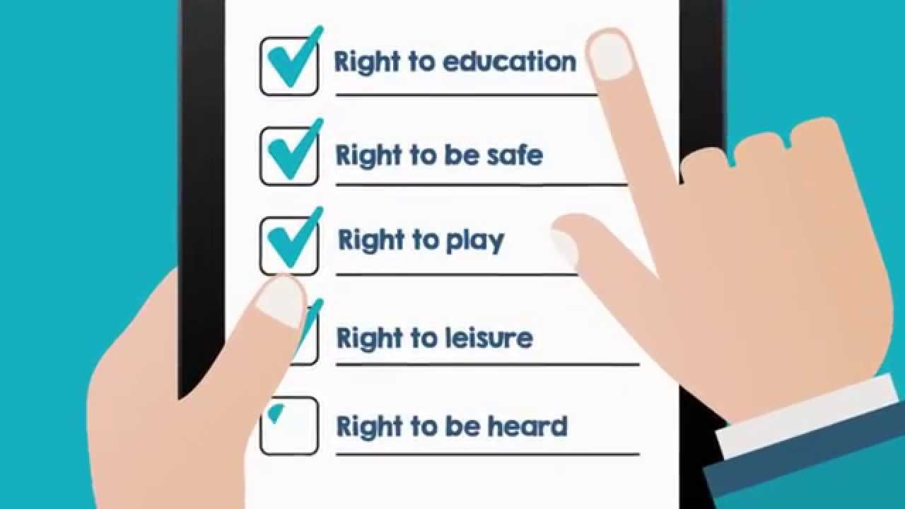Some sociologists (such as Parsons) have argued that this sort of legislation represents **a loss of function** for the modern family, as other agencies, including the education system, health authorities, social workers and even the criminal law safeguard and regulate the lives of family members and especially children. Others (such as Fletcher) have stressed the way that such acts **reinforce the functions** of the family and even create new responsibilities for those who care for children. This assumption that the family is always right is sometimes referred to as the “**ideology of familism**”.

**Subsequent laws in 2004, 2006 etc have modified this legislation but the principle remains that children have rights over and above their parents**

**The rights of the child have also been championed by the United Nations as a necessary aim**

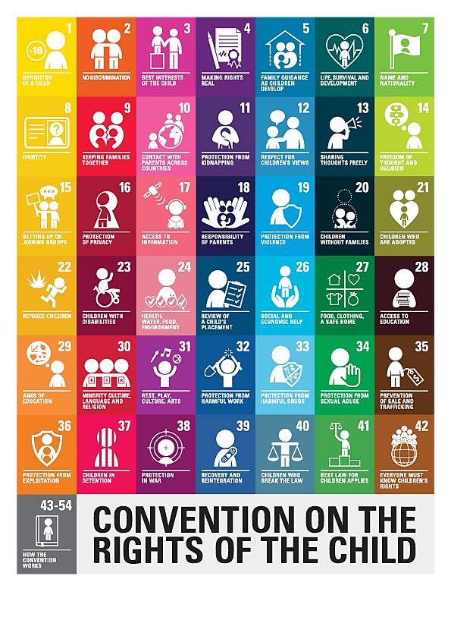

**ACTIVITY**

**Q. Identify and explain TWO other laws created in the UK in the 20th or 21st century that have had an impact on the role of children in society today:**

3. **The Law: Evidence for a blurred line between childhood and adulthood**

**ACTIVITY:** Using Internet sources identify the age at which you will be entitled to do the following things:

|  |  |  |  |
| --- | --- | --- | --- |
| Vote in a general election | Buy a lottery ticket | Get married without parental consent | Consent to a homosexual relationship |
| Watch an “adult” DVD | Be sent to prison | Join the armed forces | Be convicted of a criminal offence |
| Work a more than 40 hours per week | Buy drinks at the bar of a public house | Consent to a heterosexual relationship | Drink alcohol at home |

**Q. How does this table illustrate how difficult it is for us to identify a clear division between childhood and adulthood in modern Britain?**

**Two views of modern childhood**

The debate about the legal status of children often reflects underlying attitudes towards children, either as innocents requiring protection from a harsh outside world or as, in some sense, dangerous (feral youths, juvenile delinquency, teenagers).

Using **Sociology in Focus** (2nd edition ***pages 86-87***) describe what is meant by the **welfare view** and the **control view** of modern childhood as outlined by **Wendy Stainton Rogers**, and, using the material in this booklet give examples of laws which embody each of these views.

|  |  |  |
| --- | --- | --- |
|  | **Welfare View** | **Control View** |
| **Definitionn** |  |  |
| **Examples** |  |  |

**The End of Childhood?**

**Has childhood disappeared at the beginning of the 21st century?**

**Using the following sources - Webb et al p 182, Sociology in Focus pp 87 – 88 - and any other material available outline the arguments of Nick Lee Neil Postman, Iona Opie, and Christopher Jenks for and against this idea. And outline your own conclusions beneath.**

|  |  |
| --- | --- |
| **Childhood is disappearing** | **Neil Postman** |
| **Childhood has its own culture and has never disappeared** | **Iona Opie** |
| **Childhood is changing but not disappearing**  **Market Forces** | **Nick Lee** |
| **Childhood is changing but not disappearing**  **Postmodernity** | **Christopher Jenks** |
| **My Opinion and why** | **Me** |

**Parenting and Childhood**

It is important to review the material on childcare in booklet two in the light of the current thinking on the nature of childhood itself.

In particular there have been significant changes in the nature of both mothers’ and fathers’ roles within the family.

As a continuation of the symmetrical family thesis, some sociologists have identified an increasing desire among fathers to become more fully involved with actively parenting their children. Whether this is regarded as a new phenomenon or not depends upon the underlying perspective on the nature of conjugal roles and the sexual division of labour within the family.

Similarly, the greater involvement of women in paid employment has created issues for the bonding between mothers and their children. Jagger identifies the greater acceptance of women to be childfree rather than balancing career against family with the old dual burden.

**Toxic Childhood and Paranoid Parenting: Criticisms of the March of Progress View of Childhood**

**(based on** [**https://revisesociology.com/2015/05/09/toxic-childhood-and-paranoid-parenting/**](https://revisesociology.com/2015/05/09/toxic-childhood-and-paranoid-parenting/) **)**

The common sense view is to see these changes in domestic roles and parenting (see previous booklet) as ‘progressive’. Most people would argue that now children are more protected that their lives are better, but is this actually the case? The ‘March of Progress’ view argues that children’s lives have improved and they are now much better off than in the Victorian Era and the Middle Ages. They point to all the evidence on the previous page as just self-evidently indicating an improvement to children’s’ lives.

**Conflict theorists argue against this view** – they say that in some ways children’s lives are worse than they used to be. There are basically **three main criticisms** made of the march of progress view

1. **Recent technological changes** have resulted in significant harms to children – what Sociologist Sue Palmer refers to as **Toxic Childhood**.
2. Some sociologists argue that children today are **too controlled**. Sociologists such as Frank Furedi argue that children today are overprotected, or too controlled – We live in the age of ‘**Paranoid Parenting’**.
3. There are significant **inequalities** between children, so if there has been progress for some, there certainly has not been equal progress.

**Toxic Childhood – Toxic Childhood is where rapid technological and cultural changes cause psychological and physical damage to children**

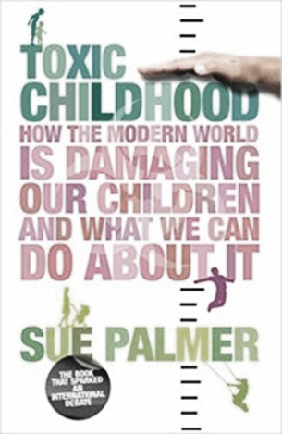Sue Palmer argues against the March of Progress View of Childhood and says, by contrast, that children today are experiencing a ‘**toxic childhood’**. She argues that a toxic mix of technological and cultural changes is having a negative impact on the development of a growing number of children. On her web site Sue Palmer outlined SIX WAYS in which childhood is toxic.

1. **The decline of outdoor play** – linked to increased childhood obesity
2. **The commercialisation of childhood** – linked to children being exploited by advertisers
3. **The ‘schoolification’ of early childhood** – reduces independence
4. **The decline of listening, language and communication skills** – because of shortened attention spans
5. **Screen saturation** – reduces face to face interaction
6. **Tests, targets and education** – increases anxiety amongst children.

***Criticisms of the view that childhood has become increasingly toxic***

* **Moral panic?** - This could be an example of an adult ‘panicking’ about technological changes.  
  Children are better off today as consumers rather than producers (child labourers)
* **Child protection and safeguarding** - Children are still very protected today – this view assumes children are delicate and in need of protection rather than resilient. (Stainton-Rogers’ Welfare view)
* **The decline of “acceptable” violence** - Catherine Bennett in The Guardian wrote that ‘in the good old days we just had to endure beatings’, although in fairness to Sue Palmer I don’t think she actually romanticizes the past, she’s really just pointing out the new and different problems children now face in a post-modern age.

**Conflict views of childhood**

**Age Patriarchy and adult control**

Using Webb pp 184 – 185 briefly outline how children remain controlled by adults under the following headings. Include studies/evidence where you can.

**Neglect and abuse of children**

**Control over children’s space**

**Control over children’s time**

**Control over children’s bodies**

**Control over children’s resources**

**Feminism and Childhood**

Following from the material above theorists such as Furedi have developed the notion of **paranoid parenting** – and see the overprotection of children as a problem.

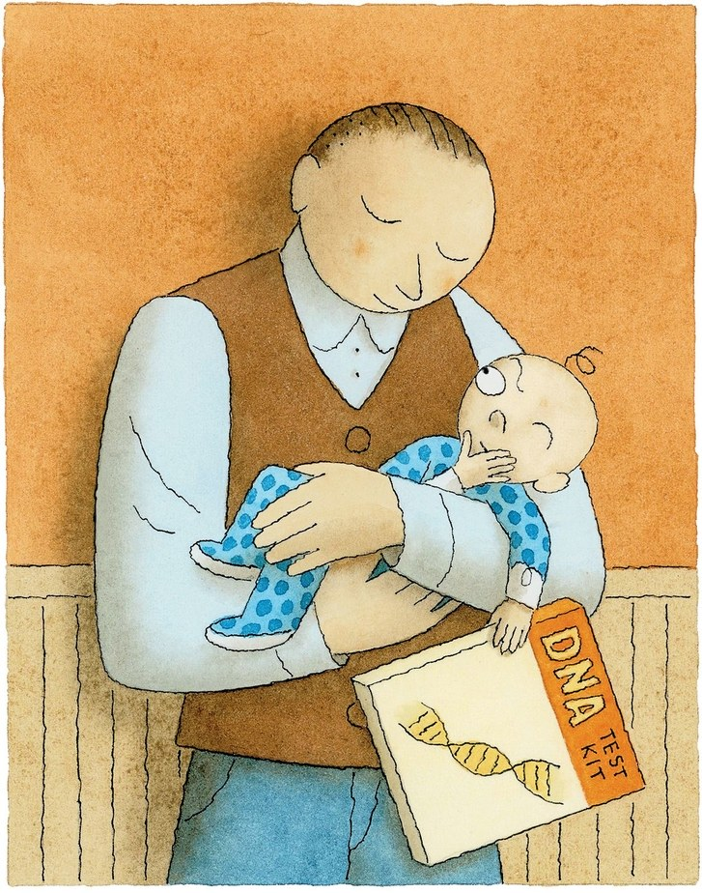Feminists have tended to see this as inherent in contemporary gender relations. **Diana** **Gittens** developed the term **Age Patriarchy** to describe the unequal relationship between adults and children. Power and control are visited on women and children within the family unit (back to the definition of “the rule of the father”).

More radical feminist approaches indicate that violence in households may often be directed at women and children and that women may often leave a marriage for fear of violence toward children. **Humphreys & Thiara**’s study (commissioned by Women’s Aid) gives evidence for this

Of the 200 women surveyed regarding their experiences of domestic violence 60% of the women had left because they feared that they or their children would be killed by the perpetrator.

(***Humphreys & Thiara***, 2002). In the same study, 41% of separated women were subjected to serious threats towards themselves or their children after separation

For some commentators, feminism has a more difficult relationship with contemporary childhood. **Oakley** (1994) regarded both women and children as members of social minority groups (regarded as culturally or physically different and therefore with unequal rights and power. Exclusion from paid work for example disempowers children, as it did women, and thus reinforces a position of dependence and economic disadvantage. Firestone believed that while women and children were both locked into patriarchal oppression, women will need to relinquish some rights over their children for children to be freed from oppression.

Evidence that children regard childhood as oppressive comes from the strategies they use to resist the status of child and the strategies that go with it. Two of these strategies are ‘acting up’ and ‘acting down’. Acting up is where a child acts older than they are in order to rebel. Acting down is where a child acts younger than they are as an act of rebellion.

The recent emphasis on women’s control over their own bodies and push for equality in the workplace has been criticised in itself. Feminism is seen as an ideology that **disregards the rights of the child in favour of women**. The New Right (and especially the religious Right) link this to the right to life for unborn children.

**The New Sociology of Childhood**

Childhood may be seen as passive and constructed by others in the traditional Sociology of Childhood. However, the personal life perspective of **Carol Smart** and others offers a more active role for children creating their own meaning and an understanding of the wide variation in childhoods in (post)modern society. Traditional views of childhood may be seen as “***adultist***” and itself an aspect of Age Patriarchy or similar.

**Using page 186 of Webb outline how Smart and Mason & Tipper’s work have tried to describe childhood “*from the child’s point of view*”**

**What strengths and weaknesses can you identify in such an approach?**

|  |  |
| --- | --- |
| **Strengths** | **Weaknesses** |

**A level Exam Practice**

* Outline and explain two changes in society which may be reducing the distinction between “childhood” and “adulthood”. (10 marks)
* Outline and explain TWO ways in which changing gender roles within the family may have affected children’s experience of childhood. [10 marks]
* Outline and explain two changes in society which demonstrate that society has become increasingly child centred (10 marks)
* Outline and explain TWO ways in which government policies may affect the experience of childhood today. [10 marks]

*Item A*

*Parents today spend a great deal of time and money trying to make sure that their children enjoy a comfortable upbringing. They want their children to have opportunities that they themselves never had. ‘March of progress’ sociologists argue that these changes in family life have led to an improvement in the position of children in society.*

Applying material from Item A, analyse two changes in the position of children in society over the last 100 years. [10 marks]

*Item A: A popular view is that childhood is a fixed, universal, biological stage of physical and physiological immaturity that is common to all human beings. Everyone will pass through it on the way to biological maturity and adulthood. However, evidence shows that what counts as childhood, what experiences children undergo and what roles they play, are far from universal.*

Applying material from Item A, analyse two argument against the view that childhood is a fixed, universal stage [10 marks]

*Item B: According to some sociologists, children in today’s supposedly child-centred society lead lives that are segregated and controlled, but childhood was not always like this. Aries describes a medieval world where there was little distinction between children and adults in either work or leisure. According to this view, industrial society brought major changes. Children’s lives became increasingly confined and regulated by adults. Not all sociologists share this view. Some argue that the distinction between childhood and adulthood is again becoming blurred.*

Applying material from Item B and your knowledge, evaluate sociological explanations of changes in the status of childhood [20 marks]

*Item B: Some sociologists suggest that contemporary families have become more child-centred than in the past. Parents today spend much more time with their children, and spend a great deal more money to ensure they give their children the most fulfilling upbringing possible. Many parents want their children to have opportunities they never had themselves as children. Critics of this point to children’s lack of control over their lives, child abuse and other problems that children today may face.*

Applying material from Item B and your knowledge, evaluate the view that contemporary families have become more child-centred [20]

**History of Childhood – Philippe Aries**

*"In medieval society the idea of childhood did not exist; this is not to suggest that children were neglected, forsaken or despised. The idea of childhood is not to be confused with with affection for children: it corresponds to an awareness of the particular nature of childhood, that particular nature which distinguishes the child from the adult, even the young adult. In medieval society, this awareness was lacking. That is why, as soon as the child could live without the constant solicitude of his mother, his nanny or his cradle-rocker, he belonged to adult society. That adult society now strikes us as rather puerile: no doubt this is largely a matter of its mental age, but it is also due to its physical age, because it was partly made up of children and youths."[p 125]*

Philippe Aries based is argument/views of childhood in medieval Europe on his analysis of secondary data – such as letters and diaries. He relied significantly on paintings produced at the time too as a source.

**Activity: Look at these paintings. What conclusions can you draw about childhood from these?**

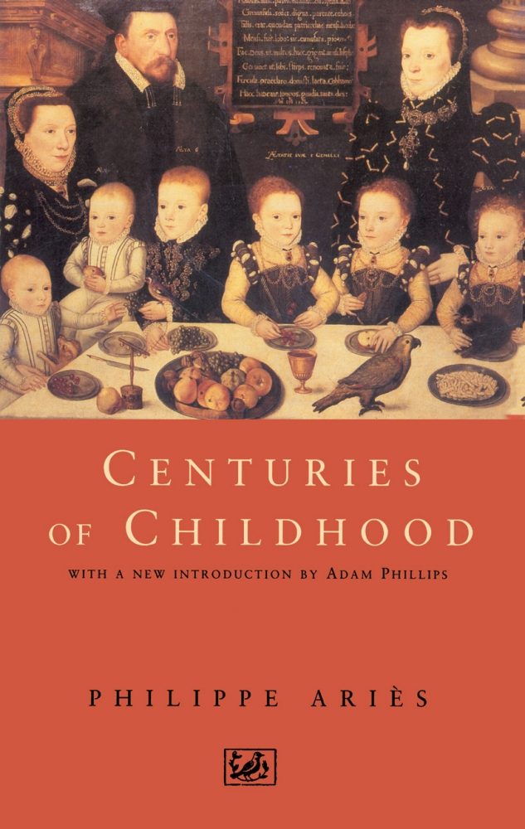

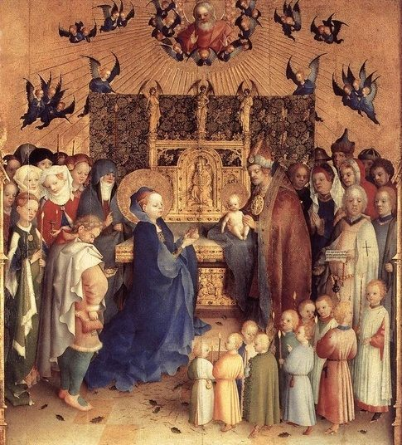



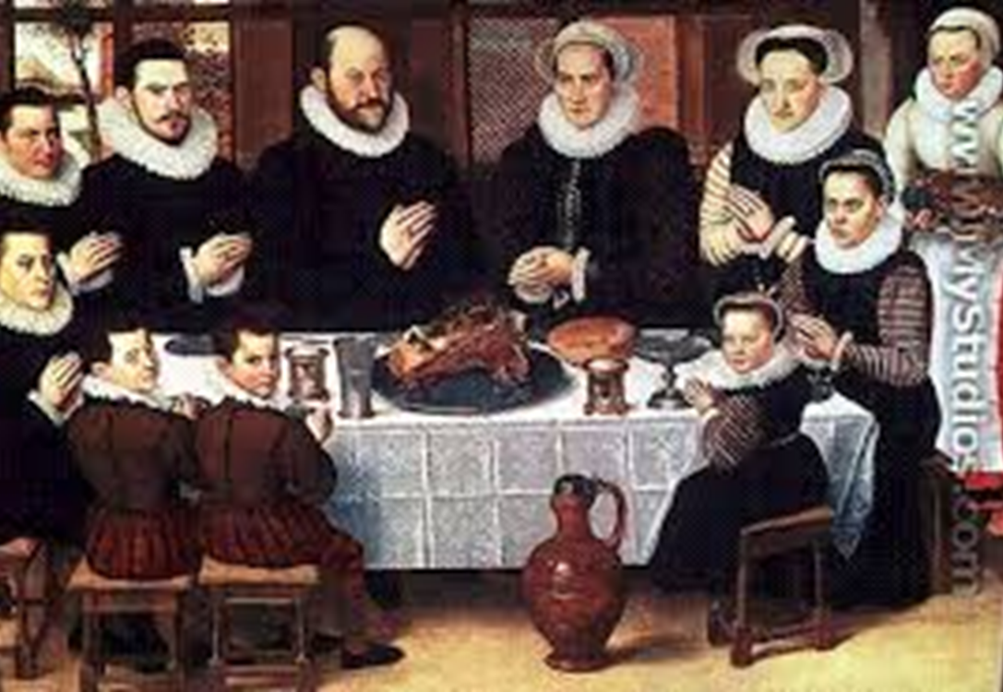

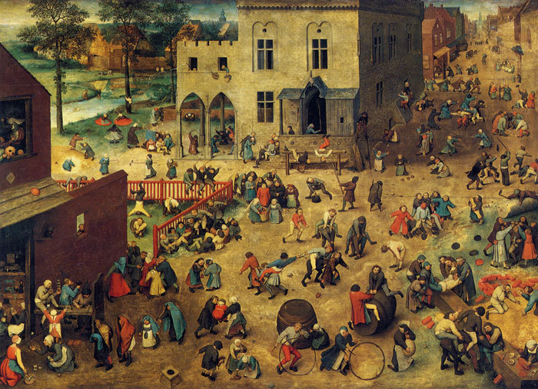

**Research Methods consideration: Do you think that the use of secondary data such as paintings are a useful method for helping sociologists make conclusions about society?**