Philippe Aries based is argument/views of childhood in medieval Europe on his analysis of secondary data – such as letters and diaries. He relied significantly on paintings produced at the time too as a source.

**Activity: Look at these paintings. What conclusions can you draw about childhood from these?**

**History of Childhood – Philippe Aries**

*"In medieval society the idea of childhood did not exist; this is not to suggest that children were neglected, forsaken or despised. The idea of childhood is not to be confused with with affection for children: it corresponds to an awareness of the particular nature of childhood, that particular nature which distinguishes the child from the adult, even the young adult. In medieval society, this awareness was lacking. That is why, as soon as the child could live without the constant solicitude of his mother, his nanny or his cradle-rocker, he belonged to adult society. That adult society now strikes us as rather puerile: no doubt this is largely a matter of its mental age, but it is also due to its physical age, because it was partly made up of children and youths."[p 125]*

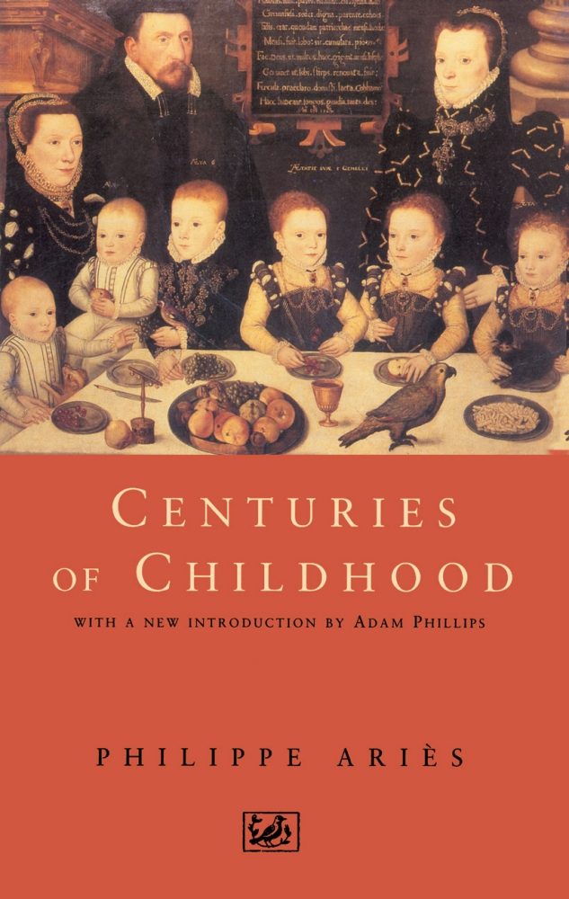

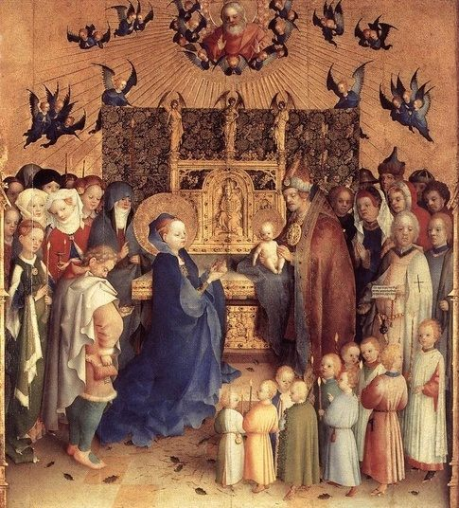



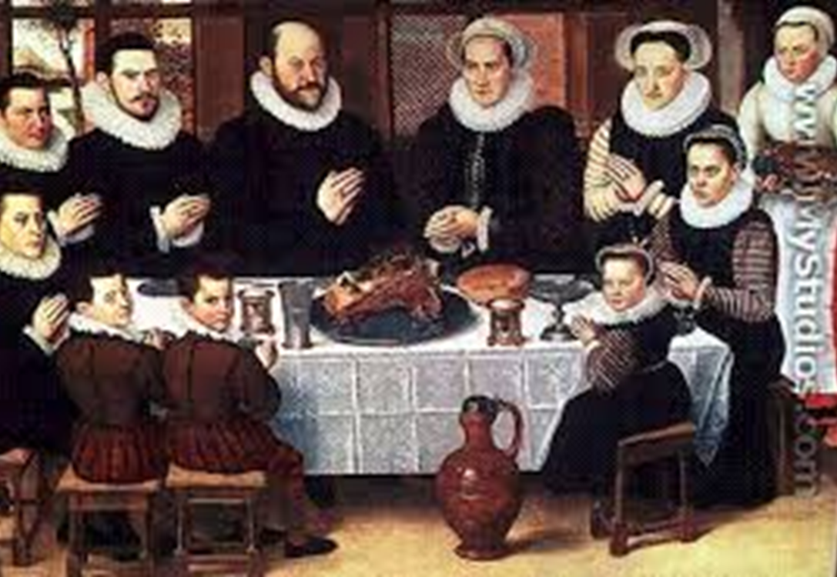

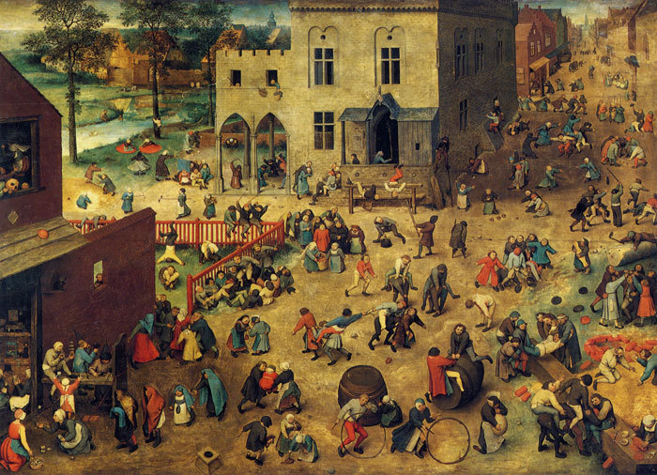

**Research Methods consideration: Do you think that the use of secondary data such as paintings are a useful method for helping sociologists make conclusions about society?**