**REPRESENTATION and NARRATIVE TASK**

[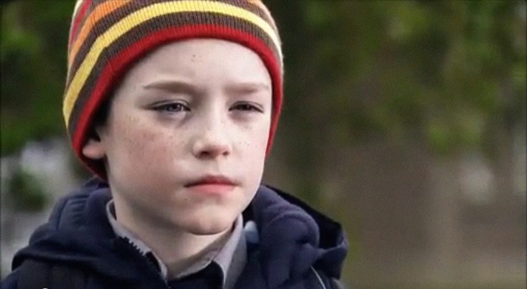](http://2.bp.blogspot.com/-mWGGbu_urvQ/TVQpZikHzdI/AAAAAAAAAUY/5hWhM8tlJ0Q/s1600/crush+still+Ardal.jpg)

***THE CRUSH* (2010)**

**Nominated for an Oscar for Best Short Film**

**Please answer the following questions in relation to the representations and narrative within the film. You will need to use imdb for some questions and you can re-watch the film on YouTube <https://www.youtube.com/watch?v=KrRSjaNmbLE>**

1. **What kind of world has been constructed by the text? (realistic? contemporary?)**

**…………………………………………………………………………………………………**

**…………………………………………………………………………………………………**

**…………………………………………………………………………………………………**

1. **Who is in control of the text (look on imdb)? Whose ideas and values have been expressed through the representations?** (remember to discuss mediation here)

**…………………………………………………………………………………………………**

**…………………………………………………………………………………………………**

**…………………………………………………………………………………………………**

1. **How have the representations been constructed? How can audiences interpret the representations?** (consider: clothing/dialogue/body language/actions)

**Ardal**

**…………………………………………………………………………………………………**

**…………………………………………………………………………………………………**

**…………………………………………………………………………………………………**

**Miss Purdy**

**…………………………………………………………………………………………………**

**…………………………………………………………………………………………………**

**…………………………………………………………………………………………………**

**…………………………………………………………………………………………………**

**Pierce (the boyfriend)**

**…………………………………………………………………………………………………**

**…………………………………………………………………………………………………**

**…………………………………………………………………………………………………**

1. **What messages/ideologies are contained within these representations?**

**…………………………………………………………………………………………………**

**…………………………………………………………………………………………………**

**…………………………………………………………………………………………………**

**…………………………………………………………………………………………………**

1. **Find quotes from two different representation theorists. How can their ideas be applied to one or more of the representations in this film? (Possible theorists include: Stuart Hall/David Gauntlett/Laura Mulvey).**

**………………………………………………………………………………………………………………………**

**………………………………………………………………………………………………………………………**

**…………………………………………………………………………………………………**

**…………………………………………………………………………………………………**

**…………………………………………………………………………………………………**

**…………………………………………………………………………………………………**

**NARRATIVE**

1. Is the narrative linear or non-linear?

**…………………………………………………………………………………………………**

**…………………………………………………………………………………………………**

1. Identify the main semic, action and enigma codes (Barthes) employed within the film.

**Semic:**

**…………………………………………………………………………………………………**

**…………………………………………………………………………………………………**

**…………………………………………………………………………………………………**

**…………………………………………………………………………………………………**

**Action:**

**…………………………………………………………………………………………………**

**…………………………………………………………………………………………………**

**…………………………………………………………………………………………………**

**…………………………………………………………………………………………………**

**Enigma:**

**…………………………………………………………………………………………………**

**…………………………………………………………………………………………………**

**…………………………………………………………………………………………………**

**…………………………………………………………………………………………………**

1. Which binary oppositions (Strauss) can you identify?

**…………………………………………………………………………………………………**

**…………………………………………………………………………………………………**

**…………………………………………………………………………………………………**

**…………………………………………………………………………………………………**