**Geography Department**

**YEAR 2 - 3.2.1 Global Systems and Global Governance**

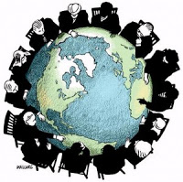

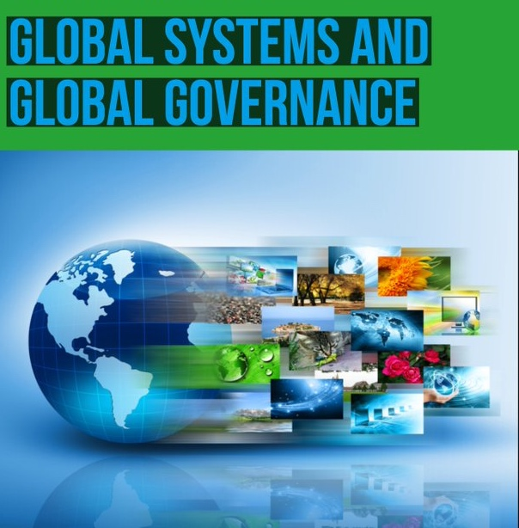

Table of Contents

1. Introduction 3

1.1 An outline of this unit (3.2.1) 3

2. Globalisation – 3.2.1.1 4

2.1 Globalisation: What you need to know: 4

2.2 TASK 1: Globalisation is…. 4

2.3 TASK 2: Produce a mind map detailing the global life/journey of a particular product - MUSIC 5

2.4 TASK 3: News Headlines 5

3. Godalming OR your local town 6

3.1 TASK 4: Research the extent of globalisation in Godalming OR your local area 6

4 Further Reading on Globalisation 7

# 1. Introduction

## 1.1 An outline of this unit (3.2.1)

This section of our specification focuses on **globalisation** – the economic, political and social changes associated with technological and other driving forces which have been a key feature of global economy and society in recent decades.

Increased interdependence and transformed relationships between peoples, states and environments have prompted more or less successful attempts at a global level to manage and govern some aspects of human affairs.

**Unit Stages:**

3.2.1.1 Globalisation

Dimensions of globalisation

3.2.1.2 Global systems

Form and nature of economic, political, social and environmental interdependence in the contemporary world.

3.2.1.3 International trade and access to markets

Global features and trends in the volume and pattern of international trade and investment.

3.2.1.4 Global governance

The emergence and developing role of norms, laws and institutions in regulating and reproducing global systems.

3.2.1.5 The 'global commons'

The concept of the ‘global commons’. The rights of all to the benefits of the global commons.

3.2.1.5.1 Antarctica as a global common

An outline of the contemporary geography, including climate, of Antarctica (including the Southern Ocean as far north as the Antarctic Convergence) to demonstrate its role as a global common and illustrate its vulnerability to global economic pressures and environmental change.

3.2.1.6 Globalisation critique

The impacts of globalisation to consider the benefits of growth, development, integration, stability against the costs in terms of inequalities, injustice, conflict and environmental impact.

3.2.1.7 Quantitative and qualitative skills

Students must engage with quantitative and qualitative approaches across the theme as a whole.

# 2. Globalisation – 3.2.1.1

## 2.1 Globalisation: What you need to know:

As part of this first section on Globalisation (outlined above), you will be working towards the following learning outcomes:

1. To have a clear understanding of globalisation and its interconnected elements and scales of the global economy.
2. To appreciate that globalisation has accelerated within your own lifetime, driven by companies based in countries all over the world. It’s not just an assumed outcome of improved technology.
3. You will be able to discuss the advantages and disadvantages of globalisation.

## 2.2 TASK 1: Globalisation is….

To understand the term globalisation and consider its impact on your lives – complete the following:

1. Where are your belongings are from?
2. Where was your recent holiday (pre-COVID 19)?
3. What music do you like and where is it from?
4. What is your favourite meal? Where does the food originate?
5. Are there any patterns?

## 2.3 TASK 2: Produce a mind map detailing the global life/journey of a particular product - MUSIC

**Create** **an image** (include pictures on your minds map) showing your connections to the rest of the world based on the music you listen to, using the following questions:

* What’s the origin of the most recent song or piece of music that you listened to? (Identify the nationality of the creator of the music as well as the tradition to which it belongs.)
* What technology do you most commonly use to listen to music?
* Where is the technology made? Where is the company that owns the technology based?
* How have you obtained music – online purchases or physically bought from retail outlets?

**Collect**  some additional data from your family in relation to this and the music they listen to and then in a separate document make generalisations about any patterns in the data.

* + Do certain countries predominate in terms of musical choices and/or owning or making technology?
  + Which types of technology are most commonly used? Is online or physical shopping more popular?

**Use** your mind map to discuss the following in your first lesson back: What is globalisation?

## 2.4 TASK 3: News Headlines

**Think** of a current event featuring in headlines around the world. (Hint: politics, music, sport, film, celebrity culture, or disaster. Twitter might provide some ideas).

**Write** 500 words about the event using some of the following prompts: national identity, language, design, place of manufacture, origin of natural resources, cultural traditions, use of technology, history etc.

# 3. Godalming OR your local town

**Example: Godalming Town Centre: how local?**

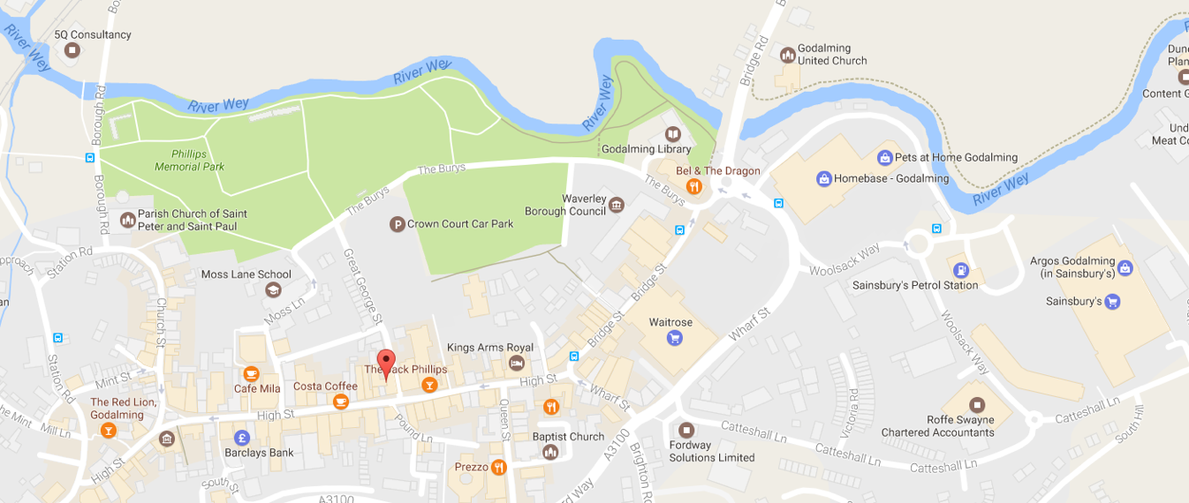

Source: <https://www.google.co.uk/maps/@51.1876812,-0.6089951,17z?hl=en>

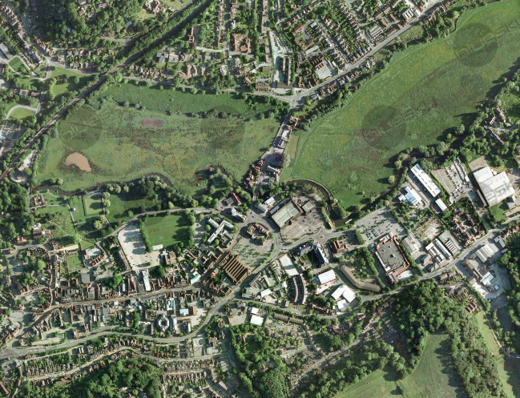

Image by Imagery ©2014 Infoterra Ltd & Bluesky, Map data ©2016 GoogleSource: <https://www.blueskymapshop.com/viewer/aerial-photography/aerial-photo-standard?x=497359&y=144089&z=2&w=500&h=500&f=&p>=[

## 3.1 TASK 4: Research the extent of globalisation in Godalming OR your local area

You can ask geographical questions about globalisation….

**Fieldwork**: Take a walk or ‘virtual’ walk down Godalming or your local high street. Does it have chain stores, independent shops, are there signs of different cultures and languages? What are the immediate signs of globalisation in the local area? Record this and write a summary about your local high street by answering the following question:

**To what extent is Godalming OR your local high street truly local?**

# 4 Further Reading on Globalisation

* The websites of the [United Nations](http://www.un.org/), [World Trade Organisation](http://www.wto.org/) and [World Bank](http://www.worldbank.org/) have material on various aspects linked to global systems.
* [The Economist](http://www.economist.com/)is useful.. Interesting articles on globalisation and development can be found at [Global Eye](http://www.globaleye.org.uk/)
* [International forum on globalisation](http://www.ifg.org/) ; [Global Issues](http://www.globalissues.org/)
* [Organisation for Economic Cooperation and Development](http://www.oecd.org/)
* “What is Globalisation?” - <https://www.youtube.com/watch?v=ZNejKHKSbl0>
* RGS Lecture on: ‘Made in Britain’: <https://www.rgs.org/geography/online-lectures/made-in-britain/>
* Post war Britain Manufacturing: <https://www.rgs.org/schools/teaching-resources/globalisation-of-manufacturing-in-post-war-britain/>