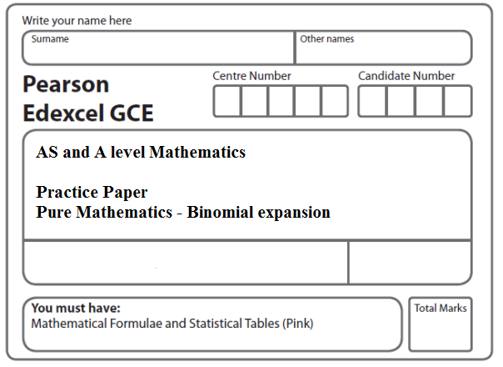
Instructions
- Use black ink or ball-point pen.
- If pencil is used for diagrams/sketches/graphs it must be dark (HB or B).
- Fill in the boxes at the top of this page with your name, centre number and candidate number.
- Answer all the questions and ensure that your answers to parts of questions are clearly labelled.
- Answer the questions in the spaces provided – there may be more space than you need.
- You should show sufficient working to make your methods clear. Answers without working may not gain full credit.
- Inexact answers should be given to three significant figures unless otherwise stated.
Information
- A booklet ‘Mathematical Formulae and Statistical Tables’ is provided.
- There are 9 questions in this question paper. The total mark for this paper is 49.
- The marks for each question are shown in brackets – use this as a guide as to how much time to spend on each question.
Advice
• Read each question carefully before you start to answer it.
• Try to answer every question.
• Check your answers if you have time at the end.
• If you change your mind about an answer, cross it out and put your new answer and any working underneath.
1. Find the first 3 terms, in ascending powers of x, of the binomial expansion of
(2 – 3x)⁵,
giving each term in its simplest form.
(4)
(Total 4 marks)
___________________________________________________________________________

2. Find the first 4 terms, in ascending powers of x, of the binomial expansion of
giving each term in its simplest form.
(Total 4 marks)
___________________________________________________________________________

3. Find the first 3 terms, in ascending powers of x, of the binomial expansion of
${\left(2−\frac{x}{4}\right)}^{\text{10}}$,
giving each term in its simplest form.
(Total 4 marks)
___________________________________________________________________________

4. Find the first 4 terms, in ascending powers of x, of the binomial expansion of
giving each term in its simplest form.
(Total 4 marks)
___________________________________________________________________________

5. (a) Find the first 3 terms, in ascending powers of x, of the binomial expansion of

(3 + bx)⁵

where b is a non-zero constant. Give each term in its simplest form.
(4)

Given that, in this expansion, the coefficient of x² is twice the coefficient of x,

(b) find the value of b.
(2)
(Total 6 marks)
___________________________________________________________________________

6. (a) Find the first 4 terms of the binomial expansion, in ascending powers of x, of
${\left(1+\frac{x}{4}\right)}^{8}$,
giving each term in its simplest form.
(4)
(b) Use your expansion to estimate the value of (1.025)⁸, giving your answer to 4 decimal places.
(3)
(Total 7 marks)
___________________________________________________________________________

7. (a) Find the first 3 terms, in ascending powers of x, of the binomial expansion of (2 – 3x)⁶, giving each term in its simplest form.
(4)
(b) Hence, or otherwise, find the first 3 terms, in ascending powers of x, of the expansion of
$\left(1+\frac{x}{2}\right)$(2 – 3x)⁶.
(3)
(Total 7 marks)
___________________________________________________________________________

8. Given that $\left(\begin{matrix}\text{40} \\ 4\end{matrix}\right)$ = $\frac{\text{40}!}{4!b!}$,
(a) write down the value of b.
(1)
In the binomial expansion of (1 + x)⁴⁰, the coefficients of x⁴ and x⁵ are p and q respectively.
(b) Find the value of $\frac{q}{p}$.
(3)
(Total 4 marks)
___________________________________________________________________________

9. (a) Find the first 3 terms, in ascending powers of x, of the binomial expansion of

(2 – 9x)⁴,

giving each term in its simplest form.
(4)

f(x) = (1 + kx)(2 – 9x)⁴, where k is a constant.

The expansion, in ascending powers of x, of f(x) up to and including the term in x² is

A – 232x + Bx²,

where A and B are constants.

(b) Write down the value of A.
(1)
(c) Find the value of k.
(2)
(d) Hence find the value of B.
(2)
(Total 9 marks)

TOTAL FOR PAPER: 49 MARKS

