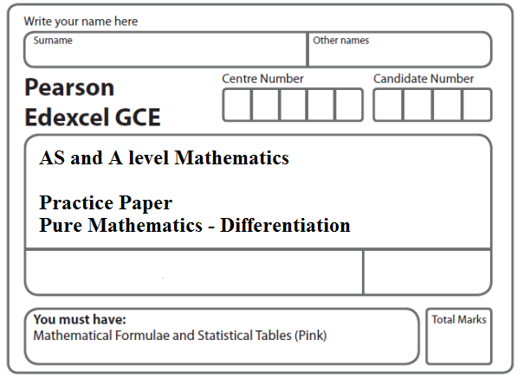
Instructions
- Use black ink or ball-point pen.
- If pencil is used for diagrams/sketches/graphs it must be dark (HB or B).
- Fill in the boxes at the top of this page with your name, centre number and candidate number.
- Answer all the questions and ensure that your answers to parts of questions are clearly labelled.
- Answer the questions in the spaces provided – there may be more space than you need.
- You should show sufficient working to make your methods clear. Answers without working may not gain full credit.
- Inexact answers should be given to three significant figures unless otherwise stated.
Information
- A booklet ‘Mathematical Formulae and Statistical Tables’ is provided.
- There are 11 questions in this question paper. The total mark for this paper is 99.
- The marks for each question are shown in brackets – use this as a guide as to how much time to spend on each question.
- Calculators must not be used for questions marked with a * sign.
Advice
• Read each question carefully before you start to answer it.
• Try to answer every question.
• Check your answers if you have time at the end.
• If you change your mind about an answer, cross it out and put your new answer and any working underneath.
1*. Given
x > 0
find the value of when x = 8, writing your answer in the form , where a is a rational number.
(Total 5 marks)
___________________________________________________________________________

2*. Given that
,
find . Give each term in your answer in its simplified form.
(Total 6 marks)
___________________________________________________________________________

3*. Differentiate with respect to x, giving answer in its simplest form
$$\frac{x^{5}+6\sqrt{x}}{2x^{2}}$$
(Total 4 marks)
___________________________________________________________________________

4*. y = 5x³ − $6x^{\frac{4}{3}}$ + 2x − 3.
(a) Find $\frac{dy}{dx}$, giving each term in its simplest form.
(4)
(b) Find $\frac{d^{2}y}{{dx}^{2}}$
(2)
(Total 6 marks)
___________________________________________________________________________
5.

Figure 1

A manufacturer produces pain relieving tablets. Each tablet is in the shape of a solid circular cylinder with base radius x mm and height h mm, as shown in Figure 1.
Given that the volume of each tablet has to be 60 mm³,
(a) express h in terms of x,
(1)
(b) show that the surface area, A mm², of a tablet is given by A = 2π x² + $\frac{\text{120}}{x}$.
(3)
The manufacturer needs to minimise the surface area A mm², of a tablet.
(c) Use calculus to find the value of x for which A is a minimum.
(5)
(d) Calculate the minimum value of A, giving your answer to the nearest integer.
(2)
(e) Show that this value of A is a minimum.
(2)
(Total 13 marks)
___________________________________________________________________________
6. A solid glass cylinder, which is used in an expensive laser amplifier, has a volume of 75π cm³.
The cost of polishing the surface area of this glass cylinder is £2 per cm² for the curved surface area and £3 per cm² for the circular top and base areas.
Given that the radius of the cylinder is r cm,
(a) show that the cost of the polishing, £C, is given by
C = 6π r ² + $\frac{\text{300}π}{r}$.
(4)
(b) Use calculus to find the minimum cost of the polishing, giving your answer to the nearest pound.
(5)
(c) Justify that the answer that you have obtained in part (b) is a minimum.
(1)
(Total 10 marks)
___________________________________________________________________________
7.

Figure 2

Figure 2 shows a flowerbed. Its shape is a quarter of a circle of radius x metres with two equal rectangles attached to it along its radii. Each rectangle has length equal to x metres and width equal to y metres.
Given that the area of the flowerbed is 4m²,
(a) show that
y = $\frac{\text{16}−π x^{2}}{8x}$.
(3)
(b) Hence show that the perimeter P metres of the flowerbed is given by the equation
P = $\frac{8}{x}$ + 2x.
(3)
(c) Use calculus to find the minimum value of P.
(5)
(d) Find the width of each rectangle when the perimeter is a minimum.
Give your answer to the nearest centimetre.
(2)
(Total 13 marks)
___________________________________________________________________________

8.
Figure 3

Figure 3 shows the plan of a pool.
The shape of the pool ABCDEFA consists of a rectangle BCEF joined to an equilateral triangle BFA and a semi-circle CDE, as shown in Figure 3.
Given that AB = x metres, EF = y metres, and the area of the pool is 50 m²,
(a) show that
(3)
(b) Hence show that the perimeter, P metres, of the pool is given by
(3)
(c) Use calculus to find the minimum value of P, giving your answer to 3 significant figures.
(5)
(d) Justify, by further differentiation, that the value of P that you have found is a minimum.
(2)
(Total 13 marks)
___________________________________________________________________________

9. The volume V cm³ of a box, of height x cm, is given by
V = 4x(5 − x)², 0 < x < 5.
(a) Find $\frac{dV}{dx}$.
(4)
(b) Hence find the maximum volume of the box.
(4)
(c) Use calculus to justify that the volume that you found in part (b) is a maximum.
(2)
(Total 10 marks)
___________________________________________________________________________

10. Joan brings a cup of hot tea into a room and places the cup on a table. At time t minutes after Joan places the cup on the table, the temperature, θ °C, of the tea is modelled by the equation
θ = 20 + Ae^{−kt},
where A and k are positive constants.
Given that the initial temperature of the tea was 90 °C,
(a) find the value of A.
(2)

The tea takes 5 minutes to decrease in temperature from 90 °C to 55 °C.

(b) Show that k = $\frac{1}{5}$ ln 2.
(3)
(c) Find the rate at which the temperature of the tea is decreasing at the instant when t = 10. Give your answer, in °C per minute, to 3 decimal places.
(3)
(Total 8 marks)
___________________________________________________________________________

11. The mass, m grams, of a leaf t days after it has been picked from a tree is given by
m = pe^{−kt},
where k and p are positive constants.
When the leaf is picked from the tree, its mass is 7.5 grams and 4 days later its mass is 2.5 grams.
(a) Write down the value of p.
(1)
(b) Show that k = $\frac{1}{4}$ln 3.
(4)
(c) Find the value of t when $\frac{dm}{dt}$ = −0.6 ln 3.
(6)
(Total 11 marks)

TOTAL FOR PAPER: 100 MARKS

