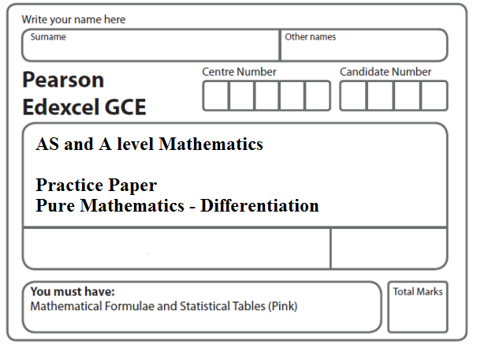
Instructions
- Use black ink or ball-point pen.
- If pencil is used for diagrams/sketches/graphs it must be dark (HB or B).
- Fill in the boxes at the top of this page with your name, centre number and candidate number.
- Answer all the questions and ensure that your answers to parts of questions are clearly labelled.
- Answer the questions in the spaces provided – there may be more space than you need.
- You should show sufficient working to make your methods clear. Answers without working may not gain full credit.
- Inexact answers should be given to three significant figures unless otherwise stated.
Information
- A booklet ‘Mathematical Formulae and Statistical Tables’ is provided.
- There are 9 questions in this question paper. The total mark for this paper is 100.
- The marks for each question are shown in brackets – use this as a guide as to how much time to spend on each question.
- Calculators must not be used for questions marked with a * sign.
Advice
• Read each question carefully before you start to answer it.
• Try to answer every question.
• Check your answers if you have time at the end.
• If you change your mind about an answer, cross it out and put your new answer and any working underneath.
1*. The curve C₁ has equation
y = x²(x + 2).
(a) Find $\frac{dy}{dx}$.
(2)
(b) Sketch C₁, showing the coordinates of the points where C₁ meets the x-axis.
(3)
(c) Find the gradient of C₁ at each point where C₁ meets the x-axis.
(2)
The curve C₂ has equation
y = (x − k)²(x − k + 2),
where k is a constant and k > 2.
(d) Sketch C₂, showing the coordinates of the points where C₂ meets the x and y axes.
(3)
(Total 10 marks)
___________________________________________________________________________
2*. The curve C has equation
y = (x + 1)(x + 3)².
(a) Sketch C, showing the coordinates of the points at which C meets the axes.
(4)
(b) Show that $\frac{dy}{dx}$ = 3x² + 14x + 15.
(3)
The point A, with x-coordinate –5, lies on C.
(c) Find the equation of the tangent to C at A, giving your answer in the form y = mx + c, where m and c are constants.
(4)
Another point B also lies on C. The tangents to C at A and B are parallel.
(d) Find the x-coordinate of B.
(3)
(Total 14 marks)
___________________________________________________________________________
3*. The curve C has equation
y = $\frac{(x^{2}+4)(x−3)}{2x}$, x ≠ 0.
(a) Find $\frac{dy}{dx}$ in its simplest form.
(5)
(b) Find an equation of the tangent to C at the point where x = –1.
Give your answer in the form ax + by + c = 0, where a, b and c are integers.
(5)
(Total 10 marks)
___________________________________________________________________________

4*. The curve C has equation y = 2x³ + kx² + 5x + 6, where k is a constant.
(a) Find .
(2)
The point P, where x = –2, lies on C.
The tangent to C at the point P is parallel to the line with equation 2y – 17 x – 1 = 0.
Find
(b) the value of k,
(4)
(c) the value of the y coordinate of P,
(2)
(d) the equation of the tangent to C at P, giving your answer in the form ax + by + c = 0, where a, b and c are integers.
(2)
(Total 10 marks)
___________________________________________________________________________

5*. The curve C has equation
y = 2x − 8√x + 5, x ≥ 0.
(a) Find $\frac{dy}{dx}$, giving each term in its simplest form.
(3)
The point P on C has x-coordinate equal to $\frac{1}{4}$.
(b) Find the equation of the tangent to C at the point P, giving your answer in the form y = ax + b, where a and b are constants.
(4)
The tangent to C at the point Q is parallel to the line with equation 2x − 3y + 18 = 0.
(c) Find the coordinates of Q.
(5)
(Total 12 marks)
___________________________________________________________________________

6*. The curve C has equation
y = $\frac{1}{2}x^{3}$ – $9x^{\frac{3}{2}}$ + $\frac{8}{x}$ + 30, x > 0.
(a) Find $\frac{dy}{dx}$
(4)
(b) Show that the point P(4, –8) lies on C
(2)
(c) Find an equation of the normal to C at the point P, giving your answer in the form ax + by + c = 0 , where a, b and c are integers.
(6)
(Total 12 marks)
___________________________________________________________________________
7*.

Figure 1

Figure 1 shows a sketch of the curve C with equation
y = 2 − $\frac{1}{x}$, x ≠ 0.
The curve crosses the x-axis at the point A.
(a) Find the coordinates of A.
(1)
(b) Show that the equation of the normal to C at A can be written as
2x + 8y −1 = 0.
(6)
The normal to C at A meets C again at the point B, as shown in Figure 1.
(c) Find the coordinates of B.
(4)
(Total 11 marks)
___________________________________________________________________________

8*.
Figure 2

A sketch of part of the curve C with equation
, x > 0
is shown in Figure 2.
Point A lies on C and has an x coordinate equal to 2.
(a) Show that the equation of the normal to C at A is y = –2x + 7.
(6)
The normal to C at A meets C again at the point B, as shown in Figure 2.
(b) Use algebra to find the coordinates of B.
(5)
(Total 11 marks)
___________________________________________________________________________
9.
Figure 3

Figure 3 shows a sketch of part of the curve with equation
y = 4x³ + 9x² – 30x – 8, –0.5 ⩽ x ⩽ 2.2
The curve has a turning point at the point A.
(a) Using calculus, show that the x coordinate of A is 1
(3)
The curve crosses the x-axis at the points B (2, 0) and C
The finite region R, shown shaded in Figure 3, is bounded by the curve, the line AB, and the x-axis.
(b) Use integration to find the area of the finite region R, giving your answer to 2 decimal places.
(7)
(Total 10 marks)

TOTAL FOR PAPER: 100 MARKS

